Відділ освіти Підволочиської райдержадміністрації

Районний методичний кабінет

Розробка
уроку англійської мови
у 10 класі на тему:


Підготував:
викладач англійської мови
Підволочиської гімназії
імені І. Франка
Кобильняк В.В.

Підволочиськ 2015

Form 10

Level: Pre-Intermediate

Time: 45 minutes

Theme: Повторення та закріплення вивченого граматичного матеріалу. Умовний спосіб дієслова.

Aims:
- To develop grammar skills;
- To revise theoretical material about conditionals 1&2;
- To practice the use of conditionals 1&2;
- To develop reading and writing skills;
- To activate and revise learned vocabulary;
- To check pupil’s knowledge.

Teaching aids: handouts, a laptop, an interactive board, a projector.

PROCEDURE
- Introduction, warm up. (5 min)
- Start by talking about what you like to do: go fishing, go to the theatre, play football, watch TV, read biographies etc. Then continue: If I finish early this evening, I’ll go to see (whatever film is on at the local cinema); and if it’s fine at the weekend, I’ll play football/go walking/work in the garden etc.
Write the sentence on the board. Then ask some students: What will you do if you get home early tonight/tomorrow? What will you do if the weather’s fine at the weekend.
Accept part answers such as: I’ll see my friend.

- Ask a student: What are you going to do on Saturday? (Choose someone you expect will be doing some outside activity.) When you've found someone doing something out-of-doors, ask: What would you do if it rained? Then add to the question: Rain is possible. Would you do something else?
Then ask other students where they are going for their holiday. Respond to each one with a negative-feeling question. For example, if people say they are going skiing, ask them: What would you do if there wasn't enough snow? If people say they are going to a beach resort, ask them: What would you do there if it rained? Write the questions on the board.

- Revision (7 min)
- The First Conditional (Solutions Pre-Intermediate Unit 7 Grammar 2)
Point out to the students the form of the sentences.
IF + Present Simple // modal (usually WILL or WON'T) + main verb without TO
Explain to the students that when we use this form of the conditional, we are talking about something that is not unlikely to happen, although we can't be certain that it will happen. For example: If the weather's fine at the weekend, I'll go fishing. You can't be certain that you'll go fishing. But this is what you'll do in particular, not unlikely circumstances. Point out that won't is the contraction of will not.

- The Second Conditional (Unit 8 Grammar 1)
Remind students of the form of the earlier conditional and write on the board: First Conditional
IF + Present Simple // modal (usually WILL/WON'T) + main verb without TO Give two examples:
If it rains on Sunday, I'll stay at home and watch TV.
If the school falls down, we'll move to a new building on the other side of the town.
Explain to the students that when we use this form of the conditional, we are talking about something that is quite likely to happen, but we can't be certain if it will happen or not.
Now write on the board: Second Conditional
IF + Past Simple // modal (usually WOULD/WOULDN'T) + main verb without TO
Give two examples:
If it rained on Sunday, I would stay at home and watch TV.
If the school fell down, we would move to a new building on the other side of the town.
Explain that we use this form when we are talking about something that is possible but unlikely (in the first example, you are in a country where it doesn't usually rain at this time of year). We often use the second conditional to talk about something which doesn't take place. It is more imaginary. Elicit from students four or five questions beginning: What would you do if...?

- Grammar in Context (10 min)
Now let’s look how these conditionals are used in context.
Read this extract and underline the examples of the First Conditional.
Unit 7 Grammar 2
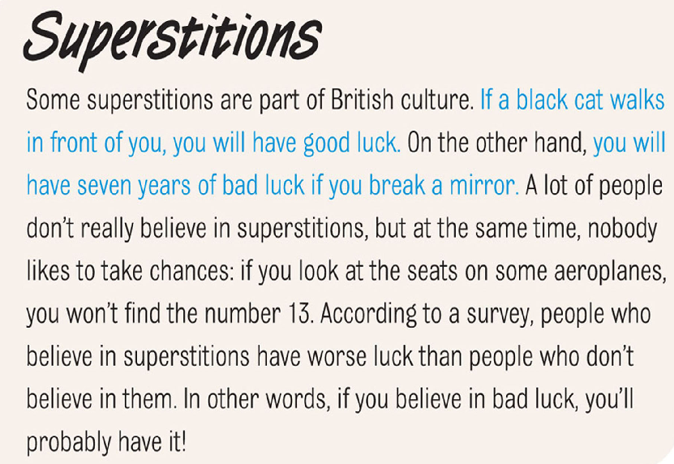
And now you’ll listen to this extract and fill in the gaps with the correct words in Conditional 2
Unit 8 Grammar 1
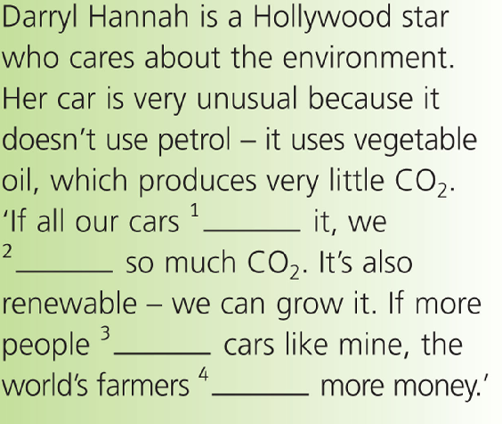

- Grammar Practice
- The First Conditional (instant lessons 2 intermediate pg 71-72)
Activity A. Play the game in pairs. Give each pair a set of dominoes and explain that they have to match the second part of one domino to the first part of another to make a full sentence. They should arrange the dominoes to make a square. Put this shape guide on the board to help them.
Key:
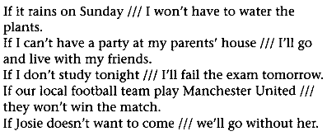
Activity B Put the students into groups. Give each group a set of the cards. In turn each student takes a card and has to complete the sentence, either with the if clause or the main clause.
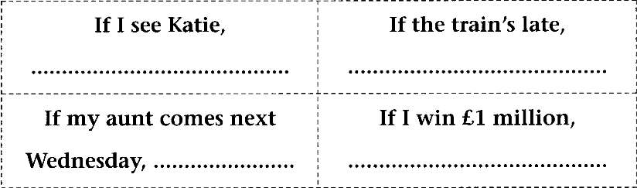
- The Second Conditional (instant lessons 2 intermediate pg 79)
Activity A Give students the handout. The students can work in pairs for the matching exercise. See which pair completes it first.
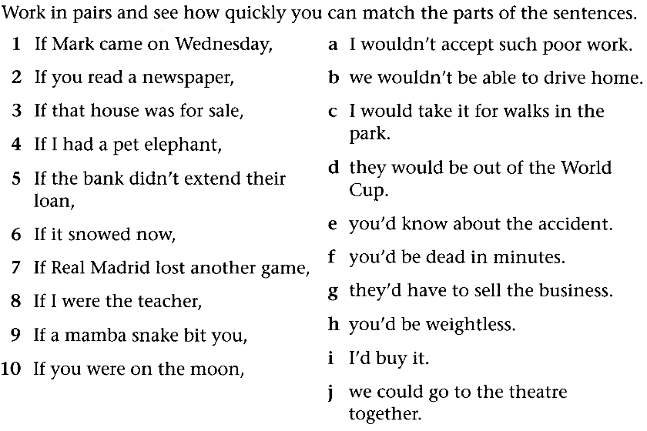
Activity B Put the students into groups. Give each group a set of the cards. In turn each student takes a card and has to complete the sentence, either with the if clause or the main clause.
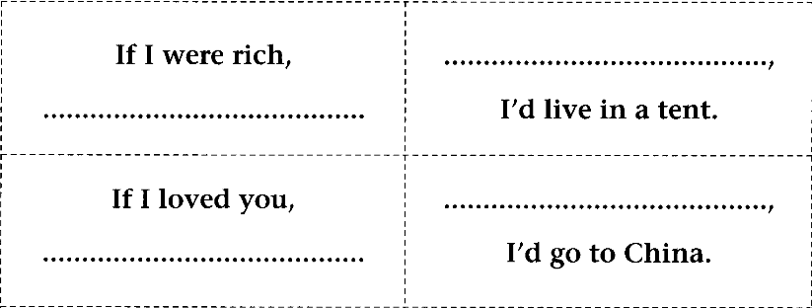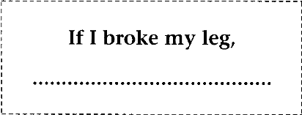
- Multimedia exercises
Grammar friends 6 Unit 1-3 ex 3 or tests
- Sentence chain
If I had a million dollars, I’d…
- Conclusion and home assignment.
Write a composition “If I left my country, I’d live…”
THE HANDOUTS

