Відділ освіти Підволочиської райдержадміністрації
Районний методичний кабінет

Розробка
уроку англійської мови
у 9 класі на тему:
«British schools and students»

Підготував:
вчитель англійської мови
Підволочиської гімназії
імені І. Франка
Кобильняк В.В.

Підволочиськ 2015
Level: Pre-Intermediate

Time: 45 minutes

Theme: British schools and students.

Aims:
  - To review Past Simple and vocabulary;
  - To check grammar skills and vocabulary;
  - To develop speaking and writing skills;
  - To practise listening skills;
  - To extend vocabulary with school words;
  - To introduce some information about British educational system;
  - To get acquainted with British student’ school life.
Teaching aids: Success Pre-Intermediate student’s book, language power book, CD, Window on Britain Video and SB, triumph board, laptop.
Key vocabulary: netball, boarding, primary, secondary.

PROCEDURE

І. Greeting

Stand up everybody! Good morning students! Sit down, please! Nice to meet you.
How are you?
I am so excellent, if there was a law against it I would be arrested.
How are you doing
Great – Every day above ground is a great day!
How is it hanging?
If I were any better, I’d have my own page on Wikipedia.
How are you getting on?
If I were any better, Energizer would give me my own drum.
How've you been
If I were any better, I’d have my own flag.
How's life
I’m doing so well that I have to sit on my hands to keep from waving at everyone.
What are you up to?
If I were any better you’d have to tie me down ’cause I’d fly to the moon.
How's it been going?
Pretty good, but I’ll be even better once I see you smile.
How's by you?
As always I’m wondefully well, feelin on top of d world.

II. Warm up
You’re marvelous! Now let’s warm up a little before our main work and chant a little bit

2.3 I'm Glad to Meet You. I've Heard So Much About You
I'm glad to meet you.
I've heard so much_about_you.
I'm glad to meet you.
I've heard so much_about_you.
I'm glad to meet you.
I've heard so much about you.
Thank you, I'm glad to meet you.
I've heard so many nice things_about you.
I've heard so many nice things about you.
So many nice things.
I've heard so many nice things.
I've heard so many nice things about you.
I'm glad to meet you.
I've heard so much about you.
Thank you, I'm glad to meet you.

III. Introducing the theme

It is impossible to imagine our life without modern technologies. There are lots of different devices which help us to get new information and study. So today we’ll have an opportunity to work with triumph board, there’ll be a lot of video, many different activities and of course all of you will write and click on the board. And all the information you’ll get today is about the educational system in England and Wales: the school day, the subjects taught, extra-curricular activities, state and independent schools.
IV. Grammar and vocabulary review

But before we go on, let’s review some grammar and vocabulary.

Success Pre-Int CD

Unit 3 Vocabulary 1 or 2

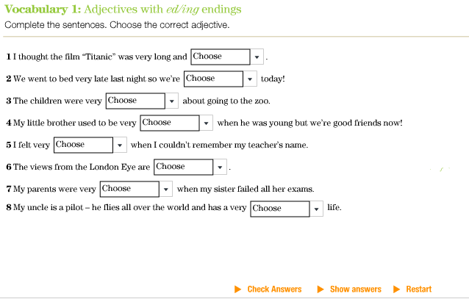

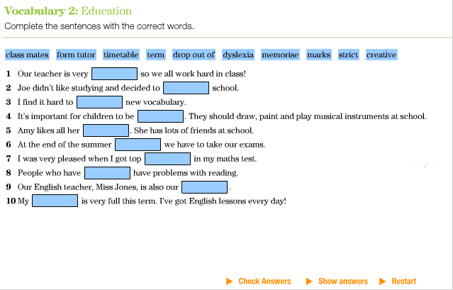

New Grammar Time 4 Unit 2 (Past Simple & used to)

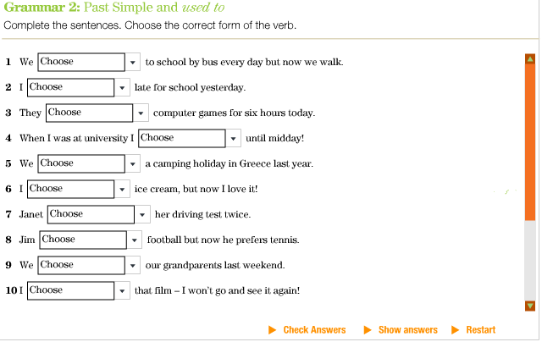

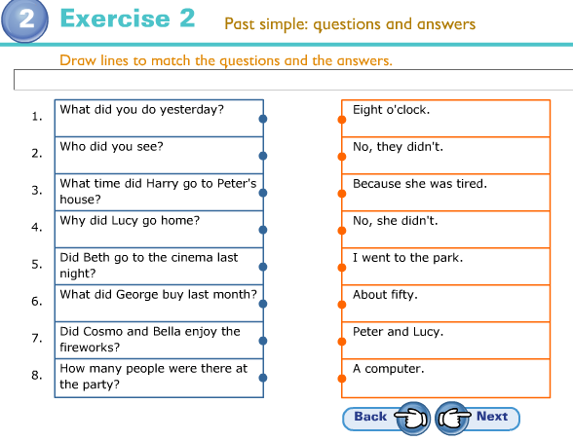

V. Main Part
1. Extending vocabulary. At last we’ve come up to our main theme for today – British schools and British students. The first exercise will be necessary for you for better understanding the following material. 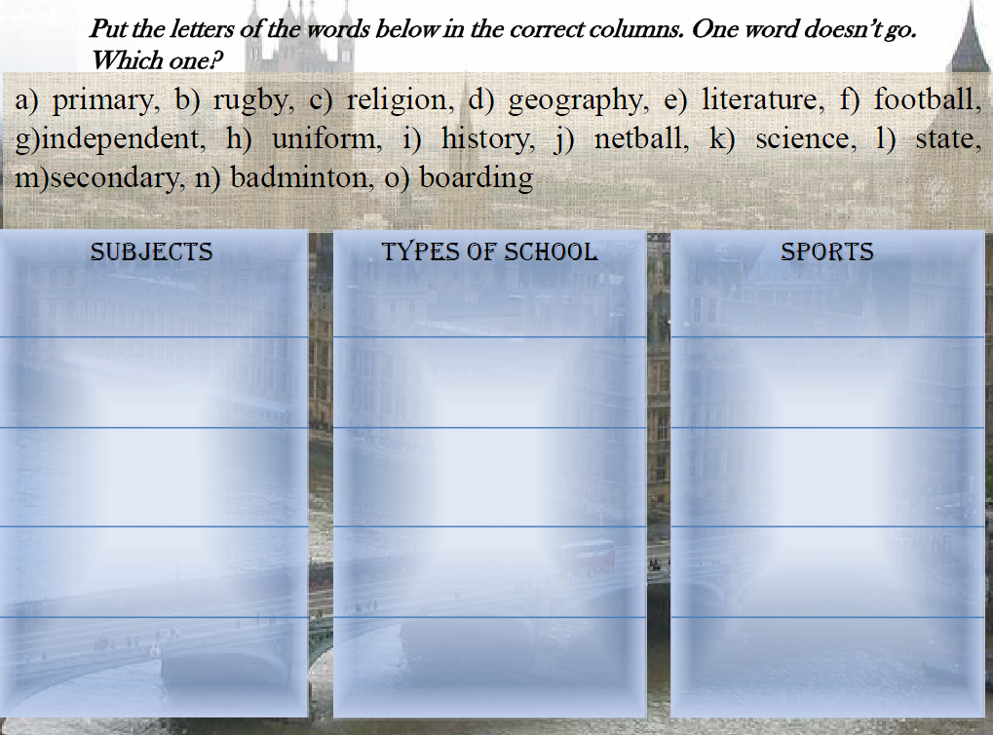
2. Practice
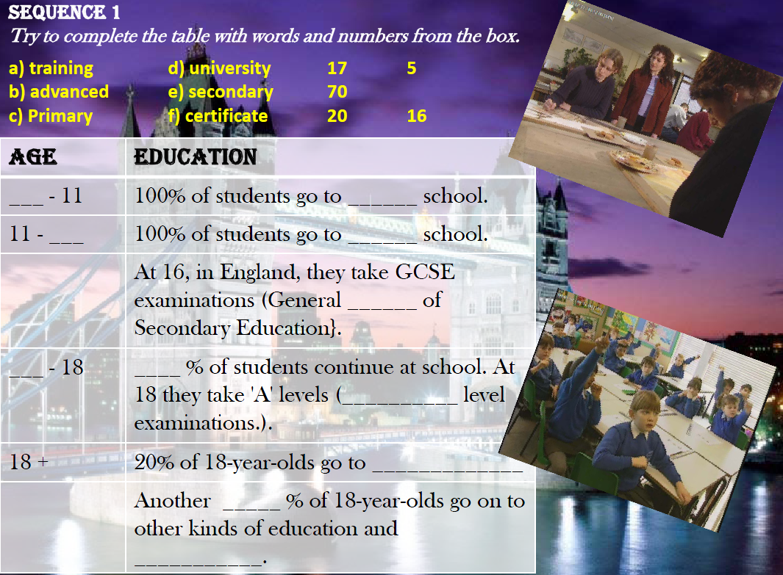
3.
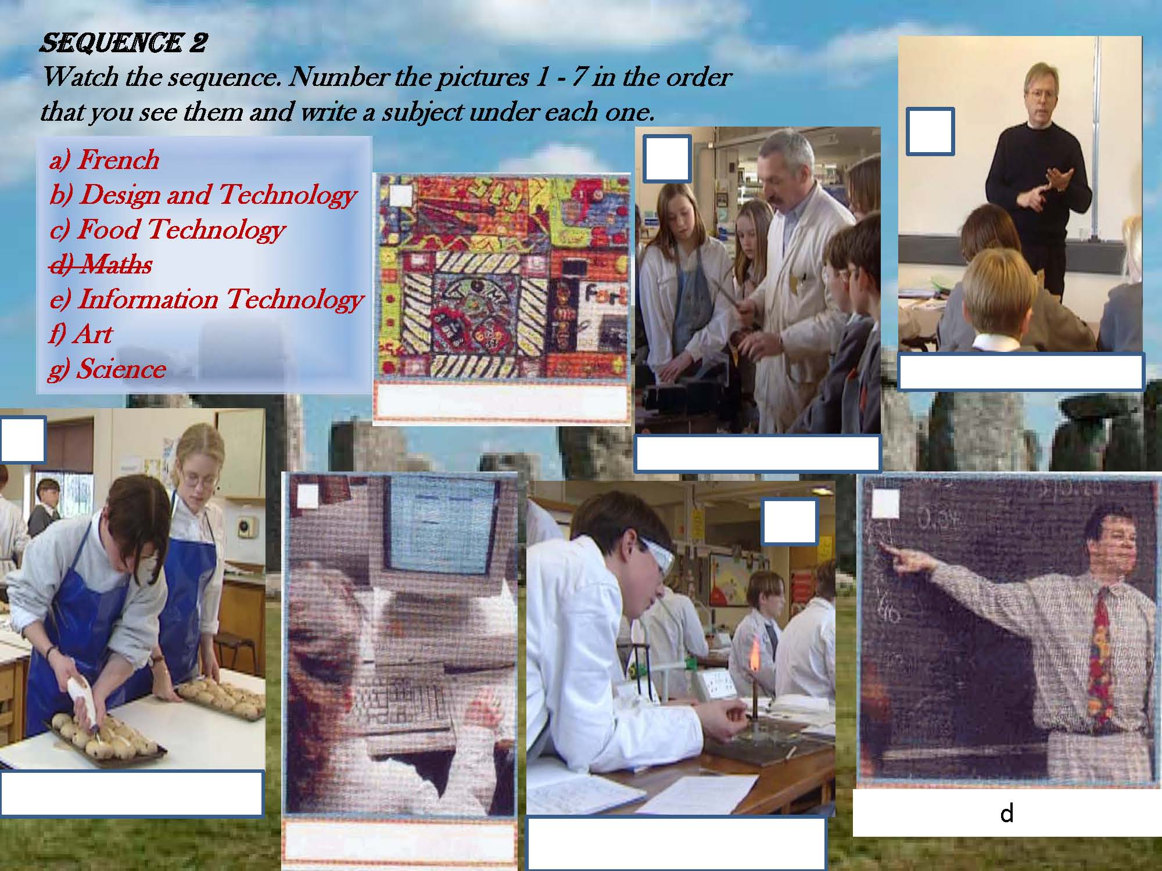
4.
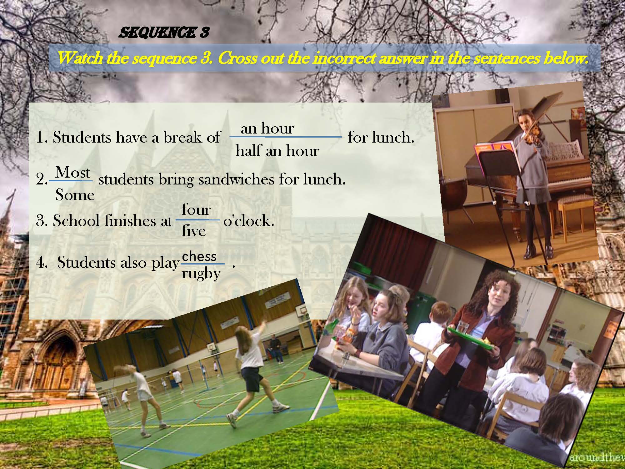
5.
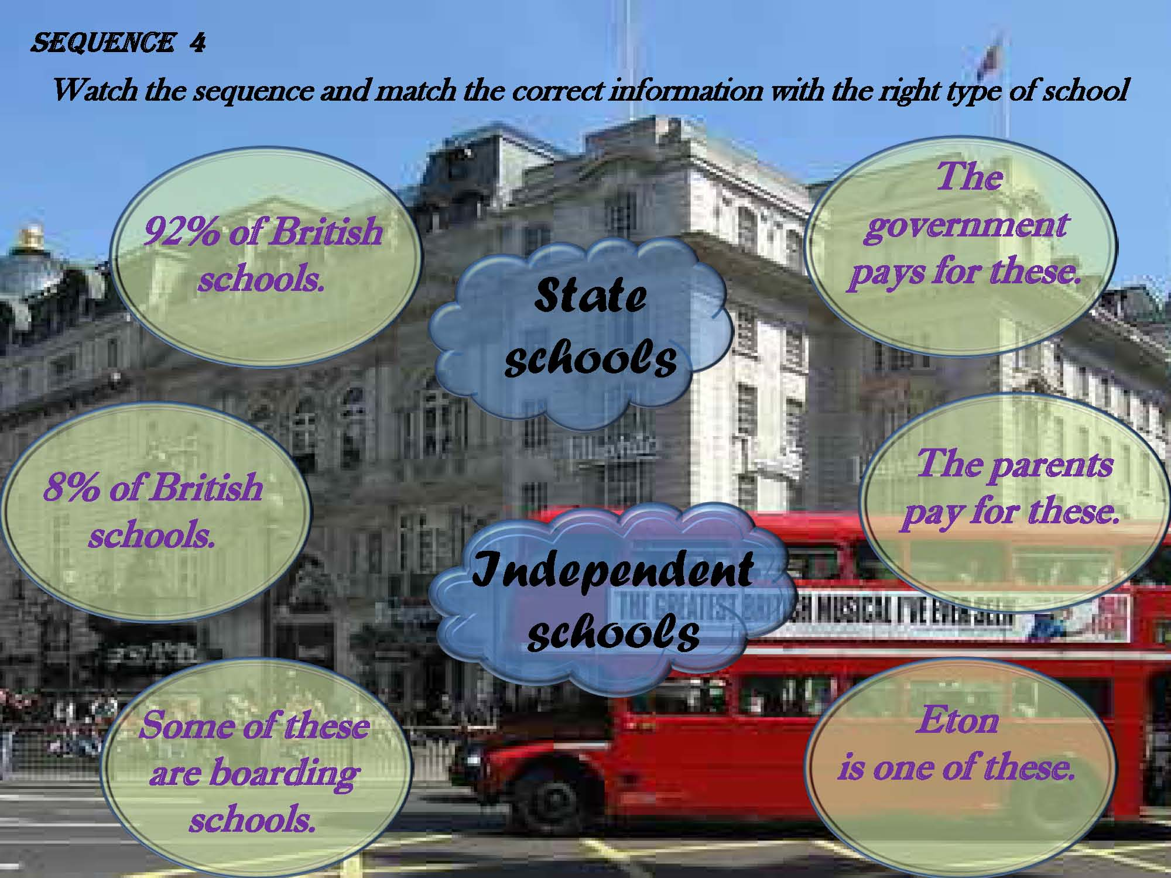
VI. Concluding part.
To sum up all the information you’ve got today let’s do the quiz and check how well you’ve remembered the information.
(Additional task: Work in groups of four. Talk about school and education. Make sentences that everyone in the group agrees with, e.g.:
Information Technology is very useful. We don’t like Math on Monday morning. We want less homework.
Write down as many sentences as possible. The group with the most sentences is the winner.)
VII. Home assignment.
(For homework a teacher gives students a handout of the text with tasks)
For the next lesson you have to read the letter from the handout and do the tasks, and write your own one.
Handout
