Theme: Environmental problems. Focus on vocabulary
Objectives: - to enrich pupils’ vocabulary on environmental problems;
- to teach pupils use new vocabulary in dialogue speaking;
- to develop pupils’ speaking, reading, listening, writing skills;
- to enhance pupils’ awareness on environmental problems.
Equipment: Quiz “Do you worry about the environment?”, Power Point Presentation “Vocabulary Point. Prevent/avoid/protect”; videos “Learn environment vocabulary”, “Learn English conversation: Environment and Pollution”, textbook “English 11” by O.Karpiuk, handouts.
Procedure
- Introduction.
Teacher. On our previous lesson we started speaking about different types of environmental problems. Today we are going to expand on the topic.
- Warming-up. Pair work.
Teacher. I give you strips of paper. There are 10 of them. You can see the names of different environmental problems written on the strips. In pairs you have to make a top10 list of the most important hazards as to your mind. Put the most dangerous environmental problem the first. The least dangerous must be the last.
- Reading.
Teacher. Let’s do a quiz “Do you worry about the environment?” and you will find out if you are environment conscious people.
Quiz "Do you worry about the environment?”
1) Imagine you are on a holiday abroad. You drink water from a plastic bottle, but there is no rubbish-bin to put it. What do you do?
a) Keep the bottle with you until you see a bin. (3)
b) Throw it on the ground. It’s not your fault there aren’t enough rubbish-bins. (1)
c) It depends. If there’s a lot of rubbish on the ground you might "drop it accidentally”. (2)

2) On the way home you get very thirsty. What do you buy?
a) Something in a non-recyclable plastic bottle. (1)
b) Something in a glass bottle or aluminum can. (3)
c) Something in a carton. (2)

3) Your walkman always needs new batteries. What do you buy?
a) Buy rechargeable batteries. (3)
b) Throw away old batteries and buy new ones. (1)
c) Buy new ones and take old ones to a recycling centre. (2)

4) You live near a beach. A new fast food restaurant is opened there. How do you react?
a) Pleased but also worried about more rubbish on the beach. (2)
b) Pleased. Now you can eat burgers on the beach. (1)
c) You never eat at fast food places because there is too much packaging. (3)

5) You buy a few things in a shop. The cashier offers you a plastic bag. What do you say?
a) "No, thank you”. (You have brought a bag from home.) (3)
b) Nothing. You let him / her put the things in the bag. (1)
c) It depends on whether you can carry the things easily without a bag. (2)

6) There are flies in your room. They are annoying you. What do you do?
a) Try to kill them with a newspaper. (2)
b) Try to kill them using aerosol. (1)
c) Hit the air with a newspaper so they leave you alone. (3)

7) You are writing a letter to a good friend. You’ve made several mistakes and need to cross things out. What do you do?
a) Start the letter again on another piece of paper. (1)
b) Continue writing, your friend will excuse your mistakes. (3)
c) Continue writing, but if you make any more mistakes, start again. (2)

Add up your score and read the analysis.
• 7–10: You do not worry about the environment at all. You think pollution is someone else’s problem, not yours. You think recycling and saving energy resources have no sense.
• 11 –17: You care about the environment and you have some good habits, which help save it. However, there are probably a few more things you could do.
• 1 8–21: You definitely care about the environment. You think about it when you make everyday decisions.
- Vocabulary Point.
Teacher. When speaking on ecological problems we often use the words PREVENT, AVOID and PROTECT. They are often confused by learners. Let’s find out the difference. Look on the screen.
(Power Point Presentation “Vocabulary Point. Prevent/avoid/protect”)
- Environmental problems. Use of language
- Watching the video “Learn environment vocabulary”.
Multi-level tasks.
Teacher. Now you will watch a video “Learn environment vocabulary”. After you have watched it, you will do the following tasks:
Level 1. Write down the environment words.
Level 2. Make up your own sentences with topic words from the video.
Level 3. Write down as many sentences from the video as you can remember.
Topic vocabulary: urban, sewerage system, green, nature reserve, fossil fuels, smog, global warming, greenhouse effect, rural, endangered species, go off, die out, run out off, give off, cut down, bring out, clear up, throw away.
- Watching the video “Learn English conversation: Environment and Pollution”. Speaking.
- Pair work. Using tape scripts make similar dialogues and role-play them.
- Reading. Group work.
Ex. 3, p.140-141.
Match the words with their definitions. (Pupils work in groups of 5-6. Teacher distributes tasks A or B to pupils.)
- Summing up. Home assignment.
Teacher: I give you different word clouds on the topic environment. Circle the words you already know blue, the words you don’t know – red. Can you suggest any other words to add to the word cloud?
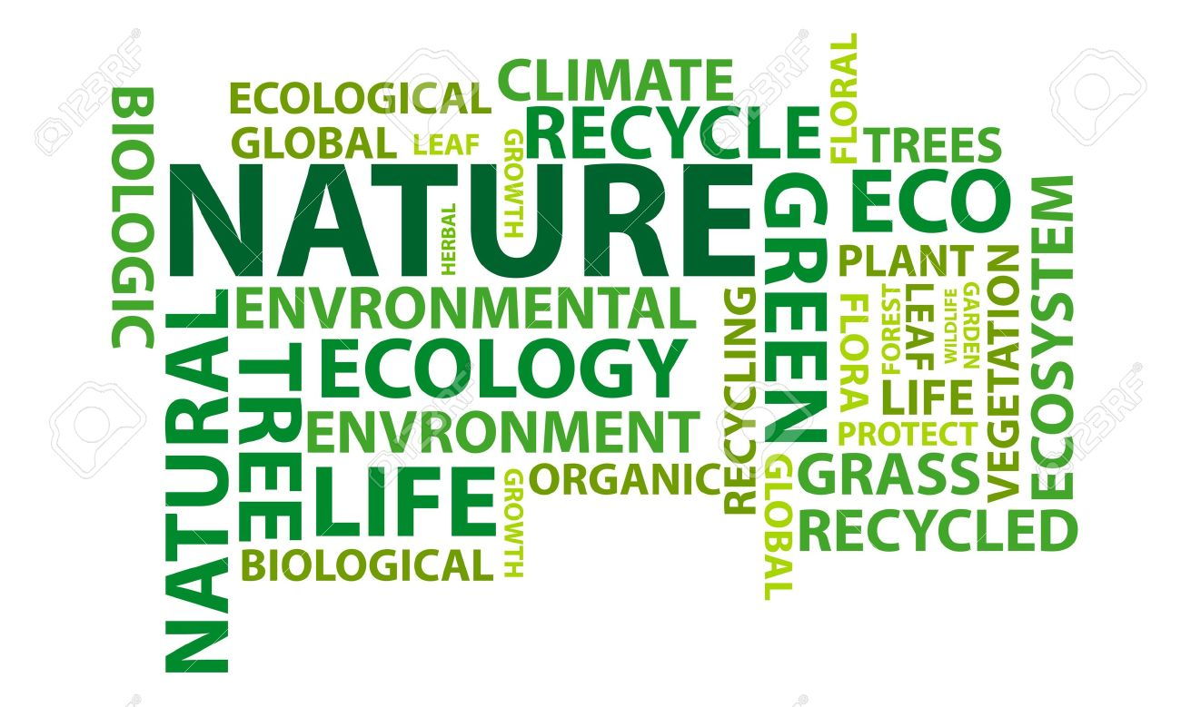
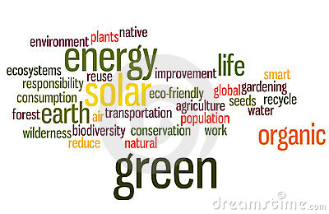

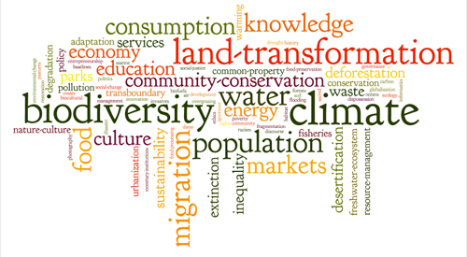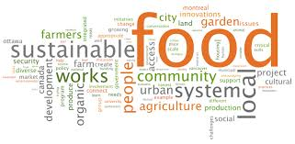
Your hometask is the following:
Level 1. Find the meaning of all the words in the word cloud.
Level 2. Make up a story using as many words from the word cloud as possible.
Level 3. Make your own word cloud to the word “ The Earth”. Use the cloud service Tagxedo, Wordle or any other generator.

