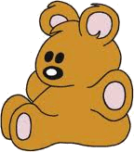
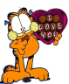


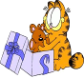






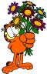
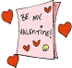

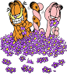
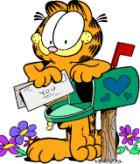









I like ______a lot.

a. cakes
b. cokes
c. sweets
a. bear
b. wild bear
c. teddy bear
a. kiss
b. hug
c. smile

a. balls
b. balloons
c. roses
a. loves
b. love
c. date
a. cup of tea
b. date
c. party
a. chocolate
b. candies
c. chocolates
a. flowers
b. candies
c. toys
a. sends
b. sending
c. receive
a. decorations
b. celebration
c. invitation
a. cords
b. hearts
c. cards
a. Odet
b. Cupid
c. love angel
a. gardens
b. roses
c. flowers
a. love
b. heart
c. hand
a. presents
b. teddy bear
c. a present
a. rose
b. roses
c. flower
When I was
young my favourite toy was
a _____.
Can you give me a _____ ,
Odile?
I have got
three red ________.
They are in ____.
Tonight
I’ve got a _____
with Olile.
I’m eating
a box of _______.
He has got
a bag full
of
______.
He’s _____
a card
to his
girlfriend.
He’s making some heart _______.
On St. Valentine’s day we send ______ to our couples

is the
angel of love
He’ll give some
_______ to Odile.
He’s painting a red ______
on the wall.
He’s smelling a
_______.
He has received a

for St. Valentine’s .
Garfield St. Valantine's

