Урок – круглий стіл, 9 клас

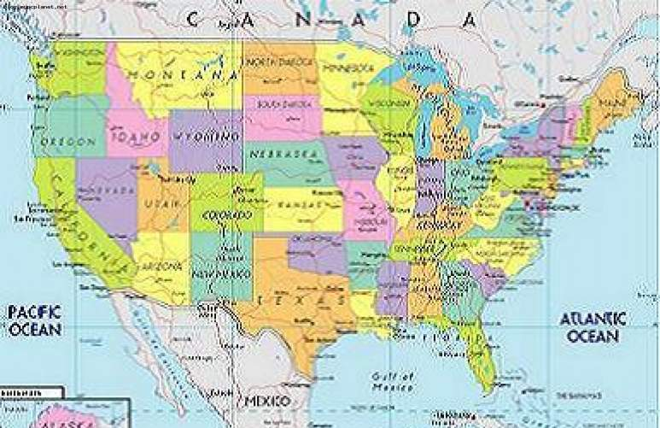

Підготувала Демчишин М.В.
учитель англійської мови

Цілі уроку: активізація навичок та вмінь монологічної мови; перевірка вивченого за темою; виховання поваги до звичаїв та історії іншої країни, виявлення зацікавленості до теми.

Обладнання: карта США, національний прапор, ілюстрація з видами міста і монументів, реферати дітей, книга В.М. Павлоцького «Знайомтесь із Америкою».
ХІД УРОКУ
- Оргмомент
- Слово вчителя
Good morning, dear guests, good morning my dear children, good morning my dear friends. I am glad to meet you here in my classroom and now we begin to work. Today we'll have an unusual lesson because today is a round-table talk. When we hear Alabama, California, Georgia, Indiana, Illinois, Mississippi, Washington we understand that we speak about America. It's a very beautiful country with its nature and people, with its history and culture. The USA is a highly developed industrial, political and cultural country. The history of each country begins with its discovery.
- Виступи дітей
1-й у ч e н ь. In the 15th century people knew only 3 places: Europe, Asia and Africa. They knew nothing about America. The man who was thought to be the discoverer of America was born in 1451 in Italy. His name was
Christopher Columbus.

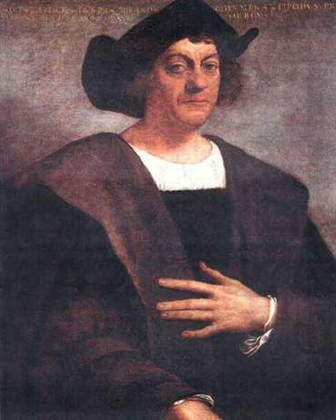
Knowing that the earth was round he decided to reach India by sailing to the west. It was very difficult for him to organize an expedition as nobody wanted to help him. At last the Spanish king gave him some money. In the 1492 he sailed with 3 small ships in to the Atlantic Ocean. They had been sailing for more than 2 months and at last they saw land. Columbus was certain that the lands he discovered were part of India and he called these islands "The West Indies". He made 3 voy- ages to America. His last voyage was made in 1502-1504. After that seriously ill he remained in Spain until his death. He died believing that Cuba was part of Asia. Columbus's voyages gave Europe first important knowledge of the new world. Many places have been named in his honour. America however was named after another explorer Amerigo Vespucci.
2-й учень.
Main characteristics
Official name: The United States of America (the USA)
Status: A federal republic, a union of 50 states.
Area: 3.623,420 square miles.
Capital: Washington D.C.
Nationality: American or United States.
Languages: English is the official and predominant language. Other languages include Spanish, Italian, German, Polish, Yiddish, Russian, American, Indian tongues, Chinese and Japanese.
3-й учень. The Geographical Position
The territory of the USA is almost 9.400.000. sq. km. It is washed by the Atlantic Ocean in the east, the Arctic Ocean in the north, the Pacific Ocean in the west. The population is 252 mln. people. The climate is different in different parts: from a polar climate in Alaska to a continental in the greater part of the country and subtropical and tropical in the south. The country is very rich in mineral resources.
4-й учень. The National Flag of the USA
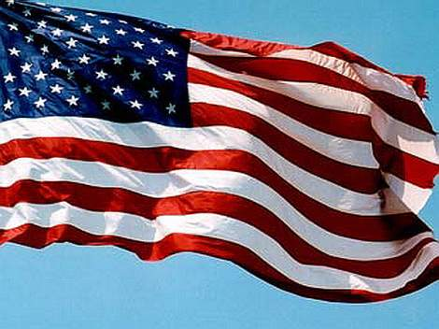
It is called Stars and Stripes. It symbolizes American way of life. The horizontal red and white strips represent the original 13 states that declared they would no longer be colonies of Great Britain. The stars in the flag — white on a dark background represent the number of states, making up the US today.
There are 50 of them now. The red stripes proclaim courage, the white proclaim liberty, the field of blue stands for loyalty.
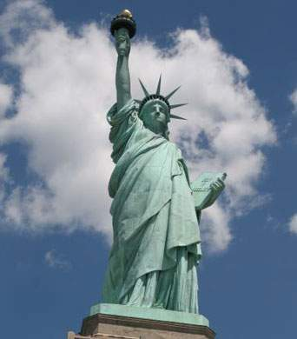
5-й учень.
The Statue of Liberty
On our blackboard you can see the picture of the statue of Liberty. You know that near the state of New York there is Liberty Island where this statue stands. The Statue is the symbol of American democracy. Liberty carries the touch of freedom in her right hand and in her left she is holding a tablet the inscription "July 4, 1776" — American Independence Day.
6-й учень. The nature of the country
The Grand Canyon
Last year you read that the Grand Canyon belongs to seven Nature's greatest wonders. It is formed by one of most important rivers of the Pacific Basin, the Colorado, with its source in the snow-clad mountains. It flows across a plateau carving a deep gorge edged by craggy walls. This gorge is called the Grand Canyon.

The Great Lakes
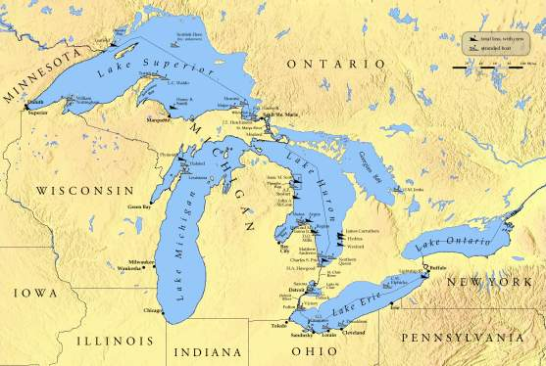
There are many lakes in the USA. Five lakes stand out especially. There are Lake Superior, Lake Michigan, Lake Huron, Lake Erie and Lake Ontario (find them on the map). Together they are called the Great Lakes. Any of these lakes is larger than Lake Ladoga, the largest lake in Europe. Lake Superior is the largest freshwater lake in the world. The lakes lie at different altitudes and are connected by short swift channels.
Lake Erie and Lake Ontario are connecter by the Niagara River. Throwing its waters over a ledge 50 metres high, it forms the great Niagara Falls, which provides a great attraction to tourists. There are some hydroelectric power stations there.
7-й учень. New York
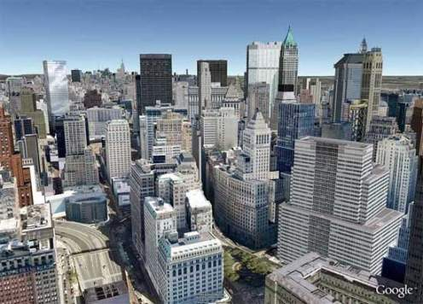
New York is the largest city in the United States and one of the largest cities in the world. It is situated in natural harbour of the mouth of the Hudson River. In 1626 the Dutch Trade Company brought Manhattan Island from the local Indians for twenty four dollars. Here the Dutch founded their colony and gave it the name New Amsterdam. Forty years later the English fleet entered the harbour, captured the city and renamed it New York.
New York is a city of "skyscrapers", those incredible, high buildings which Americans invented. If you want to have a good view of New York you can do it from the top of the Empire State Building (112 stories). Not far from the Empire State Building there is an interesting architectural ensemble — Rockefeller Centre. It was built according to one general plan. Rockefeller Centre consists of 15 skyscrapers. Rockefeller Centre houses all kinds of offices, enterprises, theatres and music halls.
New York is the national leader in business, finance, manufacturing, advertising, fashion and the arts.
New York is often called the cultural capital of the USA. The city has the Metropolitan Museum of the Art, the Museum of Modern Art, the Lincoln
Arts Centre. You can see the: plays and shows on Broadway s of America theatre, as Holly woo American cinema.
8-й учень. Washington
The beautiful city of Washington is the capital of the United Stat the centre of its government capital was named after the first President George Washington am founded in 1790. It is situated on the Potomac River in the District Columbia. Washington is not the 1argest city in the USA. It has a population only 900.000.
Washington is the residence c President and the Congress of the White House is the President's residence, the Capitol — the seat American Congress. The larges the tallest among the buildings Capitol with its great House of Representatives and Senate Chamber. There are no skyscrapers because no building must be taller than the Capitol. All American presidents except George Washington (the White House was not yet built in his time) have lived in the White House. It was built in 1799.
Washington is a large scientific and cultural centre, where there are mar search institutes, five universities; National Academy of Science and the Library of Congress.
There is one more well-known building in Washington - Pentagon, the residence of the US Military department. It is situated in the suburbs to the south of the Potomac River.

9-й учень. The Capitol
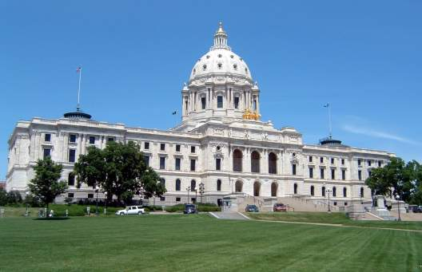
Because of its great size, central location, and elevated position on Capitol Hill, the Capitol dominates the Washington skyline. The US Congress r in this building. Visitors may a congressional sessions to watch legislators in action.
The Capitol is one of Washington's most magnificent buildings. It is constructed of white sandstone and, marble and crowned by an impressive dome. On top of the dome stands a bronze Statue of Freedom. Public rooms include the Rotunda, decorated with paintings and statues of events and people in American history, and Statuary Hall, which contains statues of distinguished citizens from every state.
The Capitol is set in a small park around which are a number of impressive government buildings, among which are the Supreme Court Building, modelled after a Greek temple and the Library of Congress, one of the largest libraries in the world.
10- й у ч e н ь. It's interesting to know about the holidays in America.
On July 4, the Americans celebrate their national holiday, Independence Day. It was declared in 1776. People have picnics with favourite foods like hot dogs, hamburgers, potato salad, baked beans, etc. Lively music is heard everywhere. People play baseball or compete at 3-legged races or pie-eating or watermelon-eating contests. In the evening people gather to match fireworks displays.
11-й учень. Thanksgiving Day
Thanksgiving Day was celebrated in 1621 by English settlers of the Plymouth colony. During their first winter over half of them died of hunger. But finally the fields produced a rich harvest and they decided to celebrate it. In 1863 it became an official holiday.

12-й учень.. Christmas Holiday
They begin celebrate it on the 25th of December. Santa Claus, shepherds, angels appear in shop windows: many families go to the church on eve and in the morning. Then they open their presents and have traditional dinner-turkey, ham, potatoes, vegetables and cranberry sauce. Dessert is usually fruit cake, plum pudding or mince pie. People sing Christmas Carols.

13-й учень. About Americans' Food
American food is part British, part Italian, part German, part Mexican, part Chinese, part Ukrainian... When people from other countries came to live in the USA. they brought different cooking traditions. Some of them opened restaurants and food stores, and today Americans enjoy food from all over the world.
The USA is famous for fast food. The first fast food restaurants served hamburgers, but now they serve other kinds of food as well.
Americans eat out a lot and when they go to a restaurant, they don't expect to be hungry afterwards. Most restaurants will put a lot of food on your plate — sometimes it can be too much. But if you can't finish it all, don't worry: the waiter will bring you a "doggy bag" and you can take it home with you.
14-й учень. Sport in the USA
Sports play such an important role in American life that the sociology of sports, sports medicine, and sports psychology have become respectable specializations.
Many Americans jog every day, or play tennis or bridge two or three times a week.

American football derives from the English game of rugby. It started at Harvard University in the 1870's. It is a game for two teams of eleven men on the field. The object of the game is to have the control of the ball and to score points by carrying it across the goal-line.

Baseball is a team game derived from the English game of cricket. It is played with a bat and ball by two teams of nine players each, on a field with four bases. Baseball is the national game in the USA and it is very popular in Canada too.
Basketball is a game which nowadays is-popular all over the world. It was invented in 1891. During the '20s the first US league championship was organized. In the 70s the American Championship was divided into two leagues: the ABA (American Basketball Association), which does not exist any longer and which played with a blue, red and white ball and the NBA (National Basketball Association).

Summing up
T. Dear children, you have done a great job today. You were very active and most of you have shown perfect knowledge on our topics. For the next lesson you’ll make a presentation on the topic “The country I would like to live in”.

