Extra- curriculum activity as a means of learning English at school

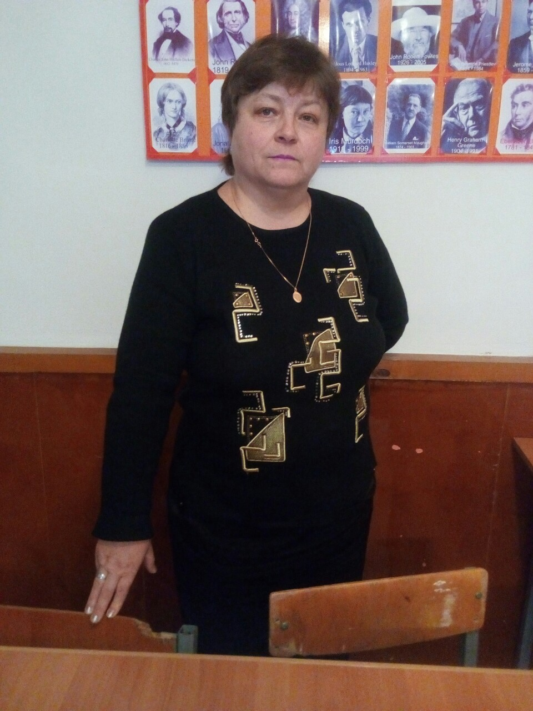 “ The object of teaching a child is to enable him to get along without
a teacher ”
Elbert Hubbard

The more I work at school the more convinced I get: our main task is to teach the pupils of ours to communicate. Practicing at school for more than 30 years, I have worked out my own methods and forms of teaching. And, of course, I’ve got many useful skills and personal points of view as to teaching. For sure, main and principal methods can’t have been changed, but the ways of their usage and applying are various. All in all, I came to a very significant conclusion: it’s not enough to teach students grammar, phonetics, lexical units at the lessons! In my view, it is even more important to develop their interests to the very foreign language doing extra-curriculum activities. Thus, I’ve organized a literary pen-club for young budding poets. And, having conducted its circulation since 2005, I must admit that all my attempts were not in vain. As a result, we have released 5 collections of pupils’ creative works: chants, poems, Japanese haikus, translations from famous English and American writers made into Ukrainian by our young poets. They also write limericks in English.
Example of limericks: Once in the forest I met a frog
That was so drunk to have fallen off the log.
I took it home, warmed and fed,
Suggested sleeping on a soft bed,
But in the morning the frog got mad!

There once lived a young deer,
He was very neat and lived in a den, so clear!
But once he happened to meet a hunter
Who was eating fresh bread and butter,
They collided – people could watch a loud clutter!

Examples of haikus: Tears are different…
Smiles can be different too,
Are they true or false?

Your friends are you foes…
How can it be in our life?
Better not to have!

I hate cowardice…
I do like friendship and love,
But how to differ?

You can’t even imagine how talented, inventive and imaginative they are! Tutoring the pupils, I don’t try to impose my own views and approaches to the World, Nature and Beauty. I do my best to develop their personal attitudes, likes, meditations and speculations over the things, events around them. All I do- I encourage their poetical skills when composing verses, rhyming lines.
A poem: “ Why so many “why”s?

People are eager to know
Why the ocean is deep,
Why we close eyes when sneezing,
Why the desert needs a creek?

Why the birds are making nests,
Why the world is moving “west”,
Why the animals are extinct,
Why there’re left so few kings?

Why the authorities are lying,
Why so many people are dying?
Why greedy humans come to power?
Why our planet is having less shower?

There are many “why”s and “because”s,
They can be as fast as wild horses.
Racking our restless brains,
Questions and words are pouring like rains!
Very often at the lessons, during warming-ups, I write rhyming words on the blackboard and we make up small rhymes.
Example: I like to smell flowers,
Take these ones of ours.

I can count up to nine-
Can you count cards of mine?
Doing such work gives them a possibility to revise already known grammar material about pronouns and, at the same time, to try themselves as poets. Such gradual but persistent work leads to the inevitable growing of their skills to composing. I’m sure: there are no ungifted pupils, you must simply reveal their mental potential and let it flourish.
Besides my running the literary club I always organize different parties, after-classes activities. From my own experience, I can say that the events of such a kind are very effective and helpful when studying English. They are a logical continuation of the very teaching process. Because after the classes extra-curriculum activities give a relaxing and entertaining way of educating. We socialize, compete, have fun, relax and… continue studying! We don’t get marks, only points, applause and cheers. In such a way the pupils, teachers and English are inseparable parts, doing one and a very important mission – learning English. That’s why I’ve decided to involve my own seeing and attempts to improve the process which must bring our young generation to a better comprehension of a foreign language studying process.
No modern school can exist without funny shows, interesting contests, instructive games or plays. All the year round the pupils should be involved into different merry events. The unity of the lessons themselves and such extra-curriculum activities create a favourable atmosphere for learning English. Without any doubts the pupils can get much from after-classes activities. Which is more, they can get much new information during Quiz-contests. Bright and lively games allow the teachers to instruct their pupils in a free and relaxed way. The method of subconscious learning works perfectly in such situations. So, you are welcome to resort to various kinds of work: descriptions, debates, argumentations, interactions, elicitation, simulations, presentations etc. – all aimed at obtaining high and effective results in practical using English.

СЦЕНАРІЙ
ПРОВЕДЕННЯ ПОЗАКЛАСНОГО ЗАХОДУ З АНГЛІЙСЬКОЇ МОВИ ДЛЯ УЧНІВ 5-7 КЛАСІВ

“THE BALL OF FLOWERS”

Підготувала
учитель-методист англійської
мови
Кременецької спеціалізованої
школи І-ІІІ ступенів № 2
Чоповська О.С.

Мета: на основі лексичного матеріалу посилити інтерес учнів до вивчення англійської мови; розвивати навички та вміння висловлюватись іноземною мовою; викликати позитивне ставлення до предмета; виховання високих естетичних смаків у дітей; розвиток повагу до навколишнього середовища; узагальнення вивченого матеріалу по темі “Seasons”, “Colours”, “Flowers”; ознайомлення із музичними творами видатних композиторів.
Організаційний момент: у конкурсі можуть брати участь учні 5-7 класів. Костюми квітів; декорована сцена, записи музичних творів; проектування на сцені/екрані пейзажів, квіткових композицій.
********************************************************************************
Presenter I: Hello to everybody! Today we are meeting her Majesty Spring. It is coming to us with green leaves and bright colours, with white blossom and fragrance of blooming glades. It is the time when Nature awakens from a long winter sleep! It is coming back to reality and vitality!
Presenter II: But today we are also meeting the beautiful children of Spring – flowers. They feel the dotting love of their Mother Nature every minute. It reveals itself in lovely spots of colours all over the grass. They are like small drops of Rainbow Father on the grass, so gay, lively, magic and tempting!
Presenter I: So, you see, people can’t live without beauty and brightness. They grow flowers to enjoy. But these plants are not only for pleasure. Many of them come to our life to help people. They give us food, oil, perfumes, hay, useful medical ingredients.
Presenter II: So, let’s stop talking and welcome our guests! Please, come onto the stage, our small beauties!
(На сцену виходять діти у костюмах тюльпана, підсніжника, соняшника, лілії, незабудки, маку, троянди. Всі вони вітають оплесками свою королеву – троянду.)
Queen Rose: Hello, everybody! Nice to see you here! I’m very happy to introduce my faithful friends, your favourite flowers: Mr. Tulip, Mr. Snowdrop, Miss Lily, Mr. Poppy, Miss Forget-me-not. Look, how gorgeous they are! All of them are dear for me; each of them has own merits and features. They appear on the Earth in their own times and bring happiness to people. They are brave, timid, strong and gracious, aren’t they?
Tulip: But Miss Rose, let me say a few words. Dear friends! We can’t, but mention that our Queen is the most beautiful and powerful here. It is the symbol of love, tender, passion and beauty. You can meet her Majesty everywhere on the planet. It is of different colours, sizes, but everybody can recognize roses whenever they are!
Presenter I: OK, OK. I can see that all of you are real wonders. But isn’t it a high time for the flowers to present themselves? They are eager to do this. You are sure to learn much interesting about them!
Presenter II: You are right! Please, relax and enjoy our party. Make your choice when watching the show: whose costume will be the best. Later, after collecting all your cards, we will define the winner of the today’s show.
(Діти-квіти займають місця на стільцях. Королева-Троянда помахом магічної палички “And now your turn, please!” викликає на сцену «квіти».)
Forget-me-not: Look at me! I’m “forget-me-not”. Do you like my blue colour? Of course, you’ll never forget me, because I’m just like the sky. I’m very tender, tiny, but pretty. I bloom from spring till autumn. My flowers are not large because I’m very shy. But they are like small eyes of a baby, of a lake, so deep and meaningful.
Snowdrop: I am a spring flower – a snowdrop. I am very brave because I come to live right after the snow with the first warm rays of the sun. My white colour is so pure! But I am slim and weak. I am the first! I am like a small soldier of Nature.
Tulip: I am a foreign guest, a tulip from Holland. But I like Ukraine very much and grow here. You can see me in the parks, squares, near the houses. My flower is like a bell of different colours and forms. I don’t smell, but I am a real wonder! I am sure that people can’t be indifferent to me when seeing!
Sunflower: And now my turn. I am a real Ukrainian kind of the fields, a sunflower. I am like the Sun on the ground. My father Sun kisses my head, hugs my big leaves. I am very useful for the Ukrainian people: oil, tasty seeds come to the dining tables of them. Enjoy and be proud of me! And I will guard the tenderness of small flowers!
Poppy: And now a few words about me, a poppy. I am like a drop of blood on the field of yellow wheat. Every Ukrainian family enjoys tasty pies with poppy seeds. My tender petals are like pink lips of Nature. The pictures with me are perfect and lovely. Moreover, you can see me on jackets of people on some great holidays.
Lily: Nice to see you here! I am a lily, pretty lady of the waters and gardens. My purity and beauty charms everybody. My sweet smell drives mad all people. I can be of all colours and tints. I am the favourite flower of all gardeners! No people can resist my fragrant charm!
Presenter I: Please, please stop! Don’t argue! All of you are good and adorable! But stop boasting! Let’s invite here your Queen Rose. Let her speak!
(Виходить «Королева» Троянда. «Квіти»- діти схиляють голівки.)
Queen Rose: My dear children, friends, guests! I am a Rose, the Queen flower of all. I am red or white, yellow or orange, pink or blue. Women and girls like to get roses as presents. Many romantic stories are connected with roses. But I am not only sweet and kind. I can be also strict and hurt you with my sharp thorns.
Presenter II: But your Majesty, now let’s check up what your children can do. We’ll organize some competitions. I am sure, they are not only pretty, but also gifted.
Presenter I: Let’s start! We also invite our guests to take part. So, you get sheets of papers and draw your favourite flowers. Our “flowers” will also do it.
(Гості, глядачі малюють свої квіти, а дійові особи, «квіти», малюють троянди.)
Queen Rose: I wish you stopped! Hand in your pictures! Wow, as far as I can see, all my children have my portraits! It’s good that you like me so much. You flatter me! If it is so, then I am really, happy of your love and respect. Thank you so much!
Presenter I: But let our audience show their pictures and name them.
(Глядачі коментують та називають свої квіти.)
Presenter II: Your Majesty! Let’s see how they can dance. We’ll now hear the beautiful music and your “flower company” will dance the waltz. So, music!
(Грає мелодія «Вальс квітів» П.І.Чайковського (з «Лускунчика») і всі квіти танцюють. Королеву-Троянду запрошує Король-Сонях. Після танцю «діти» стоять півколом, їх Королева перед ними.)
Queen Rose: Thank you, my dear! Today we had a real holiday: you showed how beautiful, useful and extraordinary you are. Nobody and nothing can do without us. We fill our life with love, tenderness and fragrance. Love, respect and save us! I wish we could be so helpful all the year round! Make Beauty and Peace, no Wars, no Tears!
(Діти всі разом цитують вірш:
Rose and tulip, and lily and poppy, Beautiful flowers, making us happy! Smelling together in our green Nature, Look and enjoy, we are your pages!
В цей час в залі помічники зібрали результати голосування глядацьких симпатій щодо костюмів квітів.)
Presenter I: And finally, our winner: the best costume was made by… Let’s greet him/her and wish him/her longer time for blooming! See all of our flowers in Nature! Bye!
Presenter II: Plant flowers, look after them and present your best friends, relatives with them!

