**Americans Holidays**

**Teacher:** Today we'll have the competition. You will divide into teams. You will do different tasks. I hope it will be interesting, funny and useful. Each of you must be active and get as many points as you can.

***1. Guess the holiday(за кожне вгадане свято команда отримує бали)***

I think we will begin with the holidays. You know the Americans like holidays, parties and enjoy them. Listen to me carefully and guess the holiday.

Учитель читає опис свята, не називаючи його.

1.Families and friends celebrate this day. Every town and every city has parades, games and sports with prizes. On that day in 1776 the United States became independent from England. It was the beginning of a new life. *(Independence Day.)*

*2.*This is the biggest holiday of the year. Many people enjoy it most: of all and say this is the main holiday of the year. The President gives his speech on TV. Parents tell their children that

Santa Claus will come to their house at night and leave presents for them. *(Christmas Day.)*

3.This is one of the most favourite holidays of the year. Children dress up, shout "Trick or treat", get sweets, fruit, cakes and people have pumpkins with candles in their windows. *(Halloween.)*

4.This is a day of rest for the workers. There are also parades on that day. This day is the end of summer and the beginning of the school year, *(Labour Day.)*

5. People celebrate this holiday in America in the same way they celebrate it in England. People make jokes on this day and have a lot of fun. People celebrate this holiday in spring. *(April Fool's Day.)*

6. On this day students and pupils read about George Washing ton, Abraham Lincoln and other American presidents. *(President's* *Day.)*

7. You can see the American flag everywhere on this day. People honour the man who was the discoverer of their country. *(Columbus* *Day.)*

8. This holiday is very popular in the cities where there are many People from Ireland. People often wear green on this day. If you don' t wear green, someone may pinch you. *(St. Patrick's Day.)*

***2. Make Words***

Команди учнів отримують аркуші зі словом ***Independence day.*** Їхнє завдання скласти якнайбільше слів з цього слова. Враховується швидкість і правильність написання слів.

|  |  |  |  |  |  |
| --- | --- | --- | --- | --- | --- |
| independenceday | | | | | |
| america7 |  | | | | |
| How many words can you make out of *INDEPENDENCE DAY*? | | | | |
| **I N D E P E N D E N C E D A Y** | | | | |
|  | ___________ |  | ___________ |  |
|  | ___________ |  | ___________ |  |
|  | ___________ |  | ___________ |  |
|  | ___________ |  | ___________ |  |
|  | ___________ |  | ___________ |  |
|  | ___________ |  | ___________ |  |
|  | ___________ |  | ___________ |  |
|  | ___________ |  | ___________ |  |
|  | ___________ |  | ___________ |  |
|  | ___________ |  | ___________ |  |

|  |  |  |  |
| --- | --- | --- | --- |
|  | A dessert |  | america9 |
|  | Frozen water |  |
|  | Mom’s friend |  |
|  | A short sleep |  |
|  | A number |  |
|  | A kind of tree |  |
|  | Finish |  |
|  | The opposite of shallow |  |
|  | The opposite of war |  |
|  | Something you roll |  |
|  | Another word for eat |  |
|  | Move your body to music |  |
|  | A part |  |
|  | A small round vegetable |  |

|  |  |  |  |
| --- | --- | --- | --- |
|  |  |  |  |
|  |  |  |  |
|  |  |  |  |

***3. What do you know about American holidays?***

*T:* As you know, Americans are proud of their country and their people. They are proud of their symbols. Who can tell us about the symbols of America?

Учні розповідають про символи Америки.

1. There are big football games and parades on this day. People can watch them on television. Families and friends usually have dinner together. *(New Year's Day.)*

*2.* On this day people give cards with hearts, presents and flowers to their boyfriends, girlfriends, husbands and wives. Some people do not put their names at the end of their cards because they want their name to be a secret. *(St. Valentine's Day.)*

3. People make jokes and have a lot of fun on this day. People celebrate this day in America in the same way they celebrate it in England. Some people believe that the tradition to celebrate this holiday began in France. *(April Fool's Day,)*

4. People celebrate this holiday in March. People often wear green on this day. If you don't wear green, someone may pinch you. This holiday is very popular in the cities where there are many people from Ireland. *(St. Patrick's Day.)*

***4. Quick Quiz***

***T:****Answer the questions very quickly.*

1. What is the name of the Dutch settlement which became New York City?
2. Which country presented the USA with the statue of Liberty? What was the occasion?
3. In which famous place do people in New York City celebrate New Year’s Day?
4. Which American rock-and-roll star lived in Memphis, Tennessee?
5. What monument in Washington D.C. dedicated to an American President is nicknamed “The Pencil”?
6. What is the name of the famous collection of museums in Washington?
7. Explain the symbolism of the stars and stripes on the US flag.
8. On what river is the capital of the USA situated?
9. Where does the President of the USA live and work?
10. Which is the biggest state in the USA?
11. Who was the 1st President of the USA?
12. What do the Americans celebrate on the 4th of July?
13. In which city is Hollywood?
14. What street in New York is called “The Great White Way”?
15. What is the highest building in Washington?
16. Who was the 1st President lived in the White House?
17. What is the largest city in the USA?
18. In which state do the highest trees in the world grow? What are they called?
19. Which is the smallest state in the USA?
20. Who is the President killed by Oswald?
21. The first colonists started the tradition of a) Halloween, b) Independence Day, c) Thanksgiving Day, d) Memorial Day.
22. Who was the 42d President: a) Clinton, b) Kennedy, c)Johnson, d) Washington

***5.Crossword.***

*T:* The next task for us is to fill in the crossword.

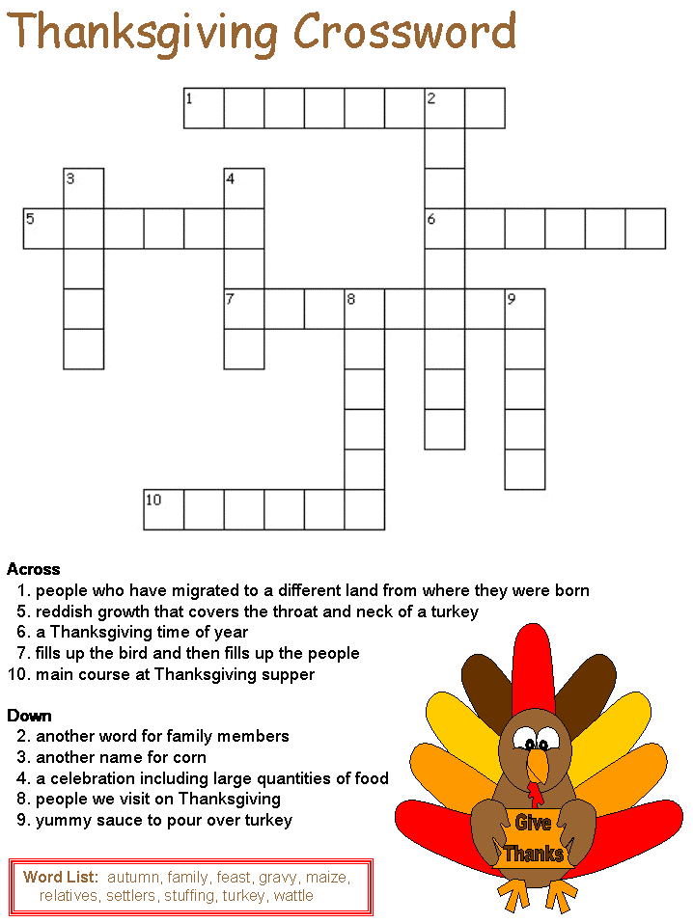

6***. Wordseach***

T: Find the words in the following grid.

|  |  |  |  |  |  |  |
| --- | --- | --- | --- | --- | --- | --- |
| continentoceanwordsearch2 | | | | | | continentoceantitle  Find all of the continents and oceans in the grid to the left.  Write C next to the continents and O next to the oceans. |
| Africa  Antarctica  Arctic  Asia  Atlantic  Australia | | Continent  Equator  Europe  Globe  Indian  North America | | North Pole  Ocean  Pacific  South America  South Pole  Southern | | |
| What continents are these? | | | | | | |
| africa | antartctica | | southamerica | | australia1 | |
| (1)_____________ | (2)_____________ | | (3)_____________ | | (4)_____________ | |

***7.Poems and songs***

*T:* It's time to sing songs and recite poems now. Let's remember the songs and poems we have learnt on the topic «America».

**Pupil1**: A m e r i c a n C o i n s

Pennies, nickels, dimes, and quarters.

Pennies, nickels, dimes, and quarters.

How many pennies in a nickel? Five.

How many nickels in a dime? Two.

Pennies, nickels, dimes, and quarters.

Pennies, nickels, dimes, and quarters.

How many dimes in a dollar? Ten.

How many nickels in a dime? Two.

Pennies, nickels, dimes, and quarters.

Pennies, nickels, dimes, and quarters.

How many quarters in a dollar? Four.

How many nickels in a dime? Two.

**Pupil2:** M y P e o p l e

The night is beautiful,

So are the faces of my people.

The stars are beautiful,

So are the eyes of my people.

Beautiful also is the sun.

Beautiful also are the souls of my people.

**Pupil3:** L e t ' s R e m e m b e r C o l u m b u s

In fourteen hundred and ninety-two

Columbus sailed the ocean blue...

Let's sing together this old song

About the voyage that took him long,

About the sailors, these strong brave men.

Let's sing and remember them all again!

**Pupil4:** I n d i a n s

One little, two little, three little Indians.

Four little, five little, six little Indians.

Seven little, eight little, nine little Indians.

Ten little Indian boys.

Ten little, nine little, eight little Indians,

Seven little, six little, five little Indians,

Four little, three little, two little Indians,

One little Indian boy.

Teacher: Thank you, boys and girls. You were so active today. You took active part in all the tasks. Lets count your points. The winner is…. Thank you very much for your participation.