THE MINISTRY OF EDUCATION AND SCIENCE OF UKRAINE

TERNOPIL SPECIALIZED SCHOOL № 29

Комбінований урок
4-ий клас

BURNS NIGHT
Проведено: вчителем англійської мови
Боднарчук Жанною Валеріївною
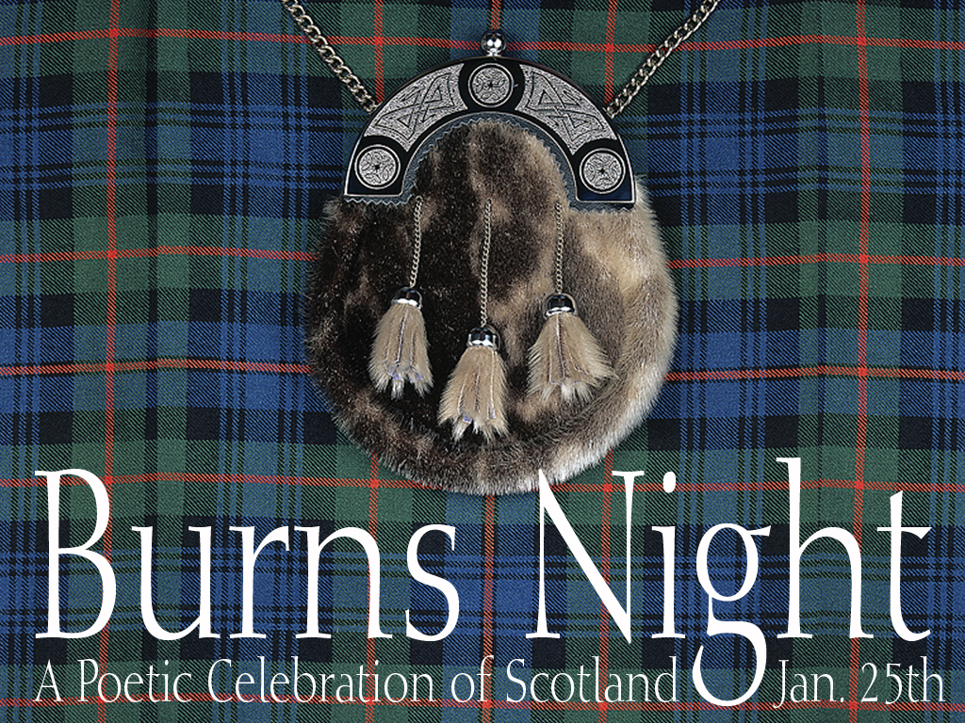

TERNOPIL 2012

THEME: Burns Night

OBJECTIVES:
- to revise some facts about Scotland
- to present the way of celebrating Burns Night
- to practise reading for specific information
- to practise listening for specific information
- to practise using food vocabulary
- to recite Robert Burns’ poem (My heart’s in the Highland)
- to sing Robert Burns’ song (Auld Lang Syne)

MATERIALS NEEDED:
- a map of the UK
- Robert Burns’ portrait
- a picture of winter
- an invitation written on a big piece of paper
- CD/ DVD player
- CD and DVD (Welcome 3)
- a kilt
- Haggis
- texts cut into pieces
- recipes with missing words and phrases
- flashcards

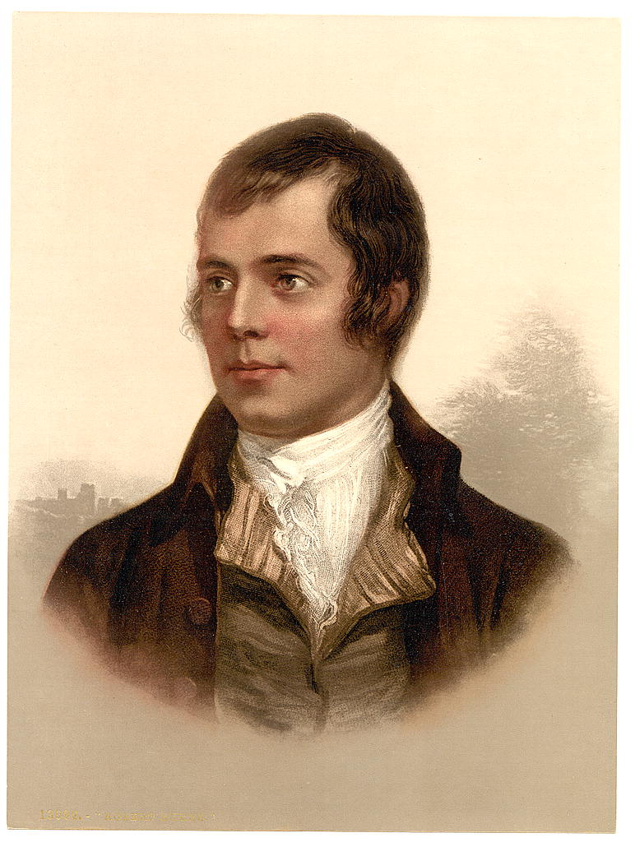

THE PROCEDURE OF THE LESSON

GREETING
Teacher: Good morning pupils.
Pupils: Good morning teacher.

T.: Are the lights on?
P-s: Yes, they are.
T.: Is the blackboard clean?
P-s: Yes, it is.
T.: Is there date on the blackboard?
P-S: Yes, there is.
T.: Is there any chalk?
P-s: Yes, there is.
T.: Are the pupils here?
P-s.: Yes, they are.
T.: Is the teacher here?
P-s: Yes, she is.
T.: Is it time to begin?
P-s: Yes, it is.
T.: Then, sit down and let’s begin.

TELLING THE THEME / WARMING-UP
T.: Today we’re going to have a very special lesson. We’ll celebrate Burns Night. This holiday is on the 25-th of January, but it isn’t a problem for us. We’ll travel through time. Look! This is our time machine. It will take us to the year 2009, the 25-th of January. But for this you have to answer the questions correctly.
Who is Robert Burns?
P.: Robert Burns is a famous Scottish poet.
T.: So, he lived in Scotland. Where is it situated? Look at the map.
P.: (goes to the blackboard and shows) This is Scotland. It is situated on the north of Great Britain.
T.: What is the capital of Scotland? Where is it situated?
P.: Edinburgh is the capital of Scotland. It is on the south-east coast of Scotland.
T.: You’ve answered all the questions correctly. It’s January now.
(the teacher shows the picture of winter)

READING/LISTENING
T.: Look! This is an invitation for us. Help me to read it.
P.: (takes invitation written on a big piece of paper and reads)
Dear children!
We’re celebrating Burns Night on 25th January. I hope you can join us. The celebration starts at 8 o’clock and finishes at about midnight.

We’re preparing lots of delicious food. Haggis is the main dish. It is a tradition to eat haggis on Burns Night.
One more thing, boys, don’t forget to wear your kilts. All men wear kilts on Burns Night! Do you know any of Robert Burns’ poems? Everyone should say a poem or sing a song. It is the tradition!
Please, come to our celebration.
Love,
Lia.

|T.: Look! There is something else. (the teacher takes out of a bag a kilt and haggis) this is a kilt, this is haggis. These are men wearing kilts and these are Scottish children holding haggis on a plate. (the teacher shows some pictures)
P-s: (repeat after the teacher) haggis, kilt.
T.: Did you understand everything from the invitation? Let’s check. Look at the questions and answer them.

Answer the questions.
- Who is this invitation from? (Lia)
- What are they celebrating? (Burns Night)
- What are they preparing? (a lot of delicious food)
- What is the main dish? (haggis)
- What do all men wear on Burns Night? (kilts)
- What else should everyone do? (say R. Burns’ poem or sing a
song)

LISTENING
T.: How do Scottish children prepare for this holiday? Let’s listen. But there is a task for you. Look at the sentences, listen and underline the correct word.

TAPESCRIPT
Lia: Hi, Professor.
Professor: Oh! Hello! I’m inventing a new type of kilt!
Oscar: What’s a kilt?
Professor: It’s a traditional Scottish costume, of course.
Lia: But, what’s different about it? It looks the same to me.
Professor: Look here! Watch this! It’s a very special kilt!
Lia: Ha, ha! Look! It’s singing!
Oscar: Shall I wear it tomorrow? We’re celebrating Burns Night tomorrow evening.
Lia: That’s a great idea! Well done, professor!

Listen and underline.
- The professor is inventing a new type of kilt/kite.
- The kilt is the traditional English/Scottish costume.
Pupils listen and choose the correct answer. The teacher checks pupils’ answers.

WATCHING
T.: Everything is clear with the clothes: men should wear kilts. And now let’s look how Scottish people celebrate Burns Night.

(Pupils watch the video (DVD welcome III). Then they get the text but the sentences are separately.)

Put the events in the right order.
a. Oscar is going to Lia’s house. He’s wearing a kilt.
b. Everyone is sitting at the table and eating haggis.
c. They’re all singing and dancing.
d. Lia, Carmen and Kamal are in the kitchen. They’re preparing the food.
e. Oscar is helping his friends to make the food.

T.: Now put the events in the right order.
(Pupils do the task, teacher checks pupils’ answers)

RUNNING DICTATION
T.: We can’t celebrate without any food. Here are four recipes. But look some words and even phrases are missed! We have to fill them in. You’ll be divided into four groups. Each group will get one recipe. The words from each recipe are in the classroom. You must choose runners writers and a presenter. Runners must run around the classroom find the missing words and phrases (pay attention on colour) then dictate them (words and phrases) to writers. The rest of the group tries to fill them in. When the recipe is ready the presenter will go to the blackboard and read it. While reading you’ll have to show “peel”, “chop”… .
The recipes

- Tatties and Neeps (Potatoes and Turnips)
Ingredients
1 kilo of potatoes
1 onion
1 kilo of turnips
2 teaspoons of butter, salt and pepper

To make Tatties and Neeps, first peel and chop the potatoes, turnips and onion. Then, boil the potatoes in one saucepan and the turnips in another.Next, put the potatoes and the turnips in a bowl. Add the onion, salt and pepper. Finally, mash them and mix them very well together.
You can serve Tatties and Neeps with haggis or any other meat.

- Potato salad
Ingredients
1 kilo of potatoes
1 onion
1 teaspoon of mustard
3 tablespoons of mayonnaise

To make potato salad first peel and chop the potatoes and onion. Then boil the potatoes in a saucepan. Next mix a little mustard and mayonnaise. Finally pour the mixture onto the potatoes and onions.
You can serve a potato salad with any meat (for example haggis)
- Tuna salad
Ingredients
1 tin of tuna
4 potatoes
4 tablespoons of mayonnaise
1 teaspoon of mustard
Salt and pepper

To make tuna salad, first wash and boil four potatoes. Then cut the potatoes into small pieces. Next, chop the onion and put everything in a bowl. Add the tin of tuna, four tablespoons of mayonnaise, a teaspoon of mustard, salt and pepper and mix them together. Finally, put the tuna salad in the fridge for one hour before you serve it. It’s delicious.

Pupils do the task.

RECITING
T.: It was great. I hope all the dishes are delicious. We forgot about an important tradition. We have to recite Robert Burns’ poem. Who wants to?
Pupils recite a poem “My Heart’s in the Highland”

My Heart's In The Highlands
My heart's in the Highlands, my heart is not here,
My heart's in the Highlands a-chasing the deer -
A-chasing the wild deer, and following the roe;
My heart's in the Highlands, wherever I go.

Farewell to the Highlands, farewell to the North
The birth place of Valour, the country of Worth;
Wherever I wander, wherever I rove,
The hills of the Highlands for ever I love.
Farewell to the mountains high cover'd with snow;
Farewell to the straths and green valleys below;
Farewell to the forrests and wild-hanging woods;
Farwell to the torrents and loud-pouring floods.
My heart's in the Highlands, my heart is not here,
My heart's in the Highlands a-chasing the deer
Chasing the wild deer, and following the roe;
My heart's in the Highlands, whereever I go.

SUMMING-UP
T.: That was great. Did you like our lesson? Let’s check. Answer the questions.
- When do people celebrate Burns Night?
- What do men usually wear on Burns Night?
- What is Scottish traditional food on Burns Night?
- What else do they do?

T.: Do you know what this celebration finishes with? Scottish people traditionally link their hands and sing the song “Auld Lang Sine”. Let’s do it now. Look at the screen, link your hands and sing all together.

