ТЕРНОПІЛЬСЬКА СПЕЦІАЛІЗОВАНА ШКОЛА №29
З ПОГЛИБЛЕНИМ ВИВЧЕННЯМ ІНОЗЕМНИХ МОВ
ТЕРНОПІЛЬСЬКОЇ МІСЬКОЇ РАДИ ТЕРНОПІЛЬСЬКОЇ ОБЛАСТІ

Great Britain.
Sightseeing in London.

Конспект відкритого уроку за підручником

“Opportunities Pre-intermediate”

Підготувала і провела
у 8 класі
вчитель англійської мови
Потіха Г.Т.

ТЕРНОПІЛЬ - 2005
Theme: Great Britain. Sightseeing in London.
Objectives:
- to systemize students’ knowledge on the theme;
- to develop students’ speaking, reading and writing skills through various creative activities;
- to develop students’ quick reaction and ability to select necessary words;
- to broaden students’ knowledge about Britain.
Equipment: pictures, a map, cards, illustrations, photos.
Technical Appliances: a tape-recorder.

Procedure
T. Good afternoon pupils. Very glad to see you again. How are you on a fine afternoon like this?
P. We are fine, thank you.
T. Wish something pleasant to each other.
- Be happy, be healthy, be strong, be wealthy, may all your dreams come true, be merry, good luck, have a lot of sunny days, have a lot of joy, have good results at school, have a lot of good friends, be polite in everything you do, remember always to say “please” and don’t forget “Thank you”.
T. I see you are very polite. I am also sure you are thirsty for knowledge, aren’t you?
P. Yes, we are.
T. Are you ready to work?
P. Yes, we are.
T. Do you promise to work hard?
P. Yes, we do.
T. I’m happy to hear this. Let’s get started. So we are in our English lesson and I am going to use only English. I’m sure you will join me. But why do you study English? Is it important to know English nowadays?
P1. I study English because I’m sure it’s worth studying. As the English proverb says “So many languages you know so many times you are a man”
P2. Another proverb says “A new language – a new world”.
P3. I study English because I like to travel very much. It’s always interesting to go abroad.
T. Why is it interesting?
P4. The more we travel, the more we learn about the countries, their people, their culture and traditions.
T. I fully agree with you. So, pupils, all of you like traveling, without doubt, it is very important to know a foreign language if you are going to another country. Today I invite you to travel Look at the map. What country will you visit?
P. The United Kingdom.
T. What is the capital of the UK?
P. London.
T. Today we are going to concentrate on sightseeing in London. The motto of our lesson is “When a man is tired of London, he is tired of life”. Whom do these words belong to?
P1. To Dr Samuel Johnson (1700-1784), English lexicographer.
T. What do you know about him?
P2. He was the focus of London literary life of his day. His dictionary was published in 1755.
T. But first let’s check up what you know about the UK and do a little “All-Britain-Quiz”. You’ll work in groups. Write down the answers on the blackboard. You may use the map while answering the questions. Try to cope with the task quickly and correctly.
- 1. Who is the head of state in GB? (Queen Elizabeth II)
2. What is the official name of GB? (The United Kingdom of Great Britain and Northern
Ireland)
3. What is the capital of Scotland? (Edinburgh)
4. What river is the longest in Great Britain? (The Severn)
5. What is the national emblem in England? (Red rose)
6. What is a double-decker? (A bus)
7. What king had 6 wives? (Henry VIII)
II.
- Who is the head of government in GB? (Prime Minister)
- Which countries belong to the UK? (Scotland, Wales, England, Northern Ireland)
- What is the capital of Wales? (Cardiff)
- What’s the highest mountain in GB? (Ben Nevis)
- What is the national emblem of Wales? (Thistle)
- What is Harrods? (A department store)
- What did Agatha Christie write? (Detective stories)
T. Let’s check. Read the question and the answer. The pupils of the second group will check and correct the mistakes if there are any.
T. So you know a lot about GB. It’s high time to travel. The only possible way to get to the Isles is by sea. There is a nice 18th century British song “My Bonnie” which is an example of a “sea shanty”. Sailors often sang sea shanties when they were working on a ship. ”My Bonnie” means “my loved one”. “Ye” is an old form of “the”. If you go to England, you can still see this old word on some signboards of shops and inns, especially in the country.
Let’s sing this song.

My Bonnie

My Bonnie lies over the ocean,
My Bonnie lies over the sea,
My Bonnie lies over the ocean,
Oh bring back my Bonnie to me!
Chorus:
Bring back, bring back,
Bring back my Bonnie to me, to me;
Bring back, bring back,
Oh bring back my Bonnie to me!

Oh blow ye winds over the ocean,
Oh blow ye winds over the sea,
Oh blow ye winds over the ocean,
And bring back my Bonnie to me.

Chorus: Bring back, etc.

Last night as I lay on my pillow,
Last night as I lay on my bed,
Last night as I lay on my pillow,
I dreamed that my Bonnie was dead.

Chorus: Bring back, etc.

The winds have blown over the ocean,
The winds have blown over the sea,
The winds have blown over the ocean,
And brought back my Bonnie to me.
Chorus: Bring back, etc.

T. When people travel they need some information in order not to have problems. So imagine that we arrived to London. We are at the airport. We see a lot of signs everywhere. You can manage much better if you understand the signs that you read around you. One of you will be our guide at the airport and give us some information about the signs.
P. Attention, please. Look at these signs. They are useful and it's necessary to know them.

DO YOU KNOW THE SIGNS?

Entrance. If you want to get somewhere, look for this sign.
Exit. This sign shows how to get out.
Telephone. If you are not the happy owner of a cell telephone and you have to make some calls look for this sign.
Information. Here you can get information on travel, accommodation, events and entertainment.
No smoking. I think there is no need to explain. It means "No smoking".
Meeting Point. The airport is rather big. It's very easy to get lost. If it happens, go straight to the meeting point.
Exchange. In the exchange office you can get British currency. Be sure to check in advance the rate of exchange.
Cafe. I suppose this sign is international. You can get some food or at least a glass of mineral water there.
Baggage Claim. This sign shows "Baggage Claim".
Souvenirs. If you want to buy some souvenirs, look for this sign.
Checkroom. Here you can leave your things to the check-room attendant.
First Aid. You can get first aid there.
Taxi. It's easy to find the way to the taxi rank with the help of this sign. Look for the signs and you won't have problems at the airport. At least you'll be able to find your way out.
T. Thank you. I hope this knowledge will be very useful for you.
T. Let's assume that you managed to find your way out, safely got to the hotel, had your dinner. Now you have to think about sightseeing. If you can stay only a few days in London you won't have much time for sightseeing. And how to spend your time to the best advantage is rather a problem. If I were you I should make up my mind beforehand. What places would you visit?
PI. Trafalgar Square.
P2. Buckingham Palace.
P3. Houses of Parliament.
P4. Tower of London.
P5. Westminster Abbey.
T. Listen to the text. Number the places of interest mentioned there.
T. All these places have long history. Your hometask was to learn London timeline and speak about the History of London.
• 43 AD When the Romans arrived in Britain, London was already a small town. Under the Romans 'Londinium' became the capital of the Roman province of Britannia.
• 886 King Alfred the Great united England. He captured London from the Danes and made it capital of his kingdom.
• 1666 The Fire of London destroyed much of the city. The reconstruction was organised by the architect Christopher Wren who designed St Paul's Cathedral.
• 1850 By the middle of the nineteenth century, London was the largest city in the world and the most important port. In this period it was famous for its terrible pollution.
• 1939-45 In World War II, London was seriously damaged by German bombing.
• 1980 In the last twenty years, the old port area has been rebuilt. There are big, new skyscrapers and the Millennium Dome, the largest dome in the world, which was finished in 1999. In 2000 it held the millennium exhibition.
T. There is one more interesting episode in the history of London. It is Guy Fawkes' Night. Listen to the story.

The Story of Guy Fawkes and Guy Fawkes' Night
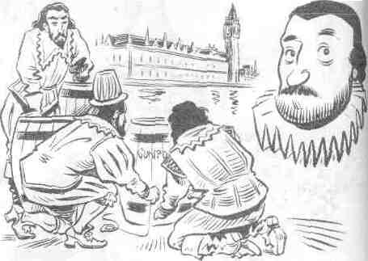
On 5 November 1605 Guy Fawkes and some other men wanted to blow up the king, James I, and the Houses of Parliament, in London. But they were not blown up.
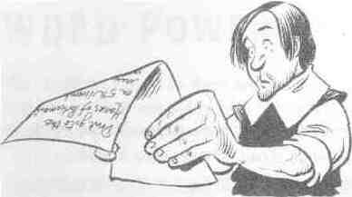
A letter was found from one of the men, Francis Tresham, to one of his family. The letter said 'Don't go to the Houses of Parliament on 5 November'.
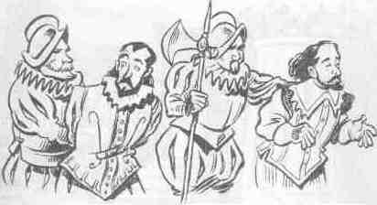
Because of the letter, Fawkes, Tresham and the others were caught and the king and
the Houses of Parliament were not blown up.
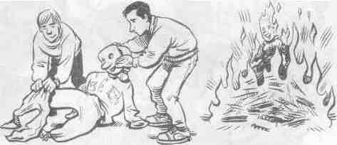
We celebrate this every year in Britain when 'guys' are made. A mask is bought or made for the guy's face and an old jacket and some old jeans or trousers are used as a costume for the guy.
Then, on the evening of 5 November, all the guys are put on bonfires in the garden.
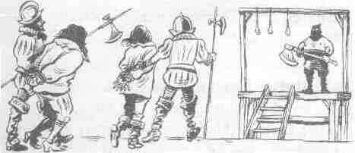
But Guy Fawkes, the man, was not burnt like the guys. He and Tresham and the others were cut into four pieces.
T. Are you tired?
Let's relax. Are you happy? Then sing a song:

If you're happy

If you're happy and you know it
Clap your hands,
If you're happy and you know it
Clap your hands,
If you're happy and you know it
And you really want to show it,
If you're happy and you know it
Clap your hands.

If you're happy and you know it
Snap your fingers,
If you're happy and you know it
Snap your fingers,
If you're happy and you know it
And you really want to show it,
If you're happy and you know it
Snap your fingers.

If you're happy and you know it
Slap your legs,
If you're happy and you know it
Slap your legs,
If you're happy and you know it
And you really want to show it,
If you're happy and you know it
Slap your legs.

If you're happy and you know it
Stamp your feet,
If you're happy and you know it
Stamp your feet,
If you're happy and you know it
And you really want to show it,
If you're happy and you know it
Stamp your feet.

If you're happy and you know it
Say: ' O.K.',
If you're happy and you know it
Say: 'O.K.',
If you're happy and you know it
And you really want to show it,
If you're happy and you know it
Say: 'O.K.'.

If you're happy and you know it
Do all five,
If you're happy and you know it
Do all five,
If you're happy and you know it
And you really want to show it.
If you're happy and you know it
Do all five.
T. I see you are full of energy again. Read the text which consists of 4 paragraphs. Write down the topic of each paragraph. Be ready to answer the questions.
Read the model below and write down the topic of each paragraph. Are there any sights of special interest? What can holidaymakers do? Where would you expect to find a description like this?
.Set in the heart of southern England, London is one of the biggest and busiest cities in Europe. A truly international city, London attracts millions of visitors every year from all over the world, yet never loses its own unique charm.
London has many impressive sights to see, ranging from the historical beauty of St Paul's Cathedral and Big Ben to Buckingham Palace and the Houses of Parliament, in this city of contrasts, you can be walking along one of the busiest streets, yet still be less than a mile from one of the many huge, peaceful parks. London is a great cultural centre, too; the National Gallery contains one of the finest collections of classical paintings in the world.
London is also well known for other things apart from its monuments and art galleries. Shoppers will enjoy visiting the department stores on Oxford Street or they could try Harrods, the most exclusive shop in London. For evening entertainment, the choice of theatres is enormous. From the famous Southbank Theatre complex to the smaller theatres of Covent Garden, there is no end of plays to see. Soho and its pavement cafes are also worth visiting.
London is an exceptional place, a truly modern city that has managed to keep its traditional style and sense of history. You may get exhausted in London, but one thing is certain; you will never get bored because, as Dr Johnson once said, 'When a man is tired of London, he is tired of life."
T. We've learnt a lot of new words on the topic. Let's revise the vocabulary. Say what you associate with GB.
GB

T. Let's see how well you know the words on the topic. You'll work in groups. The first group will arrange the words in pairs of synonyms. The second group will arrange the words in pairs of antonyms.
Arrange the words in pairs of synonyms

1. immense a. outstanding
2. region b. hills
3. prominent c. to divide
4. to separate d. to fall into
5. highlands e. huge
6. main f. area
7.to flow into g. chief

Arrange the words in pairs of antonyms
1. South a. East
2. lowlands b. North
3 immense c. highlands
4. West d. to join
5. suitable e. undeveloped
6.to separate f. small
7. developed g. unsuitable

T. Let's sum up. I hope that during our trip you enriched your knowledge about the country you've visited. Express your ideas about the lesson on the flower petals. Work in groups.
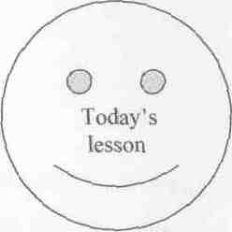
T. That seems to be all for today. I'm happy to say we've done a good bit of work during this lesson. I'm pleased with the work of the group. You worked hard and got such marks.........
Write down your hometask SB.p.l09.Ex.4. Make a list of places for a tourist to visit in your area.

