ПЛАН-КОНСПЕКТ

ВІДКРИТОГО УРОКУ З АНГЛІЙСЬКОЇ МОВИ

У 6 КЛАСІ НА ТЕМУ:

«КРУГ ІНТЕРЕСІВ. ДІЄПРИКМЕТНИКИ З ПРИЙМЕННИКАМИ.»

ВЧИТЕЛЯ АНГЛІЙСЬКОЇ МОВИ

БУЧАЦЬКОЇ ЗОШ І-ІІІ ст. №2

КУРЦЕБИ ОЛЕКСАНДРИ МИКОЛАЇВНИ

2013

Level A1-A2 SB Friends 2

Objectives: by the end of the lesson students will be able to

* talk about their hobbies;
* develop their reading, writing, listening and speaking skills;
* enrich their basic vocabulary;
* revise vocabulary related to various aspects of the topic;
* practice using adjectives with prepositions + -ing /nouns.

Equipment: SBs and WBs Friends2 , a tape recorder, an audio cassette, a CD with students’ photos, cards with adjectives, computers.

PROCEDURE

I. Warm up.

T.: Morning, children! Today we are going to talk about hobbies. We’ll find out what hobbies personally you do. Furthermore, you have to master your grammar skills. You are supposed to know adjectives with prepositions + -ing / nouns.

They are good at,

bad at,

interested in,

crazy about,

keen on,

fond of.

I’m sure you are good learners and you’ll do your best.

II. Main part.

1. Speaking. We’ll start with your photos.

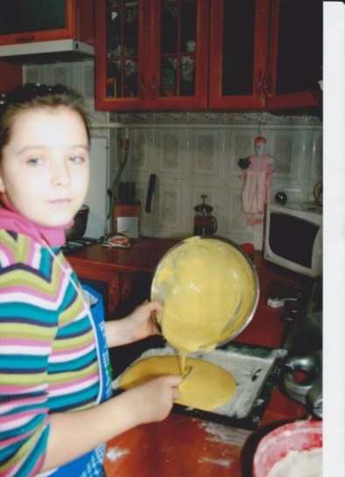Have a look at the picture gallery. In these pictures you are doing your favourite activities. Let’s look closer and describe them.

Photo 1.

Olesya: In this picture you can see me pouring the mixture onto a baking tray. It is going to be a biscuit. I enjoy baking. I’m crazy about it.

S2. In this picture we can see Olesya pouring the mixture onto a baking tray. It is going to be a biscuit. She enjoys baking. She’s crazy about it.

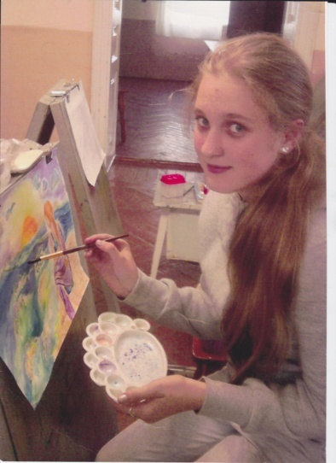Photo 2.

Lilia : In this photo you can see me painting a picture. If you look closer you will notice a girl sitting on a beach, watching the sunset. The sea is rough. It is going to be a storm.

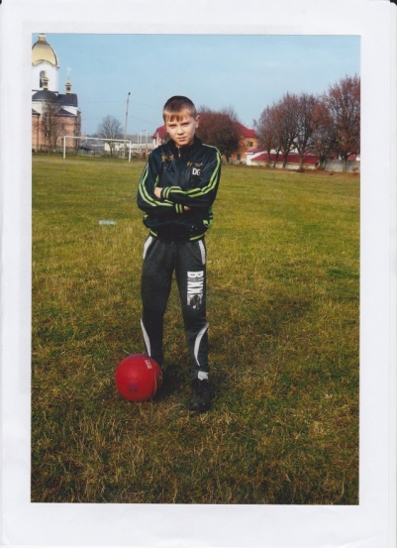Photo 3.

Dima: Can you see me? Oh, yes. I’m at the stadium waiting for my friends. We are going to play football. I play for the school football team.

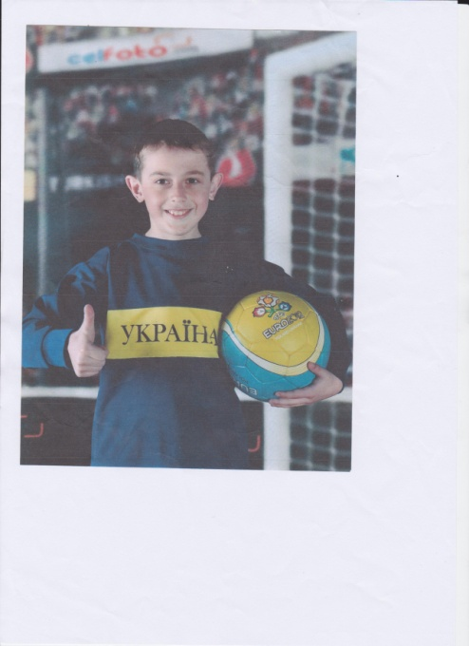Photo 4.

Vitaliy: I hope you’ve recognized me. I’m wearing a blue and yellow track suit with the writing ‘Ukraine’. I support the national football team. I’m crazy about football. I like both watching and playing football.

S 3. In these photos you can see Dima and Vitaliy who are crazy about playing football . They play for the school football team . They are the best footballers.

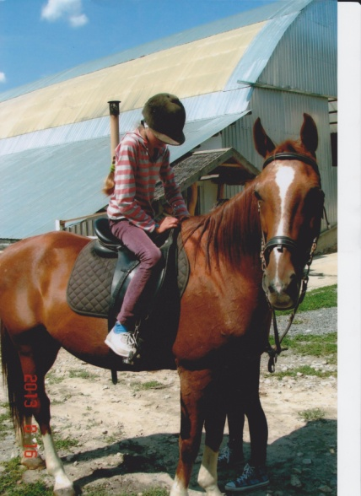Photo 5.

Darynka: This is a picture of me and a horse. I’m on horseback. I’m keen on horse riding. I ride a horse at the weekends. It makes me feel better.

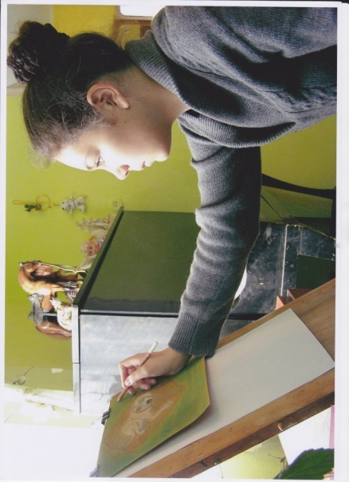

Photo 6.

Sofia: I’m interested in Art. I enjoy painting very much. In this photo I’m drawing a picture of a dog. I like animals.

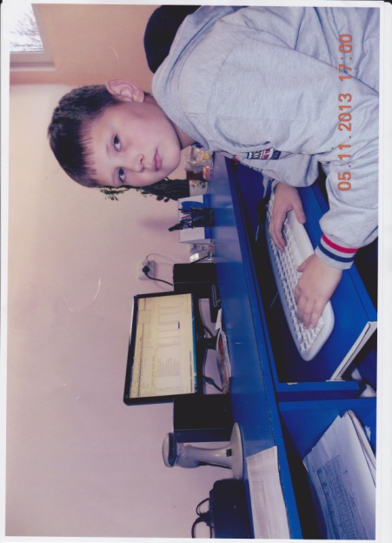I go to the Art Studio three times a week. I hope to be a famous painter.

Photo 7.

Maksym: As for me , I’m interested in Computer Studies. I’m crazy about science-fiction. I’m good at finding information on the Internet.

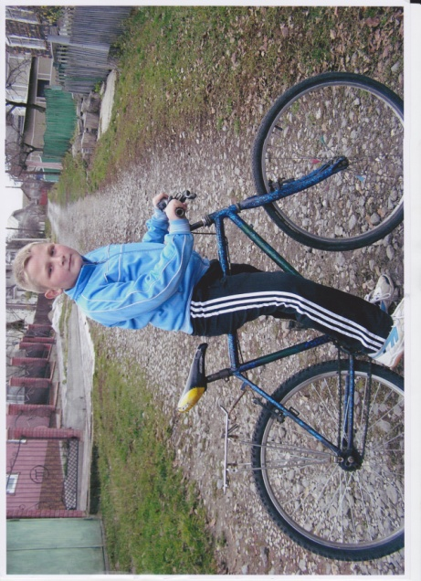In the photo I’m surfing the Net. I’m looking for the tests in English.

Photo 8. Tolik : In this photo you can see me riding a bike. I’m very good at it. I usually go for a bike ride after school. I think sport is good. It makes me feel happy and healthy.

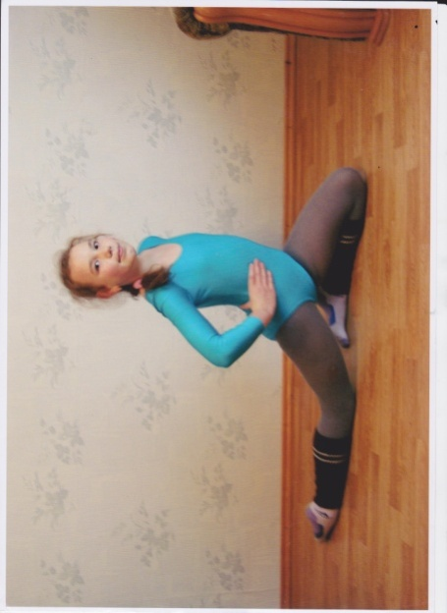Photo 9.

Maria: I’m also interested in sports. I want to be healthy as well. Gymnastics is my favourite sport.

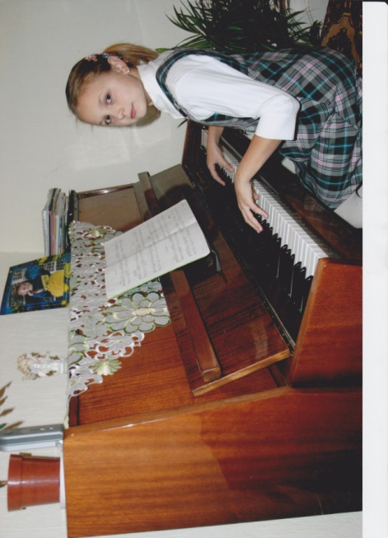In the photo you can see me doing exercises. I’m sure when I grow up I’ll become a famous champion.

Photo 10.

Irynka : I’m interested in music. I’m crazy about pop music. I’m good at singing and playing the piano. In this picture I’m playing the piano.

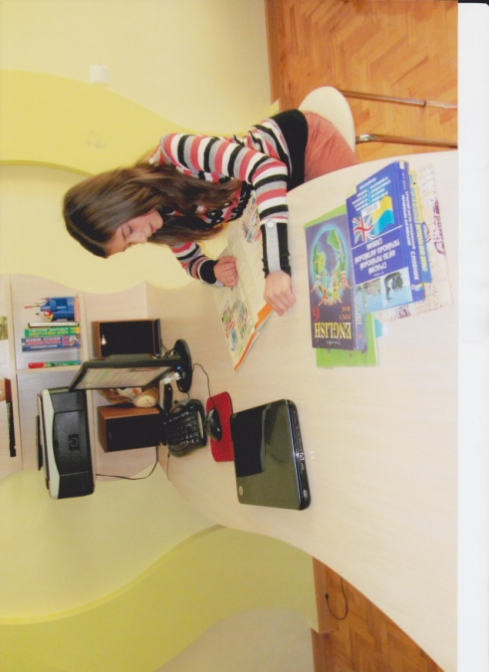

Photo 11.

Diana : I’m interested in learning foreign languages. I’m crazy about reading geography magazines. I’m good at English. I can read and speak English fluently.

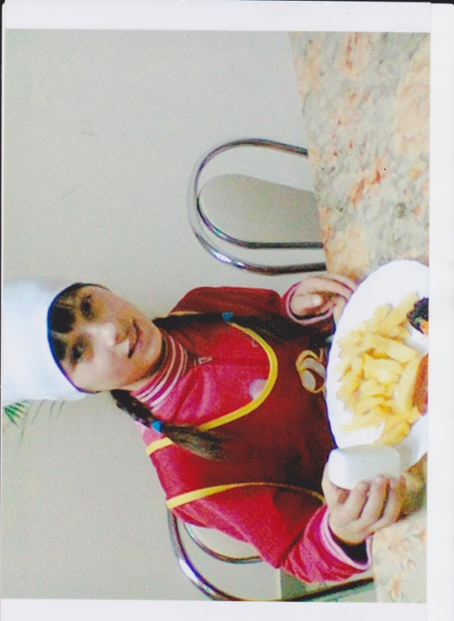In this picture I’m doing my homework in English. I’m reading the text about a poor boy from Turkey and his adventures.

Photo 12.

Khrystyna : I’m interested in food around the world. I’m crazy about chips with ketchup. I’m good at cooking.

S4. I’ve got to know that Khrystyna is interested in food around the world .She’s crazy about chips with ketchup. She’s good at cooking.

S5. To sum up, I’ve found out that all the children in our class do a lot of hobbies: playing the piano, cooking, horse-riding, playing football, surfing the Net, reading, singing and painting.

2.Listening.

Let’s listen to the dialogue about Mrs. Smith and find out what her hobby is.

Interviewer: Do you have a hobby?

Mrs. Smith: Well, I’m keen on working in the garden because I love flowers.

Interviewer: What sport are you interested in?

Mrs. Smith: Well, I’m interested in judo.

Interviewer: Are you good at judo?

Mrs. Smith: No, but I’m crazy about watching it on television.

Interviewer: What are you good at?

Mrs. Smith: I’m good at cooking and Clueless and Holmes are very fond of my food.

Interviewer: What are you bad at?

Mrs. Smith: I’m bad at singing and dancing.

Interviewer: I think gardening is a good hobby for you.

Mrs. Smith: Yes, but I haven’t got a garden.

T.: So, what have we found out about the lady?

Students’ answers, e.g. :

Mrs. Smith is keen on working in the garden because she loves flowers.

She is interested in judo.

She’s crazy about watching it on television.

Mrs. Smith is good at cooking and Clueless and Holmes are very fond of her food.

She’s bad at singing and dancing.

Mrs. Smith hasn’t got a garden but she likes gardening.

T.: Well done.

Now let us act out the dialogue. But , please, use she instead of I.

Keys:

Dialogue 1

* Does Mrs. Smith have a hobby?
* Well, she’s keen on working in the garden.
* What sport is she interested in?
* Well, she’s interested in judo.
* Is she good at judo?
* No, but she’s crazy about watching it on television.
* What is she good at?
* She’s good at cooking.
* What is she bad at?
* She’s bad at singing.

Dialogue 2

* What is Mrs. Smith keen on?
* She’s keen on working in the garden.
* Has she got a garden?
* No, she hasn’t.
* Does she love flowers?
* Yes, she does.

3. Role play. Collecting information to fill in a chart.

T.: You’ll be given the role cards ( see Resource 22) . There is some information on them. Please, read the information carefully.

I also need three interviewers whose task is to interview you and find out what each of you is interested in, crazy about and fond of, and to complete their charts.

Ss walk around the classroom asking and answering questions e.g.:

What are you interested in?

I’m interested in sport.

What are you crazy about?

I’m crazy about reading cartoons etc.

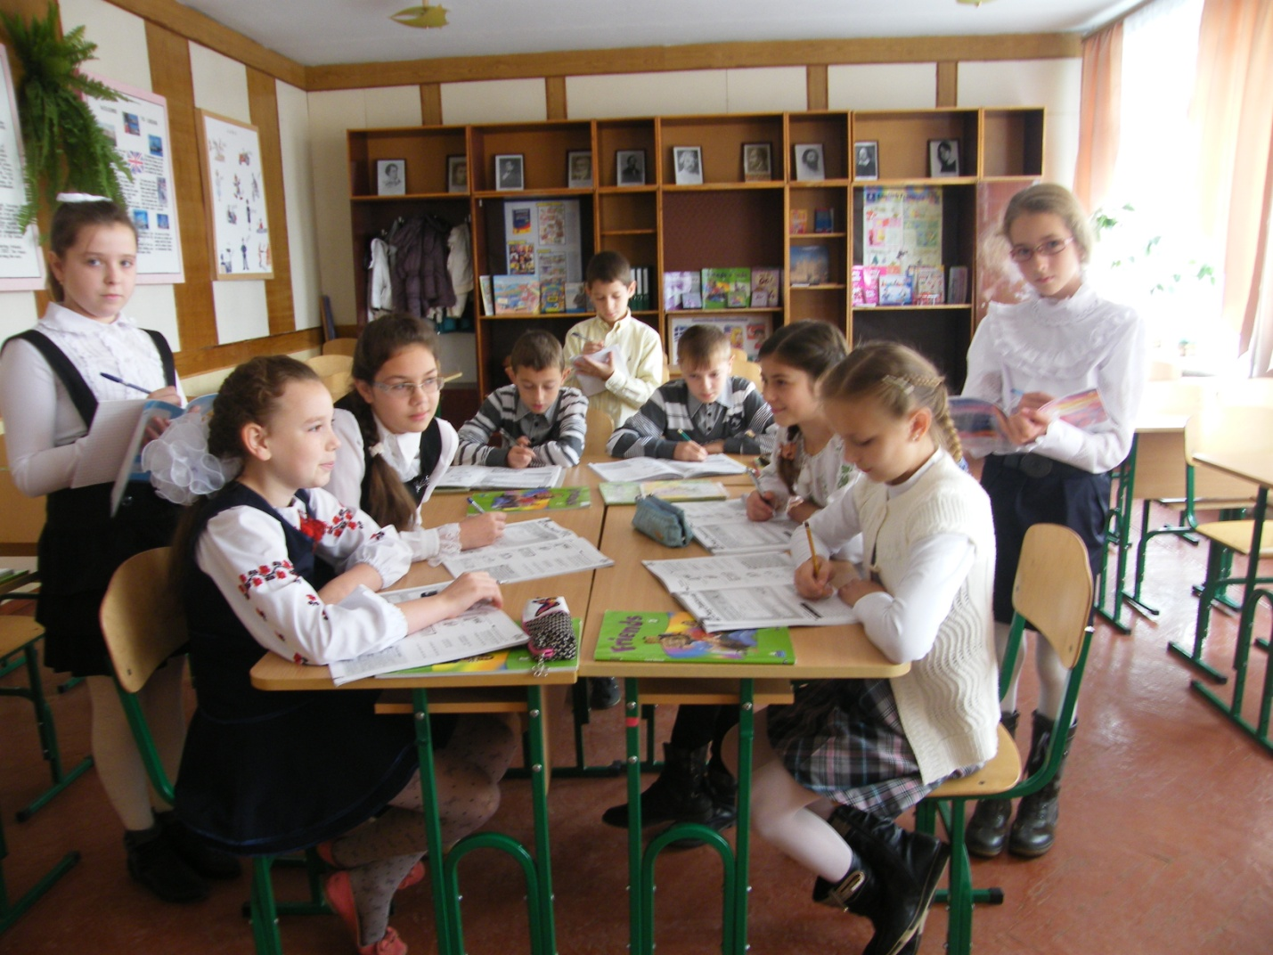

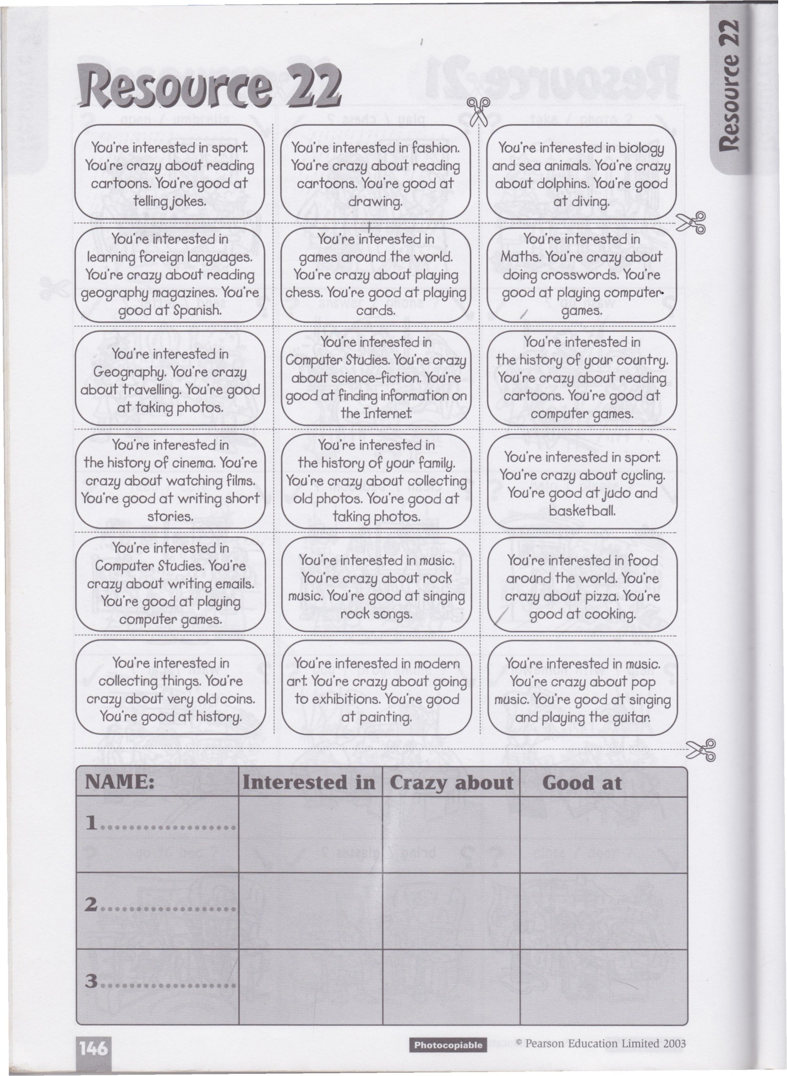

4. Song time. SB, page 105.

T.: We’ve done a lot of work so that we deserve to have a rest. Shall we sing a song?

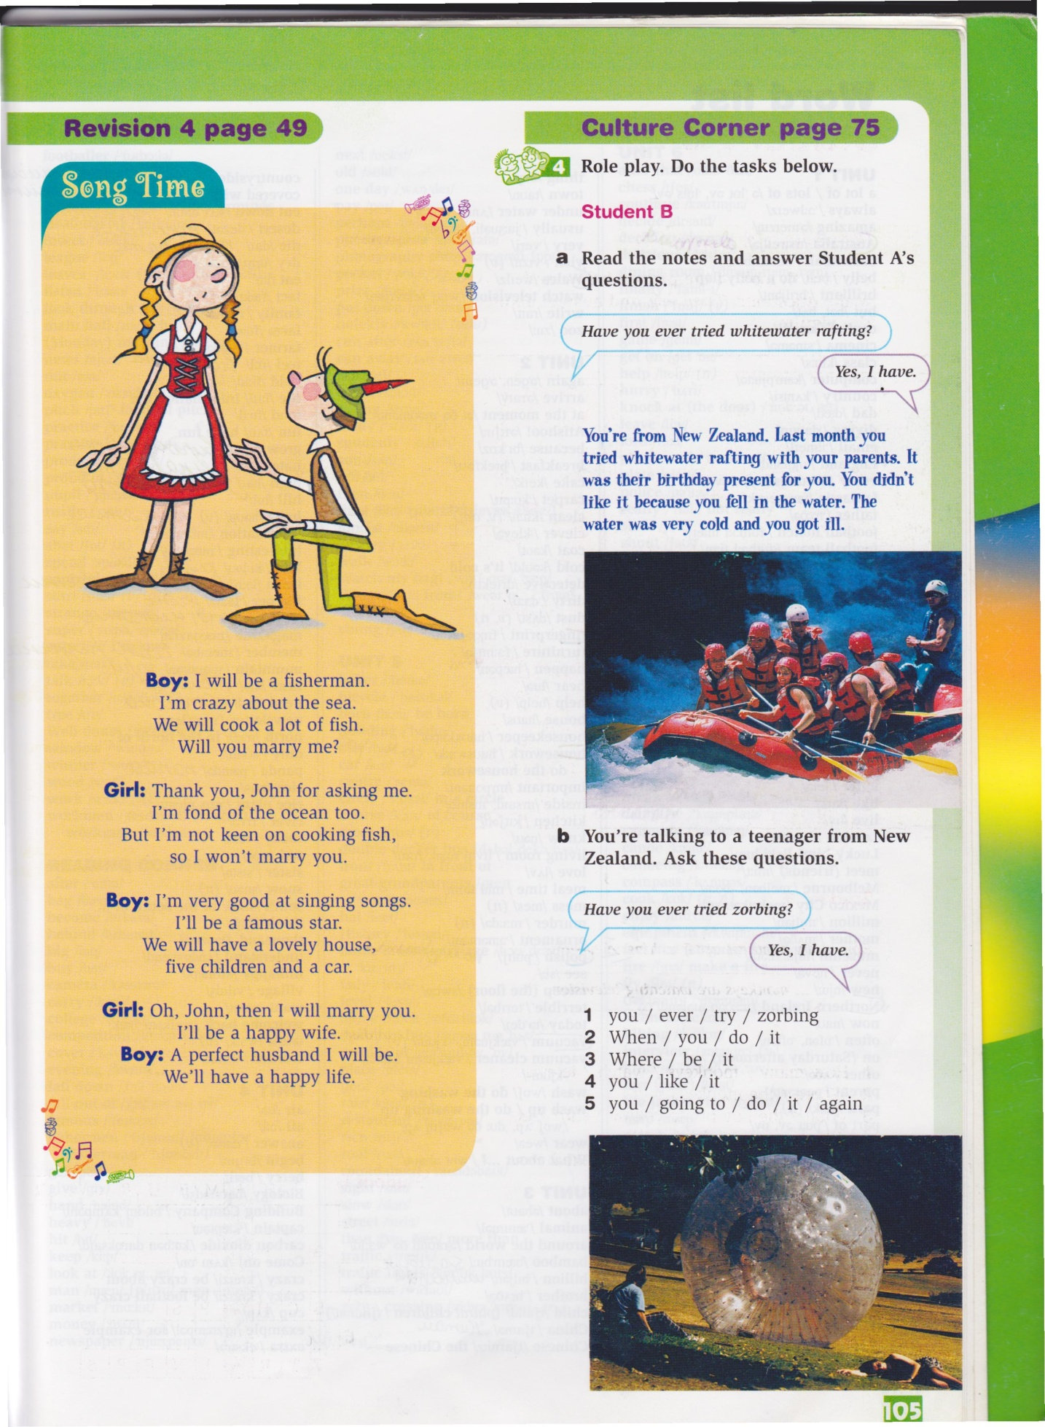

5. Writing. Complete and answer the questions.

1.Are you interested ….. taking up a hobby?

………………………………………………………………………………………………

2.What sport are you good …..?

……………………………………………………………………………………………….

3. Who are fond ….. at your school?

……………………………………………………………………………………………..

4. Which school subjects are interested ….. ?

…………………………………………………………………………………..

5. Is your best friend keen ……….. playing chess?

……………………………………………………………………………………………..

6. What animals are scared …?

…………………………………………………………………………….

Keys: in, at, of ,in, on, of.

III. Evaluation ( making a feedback, praising students, marking their positive attitudes and progress).