ПЛАН-КОНСПЕКТ

ВІДКРИТОГО УРОКУ З АНГЛІЙСЬКОЇ МОВИ

У 10 КЛАСІ НА ТЕМУ:

“Clothes.

Describing people. ”

ВЧИТЕЛЯ АНГЛІЙСЬКОЇ МОВИ

БУЧАЦЬКОЇ ЗОШ І-ІІІ ст. №2

КУРЦЕБИ ОЛЕКСАНДРИ МИКОЛАЇВНИ

2013

Topic: 'Describing people'.

Sub-topic: 'Clothes'.

Level: Intermediate / upper-intermediate

Lesson objectives

* To check and consolidate grammar studied in this module - adjectives.

* To revise vocabulary associated with clothing.

* To develop writing skills.

Procedure

I. Warm up.

Hello! Today we are going to talk about clothes. Moreover, we'll describe people. While doing this we'll master our speaking and writing skills.

II. Main part.

1.Speaking .

Well, let us find out what the clothes we choose to wear tell other people about us.

E.g. The clothes we choose to wear tell other people a lot about ourselves. We often judge people by what they are wearing. For example, people dressed in expensive clothes are thought to be wealthy. Our shoes, accessories and jewellery, all tend to create an impression of our social class and personality. Similarly, our choice of clothes also depends on our age and who we are influenced by.

On the other hand we do not always get the chance to choose our clothes. If we work as a nurse, police officer or fire-fighter we have to wear a standard uniform. Lastly, our ideas of beauty are revealed by our style of dress. Dressing in a particular outfit might be a way of saying, "This is what I think looks nice, and I believe it makes me look more attractive". In conclusion, more than being just a way to keep warm, clothes reveal a lot about a person's life, character and status.

2. Practising vocabulary. Writing.

You probably already know most of the everyday words for clothes. Here are some items of clothing or parts of them which are perhaps less familiar.

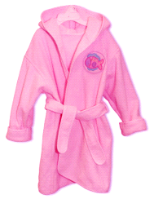 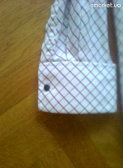 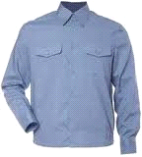 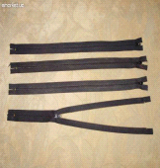 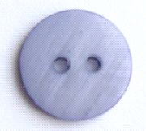 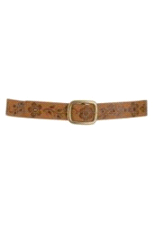

dressing- cuff sleeve zip button belt, buckle

gown

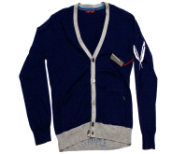 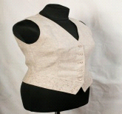 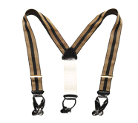 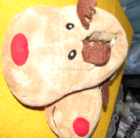 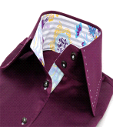 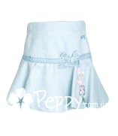

cardigan waist coat braces slippers collar hem

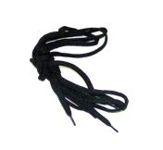 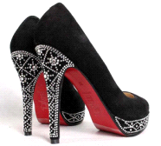 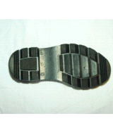 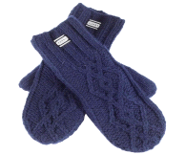

laces heels sole mittens

Which of the words illustrated above fit best in the following sentences?

1. I must get my black shoes repaired. One..........................is broken and both the..........................................have holes in them.

2. Do up your.....................................or you'll fall over.

3. There's someone at the door. You'd better put your..............................................on before you open it.

4. Put your............................................................on - this floor is very cold.

5. I've eaten too much - I'll have to loosen my............................................ .

6. I've almost finished making my dress for the party but I've still got to sew up the..............................................and sew on some......................................................... .

Keys: buckle, soles, laces, dressing-gown, slippers, belt, zip, buttons.

3. Describe in as much as possible what the people in the pictures are wearing. Here are some adjectives for describing people's clothing.

How things fit: baggy, loose, tight, close-fitting.

Style: long-sleeved, V-neck, round-neck.

General: elegant, smart, scruffy, chic, trendy, with-it.

Appearance: well-dressed, badly-dressed, old-fashioned, fashionable.

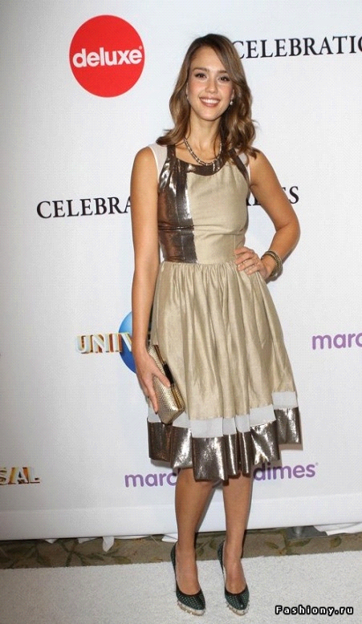 

4.Listening.

First look at the table and listen to the following description to fill in the missing information. Use the notes to desсribe Mary.

___________________________________________________________

Height/ Facial Hair Clothes Character Hobbies/

Build Features Accessories Interests

___________________________________________________________________________

in her ....- oval face, red, fashionable polite, goes to

twenties, small nose, shoulder- tops, ........... the gym

tall, ..... lips, length ............

...........

___________________________________________________________________________

Tapescript:

Susan: Oh, Jane, are you still looking for a babysitter?

Jane: Yes, why? Have you found one?

Susan: Yes. Mary - one of the receptionists at my office.

Jane: Oh wonderful! How old is she?

Susan: Oh, in her mid-twenties, I'd say.

Jane: And what does she look like?

Susan: She is quite tall, about 5' 9" and she is slim... Um, she's got an oval face with a small nose, full lips and beautiful green eyes. She's got red shoulder-length hair, a bit like yours.

Jane: It seems she is good looking, then.

Susan: Yes, and she usually wears fashionable tops and jeans.

Jane: What do you think of her?

Susan: Well, she's really polite and sociable so I'm sure she'll get along fine with your kids.

Jane: How can I reach her?....(fade)

Keys: mid, slim, full, jeans, sociable.

III.Hometask.

Rose is going to meet her student exchange partner Paul at the airport. They have never met before. Complete Paul's email in which he tells Rose what he looks like.

Hi Rose,

Thanks for your email. My plane lands at 12.40. And this is what I look like: I'm t........ and thin; I've got long, w......, fair hair in a p............... I've also got a m..............., but no beard. I'll be wearing j........., a black s..........., an a............. and trekking b........... I'll be carrying a big backpack.

Looking forward to seeing you,

Paul

Keys: tall, wavy, ponytail, moustache, jeans, sweater, anorak, boots.

IV. Evaluation ( making a feedback, praising students, marking their positive attitudes and progress).