BRAIN TEASER

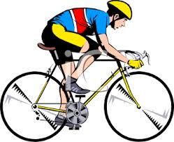

1. You are a cyclist in a cross-country race. Just before the crossing finish line you overtake the person in second place! What place did you finish in?

5. Which came first, the chicken or the egg?



2. In a year there are 12 months. 7 months have 31 days. How many months have 28 days?



3. I do not have any special powers, but I can predict the score of any football game before it begins. How can I do this?



4. Which is heavier? A pound of feathers or a pound of rocks?



Answers:

1. Second Place. If you pass the person in second, you take second place, and they become third.
2. They all do.
3. I can predict the score BEFORE it begins. Well, the score before any football game is always zero to zero!
4. Neither. Both weigh a pound!
5. The egg. Dinosaurs laid eggs far before there were chickens!