MISS 1 TURN
MAKE A SENTENCE
Use different tenses
RULES
Make a sentence with the verb you land on. Choose another player and let him/her tell you in which tense the sentence must be. Be creative!
present tense
fix
close
grab
smile
train
START
like
bite
cry
take
do
pick
Go back
make
have
buy
sell
think
jog
rest
set
Short cut
win
lose
Short cut
swim
crawl
leave
break
sleep
want
dig
jump
slam
send
know
hold
lean
get
bend
fold
type
smell
sniff
say
burp
clear
row
Go back
hug
plug
stay
tell
kick
laugh
bow
bare
Short cut
Finish
grow
stuck
keep
wave
pull
push
help
open
mend
look
post
see

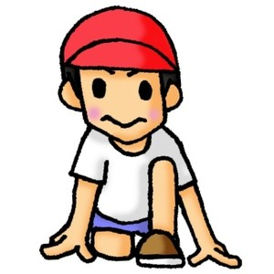
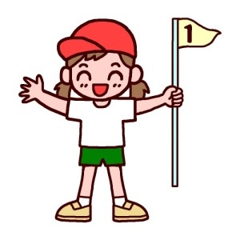


past tense
present continuous tense
past continuous tense

