Examination Card №31

I. Read the text and match each paragraph with the most suitable title. There are two titles you do not need to use.
Ireland is ranked friendliest place in the world
A. Irish oral tradition.
B. British attitude towards the Irish.
C. Good humour after hard times.
D. More than you can expect.
E. The biggest attraction in Ireland.
F. What the Irish think of Britain.
G. Having a nice time.
H. Three reasons to visit Ireland.

1. _______________________________
The British have rarely been complimentary about the Irish down the centuries. There have been the Irish jokes, insulting nicknames and the attitude that much that went on the neighboring island was simply unacceptable.

2.________________________________
Now it turns out that the friendliest country in the world is Ireland. The prestigious British ravel guide Lonely Planet reckons that the island’s inhabitants have reverted to what they do best – drinking good liquor, making strangers feel at home and having fun.

3._________________________________
The 2008 edition of The Lonely Planet Bluelist – a guide to places you should think about visiting – says: “Centuries of turmoil, conquest, famine and subsequent immigration have left them with a deliciously dark sense of humour and a welcoming attitude towards strangers.”

4.__________________________________
“That famous ability of the Irish means you’re always having fun. A cautious optimism reigns supreme, infecting the land once again with the sense that anything is possible.”

5.__________________________________
The verdict was greeted triumphantly by tourism officials yesterday. Lawrence Bate, of Tourism Ireland, said: “We are delighted to have this endorsement of thousands of Lonely Planet readers. People have expectations that are far and away exceeded when they visit Ireland.”

6.__________________________________
The Irish have further reason to smile after claiming a place in the Lonely Planet list of the world’s 10 best brewery headquarters, leased by Arthur Guinness in 1759. “If you don’t know what it is that makes the Guinness brewery Ireland’s number one visitor attraction, you must be under 18,” the book says.

II. Choose the correct answer.
What’s the point of family history?
Family history is 1)___ referred to as genealogy. It is one of the world’s most popular pastimes, and millions of people around the planet are investigating their origins as I write this. From 2)___ beginners to experienced genealogists, the attraction of 3)___ out more about the past through your own family is hard to resist. Once you have 4)___ out on the research road, the work can become absolutely fascinating. There are many reasons 5)___.
As you explore this route to the past, you’ll develop new skills, which you can use in many ways. You’ll also enjoy the excitement of the detective process. The voyage of discovery into your family’s past often leads to a greater understanding of history. It’s also a social pastime, and will 6)___ you into contact with many new and like-minded people.

1 | A) and | B) too | C) also | D) both
2 | A) full | B) complete | C) whole | D) thorough
3 | A) finding | B) meeting | C) learning | D) knowing
4 | A) set | B) done | C) put | D) made
5 | A) because | B) since | C) why | D) so
6 | A) send | B) carry | C) give | D) bring

III. You’ve got an email from your English-speaking friend in which he/she asks you about your favourite school subject. Write a reply including the following information:
- What is your favourite subject and why?
- How will the knowledge of this subject influence your future?

Examination Card №32

I. Read the text and for questions 1-6 choose the correct option a), b) or c).
CURRICULUM VITAES: TIPS THAT HELP
Six out of ten CV’s which are prepared by Information Technology professionals fail to meet the basic standards and are turned down without even being read fully, according to a recruitment company. As a consequence, thousands of candidates are excluding themselves from attractive job opportunities.
Although the company handles over 60,000 CV’s per year, it estimates that at least 60% would not be admitted if they were sent directly to potential clients due to basic errors.
The company Marketing Director said, “Sadly it’s often the most highly qualified candidates whose CV’s are so poorly constructed that they are literally dead on arrival. Attractive job opportunities in the IT industry often generate intense competition and there is often little to choose between the candidates”.
“Advice on the presentation format of CV’s in relation to the requirements that they are being submitted for should be an Industry standard so as to add real value to the candidates that you are representing and indeed to fulfill your professional obligations to your clients”.
“Writing a CV can be extremely difficult and too often a CV turns out to be a generic overview including a lot of information that is irrelevant. People should remember that an employer typically spends between 15 and 30 seconds scanning each CV and you have that one chance to make an impression”.
“A good CV is more than just documentation of your career path; it is a marketing tool designed to present your professional career experience according to the new job specification. It should also include details of past professional successes that effectively demonstrate your ability to undertake the job responsibilities outlined”.

1. Recruitment companies say that potential clients …
a) make basic mistakes.
b) only get 60% of CV’s.
c) reject CV’s with mistakes.
2. The Marketing Director said that the best candidates …
a) are the most affected.
b) do not send CV’s.
c) write the best CV’s.
3. The Marketing Director suggests that candidates ought to pay attention to …
a) CV’s presentation.
b) other companies.
c) other competitors.
4. The Marketing Director says that very often CV’s include …
a) necessary details.
b) unimportant information.
c) very little information
5. Candidates should remember that employers …
a) are typical people.
b) are very busy people.
c) make an impression on people.
6. A good curriculum should show …
a) the new job specifications.
b) your marketing tools.
c) your overall skills.

II. Choose the correct answer.
L’Australie – c’est chic!
One of the most surprising business success 1)___ in Paris these days is the Australian Bookshop. Since the shop opened two years ago, French in Australian literature 2)___. Located in the heart of the city’s literary district, the shop is 3)___ by Elaine Lewis, from Sydney. Lewis said she couldn’t find books by Australian writers on Paris shelves, so she resolved to remedy the situation. Angus Mackenzie of the Australian embassy 4)___ surprising that the French want to read Australian books – ‘not because the books are not 5)___, but because of the language barrier,’ he said. French publisher Marc de Gouvenain thinks the trend is easy to explain, however. ‘In Europe, we 6)___ see the landscape with young eyes. Australian authors have a fresh way of seeing things.’

1 | A) histories | B) reports | C) stories | D) tales
2 | A) grew | B) grows | C) has grown | D) is growing
3 | A) carried | B) carried out | C) conducted | D) run
4 | A) finds | B) finds it | C) thinks that | D) thinks this
5 | A) deserving | B) estimable | C) worth | D) worthy
6 | A) any longer | B) no longer | C) no sooner | D) no more

III. Your English-speaking friend is interested in your hobby. Write him an email telling about your hobby. Include the following:
- What are the most popular free time activities among Ukrainian teenagers?
- What is your hobby and why do you like it?
- What advice would you give to your friend who wanted to take it up?

Examination Card №33

I. Read the following texts and match them to the most suitable heading from the list supplied. Each heading can only be used ONCE. There is one heading you will not need.
eBAY TIPS FOR SELLING SUCCESSFULLY
TEXT 1
Getting that first bid is critical, as buyers are more likely to jump in if there are already bids on auction. Buyers may lose interest if they assume an item is overpriced. Many successful sellers set a low opening bid to jumpstart bidding and increase their final selling price.
TEXT 2
Specifying reasonable shipping and handling costs in your listing is essential for smart selling. eBay's free Shipping Calculator provides real-time shipping costs to buyers all over the world, so you can increase your chances of success. Remember that a long wait can be both boring and frustrating for customers.
TEXT 3
Maximizing your item title is a must if you want to sell your product. Be sure to include key words that buyers will search for, such as unique or descriptive attributes, and always check your spelling. Your item title is critical in helping users find your items, so use each character wisely.
TEXT 4
A good description is concise, well organized, and easy to read. Create bold section headlines, bulleted lists, and be sure to include item style/type, brand, condition, and other attributes. Think about your listing from the buyer's perspective – the more information you provide, the more likely buyers are to place a bid.
TEXT 5
A picture really is worth more than a thousand words! Use clear, well-lit photos from a variety of angles to accurately showcase your item. Use good lighting and an uncluttered background to get the most out of your photo. Add additional photos to showcase details and unique features of your item.
TEXT 6
Always respond quickly to any buyer questions. Include extras or a handwritten note in the box to really surprise and delight your customers. Make sure to leave feedback for your buyer so they’ll do the same for you. Successful communication is one of the keys to successful business.

A A modest start is more intelligent
B A well-planned explanation can attract buyers
C Attractive and correct descriptions are essential
D Delivery prices can help you sell
E Exchanging messages will help you sell
F Put your photographs in the background
G Show what it looks like

II. Choose the correct answer.
Sherlock Holmes
A small side door 1)___ into the white-washed corridor from which the three bedrooms opened. We passed at once to the one in which Miss Stoner was now sleeping, and in which her sister 2)___ with her fate. It was a cosy little room, with a low 3)___ and a gaping fireplace, the style of old country houses. A brown chest of drawers stood in one corner, a narrow bed in another, and a dressing table on the left-hand side of the window. These articles, with two small wickerwork chairs, 4)___ all the furniture in the room, save for a square of Wilton carpet in the centre. Holmes drew one of the chairs into a corner and sat in 5)___, while his eyes traveled round and round and up and down, taking 6)___ every detail of the apartment.

1 | A) carried | B) led | C) guided | D) took
2 | A) was met | B) had met | C) was meeting | D) will meet
3 | A) floor | B) ceiling | C) window | D) walls
4 | A) made up | B) lined up | C) put up | D) took up
5 | A) silent | B) silence | C) quietly | D) silently
6 | A) in | B) on | C) through | D) up

III. Imagine that you are learning English at the language course in Great Britain and are living in a host family. Write a letter to your parents. Tell them about:
- Your accommodations;
- Your host family members and their interests;
- Your leisure time activities.

Examination Card №34

I.Read the text and for questions 1-6 choose the correct option a), b) or c).
What makes a good road sign?
Many road signs are bizarre when thought about logically. Just what is one meant to do if there is a danger of falling rocks? And if the road is slippery, will your car tyres really cross like the alarming skid marks seen on the sign?
But even if some symbols do not stand up to scrutiny, they convey a message that is quickly recognised. Or at least, that's the hope. Out of 500 drivers surveyed last year, none was able to correctly identify 12 road signs and only one sign - the speed camera - was known to them all. A review of signs has been launched by the Department for Transport, looking at ways to reduce the number of signs and introduce more technology. So what makes a good sign? "The most important thing is that it works," says Michael Wolff, chairman of The Sign Design Society.
Not only do modern drivers travel faster than before, they are also listening to the radio, chatting on their hands-free phone and trying to get children in the back under control. Distractions are everywhere. With so much competition for a driver's attention, a good sign must be clear and simple so that it can be seen, read and understood in an instant. The red no-entry sign is one that, even without words or pictures, conveys its message.
But others don't. Many drivers are unable to recognise the "no stopping" sign. And former police driving instructor Chris Walker says the "give way to oncoming traffic" sign is hotly debated at driving school because it is illogical and takes too long to work out.
The symbols on signs should not be interpreted too literally - the roadworks warning is often compared to a man opening an umbrella, while some of the most recognisable signs evoke memories of the pre-motoring age. A 19th century-style bellows camera is used, with great success, to warn of the imminent danger of racking up a speeding fine and rail enthusiasts' hearts must race at the symbol of a
steam train before level crossings. "Symbols don't have to be accurate; they are there to convey an idea and be understood," Mr Wolff says. Some widely used signs have attracted criticism for being outdated. The image of stooped elderly people crossing a road has been branded as "insulting" by Help the Aged. It originates from a children's competition in 1981.
Different colours provoke very different reactions in the human mind, says Dr David Cowell, who specialises in the psychology of colour. The brain is very sensitive to the level of energy in the light that passes through your eyes, with different colours of light carrying different amounts of energy. "Blue [the colour of motorway signage] suggests harmony and relaxation," says Dr Cowell. "It is the colour of nature in relaxed form. It encourages social communication and consideration of others." Orange and yellow "suggest a positive future", he says, the point being that the colour of signs surrounding roadworks is clearly meant to encourage frustrated drivers to think beyond the current delays.
Different shaped signs also create different psychological reactions, suggests Dr Cowell. "A triangular sign has points and represents danger," which is why the shape is used for warning signs. "Rectangular signs are the same shape as a book and therefore give information. Round signs are instructional. They look like the end of a pointing finger giving you an instruction."
While the fundamental design of the country's road signs has remained unchanged for almost half a century, the number of signs seems to be multiplying. Today British roads can seem crammed with symbols warning drivers of every foreseeable danger, from falling rocks to passing deer. As well as fuelling fears, the streetscape is being damaged, and the proliferation of signs reduces their effectiveness. "Drivers now face a system overload," says Mr Walker. "Signs are duplicated, in some cases triplicated, leaving little time for the information to be seen and processed."
Even the most well-designed road sign will be of little use if nobody can make it out.

1. A recent survey has shown that
a) drivers should revise the sign system.
b) the sign system doesn’t work at all.
c) the sign system has to be improved.
2. Today it is more necessary than ever that
a) distractions be avoided.
b) drivers pay attention on the roads.
c) signs are well designed.
3.Some signs are very effective even though they may
a) depict unrecognisable objects.
b) have a controversial origin.
c) look old fashioned.
4. The colours around roadworks are intended to
a) attract attention.
b) encourage patience.
c) indicate them clearly.
5. According to Dr Cowell, the shapes of road signs are meant to
a) make drivers behave in different ways.
b) remind drivers of a code.
c) represent different risks.
6. The number of signs on British roads
a) is cause for concern.
b) makes drivers feel fear.
c) prevents every possible danger.

II.Choose the correct answer
Rainforest
Scientists believe that rainforests may be home to more than ten million different forms of wildlife. The largest group 1)_____ of insects, which climb or fly easily from tree to tree. Most people are familiar 2)____ colourful parrots, but they are only one part of the total bird 3)_____ , which goes from tiny hummingbirds to huge toucans. Many rainforest animals have developed for living in the treetops. Some monkeys have thin webs of skin between their legs that 4) ______them to almost fly between 5)______ . Others have long, strong tails, like an 6)_____ arm.

1 | A) keeps | B) consists | C) holds | D) claims
2 | A) with | B) to | C) of | D) by
3 | A) set | B) company | C) population | D) society
4 | A) let | B) allow | C) make | D) admit
5 | A) branches | B) leaves | C) flowers | D) plants
6 | A) accurate | B) equal | C) extra | D) alive

III.Your friend has written an e-mail that he has had a bad cold. Write a reply and ask how he/she feels and give him some advice:
- To have a rest;
- To go to bed;
- To see a doctor.

Examination Card №35

I. Read the text given below. Match the headings (A–F) with the parts (1–6) of the text.
A The first students
B Staying at the universities
C No married teachers
D An exciting competition
E Women students
F Ancient universities
1_________
The towns of Oxford and Cambridge have some of the finest buildings in Britain.
They are famous for their universities, the oldest in England. All the students live and study in colleges. Cambridge has 31 colleges and Oxford has 39. Oxford’s first college started in 1249. Cambridge’s first college opened in 1281.
2_________
Before the 12th century, people who wanted a good education went to the Sorbonne in Paris. Then, in 1167, all English students in Paris moved to Oxford. Some people say King Henry II told them to move. Others say the French threw them out! The students went to study in Oxford monasteries and that was the beginning of Oxford University.
3_________
The Church was very important in Oxford and Cambridge for many years. For example, until the 19th century the university teachers were almost like priests and they couldn’t marry.
4
Women started studying later than men. The first women’s college at Cambridge
opened in 1869 and at Oxford in 1878. Today, three Cambridge colleges and one Oxford college are for women only. Men and women study together in the others.
5_________
Every year the universities compete in a rowing race over 7 kilometres of the Thames. The first race was in 1829 and it became a yearly race in 1839. All the students really want their university to win!
6_________
People can stay in rooms at Oxford and Cambridge when the students are on holiday. Some rooms are modern but the older rooms are more interesting (and more uncomfortable!). They often have low ceilings, small windows and a view of the square in the middle of the college. Imagine sleeping in the same room as an ex Prime Minister or eating at the same table as Lawrence of Arabia!

II. Choose the correct answer.
Health smart
The cold and flu season is back again, so it’s time to brush up on prevention and treatment. 1)___ to popular belief, cooler weather doesn’t cause colds. What is more likely that we stay indoors more, giving viruses a chance to spread from person to person. In addition, the cold months are associated 2)___ low humidity, and the dry air makes the nasal cavity more susceptible to bugs. Consequently, cases of colds and flu surge between the beginning of autumn and spring (the 3)___ adult gets two to four respiratory infections a year; children even more). Because the season is upon us, it is a good 4)___ to revise a few cold and flu tactics.
To prevent an infection, the best defence is a good offence. The first step is to 5)___ physical contact with the cold sufferer. When someone with a cold sneezes, coughs or sniffles, 6)___ your distance. Hugging, kissing and shaking hands are sure ways to catch a cold.

1 | A) Contrary | B) Opposite | C) Similar | D) Unlike
2 | A) for | B) on | C) to | D) with
3 | A) average | B) different | C) ordinary | D) same
4 | A) idea | B) suggestion | C) sense | D) advice
5 | A) break | B) control | C) limit | D) lose
6 | A) cover | B) judge | C) keep | D) remember

III.You are going to write a letter to your English pen-friend about your last holiday which you spent at the seaside with some of your classmates. The holiday was spoilt be several things. Write about them:
- Poor weather;
- Problems with accommodation, such as noise, dirty rooms and unfriendly staff;
- Arguments over what to do, such as sightseeing or sunbathing.

Examination Card №36

І. Read the text and choose from the sentences (A–F) the one which fits each gap
(1–5). There is one sentence that you don’t need.

A That was how Doug and Deborah’s sister got to know each other.
B After the ceremony was over, all the guests were invited to a reception in the
outdoor garden patio.
C Her parents were worried that they might get caught in peak-hour traffic along
the way and decided that it was better to be early than late.
D They bought souvenirs from New York to all their relatives.
E She and her parents had to be in New York to do the final fittings of their dresses
and suits.
F She was a professional dancer and worked for a professional dance company in
New York.
G Deborah visited Times Square with all its bright lights and the majestic Statue of Liberty.
Deborah checked in her luggage two hours before the flight was scheduled to depart. This was in line with standard airline regulations. She had arrived at the airport an hour ago. (1) ..... Thankfully, the roads to the airport were relatively clear.
Deborah and her parents were on their way to new York. Her sister had been working there for the past four years. (2) ..... Her job required her to travel all around the United States to perform. It was during one of these trips three years ago that her
sister met Doug.
Doug was an American accountant. He had gone with a friend to watch the dance performance. His friend was also an acquaintance of one of the other dancers in the company. (3) ..... Now, the two of them were getting married next month. That was why Deborah and her parents were going to New York.
Deborah was going to be one of the flower girls at her sister’s wedding. (4) ..... They also had to be present for the wedding rehearsal. While they were there, they took the opportunity to do some sightseeing in New York. This was their first visit there. (5)….. She bought souvenirs for a few of her friends back in Australia.
Finally, the big day arrived. Everyone was giddy with excitement. Deborah’s sister was a nervous wreck. She was worried that she might forget something or that something might go wrong. They had to keep reassuring her that everything was fine. In the end, the wedding ceremony proceeded without a hitch. It was a beautiful and touching ceremony. (6) ..... It was a splendid day and the food was delicious.

II. Choose the correct answer.

Don’t forget your hat
An important point to remember if you like spending time out in the 1)___ air is that the human head doesn’t work very well outdoors if it becomes too hot, cold or wet. That’s why a hat is a good investment, wherever you’re planning to go out and 2)___ . In cold climates, the problem is that the head is sending out heat all the time. As 3)___ as fifty to sixty percent of your body’s heat is lost through the head and neck, 4)___ on which scientist you believe. Clearly this heat loss needs to be prevented, but it’s important to remember that hats don’t actually 5)___ you warm, they simply stop heat escaping. Just as important is the need to protect your neck from the effects of 6)___ sunlight, and the brim of your hat will do this.

1 | A) open | B) free | C) clear | D) wide
2 | A) around | B) about | C) along | D) above
3 | A) soon | B) long | C) well | D) much
4 | A) according | B) regarding | C) depending | D) relating
5 | A) maintain | B) stay | C) hold | D) keep
6 | A) sharp | B) keen | C) bright | D) deep

III. Your friend wants to lose weight. Give him some advice how to do it. Include the following:
- To go on a diet;
- To take up exercising/ to join a sports club;
- To cut down on junk food.

Examination Card №37

I. Read the text and choose the best answer (A–D) to answer the questions (1–6).
At an elevation of 29,028 feet (8,848 metres) above sea level, Mount Everest is the world’s tallest mountain. Mount Everest is relatively young, having been formed only 60 million years ago, and it is still growing a few millimetres every year! Mount Everest is in the mountain range called the Himalayas.
The summit ridge of Mount Everest separates Nepal and Tibet. Each place has a special name for this giant mountain. The Nepalese name is Sagarmatha, which means “goddess of the sky”. The Tibetan name is Chomolungma, which means “mother goddess of the universe”. In English, Mount Everest is named after Sir George Everest, the first person to record the height and location of the mountain.
A climb to the summit was attempted by George Mallory in 1922, who famously gave his reason for wanting to climb Everest as “because it’s there”. He attempted to reach the summit again in the company of Andrew Irvine in 1924, but on this trip both climbers disappeared. The first successful ascent (and descent) of Mount Everest was accomplished by Sir Edmund Hillary and Tenzing Norgay on May 29th, 1953. The first ascent by a woman was on May 16th, 1975, by Junko Tabei from Japan.
Between 1921 and 2007, over two thousand people have climbed Mount Everest, some more than once. Since the first ascent in 1953, more than 600 climbers from 20 different countries have reached the summit. However, over two hundred climbers have died attempting to climb Mount Everest, most commonly from avalanches, but also from falls in crevasses, cold, or high- altitude sicknesses.

1. How high is Mount Everest?
A 8,848 feet B 29,028 metres C 29,029 feet D 8,848 metres
2. In what way does Mount Everest change annually?
A It is shrinking a very small amount.
B It is getting a little wider.
C It is shifting slightly to the north.
D It is growing a very small amount taller.
3. Mount Everest is in the mountain range called the ..... .
A Rocky Mountains B Andes C Himalayas D Alps
4. Who wanted to climb Mount Everest “because it’s there”?
A George Mallory C Tenzing Norgay
B Edmund Hillary D Junko Tabei
5. The first team to successfully reach the summit was ..... .
A George Mallory and Andrew Irvine
B Edmund Hillary and Tenzing Norgay
C George Mallory and Edmund Hillary
D Tenzing Norgay and Andrew Irvine
6. Since 1953, how many people have reached the summit?
A about 20 B fewer than 600 C exactly 600 D more than 600

II. Choose the correct answer.
Sudoku
Are you a fan of the popular logical puzzle that 1)___ by name Sudoku? 2)___ you’re not, the chances are you know somebody who is. Once 3)___ known outside Japan, this addictive brain teaser has become a common feature of newspaper puzzle pages all over the world. Sudoku’s great success 4)___ much to its simplicity. The game calls for neither mathematical ability nor 5)___ knowledge and there are just a few sentences of straightforward instructions to read before you can play. The only skill required is the ability to 6)___ the difference between nine different symbols, and these don’t even have to be numbers.

1 | A) goes | B) calls | C) passes | D) titles
2 | A) Apart from | B) Even if | C) In spite of | D) Regardless
3 | A) thinly | B) rarely | C) hardly | D) briefly
4 | A) results | B) thanks | C) owes | D) lends
5 | A) general | B) normal | C) usual | D) ordinary
6 | A) copy | B) match | C) notice | D) recognize

III. Your uncle is going to open a new restaurant. This new restaurant wants to offer customers a choice of healthy food. Give your uncle some advice about dishes. Include the following information:
- What dishes you would offer;
- How healthy these foods are.

Examination Card №38

I. Read the film review and choose from the list (A–G) the phrase which best summarises each part (1–6) of the article. There is оnе extra phrase which you do not need to use.

А Mad Меl
В А disappointing ending
C The man who knows too much
D The perfect couple
Е А reluctant heroine
F А villain to remember
G Аn exciting love story

1______
Mel Gibson is Jerry Fletcher, а New York taxi driver with а conspiracy theory for everything. Не publishes his ideas оп the Internet. One day one of his theories upsets some vеrу powerful men and suddenly his life is in serious danger.
2______
The only person who сап help him is also the woman he is secretly in love with. Julia Roberts plays Alice Sutton, а justice department lawyer. She wants nothing to do with Fletcher at first but suddenly finds herself drawn into his world.
3______
Conspiracy Theory is а well-written, entertaining film which successfully mixes two popular genres. As а thriller, there is plenty of action to keep the audience оn the edge of their seats and, as а romance, we end up believing that а top lawyer really could fall in love with а taxi driver.
4______
Perhaps the reason for this is in the strength of the acting. Gibson is at his best as
the paranoid Fletcher (so paranoid that he keeps his food locked in canisters, locked inside his fridge). And Julia Roberts reminds us that as well as being one the most beautiful women оn the planet, she is also one of the world’s finest actresses.
5______
But good as Gibson and Roberts аrе, the best performance of the film is from Star
Trek’s Patrick Stewart as Dr Jones, а psychologist from а sinister government department. Еvеrу minute he is оn the screen he leaves the audience wondering what evil he will do next.
6______
Му only criticism is the last 20 minutes of the film, when director Richard Donner
forgets his convincing, tense storyline and the film descends into а traditional good vs. bad shoot-out. Мауbе because he’s working with Mel Gibson again, Donner suddenly seems to think he’s directing the next in his series of Lethal Weapon movies.

II. Choose the correct answer.
Boots for Africa
Sheffield Football Club was 1)___ one-hundred-and-fifty years ago, and is the oldest in the world. As part of its anniversary celebrations, the club has 2)___ forces with the world’s largest express transportation company, FedEx Express, in a charitable scheme 3)___ as Boots for Africa. The 4)___ of the scheme is to send more than two thousand pairs of used football boots to South Africa. The boots will be given to young people living in remote rural areas who are 5)___ in taking up the sport and 6)___ up local teams.

1 | A) founded | B) invented | C) originated | D) discovered
2 | A) tied | B) added | C) joined | D) linked
3 | A) named | B) known | C) called | D) titled
4 | A) ambition | B) motive | C) reason | D) aim
5 | A) interested | B) interesting | C) keen | D) attracted
6 | A) coming | B) setting | C) beginning | D) finding

III. Write a letter to your friend and give him/her advice on the ways to improve his/her knowledge of English. Include the following:
- To read the books by English writers in the original;
- To listen to music/ watch films in English as much as possible;
- To have practice in one of the English-speaking countries.

Examination Card №39

I.Read through the text below, answer the questions that follow.

Biofuels and the Environment
Leading investors have joined the growing chorus of concern about governments and companies rushing into producing biofuels as a solution for global warming, saying that many involved in the sector could be jeopardising future profits if they do not consider the long-term impact of what they are doing carefully.
It is essential to build sustainability criteria into the supply chain of any green fuel project in order to ensure that there is no adverse effect on the surrounding environment and social structures. The report produced by the investors expresses concern that many companies may not be fully aware of the potential pitfalls in the biofuel sector.
Production of corn and soya beans has increased dramatically in the last years as an eco-friendly alternative to fossil fuels but environmental and human rights campaigners are worried that this will lead to destruction of rain forests. Food prices could also go up as there is increased competition for crops as both foodstuffs and sources of fuel. Last week, the UN warned that biofuels could have dangerous side effects and said that steps need to be taken to make sure that land converted to grow biofuels does not damage the environment or cause civil unrest. There is already great concern about palm oil, which is used in many foods in addition to being an important biofuel, as rain forests are being cleared in some countries and people driven from their homes to create palm oil plantations.
An analyst and author of the investors' report says that biofuels are not a cure for climate change but they can play their part as long as governments and companies manage the social and environmental impacts thoroughly. There should also be greater measure taken to increase efficiency and to reduce demand.
1. - ____ are worried about the boom in biofuels.
a) few people
b) many people
c) only these leading investors
2. Biofuel producers ____ know about the possible problems.
a) do not
b) might not
c) must not
3. Environmentalists believe that increased production of corn and soya
a) has destroyed rain forests.
b) may lead to the destruction of rain forests.
c) will lead to the destruction of rain forests.
4. Biofuels might
a) drive food prices up.
b) drive food prices down.
c) have little or no impact on food prices.
5. The increased production of palm oil
a) just affects the environment.
b) just affects people.
c) affects both people and the environment.
6. The author of the report says that biofuels
a) have no role to play in fighting global warming.
b) can be effective in fighting global warming on their own.
c) should be part of a group of measures to fight global warming.

II.Choose the correct answer.
Lunch
Mimi Ito carefully 1)___ together her children’s packed lunches each morning. She then photographs them on her cameraphone and 2)___ the pictures on her online blog. In this way, Mimi is able to 3)___ a record of meals that she is 4)___ of, and hungry websurfers 5)___ the chance to look at hr mouth-watering creations. For these are no ordinary lunchs, Mimi prepares what are 6)___ as bento meal for children.
1 | A) puts | B) is putting | C) put | D) has put
2 | A) mails | B) sends | C) posts | D) delivers
3 | A) hold | B) keep | C) save | D) do
4 | A) content | B) satisfied | C) proud | D) pleased
5 | A) take | B) get | C) gain | D) find
6 | A) titled | B) called | C) named | D) known

III.Write an essay with this title: “If you could be famous for a day, who would you choose to be and why?” Follow this plan:
- Say whether the choice would be difficult;
- Describe who would you like to be;
- Say why you would choose this person;
- Summarize the reason for your choice.

Examination Card № 40

I.Read through the text below, answer the questions that follow.

The Man Booker Prize
The Man Booker Prize for Fiction is awarded every year for a novel written by a writer from the Commonwealth or the Republic of Ireland and it aims to represent the very best in contemporary fiction. The prize was originally called the Booker-McConnell Prize, which was the name of the company that sponsored it, though it was better-known as simply the ‘Booker Prize’. In 2002, the Man Group became the sponsor and they chose the new name, keeping ‘Booker’.
Publishers can submit books for consideration for the prize, but the judges can also ask for books to be submitted they think should be included. Firstly, the Advisory Committee give advice if there have been any changes to the rules for the prize and selects the people who will judge the books. The judging panel changes every year and usually a person is only a judge once.
Great efforts are made to ensure that the judging panel is balanced in terms of gender and professions within the industry, so that a writer, a critic, an editor and an academic are chosen along with a well-known person from wider society.However, when the panel of judges has been finalized, they are left to make their own decisions without any further involvement or interference from the prize sponsor.
The Man Booker judges include critics, writers and academics to maintain the consistent quality of the prize and its influence is such that the winner will almost certainly see the sales increase considerably , in addition to the £50,000 that comes with the prize.
- The Republic of Ireland
- is in the Commonwealth.
- is not in the Commonwealth.
- can't enter the Man Booker Prize.
- joined the Booker prize in 2002.
- The Man group
- was forced to keep the name 'Booker'.
- decided to include the name 'Booker'.
- decided to keep the name 'Booker-McConnell'.
- decided to use only the name 'Booker'.
- Books can be submitted
- by publishers.
- by writers.
- by judges.
- by the sponsors.
- Who advises on changes to the rules?
- The sponsors
- The judging panel
- The advisory panel
- Publishers
- The judging panel
- doesn't include women.
- includes only women.
- is only chosen from representatives of the industry.
- includes someone from outside the industry.
- The sponsors of the prize
- are involved in choosing the winner.
- are involved in choosing the judges.
- are not involved at all.
- choose the academic for the panel of judges.

II.Choose the correct answer.
The world’s finest chocolate
Belgium likes to think of itself as the home of the finest chocolate in the world. Is this 1)___ is true, then the Place du Grand Salbon in Brussels must be the centre of the chocolate world. This square is not far from the city’s Museum of Fine Arts and some of the country’s 2)___ chocolate chops can be found there, 3)___ such internationally famous names as Wittamer, Godiva and Marcolini.
Marcolini is the most recent arrival in the square and is 4)___ regarded as the most fashionable chocolate-maker in Belgium. The designers of the company’s shop have evidently been 5)___ up ideas from Emporio Armani a few doors down. The Marcolini shop has black walls, a white floor and staff who 6)___ black and white shirts and resemble fashion models rather than salespeople.
1 | A) accusation | B) claim | C) demand | D) challenge
2 | A) leading | B) lead | C) winning | D) ruling
3 | A) involving | B) involved | C) included | D) including
4 | A) wholly | B) greatly | C) widely | D) deeply
5 | A) catching | B) picking | C) getting | D) copying
6 | A) carry | B) wear | C) dress | D) clothe

III.There has been some discussion in your school newspaper about healthy lifestyles. You want to contribute to this discussion and have decided to write an article entitled “Nowadays people do not have a healthy way of life”, Write about the following aspects:
- Sedentary jobs;
- Unhealthy diet;
- Polluted environment and health problems.

Examination Card №41

I. Read the text and choose the correct answer.

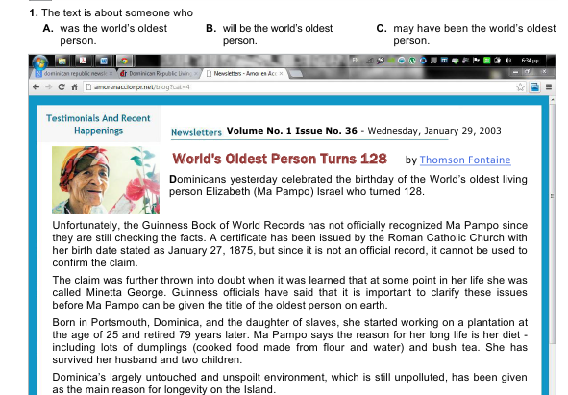
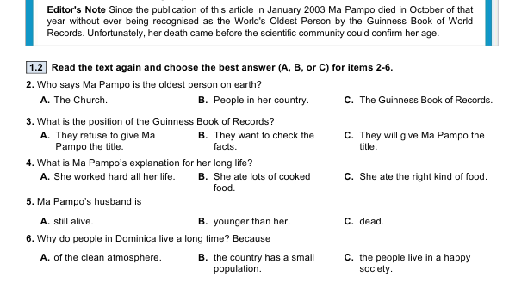

II. Choose the correct answer.
My first expedition
When I was about twelve, I 1)___ the chance to go to western China, looking for rare plants in an extraordinary area of mountains and forests. I wasn’t all that 2)___ in plants, but my dad’s a botanist by 3)___ and he was going as assistant to Professor Beall, who was leading the expedition. It was an important international expedition and my name was 4)___ not on the list of participants. But at the 5)___ moment, one of the experts broke his ankle and so had to drop out. It was impossible to get anyone else to go at such 6)___ notice, so my dad suggested taking me, for the experience.

1 | A) got | B) get | C) has got | D) has been getting
2 | A) fascinated | B) keen | C) interested | D) fond
3 | A) work | B) profession | C) job | D) employment
4 | A) completely | B) definitely | C) particularly | D) confidently
5 | A) late | B) final | C) last | D) end
6 | A) quick | B) brief | C) fast | D) short

III. Write an email to your friend and describe the vent in your life you will always remember. Write about the following:
- What was the event?
- How did you feel that day?
- What where your impressions of the event?

Examination Card №42

  - Read the text and choose the correct answer.

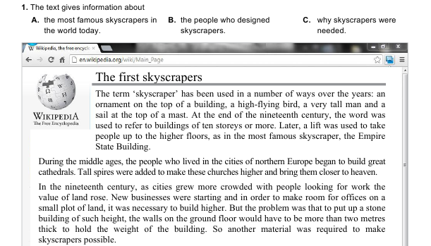
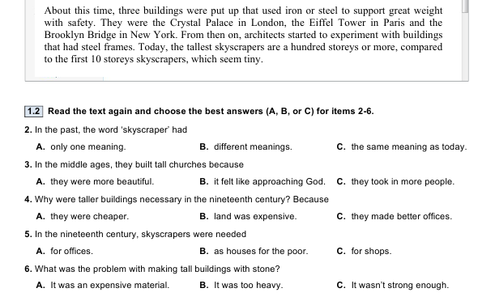

II. Choose the correct answer.

Successful invention
Today we take many inventions for granted but one of the most useful ones is the ‘not so significant’ supermarket trolley. Before the 1930s women shoppers went into grocery stores with their own baskets. 1)_____ , they would only buy a few things because their baskets wouldn’t hold much.
Sylvan Goldman of Oklahoma 2) _______this and decided that he had to think of a way to encourage people to buy more, especially since business was not 3) ____ very well.
He took a folding chair, 4)_____ wheels to the legs and placed two baskets on top. He put the trolleys near the door and waited to see his customers’ 5)_____ . He was very disappointed. No one 6) ______ any notice. Nevertheless, being a very determined man, he didn’t give up. He hired people to push them around the store filled with groceries. Customers were offered one to try out and his success story began.

1 | A) Furthermore | B) In particular | C) However | D) Apart from that
2 | A) noticed | B) watched | C) regarded | D) viewed
3 | A) making | B) running | C) doing | D) heading
4 | A) included | B) added | C) combined | D) accompanied
5 | A) replies | B) remarks | C) reports | D) reactions
6 | A) took | B) got | C) made | D) had

III.Write an email to your English pen-friend about the popular music festival you have attended recently. Include the following:
- When and where it took place;
- What the weather was like;
- How you went there and with whom;
- What you saw/did and your feelings.

Examination Card №43

I. Read the text and choose the correct answer.

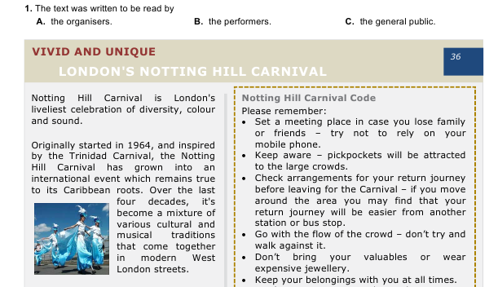
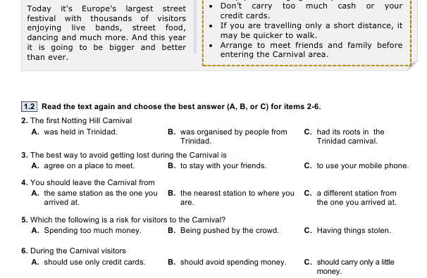

II. Choose the correct answer.
Mobile phones
Mobiles see frequent use, yet many people still don’t see the value in 1)___ slightly more for 2)____ functionality. For a product that will accompany the user wherever they go and will be accessed on a daily 3)___ , seemingly little concern is placed on usability 4)____ a purchase is made. The aesthetic appeal of a mobile or its price range will often be the 5)____ factors when buying mobiles, but by focusing on other aspects, the mobile phone experience can become a pleasure.
If a mobile phone can offer you 6)_____ that you would otherwise be carrying around an additional device to use, then you may want to consider mobiles that implement them.

1 | A) pay | B) paying | C) payment
2 | A) senior | B) super | C) superior
3 | A) basis | B) basic | C) based
4 | A) because | B) after | C) before
5 | A) deciding | B) decision | C) decided
6 | A) possessions | B) features | C) characters

III. Your teacher has asked you to write a short article on how to make your city a better place to live in. Write your article for the school magazine.

Examination Card №44

I. Read the text and choose the correct answer.
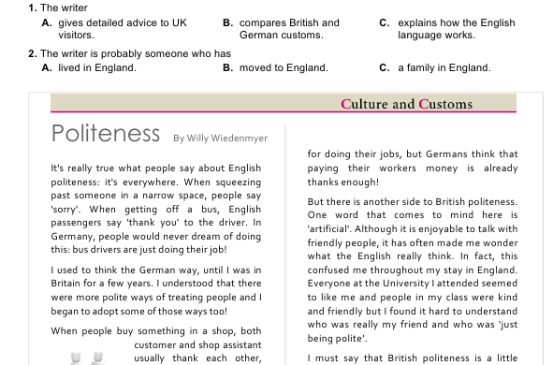
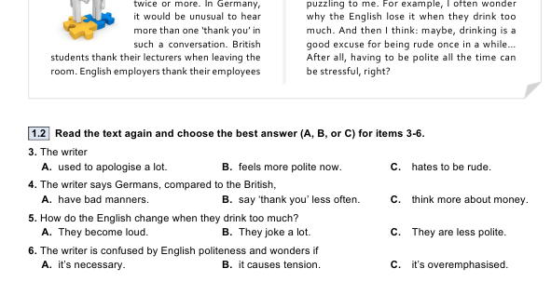

II. Choose the correct answer.
New York
New York city has grown into the second largest city in North America. It is now а major business, cultural and shopping centre 1)_____ millions of visitors each уеаr. Most tourists stay in the 2)______ of the city, in Manhattan. It is easy to see the sights of Manhattan оn foot оr you саn take а tourbus. There аrе cycle 3)_____ in the city if you want to hire а bicycle but you need to bе brave! The subway is the quickest means of public transport but you will want to avoid the 4)______ hour. And, of course, there аrе the famous yellow taxis. There аrе few taxi 5)______ – just wave your аrm at а taxi with its light оn. You will certainly want to visit Central Park, а huge ореn 6) _____which is ideal for relaxing оn а hot summer day.

1 | A) appealing | B) advancing | C) arriving | D) attracting
2 | A) heart | B) interior | C) focus | D) eye
3 | A) roads | B) streets | C) lanes | D) ways
4 | A) busy | B) rush | C) crowded | D) hurry
5 | A) ranks | B) stalls | C) kiosk | D) stations
6 | A) surface | B) region | C) space | D) estate

III. Your friend is interested in extreme sports. Write a letter to him explaining why people are in favour of them / against them. Include the following:
- Extreme sports make you get to test your limits;
- Give your own opinion about extreme sports.

Examination Card №45

I. Read the text and choose the correct answer.

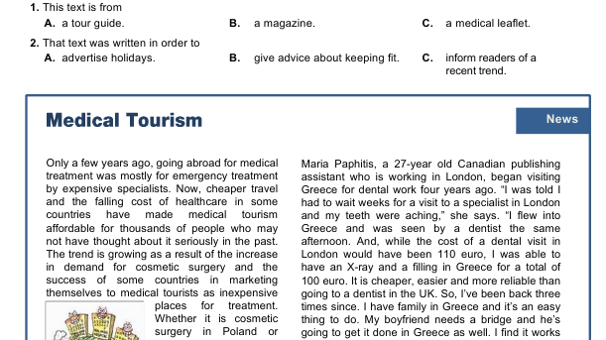
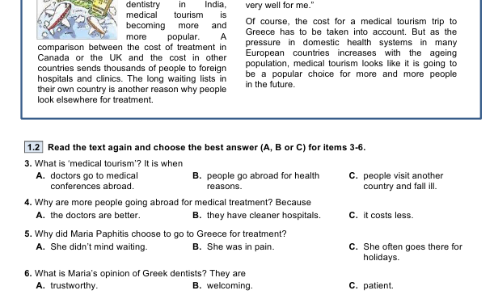

II. Choose the correct answer.

The Vikings
The Vikings were Scandinavian warriors from Denmark, Norway and Sweden. These tall, fair-haired people colonized many 1)___ of Europe between the 9th and 11th centuries. They were excellent sailors who 2)___ in long wooden 3)___ with many oars and large rectangular sails. Erik the Red was one of the 4)___ famous Vikings. He 5)___ Greenland and set up a colony there in 982 AD. Leif Erikson, his son, was the 6)___ European to set foot on the North American continent.
1. | A) parts | B) pieces | C) places
2. | A) travelled | B) toured | C) went
3. | A) canoes | B) rafts | C) boats
4. | A) most | B) much | C) many
5. | A) left | B) discovered | C) invented
6. | A) first | B) one | C) only

III.Write a short composition on the topic: “How has the Internet changed studying?” Use the prompts given below.
- Do you use the Internet when you study?
- Evaluate and compare the advantages and disadvantages of the Іnternet.

Examination Card №46
I. Read the text and choose the correct answer.

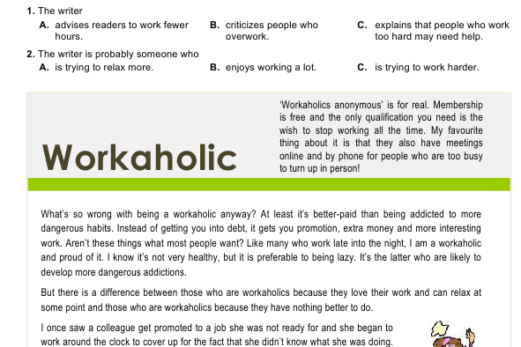
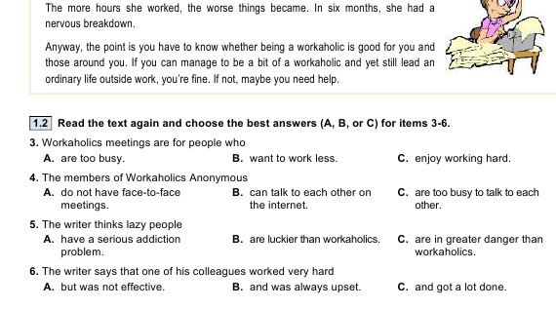

II.Choose the correct answer.

Tips for flying
The number and length of flights has increased sharply in the past few years and the number of passengers on long distance flights is also higher. As the human body was not designed for flying, people can 1)___ if they are on an aeroplane for a long time. Therefore, it is important to 2)___ certain measures to increase your comfort. A long-distance journey often 3)___ travelers feeling stiff, because they have been sitting in one 4)___ for several hours.
In order to reduce the 5)___ of this happening to you, there are some exercises you can do while you are flying. 6)___ this, a hot shower taken after the flight can be an effective way of minimizing stiffness. If you wear loose clothing made from natural materials, such as cotton, you will feel more comfortable as your skin will be able to breathe more easily.
1. | A) agonise | B) endure | C) suffer | D) tolerate
2. | A) have | B) take | C) make | D) do
3. | A) results | B) makes | C) causes | D) leaves
4. | A) position | B) point | C) space | D) situation
5. | A) accidents | B) chances | C) opportunities | D) fortunes
6. | A) Apart | B) Besides | C) Except | D) Despite

III.Write a short article on the topic: “Modern technologies and our life.” Use the prompts given below.
- How have modern technologies changed our everyday life?
- Is it good or bad for people to rely on technologies to solve their problems? Why or why not?

Examination Card №47
I. Read the text and decide if statements are True (A), False (B), or Not Stated (C).
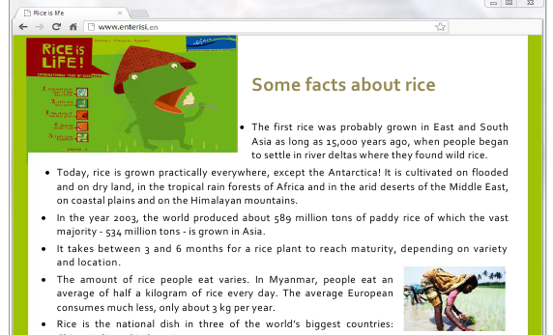
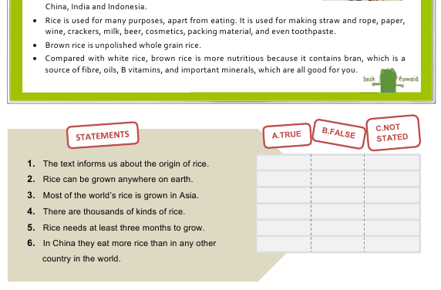

II.Choose the correct answer.
Wildlife Safari
I 1)___ took an elderly man on a wildlife safari in South America. He had obviously not read the brochure because he thought that we would be shooting the animals. I had a lot of trouble trying to 2)___ him that we were only there to 3)___ them.
4)___, some people take all the wrong equipment with them. You get people going on safari covered in gold jewellery and 5)___ two huge suitcases filled with fashionable clothes. The luggage has to be taken along on the expedition, so I 6)___ them to take one bag only.
Being a tour guide is not as simple as it seems. However, it certainly does have its memorable moments.
1. | A) lastly | B) recently | C) presently | D) occasionally
2. | A) convince | B) prove | C) convert | D) change
3. | A) look | B) glare | C) notice | D) observe
4. | A) Apart from | B) Concerning | C) In addition | D) Therefore
5. | A) getting | B) fetching | C) holding | D) carrying
6. | A) let | B) leave | C) make | D) allow

III.Write an email to your friend about the nearest and dearest person in your family. Include the information:
- What are the main features of her / his character?
- Why do you admire this person?

Examination Card №48

  - Read the text and for questions 1-6 choose the correct option a), b) or c).
CURRICULUM VITAES: TIPS THAT HELP
Six out of ten CV’s which are prepared by Information Technology professionals fail to meet the basic standards and are turned down without even being read fully, according to a recruitment company. As a consequence, thousands of candidates are excluding themselves from attractive job opportunities.
Although the company handles over 60,000 CV’s per year, it estimates that at least 60% would not be admitted if they were sent directly to potential clients due to basic errors.
The company Marketing Director said, “Sadly it’s often the most highly qualified candidates whose CV’s are so poorly constructed that they are literally dead on arrival. Attractive job opportunities in the IT industry often generate intense competition and there is often little to choose between the candidates”.
“Advice on the presentation format of CV’s in relation to the requirements that they are being submitted for should be an Industry standard so as to add real value to the candidates that you are representing and indeed to fulfill your professional obligations to your clients”.
“Writing a CV can be extremely difficult and too often a CV turns out to be a generic overview including a lot of information that is irrelevant. People should remember that an employer typically spends between 15 and 30 seconds scanning each CV and you have that one chance to make an impression”.
“A good CV is more than just documentation of your career path; it is a marketing tool designed to present your professional career experience according to the new job specification. It should also include details of past professional successes that effectively demonstrate your ability to undertake the job responsibilities outlined”.

1. Recruitment companies say that potential clients …
a) make basic mistakes.
b) only get 60% of CV’s.
c) reject CV’s with mistakes.
2. The Marketing Director said that the best candidates …
a) are the most affected.
b) do not send CV’s.
c) write the best CV’s.
3. The Marketing Director suggests that candidates ought to pay attention to …
a) CV’s presentation.
b) other companies.
c) other competitors.
4. The Marketing Director says that very often CV’s include …
a) necessary details.
b) unimportant information.
c) very little information
5. Candidates should remember that employers …
a) are typical people.
b) are very busy people.
c) make an impression on people.
6. A good curriculum should show …
a) the new job specifications.
b) your marketing tools.
c) your overall skills

II.Choose the correct answer.
One of the concerns many parents 1)____ about home education is that children 2)____ become isolated, without the chances for social interaction a school provides. Educational psychologists 3) ___parents to do all they can to make sure their children have adequate opportunities for socialising with all sorts of children of all different ages. It 4)___ children confidence and security, 5)____ an ability to think 6)___themselves.

1. | A) rise | B) have risen | C) arouse | D) raise
2. | A) are able to | B) could | C) might have | D) manage to
3. | A) insist | B) suggest | C) will make | D) advise
4. | A) gets | B) makes | C) gives | D) has
5. | A) as soon as | B) as long as | C) as well as | D) as much as
6. | A) to | B) for | C) on | D) after

III.Write a short article (not less than 35 words) on the topic: “Good friend is a great blessing.” Use the prompts given below.
- What characteristics make a good friend?
- Have you got a true friend?
- What is he like?

