Brain-ring

Teacher 1: Good afternoon, everybody! We are happy to see you at our brain-ring I am sure you are fond of English and you've already learnt many interesting things about Christmas

Teacher 2. This brain-ring will show your achievements and your knowledge of the matter. So welcome to our Brain-ring. Jog your brains! At the very beginning let’s fall into the atmosphere of Christmas. Звучить мелодія «Silent Night*

The Christmas Story

**Pupil 3:** Once upon a time.

A long, long time ago Begins the story of a baby.

That most of you should know.

**Pupil 4:** His daddy’s name was Joseph,

And Mary was His mom,

This baby was very special He was God’s only Son.

**Pupil 5:** Some angels came from heaven.

And they began to sing

To the shepherds in the fields below,

"Glad tidings do we bring!"

**Pupil 6:** A bright star lit the heavens.

To light the magi’s way.

To the baby in the manger

Who was born on Christmas day.

**Pupil 7:** And all who gathered round Him,

Rejoiced and praised His birth

For the baby, the king, named Jesus.

Is our Saviour here on earth!

Pupil 1: People all over the world, have many rich traditions.

Pupil 2: But there is no holiday, as widely celebrated as Christmas.

**Pupil l:** Christmas is celebrated on the 25th of December. It is a merry holiday of all children and grown-ups.

**Pupil 2:** On this day people give presents to each other, go to church and sing Christmas songs.

**Teacher 1:** We've got a surprise for you! Would everybody like to sing the world- known soundtrack from ‘Home Alone ! Here are lyrics for you to sing it together! So let us start!

**Song: Jingle Bell Rock**

Jingle bell, jingle bell, jingle bell rock

Jingle bells swing and jingle bells ring

Snowin' and blowin' up bushels of fun

Now, the jingle hop has begun

Jingle bell, jingle bell, jingle bell rock

Jingle bells chime In jingle bell time

Dancin' and prancin' in Jingle Bell Square

In the frosty air

What a bright time, It's the right time

To rock the night away

Jingle bell time Is a swell time

To go glidin' in a one-horse sleigh

Giddy-up jingle horse, pick up your feet

Jingle around the clock

Mix and a-mingle In the jinglin' feet

That's the jingle bell

That's the jingle bell

That's the jingle bell rock!

**Teacher 1**: Now it’s time to introduce our teams!

**Teacher 2:** Okay, we have got 2 teams. Captains! Stand up and introduce your

teams!

**Captain 1:** Meet ‘Christmas Stars*! (Team's Presentation)

**Captain 2:** My team is called ‘Jingle Bells*! (Team's Presentation)

**Teacher 1:** And our judges are:

**Teacher 1:** Are you ready to start the game.

**Teacher 2:** We wish you success. Be active, honest, helpful and you’ll be sure to win. Good luck!

**The 1st game**

**Teacher 1:** Let’s start the first game “Make a magic star". We give you a list of words related to Xmas, and you should memorize as many words as you can. You have 3 minutes to keep them in mind.

**Teacher 2:** And now make your magic star using the words you have just read. Please write in this star as many words, as you remember. You have 2 minutes.

**Score**

|  |  |  |
| --- | --- | --- |
|  | **Team ‘Christmas Stars’** | **Team ‘Jingle Bells'** |
| **The 1” game** |  |  |
| **The 2pJ game** |  |  |
| **The 3d game** |  |  |
| **The 4* game** |  |  |
| **The 5* game** |  |  |
| **The 6* game** |  |  |
| **Total:** |  |  |
|  |  |  |

Our judges have the table to fill in and score your points.

**Teacher 1:** On this day the bells’ ringing is heard all over the world

**Teacher 2:** And all over the Universe! You know, there are some aliens who have

come to our party Perhaps Christmas is celebrated not only by the human beings ?

**Song ‘Alien’**

**The 2nd game**

**Teacher 1:** The next game is called “Spelling Banner”. Look at the pictures, and

try to remember the words.

**Teacher 2:** Now we give you a confused set of letters for the same words cut out and brought into disorder. You have 2 minutes to put together the letters.

**Teacher 1:** Now look at the completed words, and compare your answers with the

correct ones.

**The 3rd game**

**Teacher 1**: And now your task is to complete the crossword as fast as you can'

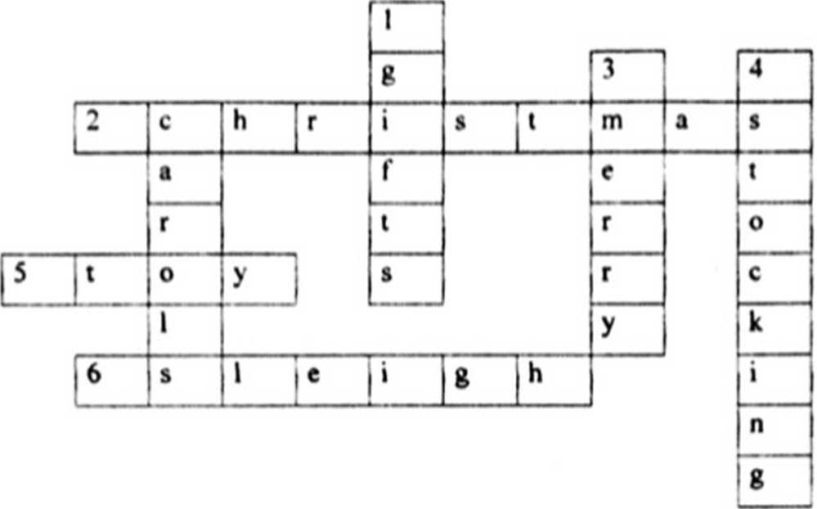

*Across*

2. It’s celebrated on December 25th.

1. It’s a child's plaything
2. Santa rides in a .

*Down*

1 The same as "presents."

2. Christmas songs of joy.

3 Christmas and a Happy New Year.

4. Santa fills it with presents for the children.

**Teacher 2:** Hand in your works, please.

**The 4th game**

**Teacher 1:** Now it’s high time to check your listening comprehension. Christmas is a time when children hope to receive presents from their parents? Do you know that Father Frost and Santa Claus are not the only ones gift givers in the world.

**Teacher 2:** There is a video for you to get some interesting facts about gift giving Watch it and do the task

**Gift givers**

1. Who is the gift giver in the USA?
2. Father Frost
3. Snow Maiden
4. Santa Claus
5. What color is the Santa Claus’ suit?
6. Green
7. Blue
8. Red
9. Who is the gift giver in England?
10. Father Frost
11. Saint Nicolas
12. Father Christinas
13. What do English children do with their letters to Father Christinas?
14. pul them on a window-sill
15. burn them
16. tear them
17. Who is the gift giver in Italy?

1) Snow Maiden

1. A witch
2. A ghost

6. What is the witch’s name?

1. La Befana
2. La Agusta
3. Luciana

7 How many gift givers do children have in Iceland?

1. **9**
2. 12
3. 13

8. Who is one of the girt givers in Iceland?

1. Door slammer
2. Window slammer
3. Door opener

9 What do children in Sweden leave for their gift givers?

1. Presents
2. Food
3. Clothes

**Teacher 1:** Now we are going to check what you know about Christmas traditions in Britain. There is the second video to help you!

**The Robinsons family. Christmas dinner**

1. Where do the Robinsons keep their presents until Christmas day?
2. under their beds
3. under their Christmas Tree
4. outside the house
5. Who people often spend Christmas with?
6. friends
7. neighbours
8. families
9. What has Mrs Robinsons got for present?
10. a pair of socks
11. perfume

4 Where do manv families go in the Christmas morning?

1. to park
2. to church
3. to a neighbour's house
4. What is inside a cracker?

U a paper hat

1. A joke
2. a paper hat and a joke
3. With what dish do English families finish the Christmas dinner'1
4. roasted turkey
5. Christmas cake
6. Christmas pudding

**Teacher** 2: And no. let’s have a break, and give our judges time to check your answers We have some more interesting facts about Xmas. Let's listen to our classmates

**Pupil 8:** US scientists calculated that Santa would have to visit 822 homes 3 second to deliver all the world’s presents on Christmas Eve. travelling at 650 miles a second.

**Pupil 9:** The tradition of putting tangerines in stockings comes from 12th-century, when French nuns left socks full of fruit, nuts and tangerines at the houses of the poor

**Pupil 10:** Nearly 60 million Christmas trees are grown each year in Europe.

**Pupil II:** Before turkey, the traditional Christmas meal in England was a pig’s head and mustard.

**Pupil** 12: Many parts of the Christmas tree can actually be eaten, with the needles being a good source of Vitamin C.

**Pupil** 13: Jingle Bells was the first song broadcast from space when Gemini 6 astronauts Tom Stafford and Wally Schirt sang it on December 16. 1965.

**Pupil** 3: Santa has different names around the world - Kriss Kringle in Germany.

La Befana in Italy, Pere Noel in France and Dedushka Moroz (Grandfather Frost) in Russia.

**Pupil** 15: Xmas pudding was originally a soup made with raisins.

**Pupil** 10: Christmas tree lights were invented by Edward Johnson.

**Teacher** 2: It’s the holiday season and that means it's time to sing a Christmas

Song! So let’s sing **“We wish you a merry Xmas’’** together.

• ••

We wish you a Merry Christmas,

We wish you a Merry Christmas;

We wish you a Merry Christmas and a Happy New Year.

Good tidings we bring to you and your kin;

Good tidings for Christmas and a Happy New Year.

Oh, bring us a figgy pudding,

Oh, bring us a figgy pudding;

Oh, bring us a figgy pudding and a cup of good cheer  
We won't go until we get some;

We won't go until we get some;

We won't go until we get some, so bring some out here

We wish you a Merry Christmas;

We wish you a Merry Christmas;

We wish you a Merry Christmas and a Happy New Year.

**Teacher 2:** It’s high time for our next game “What is in the picture.1"!

**The 5 ' game "What is in the picture?”**

**Teacher** 2: Xmas is rich in interesting things. We’ll see whether you tell us their names. Look at the screen and try to recognize the most popular objects of Christmas.

**Words: Christmas candle, Xmas carolers, Xmas tree, fireplace, reindeer,** sleigh, magi, manger, mistletoe, angel, chimney, shepherd.

**Teacher I:** Now look at the screen and compare your answers with the correct

ones.

**Teacher 2:** Are you ready to enjoy one more performance? Meet Artem Kozyra and his band with ‘l just can't get enough'!

**Teacher 1:** The last game is "Guess the Puzzles"

**Teacher 2:** It is well-known that all children like different puzzles. Would you like to solve the English ones? The winner will be the team that gives the right answer and does it quicker than the other team.

**Teacher 1:** Now look at the screen and compare your answers with the correct

ones.

**Teacher 2:** How are you doing? Do you want to have more fun? Then Let s sing ‘Happy New Year' together! We hope everybody knows this incredible song!

**Teacher 1:** Dear friends! It's a pity but our brain-ring is coming to the end. But before we learn the total score, let's remember that we are all a friendly and merry team.

**Teacher 1:** So. u s high time for our judges to announce your results!

**Judges:** Dear participants! You arc really bright and industrious. You can do different kinds of work. You’ve shown excellent knowledge of English. We are sure it will help you in your future life. But there is the best one among you. And it’s high time to announce the w inner.

The results of our brain-ring are;

The score of the team ... is... points.

The score of the team

So the winner is the team

Captain of the team! Get the diploma! Congratulations! You’ve won!

**Teacher 1:** All players of our game are getting presents!

Teacher 2: It seems to me that you will get high marks!)

Teacher 1: Thank you for coming and taking an active part in live games.