**Міністерство освіти і науки України**

**Тернопільська спеціалізована**

**школа І-ІІІ ступенів №3**

**з поглибленим вивченням іноземних мов**

## Сценарій інтелектуально-розважальної гри у форматі телевізійного шоу:

**«How well do you know Europe?»**

**(проведено у 8 класі)**

**З досвіду роботи**

**вчителя англійської мови**

**Чорної Анжели Михайлівни,**

**спеціаліста вищої категорії,**

**звання старший вчитель**

**2013**

**How do we know Europe?**

**Presenter1:** *(boy)* Hello, dear friends! Today you’re going to witness an uncompromising battle on every single piece of this stage for the world’s leadership between boys and girls!! Why are you so silent?

**Presenter2:** *(girl)* I’m just smiling. Because I’m sure as soon as you see my girls you’ll certainly surrender. Today we’re going to prove that this world belongs to girls!

Teams, Welcome to the stage!!!

(Виходять команди і капітани представляють їх)

**P.1:** What a splendid stage and look what a splendid team. It’s a great honour to be its captain! Traditionally I have to say something funny about each of them, however, just look at him as you can laugh for hours!

(presentation of boys)

I don’t think that you’ve ever seen a stronger team! And on the opposite side there is the most boring, the simplest team with its very ordinary captain.

**P.2:** What a stupid thing to say! You are only a set of boys and you worth nothing without each other and we are all the most interesting individuals you’ve ever met. Just look what a splendid team I’ve got here

(presentation of girls)

It is impossible to win if you fight against such a team!

**P.1:** Bravo! Bravo! We’ll have a real battle today because as I see my team has got really *strong* opponents today.

**P.2:** Dear boys and girls here we have got the fairest and most impartial judge who decides everything in this show

**P.1:** And who is your older sister, as I know☺

**P.2:** I wish it were the truth☺. But meet our Madam Judge

**Judge:** How do you do my beautiful ladies and hello boys among whom I can see my cousin Vania☺ Hi, Vania!

Let today the strongest win!!!

**P.2:** So my dear girls and not so dear boys I’ll tell you the rules of OUR game. There will be seven rounds and each of them I’m sure will end with our victory.

**P.1:** Ok. We have only to decide who will be the first to answer the question.

(на чувачі вирішують хто має право першими почати гру)

**ROUNDI**

**(**заставка, музика, на екрані з’являється перше питання і учні мають 60 сек. для обговорення відповіді. Таймер тікає на екрані)

**Judge:** Girls and boys don`t forget that you’ve got only 60 seconds to decide on your answer.

1. Питання: (заставка, музика, на екрані з’являється перше питання і учні мають 60 сек. для обговорення відповіді).
2. **In English libraries books, unfortunately, are often stolen. What books are stolen most often?**

(The Guinness World Records is often stolen!)

Питання: (заставка, музика, на екрані з’являється друге питання і учні мають 60 сек. для обговорення відповіді).

1. What is the largest city in Europe with a population of just under 10 million people.**?** (Paris, France)

**ІІ.** Питання: (заставка, музика, на екрані з’являється перше питання і 4 варіанти відповідей. Учні мають 60 сек. для обговорення відповіді).

**1. What is the most populated country in Europe?**

* Germany
* Poland
* Sweden
* Norway

Питання: (заставка, музика, на екрані з’являється друге питання і 4 варіанти відповідей. Учні мають 60 сек. для обговорення відповіді).

1. **Whichofthefollowingcountrieshasthebiggest number ofofficiallanguages?**

* Switzerland
* Ukraine
* Poland
* Italy

**III**. Відео питання: (музика, на екрані з’являються чотири фотографії і перше питання і учні мають 60 сек. для обговорення відповіді).

1. **Look at the pictures. Who of these people doesn’t have passport?**

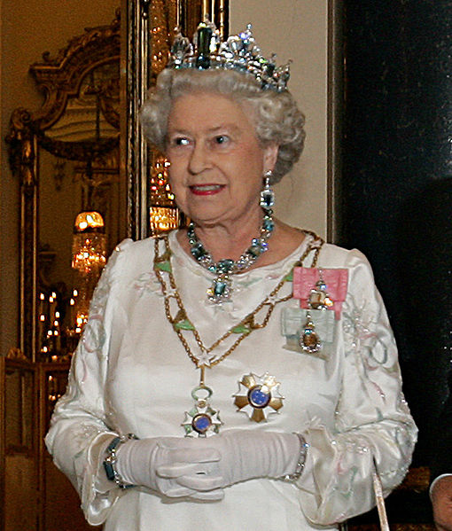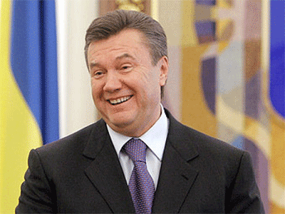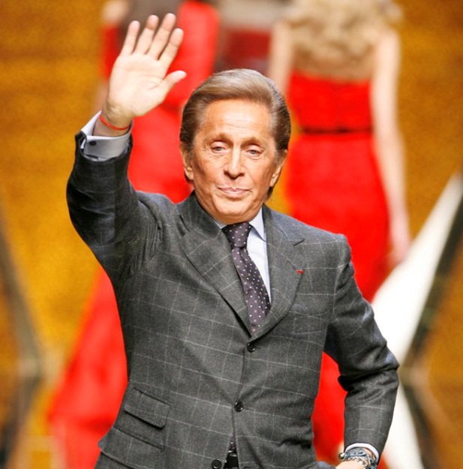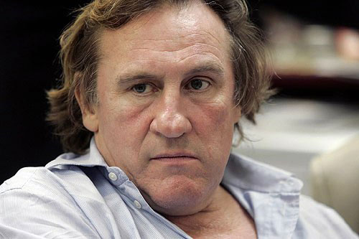

Відео питання: (музика, на екрані з’являються чотири фотографії і друге питання і учні мають 60 сек. для обговорення відповіді).

1. **Look at the pictures. Which of these cars is made in France?**

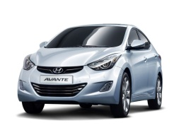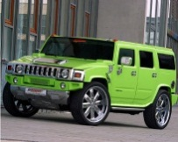

1. Відео питання: (музика, на екрані з’являються чотири фотографії, 4 варіанти відповідей і перше питання і учні мають 60 сек. для обговорення відповіді).

**IV.** 1. Відео питання: (музика, на екрані з’являються чотири фотографії, 4 варіанти відповідей і перше питання і учні мають 60 сек. для обговорення відповіді).

**Look at the pictures. What country were they taken in?**



1. Monaco 2. Vatican 3. Luxembourg 4. Italy

Відео питання: (музика, на екрані з’являються чотири фотографії, 4 варіанти відповідей і друге питання і учні мають 60 сек. для обговорення відповіді).

1. **Look at the pictures. What contest did all these people win?**

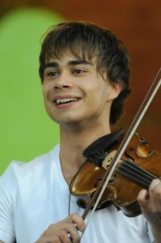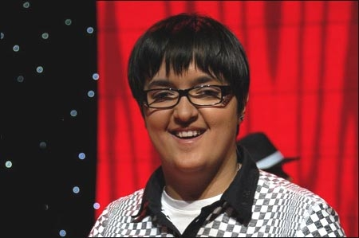

1. Grammy 2.Eurovision 3. New Wave 4. X-Factor

**V.** 1. Відео питання: (музика, на екрані з’являється відеоролик і перше питання і учні мають 60 сек. для обговорення відповіді).

Look at the video and try to guess the place.

* Відео 1
* Відео 2

1. Відео питання: (музика, на екрані з’являється відеоролик і друге питання і учні мають 60 сек. для обговорення відповіді).

**Judge:**(оголошує результати першого раундуі пропонує отримати додатковий бал програвшій команді)

Well, girls and boys, it was a really good beginning. Let’s see how many points each team got for the first round.

Girls got….

Boys got…

Don’t be so upset, …. Here’s your chance to get additional point if you answer a bonus question correctly.

**! Бонусне питання!**

1. There are nearly 750 000 words in English language. In your opinion how many of them are borrowedfrom other languages? 70%

**Round 2.**

P: Well, don’t be so upset because here comes our chance to get even. In this round the task is to arrange the letters.

P: In fact each team will have 90 seconds to show answers to as many questions as it can.

P1:Let’s have some fun watching the girls trying to think quickly.

P2: Ha-ha! I doubt it can be funnier than watching the boys trying to guess the correct spelling!

*Questions for boys*

EUROPE - a continentwherewelive

ORANGE - a fruitand a colour

LONDON -the capitalofEngland

PENCIL -we usuallydraworwritewithit

POTATO - a roundvegetablethatwasbroughttoEuropefromthe USA

SCHOOL - a placewherewestudy

FOREST - a placewherewildanimalslive

DINNER - girlsdon’tusuallyeatitafter 6 p.m.

BRIDGE - a roadovertheriver

FRIEND - a personthatyoushareallyoursecretswith

*Questions for girls*

FRANCE - a countrywherepeoplespeakFrench

PARROT -a birdthatcantalk

YELLOW - oneofthecoloursonUkrainianflag

PIRATE - a manon a shipwithblacksails

LESSON - 45 minutesofyourlife

WINTER - thecoldestseasonoftheyear

MIRROR - a glasswhereyoucanseeyourface

MONKEY - ananimalthatlivesonthe palm-treeandeatsbananas

SUNDAY - thehappiestdayoftheweek

WINDOW - Wecanseetheworldfromit

**Judge:** Well, I had a great time watching your manipulations with letters. However, here are the results: boys get ….points and girls get … points

**! Бонусне питання!**

How many countries of the world have English as anofficial language? 105

**Round 3 “Guess the name”**

P1 :Well, we really enjoyed watching the girls’ struggle with the letters but it’s time for another round which isn’t less interesting than the previous one. One person from the team has to put on these earphones on your ears trying not to spoil her hair-do of course☺ She’ll listen to the song and the rest girls will try to guess its name. All in all, the team has 90 seconds to come up with the name. But we have a chance to choose a victim! Please, ….come here.

(*A girl listens to the song for 30 sec. then she takes off the earphones and mimes the song*)

P2: Well, well, well boys let’s see how good you are at guessing games and how well you know modern music! ….we are waiting for your performance.

(*A boy listens to the song for 30 sec. then he takes off the earphones and mimes the song*)

P1: Well, in this studio we’ve got a great and fair judge who is already ready to announce the results of this round.

**Judge:** (announces results)

**! Бонусне питання!**

**Round 4 “Who Am I?”**

P2: Slowly we have come to the next round which is called “Who Am I?” In this round a representative of each team will stand in front of the screen. He will ask his team different questions and getting only “Yes”/”No” answers he’ll try to guess who he is. Of course, he can guess only with the help of his friends but he is not allowed to look back or he’ll be disqualified.

(на екрані з’являється фото відомої людини і учасник, якого вибирає протилежна команда, ставить конкретні питання протягом 120 секунд на які від своєї команди отримує відповіді лише ТАК / НІ)

(після закінчення часу)

P1: Frankly speaking we hoped to win in this round (and as you see our dream came true☺ / However it wasn’t our lucky strike☹) But it’s all right. And now it’s your time girls and we wish you good unluck☺! (і’мя) Come to the screen, please!

P2: We would like to listen to the judge’s decision. Could you announce our results, Dear Madam Judge?

**Judge:**Both teams unfortunately were unlucky in this round but we can’t have losers here so let the contest “ “ will show the winner! (суддя вибирає учасників для конкурсу «Хто кого передивиться?»)

**Round 5 “Let’s change the parts”**

**P2:** At last there will be our favourite round “Let’s change the parts”. I believe everyone will get a lot of pleasure watching how our boys together try to do such simple things each girl usually does every morning! Look at Annia. Here hairdo is called English braid. You’ve got only 120 seconds to do the same braid. Choose a girl from the auditorium with the most beautiful hair.

Your time is over dear boys, I’m awfully sorry to say! Let’s watch your results and Madam Judge will decide how skillfully you’ve fulfilled your task.

P1: Now get a strike in reply! Will show everybody in this hall how clumsy and awkward you are! As you know a tie was founded in England and Girls love boys in ties very much! …, show these ladies their task!

So you’ve got 120 seconds during which you have to repeat his performance. The attempt counts only when you manage to show a decent tie knot.

Well, it was really amazing! I couldn’t look at you without tears! From laugh of course! I looked at you girls and saw your poor future husbands!. I don’t know what the Judge’s decision will be, but I’ll eagerly listen to it.

**Round 6**

P 2: The task of this round is to arrange things in certain order. So boys, here you see photos of five famous places in Europe. Your task is to place them from the shortest to the tallest. All in all, boys, you’ll have 90 seconds to cope with this task.

Well let’s check your answers, so the right order is …..

P1: Now it’s our turn to have some fun. You girls, will have five cities and your task is to decide which of them has the largest size and which is the smallest.

And the correct answers …….

**P1:** Now the dear Madam Judge will count our points and sums everything up.

**P2:** So how many coincidences do the boys have?

**Judge:**

**Round 7**

P2: This task is really very important because the responsibility lies on each of you. We, captains, will ask questions to every member of the team in turn. You won’t have time to think because there are only 90 seconds for the whole contest. On each question just answer MAN or WOMAN.

**For boys:**

1. Whoinvented a computer? (man)
2. Who is the shortest person in Europe? (woman)
3. Who is the canceler of Germany ?(woman)
4. Who died first : Romeo or Juliet ? (man)
5. WhoisMonnaLisa? (woman)
6. Who was George Sand?(woman)
7. Who was the first Nobel Prize Winner of theUK? (man)
8. WhoisShreck? (man)
9. Who is the most beautiful person in Europe? (woman)
10. Who is the best soccer coach in Europe? (man)

**For girls:**

1.Who is the richest person in Europe? (man)

2. Who won the first golden medal for Ukraine? (woman)

3. Whoisthestrongestpersonintheworld? (man)

4. WhowascalledanIronLady? (woman)

5.Who was Marko Vovchock? (woman)

6. Whoistheofficial rulerofthe UK? (woman)

7. WhoistheauthorofHarryPorter? (woman)

8. Whoisthetallestbasketballplayer? (man)

9. Whoinvented a littleblackdress? (woman)

10. Whowroteabout Winnie-the-Pooh? (man)

P1: Dear Madam Judge how many correct answers did the girls give?

P2: Now let’s give our Madam Judge several minutes to come up with the final decision. And while waiting for her decision we’ll entertain you with some music.

Judge announces the results