My Town
Objectives: to develop pupils’ speaking, reading, listening, and writing skills; to develop pupils’ phonetic skills;
to review the vocabulary relating to the topic; to incorporate group work;
to teach pupils to respect and love their native town.
Equipment: pictures, tables, cards with letters, dialogues for reading, texts, a video-film about London

Procedure
- Introduction
1 .Teacher: Hi, how are you?
Pupil 1: I’m fine, thank you.
Teacher: Where do you live?
Pupil 2: I live in Zbarazh.
Teacher: Is your town big or little?
Pupil 3: It’s small.
Teacher: What is in your town?
Pupil 4: There are many modern buildings, many shops, and three schools in my town.
- Vocabulary Review - Brainstorming, Mind Maps about “Buildings”

Mind Map

Buildings

- Make up sentences using these words:
There are many shops in my town.
I can see a new school.
We like to go to the cinema.
- Read the jumbled words (the words are on the blackboard)
nplat
saqeru
revir
tunesiitt
tohlisap
ahetter
idilgubn
manice
Key: plant, square, river, institute, hospital, theatre, building, cinema
- Main Part
- Speaking
Make up your own dialogues with a partner. One of you likes to live in the city and the other - in the village.
Examples of pupils’ dialogues #1:
Pupil 1: Hello, nice to meet you.
Pupil 2: Nice to meet you too.
Pupil 1: Where do you live?
Pupil 2: I live in Temopil.
Pupil 1: Do you like it?
Pupil 2: Yes, I do. There are many beautiful buildings, nice shops and supermarkets in the city.
Pupil 1: But I live in the village. I like my village. I like nature.
Pupil 2: But in the city you can go to the theatre and the cinema.
Examples of pupils’ dialogues #2
Pupil 1: Where do you live?
Pupil 2: I live in a big city. It is clean and beautiful.
Pupil 1: Is there a zoo in it?
Pupil 2: Yes, there is. We can see many lions, monkeys, tigers and other animals.
Pupil 1: Great! And I live in the village. It is not very big, but very beautiful. I like my village.
- Reading
Work in groups to put the story in the right order.
A: There are a lot of beautiful modem buildings, big shops and offices in the town. You can see many cars and buses in the streets of Zbarazh.
B: Zbarazh is a cultural and historical town. There is an old castle. There are some historical places too.
C: I live in Zbarazh. It is not a very big town. It was founded in 1211. Zbarazh stands on the river Hnizdna.
D: Zbarazh is the town of youth. Day by day, Zbarazh becomes more beautiful.
- Speaking review
Speak about your native town using this text.
- Writing
- Make up sentences using these words: beautiful, city, My, is, very
- river, There, small, is, my, in, town I, town, of, the, live, the, centre, in building, of, school, is, my, the, new She, her, town, likes, very, much streets, The, are, very, nice, and, my, clean, in, town
\

- Work in pairs. Put the missing letters into the words. (Each group has 4 words)
Group 1: t_ll, vill_ge, buiding, g rden Group 2: pl_nts, bea_tiful, n_ar, thatre
      - 5. Label the picture with the words from a picture of the city on your computer screen.
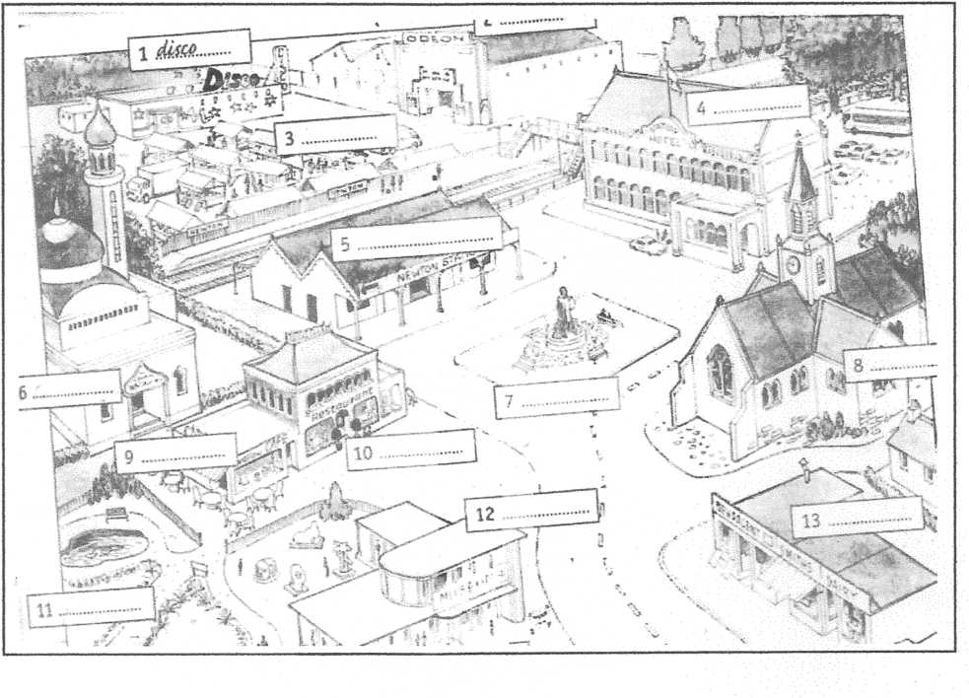
Words: disco, museum, hotel, main square, cafe, church, street, cinema, mosque, market, shop, restaurant, park, railway station
- Computer Work
Video of a tour through London. Watch and listen and describe what kind of buildings and places of interest you can see.
- Summing Up Answer the questions
- Do you like to live in your town?
- Why do you like to live in your town?
- Hometask -Speak about your native town.

