*Zbarazh District*

*Department of Education*

**Theme: «Schools in Britain»**

**(Form 8)**

***Prepared by***

***Maria Kozak***

***a teacher of Zbarazh***

***School № 3***

**Schools in Britain**

**Practical aims:** to develop listening skills;

to practise the usage of vocabulary;

to improve writing skills;

 to practise reading and speaking skills.

**Educational aim:** to broaden the knowledge of pupils about the life and study

abroad.

**Upbringing aim:** to teach to respect the teachers and classmates.

**Developing aim:** to incorporate group work and the work in pairs;

to increase cultural awareness.

**Equipment:** video “Schools in Britain”, books, workbooks, the worksheets with the different tasks, a laptop and a projector.

**Procedure**

1. **Introduction**
2. Greetings.

Good morning children. I’m glad to see you today. The theme of our lesson is “Schools in Britain”. Today we are going to speak about schools in Britain and do different kinds of tasks.

1. Warm up.

How are you today?

What school do you study?

What form are you in?

What subjects do you study?

What is your favourite subject?

What are you good at?

What are you bad at?

Brainstorming – Now go to the board and write one of the subjects that you have learned.

School

subjects

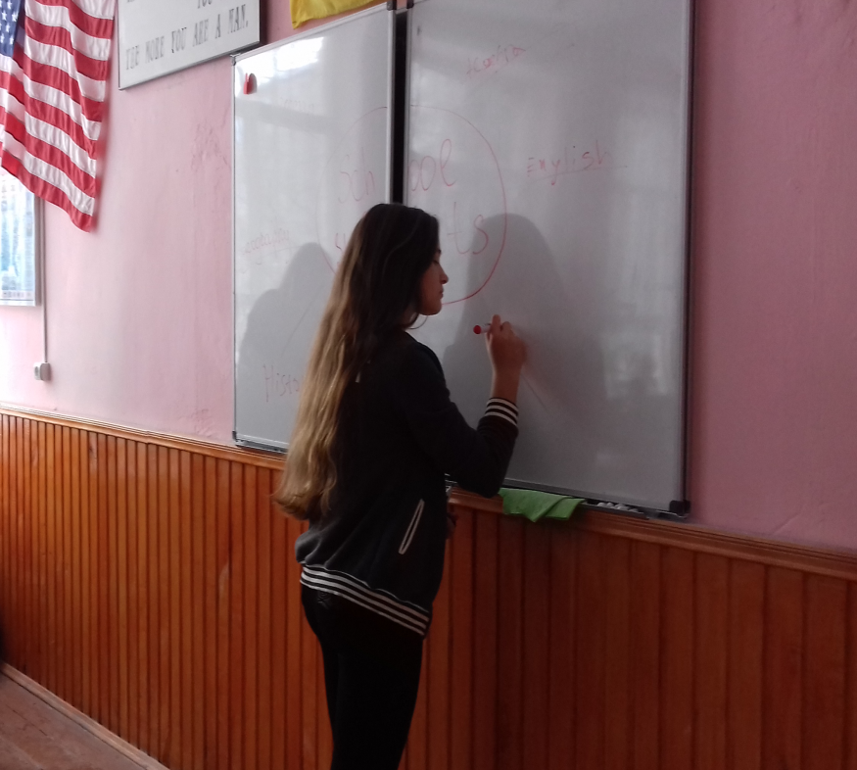

Practise with “I like…” and “I don’t like…” using the subjects.

1. **Main part**
2. Checking hometask – for your hometask you had to tell the story about your study at school.
3. Listening – watch a video about“Schools in Britain”. Divide into groups and read the statements and write true or false.

1) The students start school at 5. (T)

2) Students go to school from Monday to Saturday.(F)

3) School starts at 9 o’clock.(T)

4) Most schools are mixed – they are for boys and girls. (T)

5) The students don’t wear uniform. (F)

6) The first class is art. (F)

7) Secondary school is from 11 to 17. (F)

8) Most students study German. (F)

9) The students learn about food and cooking. (T)

10) After school some students do different activities like sport, music. (T)

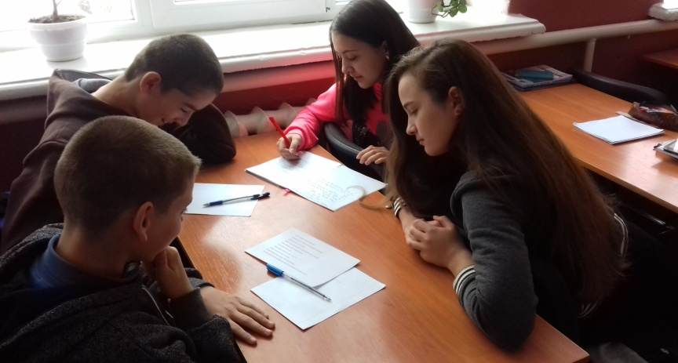

3. Reading – read the article and complete the sentences.

Schools in Britain

Ted and Mark go to a typical British school. When they were eleven, they left their primary school and went to the secondary school. Now they are thirteen and they are in year 8.

British schoolchildren study the same subjects and have the same lessons until they are thirteen. At thirteen they choose the subjects they want to do for the national GCSE(General Certificate in Secondary Education) exams. They take these exams in year 11(at the age of sixteen). British children should take national exams in six subjects, although they might take more. Then they might stay at school for two more years and study for two or more A level exams. But they might leave school after their GCSEs.

Ted and Mark are doing eight subjects. They have to study English and Maths, and they have chosen French, Physics, Biology, Chemistry, Art and Design, and Information Technology. Their classmates chose different subjects so they don't have many lessons together even though they are still in the same form. They're taking their GCSE exams in June. They also do PE1 but there isn't a PE exam.

Ted and Mark go to school from Monday to Friday, School starts at 9 o'clock. There is a 20 minute break at half past 10. They have lunch at one o'clock. A few people go home but most of them eat lunch in the canteen.

Afternoon lessons start at quarter to 2 and finish at quarter to 4. After school the boys do sport. In their school pupils can also join the music group or belong to a club. When they get home they have to do their homework.

They like their school but Ted hates the uniform they have to wear.

After school the boys would like to go to a university but none of them has decided what they want to study yet.

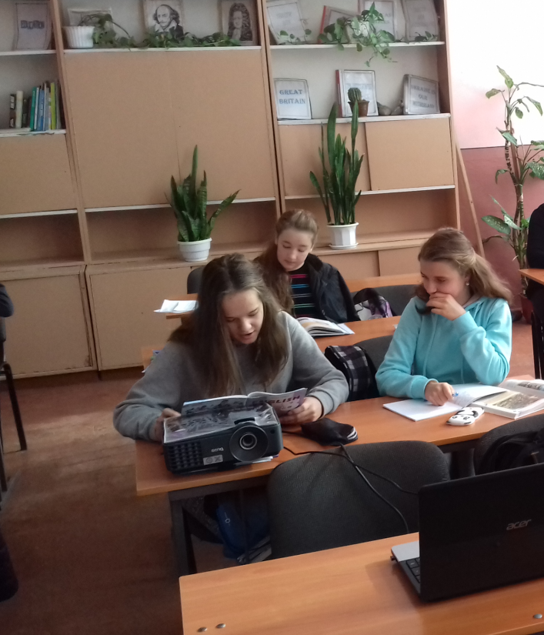 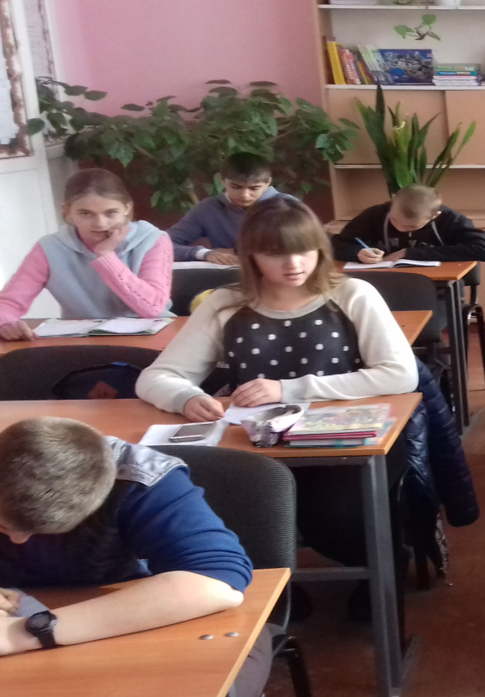

4.Writing – complete the sentences.

1. When British schoolchildren are eleven …
2. At thirteen …
3. They should take GCSE in …
4. They might leave school …
5. If they decide to go to a university they should …
6. In the school pupils can also join …
7. **Summing-up**

Read the clues and do the ‘School Crossword’.

1.You wipe the board with it. (sponge)

2.A school subject. You learn about animals, plants and your hometown.(science)

3.You write with it on the board. (chalk)

4.Teacher pin your pictures, stories, maps on it. It’s on the wall. (pinboard)

5.A school subject. You learn about continents, countries, river, etc. (geography)

6. A boy or a girl with is in the same class with you. (classmate)

7.A school subject in which you learn about important dates, famous people of the past, wars, etc. (history)

8.A school subject in which you learn about numbers. (maths)

9.A place where teachers meet during breaks. (staffroom)

10. A school subject in which you learn how to sing. (music)

11.Your mother tongue ( your language). (Ukrainian)

|  |  |  |  |  |  |  |  |  |  |  |
| --- | --- | --- | --- | --- | --- | --- | --- | --- | --- | --- |
| 1 |  |  | |  | |  | | |  | |
| 2 |  |  |  | |  | |  | | |  | |
| 3 |  |  |  | |  | |  | | | | |
| 4 | | |  | |  |  |  |  |  | |  | |
|  | | | | | 5 |  |  |  |  | |  | |  | |  | | |  | |
|  | 6 |  |  |  | |  | |  | |  | | |  | |  |
| 7 |  |  |  | |  | |  | |  | | |  | | |
| 8 |  | | | |  |  |  |
| 9 | | | |  |  |  |  | |  | |  | |  | | |  | |
| 10 |  |  | |  | |  | |
| 11 |  |  |  |  | | |  | |  | |  |  |

1. **Hometask**

Workbook Ex.8 p.40