**Suggested level --- A 1**

**Favourite Holidays**

Objectives:

* to practise vocabulary;
* to develop listening skills;
* to improve writing skills;
* to practise reading and speaking skills;
* to increase cultural awareness;
* to broaden the knowledge about holidays in English speaking countries;
* to teach pupils to respect the traditions of other countries

Equipment: pictures of different holidays in a powerpoint production, a laptop with speakers, a television, computers for the students to use in pairs, recordings of songs, worksheets with tasks, a video-film about Halloween

**Procedure**

1. **Introduction** 
   1. Warm-up

How are you?

Are you ready for the lesson?

Today we are going to speak about some different holidays.

* 1. Watching the slideshow with pictures about holidays – let pupils guess what holidays are shown.
  2. Matching – match the dates of holidays to the names on the blackboard

Christmas in English speaking countries – December 25th

Christmas in Ukraine – January 7th

New Year – January 1st

Independence Day – August 24th

Victory Day – May 9th

1. **Main Part**
   1. Listening - Please listen to this poem and tell me what you think this holiday is **Trick or Treat**

Witches, ghosts, and goblins.

Stealing down the street,

Knock on every door way,

Trick or treat!

When your door is opened,

This is what you meet,

Scary creatures shouting,

Trick or treat!

* 1. Checking hometask – for your hometask you had to read the text about Halloween and correct the mistakes in capitalization.

Halloween

Every year on the 31st of October, Americans celebrate Halloween. Children dress up in costumes and masks and visit the houses in their neighborhoods. They carry bags or buckets with them. The people give the children a treat, usually something sweet like candy. Halloween is a fun celebration for all Americans.

* 1. Watching a part of the film about Halloween.

4.Group work - Your task will be to put the dialogue in order and then read the different roles in the dialogue.

Jack: Trick or Treaters come to our house on Halloween.

Trick or Treaters: Trick or Treat? Trick or Treat?

Jack: Treat, treat! Mum!

Trick or Treaters: Thanks you!

Mum: Would you like a treat, too?

Father: Oh, yes please! Thank you! Happy Halloween!

Mum: Here you are. Have a treat!

Jack: Halloween is scary and fun at our house!

5.Speaking – tell what you learned about Halloween

6.Singing – listen and sing with the song Mr. Pumpkin

Mr. Pumpkin, Mr. Pumpkin,

Round and fat, round and fat.

Harvest time is coming,

Harvest time is coming,

Yum, yum, yum,

Yum, yum, yum

7. Listening and computer work – listen to the radio show and do a quiz on the computer in pairs.

Hello and welcome to the show. Today we are going to talk about Thanksgiving, a very important celebration in the USA. At Thanksgiving, Americans get together at their homes to say “thank you” for the harvest and for the food they eat. Thanksgiving Day is always on the 4th Thursday in November. Of course Americans love food. They eat a lot of food at Thanksgiving. They usually eat turkey with potatoes, corn, and lots of delicious pumpkin pie. Some people even call Thanksgiving, “Turkey Day.” Normally, Americans watch American football in the afternoons after they eat. Americans like this holiday very much.



8. Reading – read and fill in the gaps.

Dear Children,

How are you? I’d like to tell you about my favourite holiday. It is Christmas! In my country, we celebrate Christmas on the 25th of December. On Christmas Eve, children hang a Christmas stocking at the end of their beds and hope that Father Christmas will bring them lots of presents. I like to get presents very much.

At about midday on the 25th of December, we eat Christmas dinner. This traditional meal consists of roast turkey with vegetables and fruit pudding. I enjoy Christmas very much and look forward to it.

Write to me about your favourite holiday!

All the best,

Jerry

9.Writing – divide the words and show which traditions are from Ukraine and which are from Britain.



10. Writing - Work in groups. Write the secret messages from the worksheets.

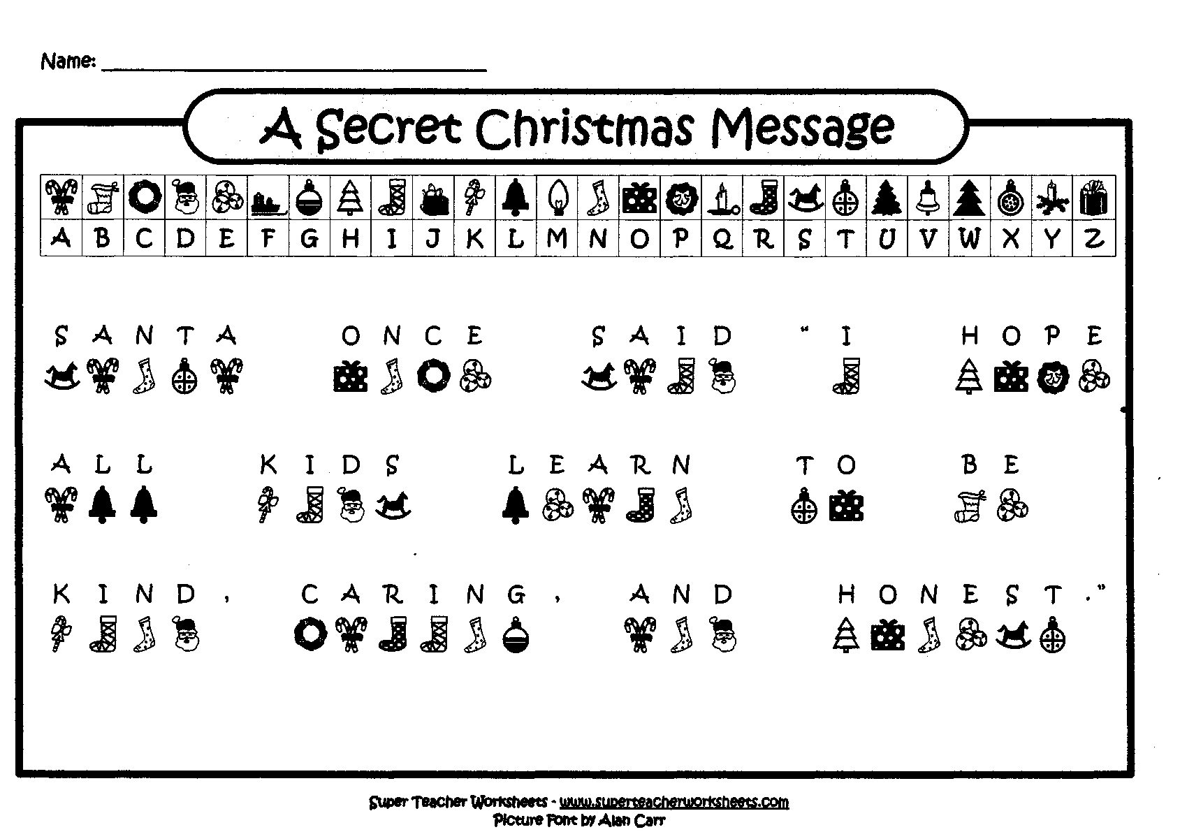

11.Group work - Making a story about different holidays and introducing it to the class. Use the following sentences:

Today I’m going to talk to you about…

We celebrate it…

On that day…

Thank you for your time, are there any questions?

12. Reading – on the board, match different greetings and phrases with the correct holidays.

Trick or treat – Halloween

Merry Christmas! – Christmas

Happy Turkey Day! – Thanksgiving

Happy New Years! – New Years Day

Time for American Football! – Thanksgiving

Santa Claus is coming to town. – Christmas

Be my Valentine – Valentine’s Day

13. Singing – “We Wish You a Merry Christmas” and give presents to the children and our guests.

1. **Summing up**
2. **Hometask**

**Write about your favourite holiday.**