Favourite Toys

**The Teaching Aims:**

* to work on the correct pronunciation;
* to work on the lexical material on the topic;
* to work on the lexical structure "I like... ";
* to develop listening, speaking and reading skills;
* to incorporate group work and the work in pairs.

**The Developing Aims:**

* to develop memory;
* to develop attention, quick reaction, interest, artistic abilities.

**The Educational Aim:**

* to bring up pupils as hard-working persons.

Equipment: the recording of the songs, the worksheets with the different tasks, pictures of different holidays in a powerpoint production ,a laptop or a computer, a projector

THE PROCEDURE OF THE LESSON

1. **Introduction**

**1. Teacher:** Good morning, pupils!

How are you today?

Are you ready for the lesson?

I'm glad to see you. Sit down, please.

**2. Warm- up.**

**Teacher:** **Let’s sing together the song “Hello, hello!”**

Hello, hello, hello

How are you?

I’m fine, I’m fine

I hope that you are too!

**Teacher:** **The topic of our lesson today is " Favourite Toys". And today we are going to play lexical games, to practise the usage of new words, we'll talk about your favourite toys. We will recite rhymes and will do different activities to develop your listening and speaking skills. So, let's start!"**

3. Phonetic Drills

**Teacher:** **Let's start with some phonetic drills as we usually do.**

P [ **p** ] pen; B [ **b** ] bag; S [ **s** ] squirrel; U [ **Λ** ] umbrella; A [ **æ** ] apple; E [ **e** ] egg;

I [ **ai** ] ice cream; W [**w**] window

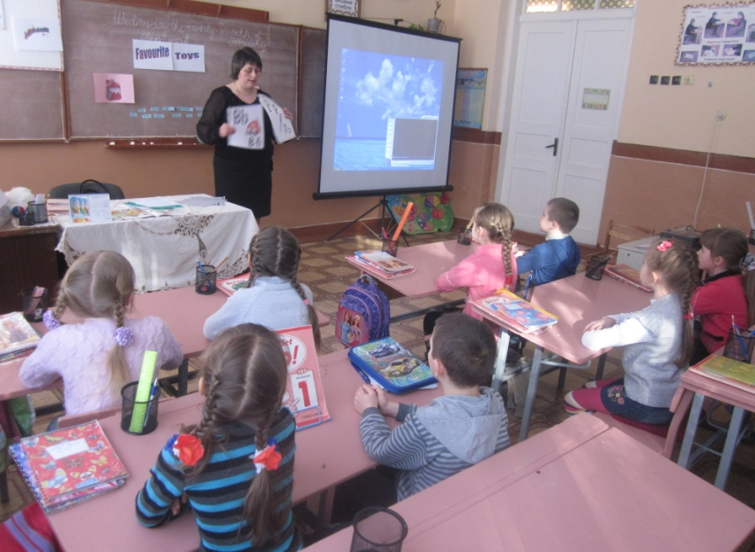

II. **THE MAIN PART OF THE LESSON**

1. Brainstorming

**Teacher:** **And now let’s watch the slideshow with toys and guess what toys are shown**

**Teacher:** **Look at the pictures, please. What is it?**

(a ball, a doll, a train, a plane, a car….are depicted)

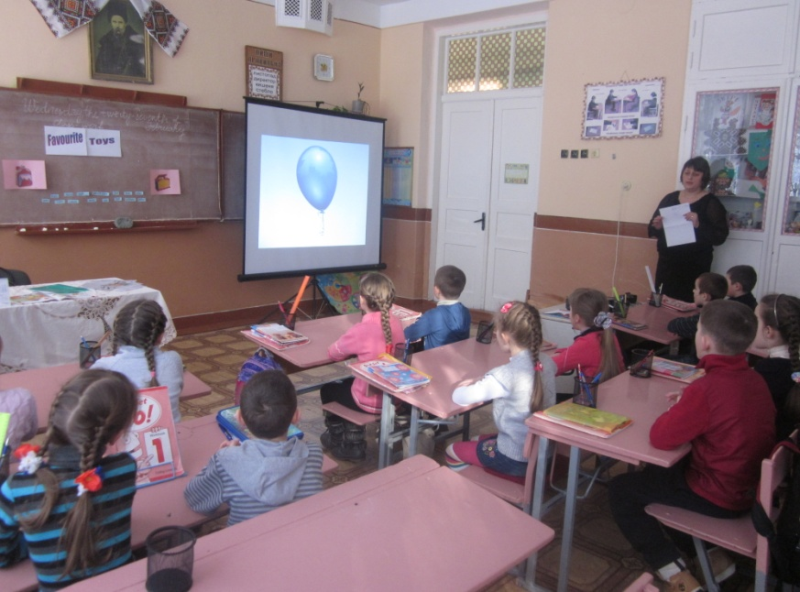

**2.Teacher: Pupils, do you like games? OK. Let’s play the game** **”Snowball”.**

”I like balls”

”I like balls and cars”

”I like ball, cars and dolls”…

3. Lexical Drills. Working on the Topical Vocabulary

**Teacher:** **Revise the colours together with the colour train.**

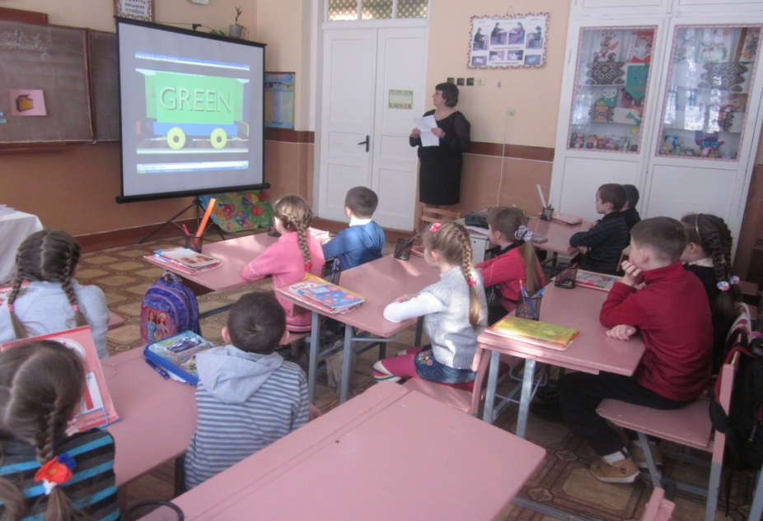

**4. Teacher:** **Look at the toys and say what colours they are.**

a red and blue ball, a pink dog, a blue balloon, a yellow car, a blue elephant,

a black dog, a white cat.

**5. Teacher: Look at the picture. I’ll name the colour of the toy and your task will be to say if it is the picture A or B**

A white ball----picture B, a purple train---picture A, a red doll---picture A

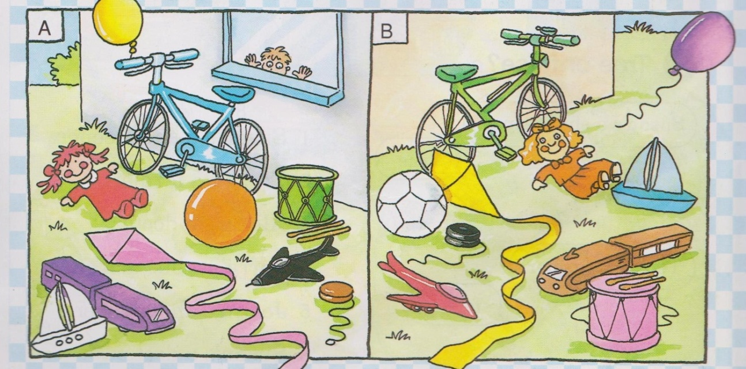

**6.Teacher: Let’s have some rest! Stand up! Sing he song!**

**Head, Shoulders, Knees and Toes**

Head, shoulders, knees and toes,  
Knees and toes.

Head, shoulders, knees and toes,  
Knees and toes.

And eyes, and ears, and mouth,  
And nose.

Head, shoulders, knees and toes,  
Knees and toes.

**7. Teacher : Read the words and divide them into two groups:**

pen pencil doll book train robot balloon bear

desk rubber ruler pencil case ball bike kite car

**School things Toys**

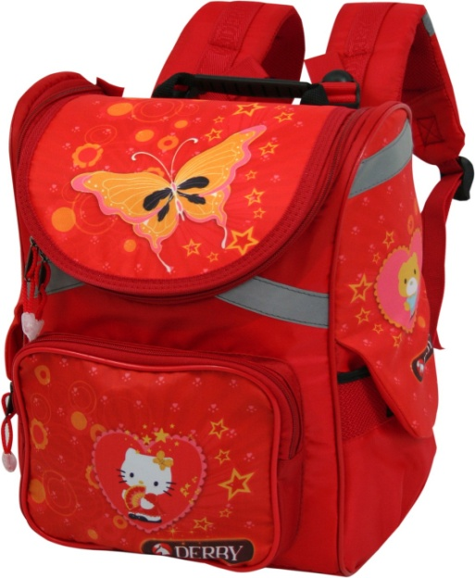 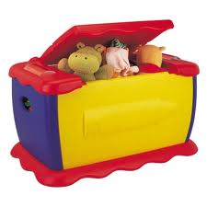

|  |  |  |  |  |
| --- | --- | --- | --- | --- |
| |  | | --- | |  |  |  |  | | --- | --- | |  |  | |  |

**8. Teacher: Work in groups and match.**

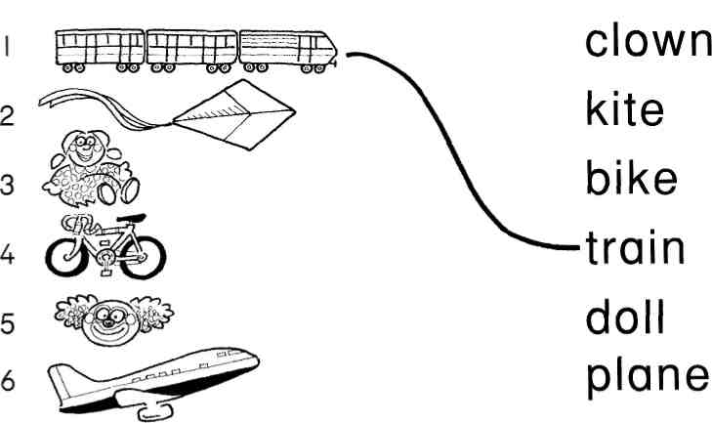

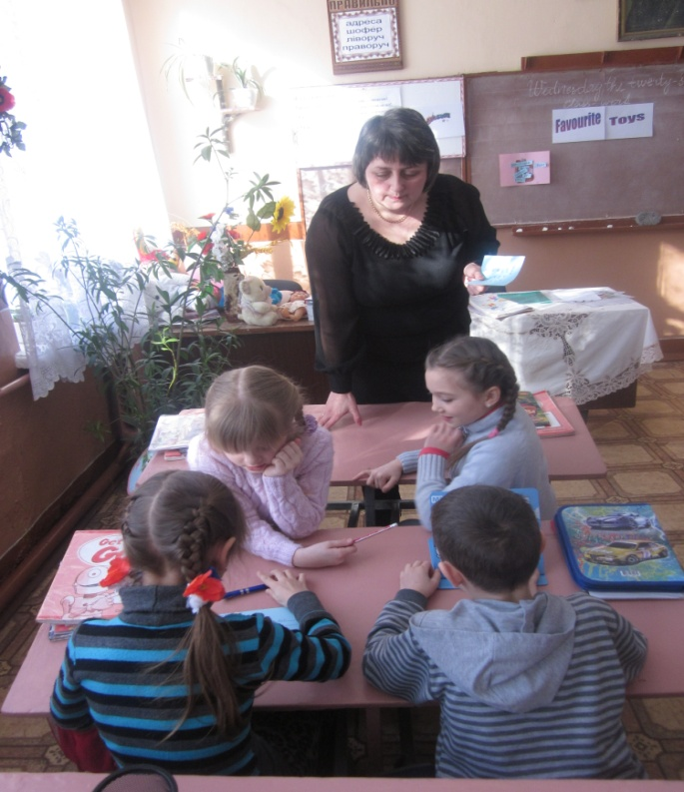

**9. Relaxation. Singing the song.**

I've got a ball,

And a bear and a clown.

I've got a little cat,

And my cat's brown.

Tabby is my cat,

And my cat's brown. I've got a ball,

And a book and a kite.

I've got a robot,

And my robot's blue and white.

Bix is my robot,

And my robot’s blue and white.

## 10. Writing . Work in pairs. Odd one out.

## Pen pencil doll book ________________________

## Train robot balloon yellow _____________________

## Pink doll red black _______________________

## Cat dog bear desk _______________________

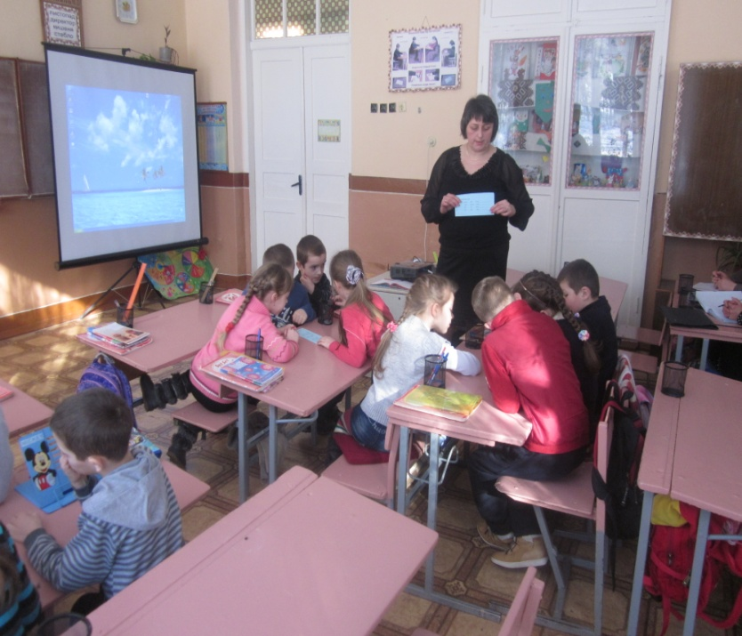

**11. Speaking .Take the toy from the magic toy box and describe it.**

Hello! I’m…. I’m…….I like toys. I’ve got a….. It’s…. I like it very much.

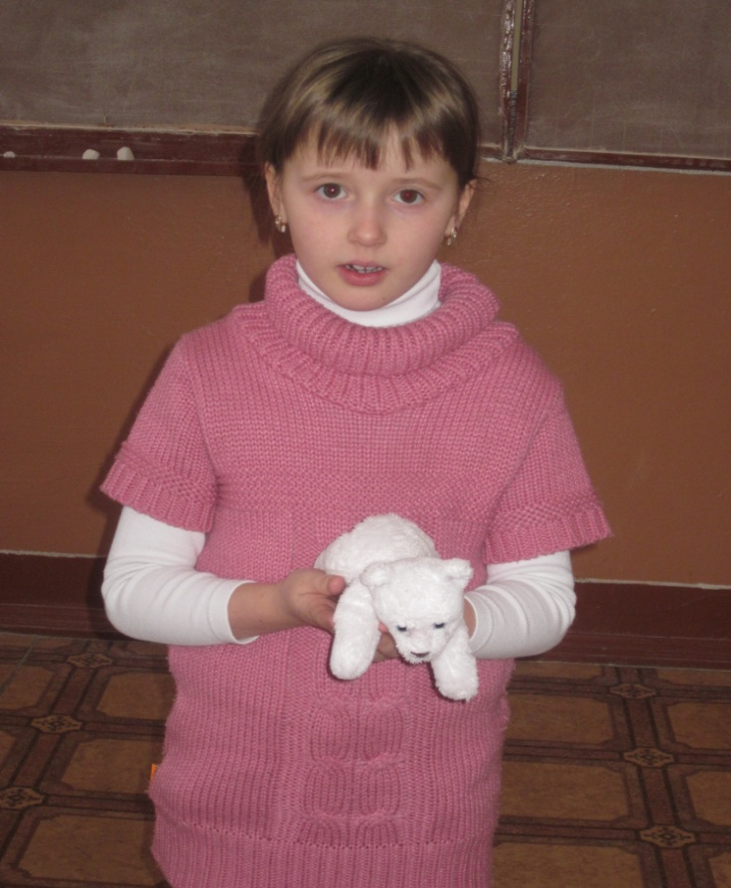

**12. Watching the cartoon about animals. Try to remember the animals which are shown and do the jigsaw puzzle**

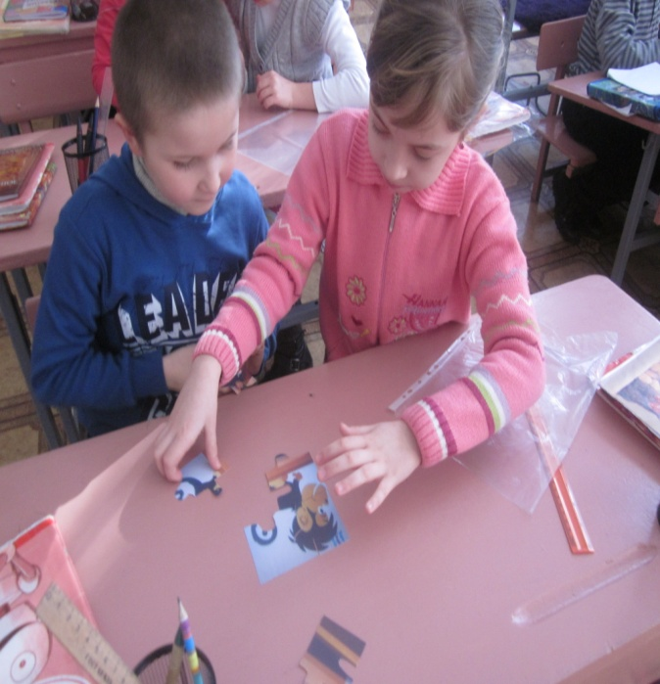

**III. Summing up**

**Teacher:** It’s time to finish our work. You were very active today.

**IV. Hometask.**

# Draw your favourite toy.