**Назва заходу:** «The Cleverest»

**Форма:** Брейн-ринг

**Клас:** 9-11 клас

**Мета:**  практична: вдосконалити навики аудіювання, читання та говоріння;

навчальна: навчити учнів сприймати та розуміти іншомовне мовлення на слух; розширити знання учнів про культуру країни, мова якої вивчається; формувати лінгвокраїнознавчу компетенцію школярів;

виховна: виховувати розуміння важливості володіння іноземною мовою як засобу спілкування;підтримувати у школярів мотивацію до оволодіння іноземною мовою;

розвиваюча: розвивати вміння усного спілкування, розвивати мовну здогадку та логічне мислення учнів.

**Обладнання:** роздаткові картки, списки запитань, презентація, комп'ютер .

**Хід заходу**

*Teacher:* Good morning our teams and guests. You’re welcome to the intellectual English contest “The Cleverest”. The aim of our meeting is to show the students’ knowledge not only of English, but about the Literature and Geography as well, to widen the outlook and encourage students to speak.

*Teacher:* Now we have two teams. Chose the captain of your team and we can start. During this contest you will have a chain of different task for which you will gain point.

**Round 1**

*Teacher:* The first contest is “Do you know Great Britain”. You have to give as many answers as possible. For every correct answer you will get 1 point. I’ll ask one question, the team has 10 seconds to give the answer if they are not able their question goes to their opponent as additional.

1. What is the official name of Britain? (the United Kingdom of Great Britain and Northern Ireland)

2. Where is the United Kingdom situated? (on the British Isles)

3. What is the capital of Britain? (London)

4. What parts does the United Kingdom consist of? (England, Scotland, Wales, Northern Ireland)

5. What part of London is the symbol of wealth and culture? (the West End)

6. What river does the British capital stand on? (the Thames)

7. What is the capital of Scotland? (Edinburgh)

8. What is the capital of Wales? (Cardiff)

9. When do British people celebrate Christmas? (on the 25th of December)

10. What is the highest peak of Great Britain? (Ben Nevis)

11. What is the longest river in Britain? (The Severn)

12. What is there in the centre of Trafalgar Square? (Nelson’s Column)

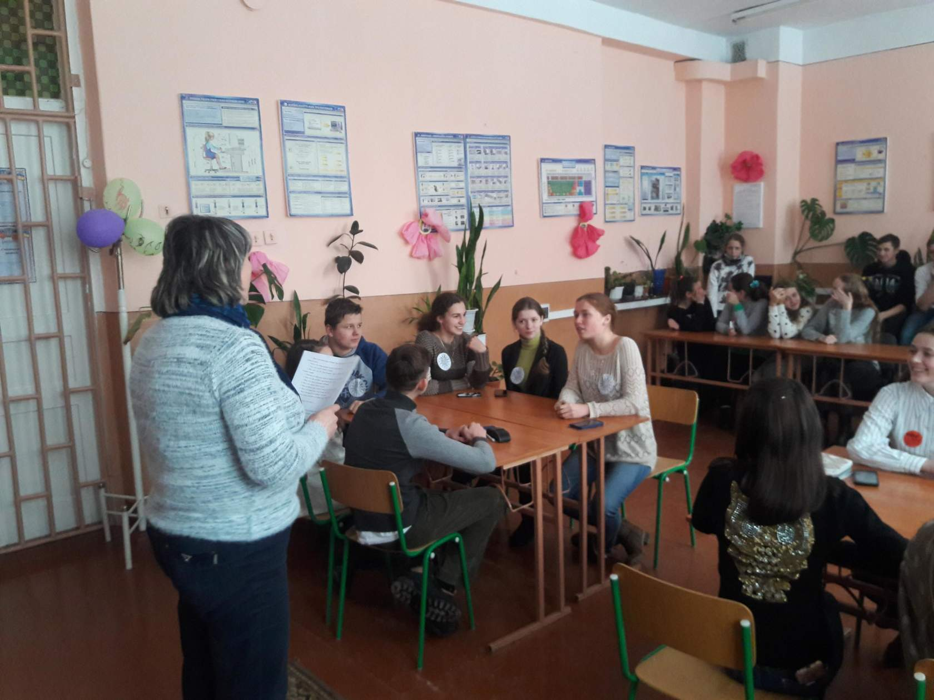

*Teacher:* The winner in this contest is…..

**Round 2**

*Teacher:* Your next task is called «Speed». You have to answer as many questions in one minute.

1. Where do kangaroos live? (In Australia)

2. Where is Chine situated? (in Asia)

3. What is the national dish of the Ukrainians? (borshch)

4. What is the official language of Canada? (English and French)

5. Name the fastest way of travelling? (by plane)

6. How many states are there in the USA? (50)

7. Which is the largest ocean? (The Pacific Ocean)

8. Are the elephants good swimmers? (Yes)

9. Who wrote “Tom Sawyer” (M. Twain)

10. I have already cleaned my room. What’s the tense? ( Present Perfect)

11. Name the odd word: tree, flower, sun, grass(sun)

12. What’s the capital of the USA? (Washington)

13. What’s the British national drink? (tea)

14. Where is Hollywood situated? (Los Angels, USA)

15. What river does London stand on? (the Thames)

16. Who wrote “Jungle Book” (R. Kipling)

17. How many oceans are there in the world? (4)

18. Where was baseball invented? (the USA)

19. Who’s the first astronaut in the world? (Gagarin)

20. When is Christmas celebrated in Ukraine? (7th of January)

21. Who discovered America? (Columbus)

22. Sam is sleeping now. Name the tense (Present Continuous)

23. Which hero performs twelve heroic deeds? (Heracles)

24. Is an orange a vegetable or a fruit? (fruit)

25. What’s the symbol of Easter? (an egg)

26. What days of the week children don’t go to school? (Saturday and Sunday)

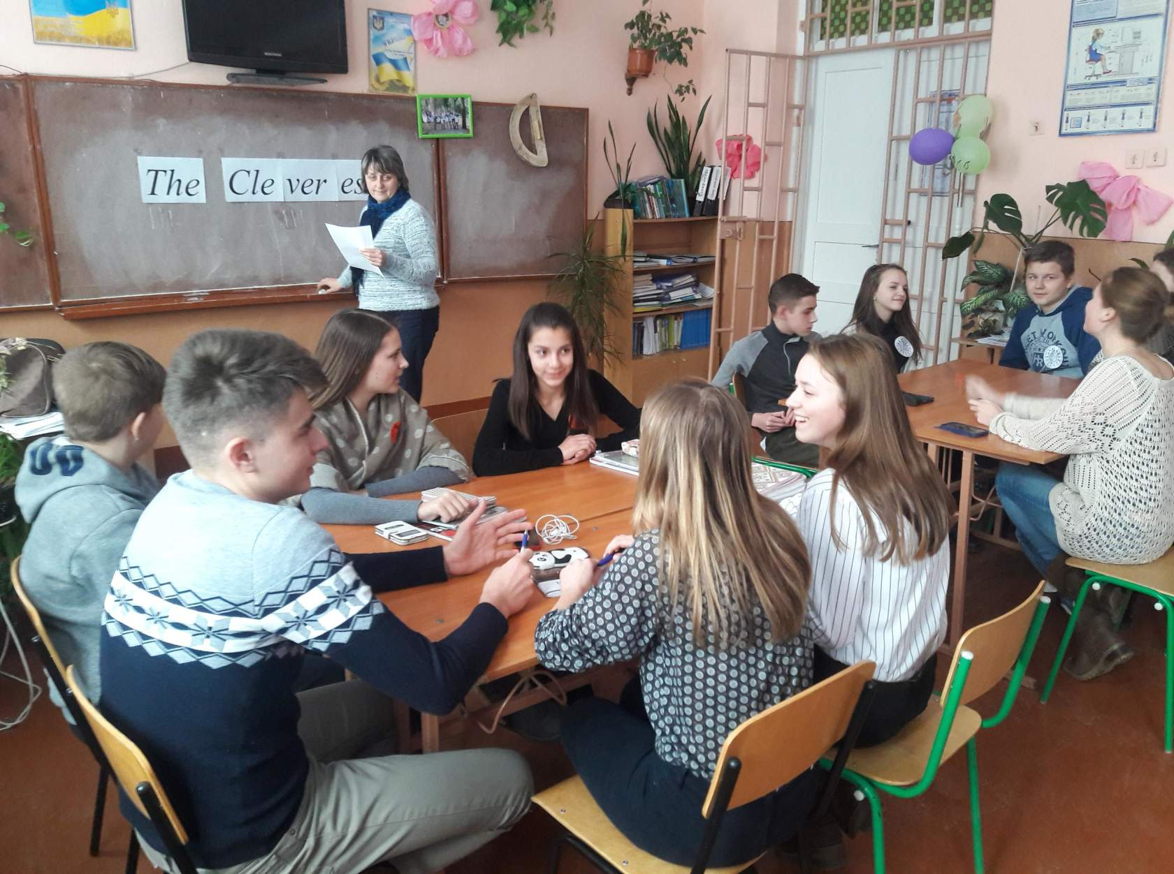

**Round 3**

*Teacher:* The next round is called “Matching Words”. Each team takes the envelope with words. I’ll give you a minute to find their opposites, match these words and then read .

|  |  |
| --- | --- |
| Hard-working  Patient  Confident  Polite  Responsible  Kind  Talkative  Generous  Funny  Honest | Rude  Mean  Unkind  Impatient  Dishonest  Lazy  Serious  Shy  Irresponsible  Quite |

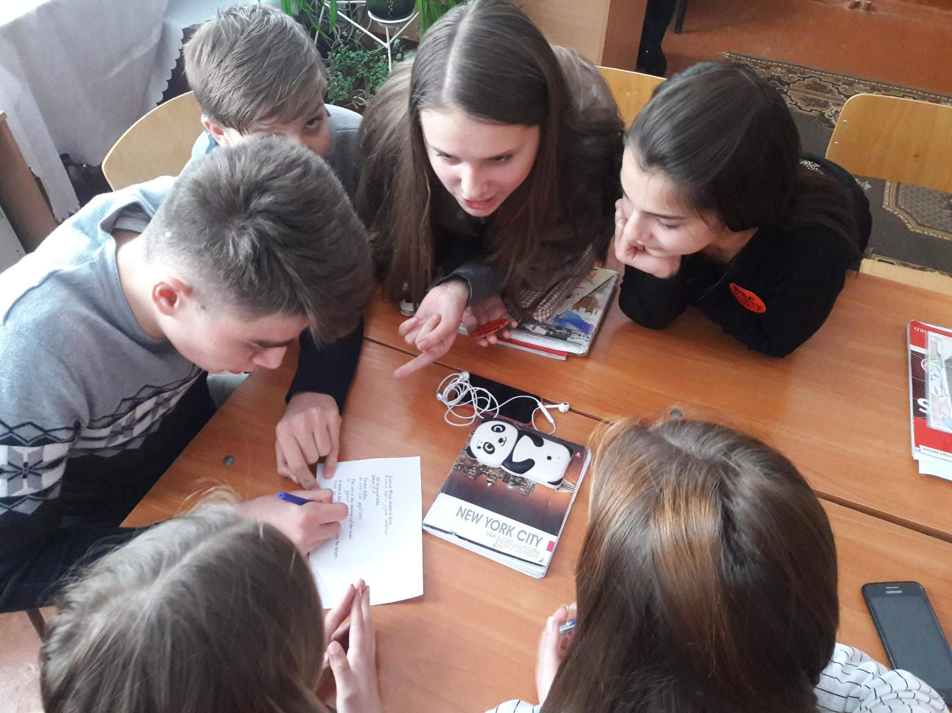

**Round 4**

*Teacher:* Now, let move to the next stage “Guess Riddles”. 2 point for correct answer.

1. *What has a foot but no legs? (A snail)*
2. *What comes down but never goes up? (Rain)*
3. *I’m tall when I’m young and I’m short when I’m old. What am I? (A candle)*
4. *What goes up when rain comes down? (An umbrella!)*
5. *If I drink, I die. If І eat, I am fine. What am I? (A fire!)*
6. *What travels around the world but stays in one spot? (A stamp!)*
7. *If I have it, I don’t share it. If I share it, I don’t have it. What is it? (A Secret.)*
8. *What can you catch but not throw? (A cold.)*
9. *What has one eye but cannot see? (A needle)*
10. *They come out at night without being called, and are lost in the day without being stolen. What are they? (Stars!)*

**Round 5**

*Teacher:* And the last task for today is connected with “*Holidays and Traditions”*. This is “*Do you believe?”*

1. Christmas is celebrated on the 25th of December in Ukraine. – (No)

2. Pudding and a roasted chicken are traditional dishes of Christmas in England. – (No)

3. Halloween is celebrated on the 31st of November. – (No)

4. St Valentine’s Day is celebrated on the 14th of February. – (Yes)

5. People receive Christmas cards without names. – (No)

6. Banks are closed on Banks holidays in England . – (Yes)

7. The Londoners call their taxis cabs. – (Yes)

8. Students and teachers in Cambridge wear dark clothes. – (Yes)

9. People celebrate Thanksgiving Day on the 4th Tuesday in November. – (No)

10. The history of Thanksgiving Day as a holiday began since 1621. – (Yes)

11. The English kings are crowned in Westminster Abbey. – (Yes)

12. English people traditionally put presents before Christmas under the beds. – (No

**Round 6**

***Famous landmarks in the world***

*Teacher:* Are you ready for a wonderful virtual trip around the world? Today I’ve combined **some famous landmarks** all over the world. They are the most recognisable images of the modern world and the most photographed. Enjoy the pictures below and tell us their names. (PowerPoint Presentation)

/Big Ben, Eiffel Tower, Kamianets-Podilskyi Castle, Colosseum , Pyramids of Giza, Sofiyivsky Park, Statue of Liberty, the Saint Andrew's Church, Great Wall of China, London Eye,  Lviv State Academic Theatre of Opera and Ballet, Taj Mahal, House with Chimaeras, Buckingham Palace . /

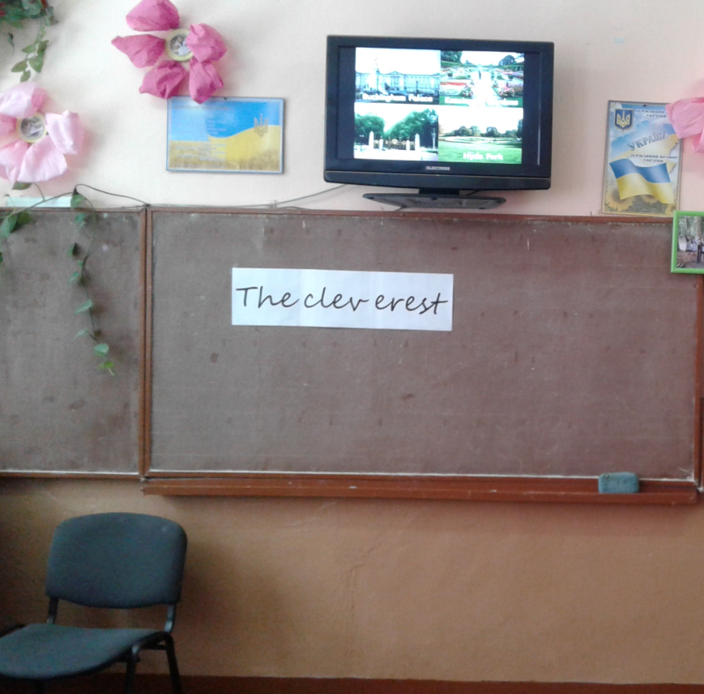

**Round 7**

***Proverbs and idioms***

*Teacher:* Proverbs are wisdom of the whole nation. Wherever you live, whatever language you speak, most of the proverbs have similar meanings. For example, *my home is my castle (мій дім – моя фортеця).* Your task is to find Ukrainian equivalents to the proverbs on your cards. Each team has five proverbs or idioms:

* *He laughs best, who laughs last / Сміється той, хто сміється останній*
* *Better late than never / Краще пізно, ніж ніколи*
* *Tastes differ / Про смаки не сперечаються*
* *The eye is the mirror of the soul / Очі – дзеркало душі*
* *It is never too late to learn / Вік живи – вік учись*
* *A man is known by the company he keeps / Скажи мені, хто двій друг і я скажу, хто ти*
* *Never put off till tomorrow what you can do today / Ніколи не відкладай на завтра те, що можна зробити сьогодні*
* *All in good time/Всьому свій час*
* *East or West, home is best /В гостях добре, а вдома краще*

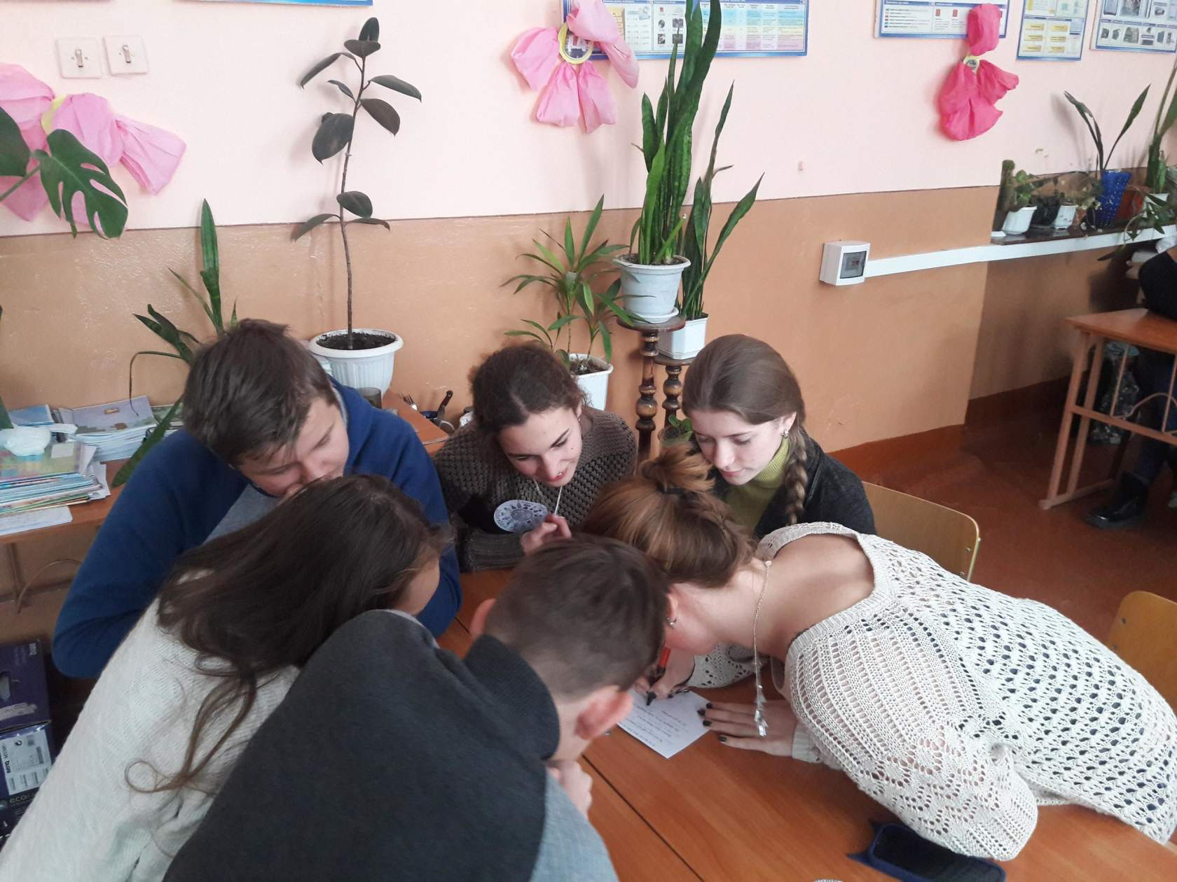

*Teacher*: This was the last competition for today, know І will count your points and define the winner. The team with the most points is……….. My congratulation.

Our competition has come to the end. Thank you for the game I hope you enjoyed it and found a lot of new information.

