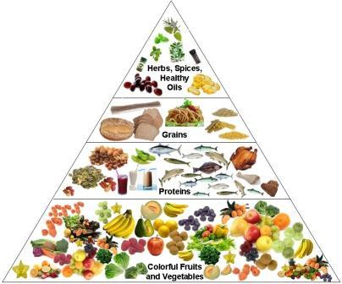**Let’s eat to live!**

All people eat to live, because eating is an essential part of our life. Humans need to eat in order to survive. If you stop eating, you will die, because our body needs vitamins, proteins, fats, carbohydrate and minerals. We should eat food with these nutrients to stay in a good health. That’s why we must pay attention to our products and get the right amount of each nutrients in our body.

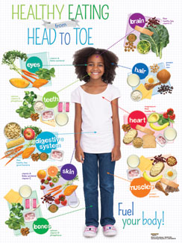 First of all people should keep healthy diet and healthy style of life. A healthy diet is an important part of staying healthy. This diet contains small amounts of fat, sugar and salt. It helps protect our body from different diseases.

People should eat a lot of vegetables, fruit, milk, cheese and dairy products. Fish and seafood must be included in our daily menu too, because they are rich in vitamins, protein and phosphorus.

It’s very useful to drink enough water, because our body needs nearly 2litres of water a day.

You should eatproper food and follow all rules of healthy dietand you will be full of energy, strength and desire to live and create the world around you. You will be able to work, think and enjoy your life.

So, follow all these recommendations and you will be healthy, wealthy and wise!