The 2d form
Theme: Feelings and emotions. Skills time! Listening.
Objectives:
- to revise pupils vocabulary on the topic “Feelings and emotions”;
- to practice speaking skills;
- to improve pupils’ writing skills;
- to practice using am/is/are.
Equipment:
Pupils’ book Family and Friends -2
Work book Family and Friends -2
flashcards 11-20
poster 2: They’re happy
CD and CD player
Phonics cards: sh, ch, th
Procedure
I Greeting
T.: Good morning children! I’m glad to see you.
P-s: Good morning teacher!
Children recite the poem “Sometimes I am happy…”
Sometimes I am happy,
Sometimes I am brave,
Sometimes I am sad,
But I am always behave.
When I’m really happy,
I laugh and smile and play,
When I’m really happy,
It’s a very good day.
T.: Is it a good day today?
P-s: Yes, it is.
T.: How are you today?
P-s: I’m great. It’s sunny today.
I’m happy. I’m in a good mood.
I’m terrific. It’s spring now.
I’m hungry. I want a sandwich.
I’m thirsty. I want to drink juice.
I’m sad. I’m in a bad mood.
I’m tired. I want to sleep.
II Warming-up
T. energizes the class by singing the song “Are you sad today?” (cassette – Get set go! – 2, Ex. 4 p. 43)
T.: Are you sad today?
P-s: No, we aren’t.
T.: Are you sad today?
P-s: No,we aren’t.
T.: Are you happy today?
P-s: Yes, we are.
We’ll clap our hands to show it.
(Children clap their hands)
T.: Are you happy today?
P-s: Yes, we are
And we want every one to know it!
III Main part
1. Actualize the lexical material on the topic “Feelings and emotions”
•T.: Open your book Ex. 1p. 14. Let’s remind the new words.
T. plays the recording, children listen, point and chant. CD 17, 19.
•Game “Music cards”
T. hands the flashcards out of different children around the class. They pass the cards to children next to them around the class while the music is playing. T. stops music suddenly. She asks the children who are holding flashcards, what’s this? to elicit the words. T. plays the music 3 times.
•Game “Jump”
Children stand at their desks. T. holds up a flashcard from the vocabulary set and says a word. If the word is the same as the flashcard, they jump. If it isn’t, they keep still.
2. Writing
a team game
There are flashcards happy, sad, angry, scared, hungry, thirsty, brave, tired, scared, angry on the board. Pupils write the words under the flashcards. They must write quickly and correctly.
T. determines the winner.
3. Dialogue speaking CD18
There is the poster 2 with a dialogue on the board.
T. plays the recording, pausing after each line the text for children to repeat. The class is divided into groups of thee to play the parts of Rosy, Tim and Mum. They come to the front of the class to act out the story using 2 dolls and a toy mail-cart. They use the poster 2 as a prompt.
Rosy: Hello babies!
Mum: They’re twins-brother and sister.
(Rosy and Tim wave at the twins. Their mother waves back.)
Rosy: Oh. They’re crying. Are they hot?
Mum No, they aren’t.
(Children switch on their dolls. The twins start crying. The mother takes off their hats and fans them).
Tim: Are they cold?
Mum: No, they aren’t cold.
(The twins are still crying)
Tim: Look! Apples.
Rosy: Can the babies eat apples?
Mum: Yes. What a good idea!
(Rosy offers apples).
Tim: Look, they’re hungry.
Mum: They like apples.
(The twins stop crying)
Rosy: They’re happy now and we’re happy too.
(Rosy and Tim wave good bye)
4. Pronunciation practice
T. teaches the sounds [∫], [t∫], [θ] using the phonics cards.
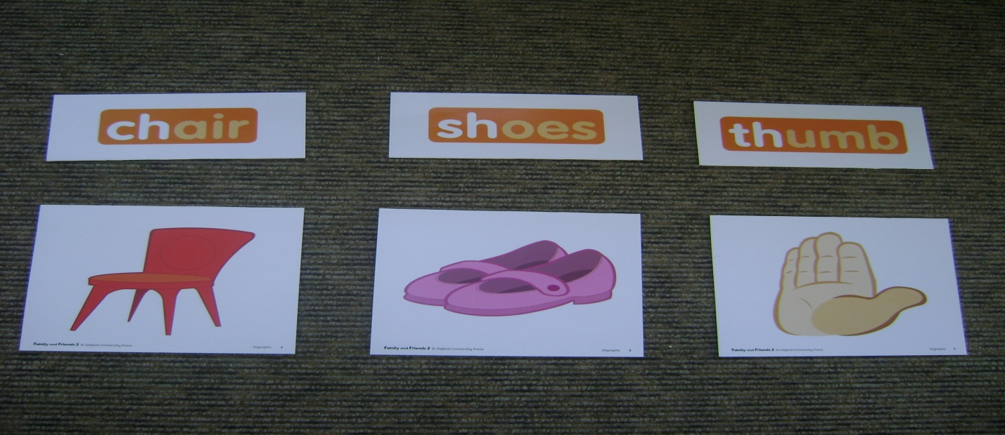
She holds up the first card and says, letters c and h make the sound [t∫]. T. says the sound for children to repeat several times. Then T. repeats the procedure with the other two phonics cards. She holds up each card in turn and model the words for children to repeat.
• Then children listen to the recording and look at the pictures in their books.
P. b. Ex 1 p 17 CD 22
• Children listen and point to the pictures.
• Then they listen, point and repeat:
[t∫] chair [t∫] teacher [∫] shoes [∫] fish [θ] thumb [θ] bath.
• T. divides the class into the groups. She assigns each group one of the sounds [t∫], [∫], [θ]. T plays the chant. When children hear a word containing their sound, they clap their hands.
• Children look at the chant in their book and circle the letter combinations -sh, -ch, -th.
Look at my teacher,
Sitting on a chair.
Her shoes are blue,
She’s got long, black hair.
A picture of a bath,
And a picture of a fish.
Look at my teacher,
Her names Miss Wish.
5. Relaxation
T.: I see, you’re tired. Let’s have a rest.
Children sing the song “If you are tired…” (P. b. – ex 3 p. 16 CD 20)
If you’re tired and you know it,
Go to sleep! [Snore, - snore] - put head on hands and
If you’re tired and you know it, close eyes
Go to sleep! [Snore, - snore]

If you’re tired and you know it,
And you really want to show it,
If you’re tired and you know it
Go to sleep! [Snore, - snore]
If you’re scared and you know it, - cross arms and hug
Hug yourself [Hug, hug]….. yourself

If you’re angry and you know it, - clench teeth and fists
Stamp your feet! [Stamp, stamp]…. Stamp feet

If you’re brave and you know it, - smile and hold hands in
Say, I can! [I can!]… fist shape
6. Skills time! Listening. P. b. – Ex 1 p 19
T.: You are going to hear a recording of a girl talking about how her friends are feeling today. You have to listen and decide which person she is talking about. You don’t need to understand every word. You listen for the word you know and try to understand the text.
Pre – listening
T.: Look at the pictures. How are girl’s friends feeling today?
T.: Picture 1.
P-s: The girl is hungry.
T.: Picture 2.
P-s: The girl is happy. etc.
Listening for gist
T. plays the recording, children listen and point to the pictures in their books.
Listening for details:
T. plays the recording, pausing for children to number the pictures.
T. goes through the answers with the class.
Answers: (top row) 3, 1, 4
(bottom row) 2, 5, 6
7. Grammar. Using am/is/are.
• Children remind using the words am/is/are and translate them.
They sing the song:
I am We are
You are You are
He is, she is they are
(музика пісні “У лісі, лісі темному…”)
• T.: Translate my sentences.
Він хоробрий. Вона гарна дівчина.
Вони щасливі. Ми у школі зараз.
Я гарний учень. Ти гарний друг.
• T. writes these sentences (without am, is, are) on the board. Children fill in the missing words.
• T.: Now, open your W. b. , please. Ex 1 p. 19. Write the long and short forms.
e.g. I am happy. I’m happy
T. goes through the exercise with the class.
IV Home assignment
T.: What do you feel when you’re doing your homework? ... Sometimes you are tired, sometimes you are sad, sometimes you are happy. I hope, you’ll be really happy to do Ex 3 p. 19 in your W. b. Draw and write about your feelings. This exercise is your homework.
V Summing up
T.: Are you happy?
P-s smile
T.: Are you sad?
P-s rub their eyes and pretend to cry.
T.: Are you thirsty?
P-s touch their mouths. etc.
T. asks about pupils feelings, children mime their actions.
T.: It’s high time to sum up the results. Thank you for your wonderful work, for your feelings and emotions in our lesson. Your marks are excellent! Our lesson is over! Good bye!
P-s: Good bye! Till tomorrow!

