Районний методичний кабінет

Конспект уроку з англійської мови
у 9 класі на тему «Advertising»
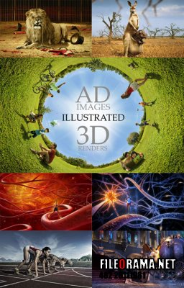

Борисяк Ольга Мирославівна
вчитель англійської мови
Теребовлянської ЗОШ №1
І-ІІІ ступенів

2014
Advertising is the greatest art form of
the 20th century
Marshal McLuhan, Canadian writer.

Level – intermediate
Objectives:
- to practice speaking skills, to encourage communication and exchanging opinions on the topic;
- to develop critical thinking, creative skills, ability to express thoughts logically;
- to encourage students to work in groups;

Equipment: a tape recorder, handouts, big sheets of paper, felt pens, posters with ads, a book ‘New Opportunities’ intermediate.

PROCEDURE

I. Introduction.
T: Hello everybody! How are you? I hope, you are OK.
And now please, look at the blackboard (the blackboard is decorated with different ads, the quotation is at the top. See appendix 3.) and guess the topic of our lesson. Well, any ideas? What can you see on the board?
P: Adverts, we’ll talk about advertising, I think.
T: Right, today we’ll talk about adverts. By the way, do you know that advertising dates back to ancient times? The first adverts were drawings on the walls in ancient Egypt. There were even political ads at that time. Later there were “street callers”, they used to walk along the streets and shout about different products. Advertising in the modern sense appeared in the 17th century in England. At that time newspapers began publishing adverts. The first advertising company appeared in Philadelphia in 1841. And now we cannot imagine our life without advertisements.
II. Warm-up. T: Well, where can we find different ads?
P: Everywhere: on TV and the radio, in papers, magazines, and just in the streets.
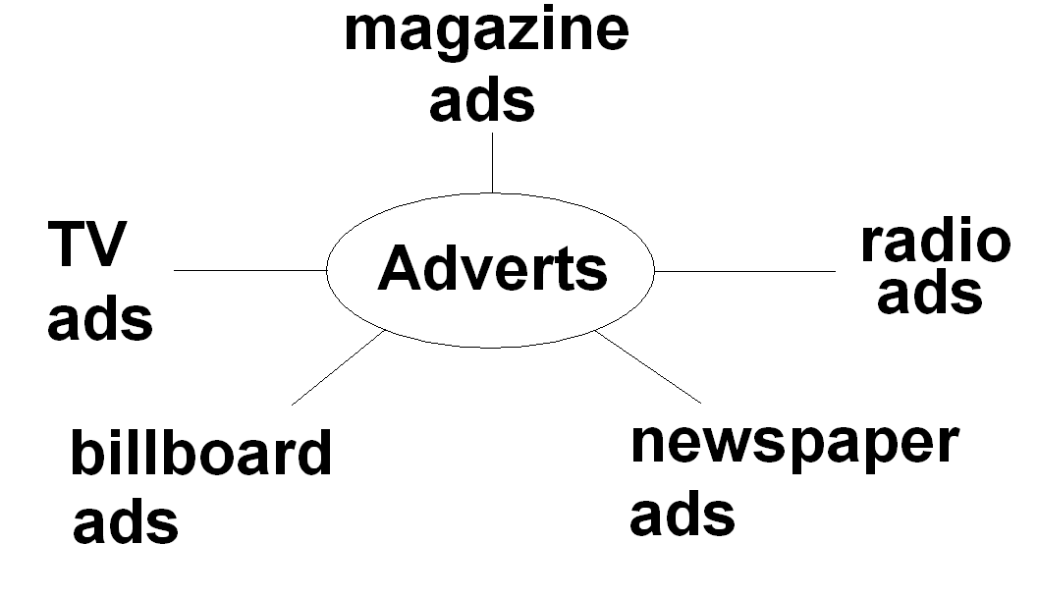
T: Right. Very often you can see people distributing adverts in the streets. Have you ever got an ad in the street? What was it about? Did you buy the thing on the ad?
P: Yes, once I got an advert about cameras. I showed it to my parents and we bought a new digital camera. There was a discount.
T: Well, every thing has something good and something bad, its pros and cons. What about ads? What is good about them? Please, tell and then write your ideas here.
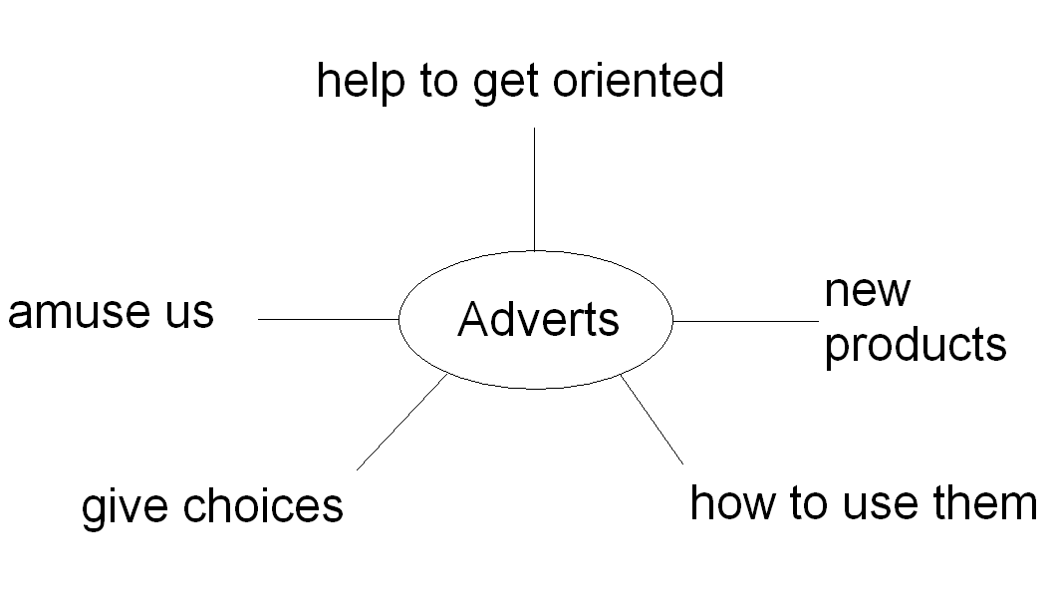

T: And now what are bad things about adverts.
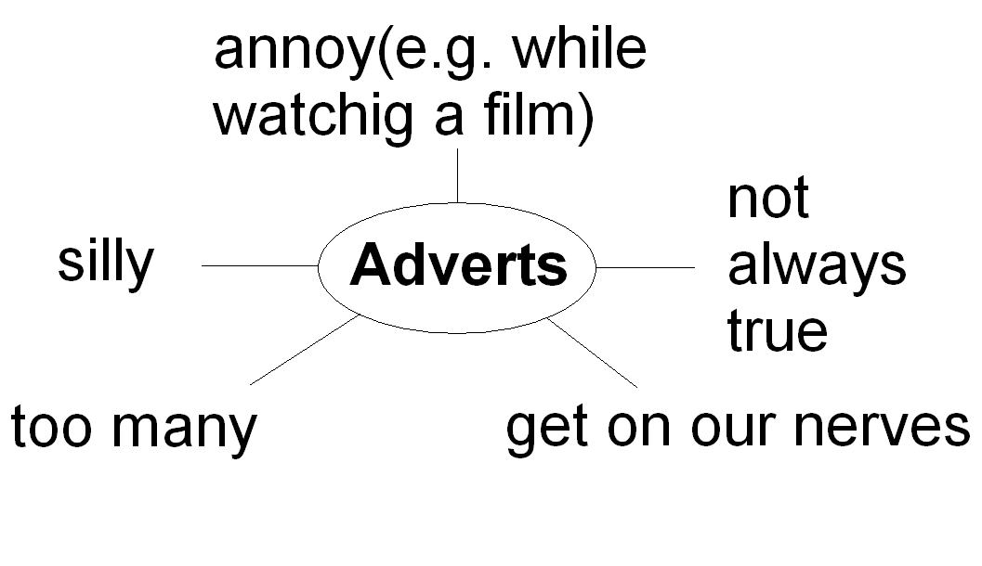

III. Main part
1. Reading + speaking
T: Open your books at p.68, look at the adverts, read them and then do these tasks. (The pupils are given cards with the following tasks.)
Look at the adverts, read them and then do these tasks.
1) According to the adverts, which product:
a) has some special offers?
- 
- is the funniest in your opinion?
- is for music lovers?
- mentions that the customers are very pleased?
- is the smallest of its kind?
- doesn’t give any contacts
g) is for those who don’t like noise?

2) Discuss the questions
  - Which is the best advert?
  - Which advert tempted you most? Why?
  - Which advert gives the most practical information? Give examples.
  - Which advert is the most difficult for you to understand? What makes it difficult?

3) Match the adjectives to the adverts:
amusing, clever, serious, funny, unusual, weird(very strange), silly, strange, terrible, useful, instructive(informational), practical .

2. Listening.
T: Listen and do the following tasks.
1) Listen to some adverts and match them to the following definitions (one definition is extra)
    - really delicious
    - stylish and good value
    - the perfect present for a woman
    - healthy and natural
    - cheap and fashionable
    - durable and reliable
Audio scripts:
a)If you are cool, if you know cool, come to our new shop “Bunzoff T-shirts” in High Street. Cool designs, top quality materials and everything’s at fantastic value. Don’t miss a chance! “Bunzoff” is the coolest place for T-shirts and pants!
b)Is it a special time next week? And still nothing to give your partner? Get something special from Harrods-Scot jeweller’s. Fantastic rings with stylish designs on the prices you’ve never dreamt were possible! Make her dream come true! At Scot’s!
c) Teshie’s! Buy something tasty! M-m-m! Tasty! Absolutely delicious! One more choice among Teshie’s crisps! Fantastic value at a fantastic price! All Teshie’s crisps!
d) At Brown’s, 50% off all bikes, yes 50%!
Top quality leather designer bikes. The latest stylish designs from London, Paris and Milan. Fantastic value for your money at Brown’s, Mill Street, next to the cinema.
e) Our new collection of marine watches is out now! Marine watches are extremely endurable. They are waterproof and truly reliable. All watches are guarantied for three years. With marine watches you get guarantied quality! Bargain prices! Marine Watches! Saint Andy Street! (Keys: 1-c; 2-a; 3-b; 5-d; 6-e)
2) T: Listen to the following advert again and draw what you think it is. (Advert 3)

3. Project
T: Now we’ll have a kind of a role play or a business game. Suppose I’m a manager of an advertising company. Three customers asked us to make adverts for their products. I have three products. You are my three teams. Each team chooses one product and makes an ad. You may choose the product yourself. So we have a mobile phone, a dogwalker and an underwater scooter. (The pupils are given pictures and cards with the information. See appendix.)

Examples of project presentations:

P1: BABEL BX99
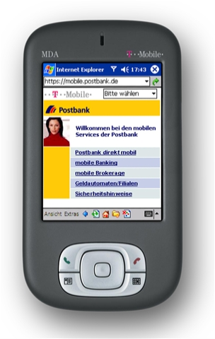
Are you bored with your old phone? Do you want something special? Then buy our Babel BX99. It’s stylish and compact. It’s got a flash screen and its functions are super. You can have a permanent internet connection and you can download anything you like from the internet. If you like taking photos, Babel BX99 is the best for this. It’s got a 300 pixel camera. And what is the most important, it’s easy to use. Besides, connection, softwear and a car charger are free. Buy Babel BX99 now! There’s a special offer- only $300, and only now! Don’t miss a chance! BABEL BX99 IS IDEAL FOR YOU!

P2: DOG WALKER

There is nobody to take your dog for a walk? You never have time? Then buy this Dog Walker! It’s great! Just look at it! What a brilliant design! It looks great, besides it’s convenient and practical. It’s got a reliable motor and a computer. So you can choose a walking program which is the best for your pet. Be sure, your dog will love it. Buy this enjoyment for your dog, it’s only $100. Your pet deserves it!
P3: UNDERWATER SCOOTER
Have you always wanted your own submarine? Now is your chance! With this new scooter you can travel underwater and look at marine life. The scooter moves at 2.5 kilometer per hour and can go to a depth of 10 meters. The scooter is easy to carry because it’s only 60 cm long and weighs just 5 kilos. The battery lasts for an hour and takes 10 hours to recharge. Only $950!


IV. Summing-up. Home assignment
T: Thank you very much. I enjoyed your presentations. Your ads were great! Just brilliant! I think the clients will love them too.
For the next lesson, please, write an add for any product you like.

APPENDIX

Babel BX99
top quality
300 pixel camera
downloading from the Internet
flat screen
permanent Internet connection
stylish , compact
easy to use
FREE : connection , software , car charger , guarantee 1 year.
special offer $300

Dogwalker
convenient, practical
brilliant design
reliable motor
a computer
price - $100

Underwater scooter
speed 2.5 km per hour
10 metres deep
60 cm long
5 kilos
battery – 1 hour
to recharge – 10 hours, price-$950

