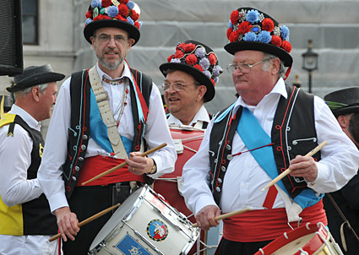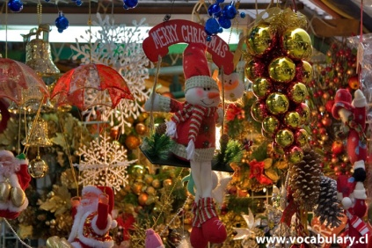

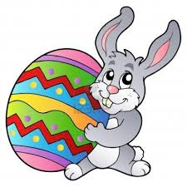«English 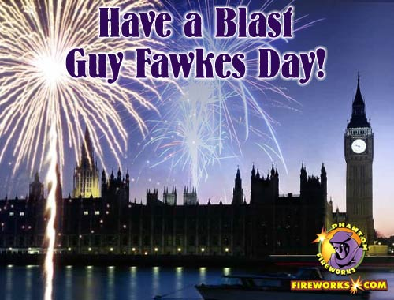Traditions»

Брейн-ринг

(Для учнів 8-9 класів)

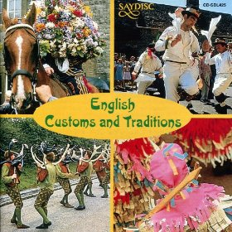

«English Traditions»

Брейн-ринг

Для учнів 8-9 класів

**Мета:** виховувати та підтримувати у школярів мотивацію до оволодіння іноземною мовою; розширити знання учнів про культуру країни, мова якої вивчається; формувати лінгвокраїнознавчу компетенцію школярів, розвинути в учнів навички слухання та говоріння; розвинути в учнів логічне мислення та пам'ять.

**Наочність:** фотографії, матеріали для презентації та картинки, атрибути свят.

**Хід заходу**

***1.*** *Етап підготовки*

* підбір запитань до гри, які відповідають вивченій темі;
* підготовка сценарію брейн-ринга;
* розробка наочних матеріалів;
* вибір учасників - для участі відібрані учні 8-9-го класів, рівень знань яких відповідає рівню складності гри.

**2.** *Сценарій проведення заходу*:

*Teacher:* Good morning, dear pupils, jury, our teams and guests! You are welcome to the intellectual English contest. The aim of our meeting is to show the students’ knowledge not only in English, but in Literature and Geography as well, to widen the outlook and encourage students to speak. Our topic is English Traditions. Now I’d like to introduce our jury to you… (The teacher introduces the members of the jury. They can be teachers as well as senior students.)

*Teacher:* Today two teams take part in our competition: the first team is represented by pupils of the eighth form. Let’s greet them (team names itself and tells their slogan).

*Teacher:* The second team is the pupils of the ninth form. They are … (The team names itself and tells their slogan).

**Round 1**

*Teacher:* The first contest is “How much do you know about the English Traditions”. You have to answer the following questions. For every right answer you will get 1 point to your score.

**Questions:**

* When do we celebrate New Year? (31 December)
* Does Christmas in Ukraine and England coincide? (no)
* What are the most popular holidays in Great Britain? Name them. (Halloween, Thanksgiving, Easter, Christmas, New year)
* What traditions are connected with Christmas in Ukraine? (singing carols)
* When do we celebrate Christmas? (7 of January)
* Could you please translate the word “carols” into Ukrainian? (колядки)
* How do English families prepare for Christmas holiday? (buy presents, decorate New Year Tree, bake turkey, prepare pudding)
* What is the symbol of England? (the red Rose)
* What is the symbol of Scotland? (the tristle)
* What is the symbol of Wales? (the daffodil)
* What is the symbol of Northern Ireland? (the shamrock)
* What is the national costume of Scotland? (the kilt)
* What is the emblem of Easter? (the rabbit)
* What is the British national drink? (tea)
* What is the national dish of the Britain? (pudding)

**Round 2**

*Teacher:* The second contest is to make up a puzzle. You will be given the puzzles of flags of English-speaking countries. Please, make the flags. You have 3 minutes for it. Every flag is a point for your team.

**Round 3**

*Teacher:* Now, let us relax a little bit and listen to the song. Teams, your task is to write down the missing words in the lyrics on your papers. We will hear it for 2 times, be attentive, please.

JINGLE BELLS

Dashing (1) … the snow

(2) … a one horse open sleigh

(3) … the fields we go

Laughing all the way

Bells (4) … bob tails ring

Making spirits bright

What fun it is (5) … laugh and sing

A sleighing song tonight

Oh, jingle bells, jingle bells

Jingle all the way

Oh, what fun it is (6) … ride

(7) … a one horse open sleigh

Jingle bells, jingle bells

Jingle all the way

Oh, what fun it is to ride

In a one horse open sleigh

A day or two ago

I thought I'd take a ride

And soon Miss Fanny Bright

Was seated (8) … my side

The horse was lean and lank

Misfortune seemed his lot

We got (9) … a drifted bank

And then we got upset

Oh, jingle bells, jingle bells

Jingle all the way

Oh, what fun it is to ride

In a one horse open sleigh

Jingle bells, jingle bells

Jingle all the way

Oh, what fun it is to ride

In a one horse open sleigh yeah

Jingle bells, jingle bells

Jingle all the way

Oh, what fun it is to ride

In a one horse open sleigh [13].

Answers: 1. Through 2.In 3. Over 4.On 5.To 6.To 7.In 8.By 9. Into

*Teachers:* Now, my friends, you’ll have a chance to get extra points for your team. Your task is to listen to the riddle and answer it.

**The riddles:**

* Clean, but not water,

White, but not snow,

Sweet, but not ice-cream,

What is it? (sugar)

* The moon is my father,

The sea is my sister,

I have a billion brothers,

I die when I reach land. ( A wave on the ocean)

* At night they come without being fetched,

And by day they are lost without being stolen. (Stars)

* What gets wetter as it dries? (A towel)
* What is white when it is dirty and black when it is clean? (A blackboard)
* I am not inside a house,

But no house is complete without me.

What am I? (A window)

* Which room has no doors, no windows? (A mushroom)
* What is always coming, but never arrives? (Tomorrow)
* What walks around all day and lies under the bed at night with its tongue hanging out? (Our shoes)

**Round 4**

*Teacher:* The forth contest is to guess the holiday. You will be shown some photos and your task is to tell me what is the name of the holiday. Every right answer will give you one point.

 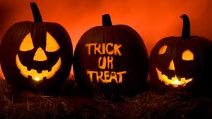

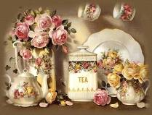 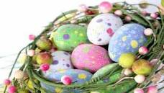

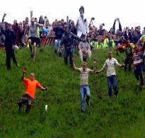 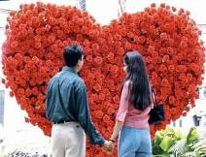

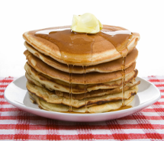 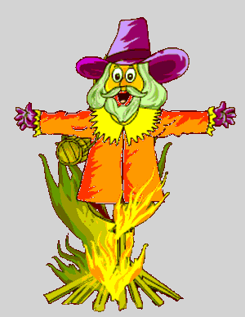

**Round 5**

*Teacher:* The next contest for you is a test. You have only 3 minutes to do it.

**Questions:**

* What is the most important festival of Welsh poetry and music?
* The Edinburgh Festival
* The Rock festival in Liverpool
* **Eisteddfod**
* Eurovision
* What is the Scottish national costume for men?
* the tuxedo
* the black uniform
* **the kilt**
* the bearskin
* What is the most popular drink in Britain?
* apple juice
* **tea**
* milk
* coffee
* What is the name for New Year’s Eve in Scotland?
* Cocney
* **Hogmanay**
* Christmas
* the evening before New Year
* What do the children usually do at Halloween?
* **“trick or treat”**
* “sing or dance”
* “give or take”
* “cry or laugh”
* Which holiday is usually celebrated on the 5th of November in the UK?
* Easter
* **Guy Fawkes Day**
* Halloween
* New Year
* What is a “bank holiday”?
* the holiday on the bank of the river
* week-end
* **public holiday**
* summer holiday
* What is the traditional Christmas song called in Britain?
* “Anthem”
* **“Auld Lang Syne”**
* “Imagine”
* “Jingle Bells”

9. When is Halloween celebrated in the UK?

a) on 31st October

b) on 31st November

**c) on 31st September**

d) on 31st January

10. Scottish surnames begin with…..

a) O**`**

**b) Mac or Mc**

c) de

d) La

**Results:**

*Teacher*: Our competition has come to the end and we are thankful to our teams, participants and jury. Please, tell me who is the winner? Thank you for the game, we wish you a Merry Christmas and a Happy New Year!