Районний методичний кабінет

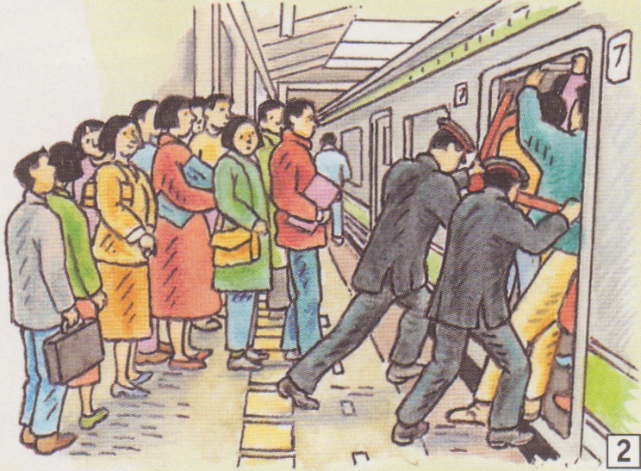

Борисяк Ольга Мирославівна
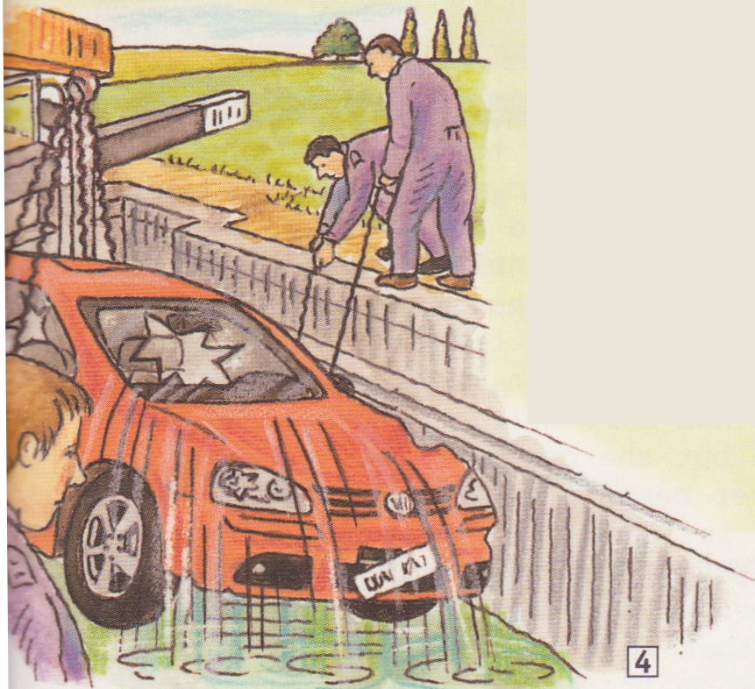
вчитель англійської мови
Теребовлянської ЗОШ №1
І-ІІІ ступенів

2014
ODD JOBS

Level – intermediate

Objectives:
- to activate the topic-related lexics involving pupils into communicative activity by means of pair and group work;
- to develop pupils’ creative skills, skills in giving opinions, pros and cons;
- to expand pupils’ knowledge about the variety of professions;

Equipment: handouts, texts, pictures.

PROCEDURE

I.INTRODUCTION. WARMING UP.
T: Good morning, everybody. Today we go on speaking about different jobs and professions. But we’ll speak about unusual, strange jobs which sometimes even may make us smile. They are called odd jobs. But first look at the board, you can see here a number 500,000. What do you think it means? Do you have any ideas? (Pupils give their opinions, e.g. workers, offices, factories, jobs and so on, the teacher may write them on the board). Well, of course there may be 500,000 workers, offices and so on, but, as far as we are talking about jobs, this is the number of jobs in the world. Yes, don’t be surprised, but this is really so. There are over 500,000 jobs in existence to choose from. So, as you can see, the choice is very wide. But the proverb says: “There are no bad jobs, there are bad workers.” Do you agree with this? (Pupils give their opinions.)

II.VOCABULARY PRACTICE. PAIR WORK.
T: Before speaking about odd jobs, let’s practice some vocabulary.

- Idiomatic expressions. Matching.
Match the idiomatic expressions 1-9 with the explanations a-i.

1. Musical Chairs 6. Desperate Measures
2. Sticky Situation 7. Pushy People
3. A Real Charmer 8. Calming Influence
4. Workaholics 9. Specialists
5. Spoilt for Choice

a) Someone who makes everyone like them
b) Aggressive people
c) To have too many options
d) A party game involving music and chairs
e) People who work too much
f) Experts in specific jobs
g) A difficult situation
h) Do something extreme
i) Someone or something that calms you down
(KEY: 1-d; 2-g; 3-a; 4-e; 5-c; 6-h; 7-b; 8-I; 9-f)

2. Collocations.
a) Read the following collocations and divide them into three groups:
offer (someone) a job, close (something) properly, turn down (an/the/their) offer, make (a/your/his) living, do well, get stuck, get the sack, try hard, find (it/something) impossible, become self-employed, provide inspiration, grow dramatically

VERB + NOUN VERB + ADVERB VERB + ADJECTIVE

b) Use these collocations to complete the following sentences.

1 My grandfather …………….. as a miner for forty years.
2 I was …………….. as a waiter in a fast-food
restaurant but I …………… because I can't stand
the smell of hamburgers!
3 I …………… to understand the instructions of my
new digital camera and had to ask a friend to help me.
4 The number of cars in our city has …………….. in
the last few years.
5 That suitcase is broken and now it doesn't ………….. .
(Key: 1) has been making his living; 2) offered a lob; turned it down; 3) tried hard;
4) been growing dramatically; 5) close properly)

- Complete the vocabulary networks with these words:
Well, a living, your best, something about it, work, somebody scared, a complaint, a job, a (big) mistake, people think, money

Make Do

(Key: make – a living, somebody scared, a complaint, a big mistake, people think, money; do – well, your best, something about it, work, a job)

III.READING

ODD JOBS

Strange Small
1. Pre-reading.
T: Look at the board, please. Here you can see the explanation of the collocation “an odd job”. Can you say now what an odd job is?
P: Yes, it’s an unusual, strange job or a small job.
T: Do you know any odd jobs?
(Pupils name the jobs they think may be odd, e.g. babysitting, car washing.)
T: Do you know who passenger pushers, gum removers or air sniffers are? No? Then read some stories about them.

2. While-reading.
Read the stories and match the headings (1-8) with the paragraphs (A-G). There is one extra topic.
1. Musical Chairs 5. Desperate Measures
2. Sticky Situation 6. Pushy People
3. A Real Charmer 7. Calming Influence
4. Workaholics 8. Specialists

ODD JOBS
A. King Alfonso XIII of Spain was going deaf so he employed an 'Anthem Man'. His only job was to give a signal to the king when the national anthem was being played so that he would know when to stand up and when to sit down!
B. If you cannot find a tuneless monarch to be your employer, the railways offer jobs of all sorts. In Japan, `Passenger Pushers' are employed full time by the railway companies in Tokyo. During the rush hour, when hundreds of people are trying to get on the metro, they do their best to squeeze everyone into trains so that the doors will close properly.

C. Another technological advance that led to job creation on the railways was the invention of chewing gum in 1928. When they finished their gum, many passengers just dropped it on the floor of the station and management at New York's Grand Central Station had to do something about it. In the end, they employed a professional gum remover who had a lot of work to do – he collected, on average, over three kilos of the sticky menace per day. I suppose you could say he got attached to his job!
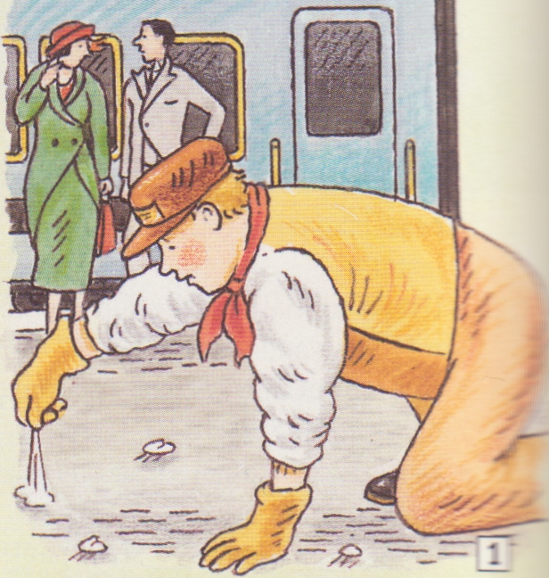

D. Escalators have provided inspiration for other rewarding careers. When the first moving staircase was installed at Harrods Department Store in London in 1898, it made many people scared. Shop assistants were put at the top of the escalator with instructions to give brandy and smelling salts to customers! And in 1911, when Earls Court underground station installed its first escalators, many people were worried about their safety. London Transport had a great idea; they employed a man with a wooden leg. His job was to walk up and down the escalators all day to show passengers how safe they were.
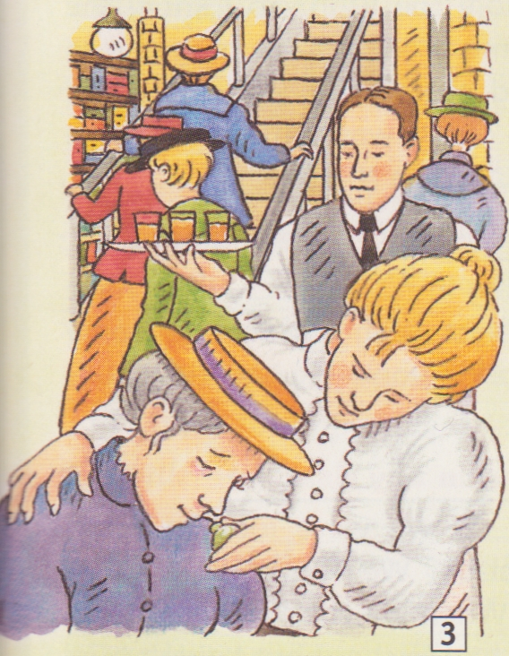
E. In 1982, dozens of neighbors in a village in Berkshire made complaints about the smell from the nearby sewage works. So twelve people were employed to sniff the air outside their homes to estimate the smell. The Amsterdam police have a similarly specialized task force called the 'grachtenvissers'. Their sole duty is to help motorists whose cars have got stuck in canals! This trend towards specialization has grown dramatically in the last few years but it is not an entirely recent phenomenon. In medieval Japanese armies, special soldiers did the gruesome job of counting up the number of decapitated heads after each battle!

F. In America, Miss Edith King was given an unusual job in the army. She was employed by the US War Department in 1905 with the task of finding soldiers who had run away from the army. She collected $50 for each deserter. Her only weapon was flirtation. If the runaway soldiers thought they were going to have a good time, they were making a big mistake — she led over five hundred into court. She must have had real charm!

G. Being unemployed often makes people think of unique ways to make money. Take Jim Parker from Sacramento. Last year he got the sack from his job in a high-tech company and has found it impossible to get full-time work. In desperation, he became self-employed and is now trying hard to sell advertising space. If the price is right, he intends to tattoo an advert — on his forehead! He has already turned down an offer of $75,000.
( Key: A-1, B-6, C-2, D-7, E-8, F-3, G-5)

3. Post-reading. Speaking.
Answer the following questions.
1 Why are 'Passenger Pushers' necessary on the metro in Japan?
2 Why does the writer describe chewing gum as a 'menace'?
3 Why did Harrods employ special shop assistants on the escalator?
4 Why were sewage works a problem in Berkshire?
5 Why was Miss King successful?

IV. A GUESSING GAME.
T: Now we’ll play a guessing game. One of you thinks about some odd job, we’ve just read about, others can ask only yes/no questions to guess it.
e.g. P1: Do you work at the railway station?
P2: Yes, sometimes.
P3: Do you wear a uniform?
P2: No, I don’t.
P4: Do you collect gums?
P2: No.
P5: Do you push people into the trains?
P2: No, never.
P6: Do you look for runaway soldiers?
P2: Yes, I do.
P6: You are Miss King.

V. GROUP WORK.
T: Now, please, split into groups of four. Do you remember Jim Parker from the stories? He has been sacked and doesn’t have a job. Try to help him. Invent some new odd job for him. Give it a name and describe what the person must do. Then you’ll share your stories.

Here are some examples of pupils’ stories.
A Bag Packer
Do you go on a holiday or a business trip and you don’t like to pack bags or you don’t have time? You can employ a “bag packer” and he or she(as you like) will do it for you.

An Employed Guest
Are you making a party soon?
Want to impress your friends?
Or do you feel lonely?
Then invite our employed guest, or guests, and you wish and you will have a lot of fun and a great time. Our guests can entertain your own guests, can be your friend or relative or colleague (as you wish). Our people can sing, play musical instruments, do magic, recite poems and do a lot of other interesting things.

A Mooder.
If you feel nervous and want to shout at somebody, “a mooder” is just for this. He’ll patiently listen to your shouting.
Are you frustrated? Do you feel desperately bad and want someone to cheer you up? “A mooder” will help you. He knows a lot of comforting and cheerful words. You’ll surely feel better.

VI. CONCLUSION. Home assignment.
T: Thank you. I like your odd jobs, I’m sure you can invent more but your homework is to write a description of your favourite job. Good luck to you.

