Конспект уроку

з англійської мови

у 9 класі на тему:

«Tourists’ attractions in Terebovlya»

**Вчитель**

**Теребовлянської №1**

**ЗОШ І-ІІІ ст.**

**Борисяк Ольга Мирославівна**

**2014**

**Sightseeing in Terebovlia**

Level A2

**Objectives**: to develop pupils’ creative skills, to encourage their team

work;

to encourage pupils’ research work on the topic;

to expand pupils’ knowledge on the topic

to develop speaking and reading skills

**Equipment:**  a computer, a video film, handouts, pictures of the town

**Procedure**

1. **Introduction**

T: Good afternoon, everybody! It’s nice to see you. Today we are having a special lesson, a lesson about our land, about Terebovlya. This is the place where you were born, where you live. It’s the place which sometimes makes you bored but still you miss it when you leave it for a long time. It brings you good or sometimes not very good memories but this is your life. It’s your hometown. And you’ll always remember it no matter where you’ll be. It’s surely the best place for all of us, for you and for me.

1. **Warm-up.**

But it can be attractive not only for us, I think. Can it be interesting for others? Can it attract tourists? These are the questions you were to answer in your project, as you remember. So, you were to make a project about our town and show that Terebovlya can really be attractive for tourists. But before watching the presentation of your project, I want you to write the main ideas of your project on these sheets of paper and then stick them on the board and make short comments.

Old and nice town ancient history

TEREBOVLIA legends

Monuments churches fortress

P1: Terebovlya is attractive for tourists because it’s an old and nice town.

P2: It also has an ancient history.

P3: There are monuments to famous people, e.g. to prince Vasylko, to T. Shevchenko.

P4: There are some churches in Terebovlia which have a historic value.

P5: We have an ancient fortress which already attracts tourists.

T: There are a lot of legends about Terebovlya which also make it attractive.

1. **Main part**

1**. Presentation of the project.** This is a long term project. The students were asked to make a project about their native town. The project should answer the following question: ‘Why should Terebovlya be attractive for tourists?’ The pupils chose to make a video film.

T: OK, thanks a lot. And now I’m eager to see your presentation. I know it was hard work but I think I’m sure; you’ve done it perfectly well. So, let’s start.

(The students present their video.)

Here’s the script of the film

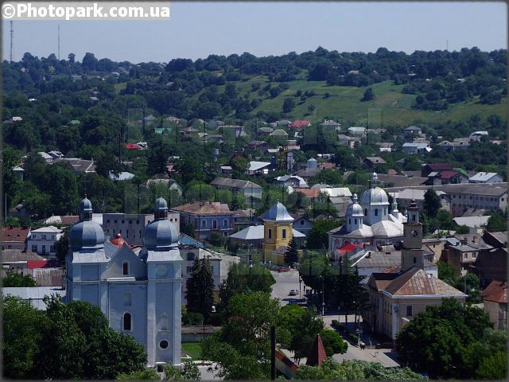

**P1**: Hello,everybody, who is a keen tourist and who has seen a lot and who wants to see more. You are welcome to an ancient and beautiful town of Terebovlya which is situated 32 kilometres south from Ternopil. Terebovlya lies on the river Hnizna which divides it into two parts – the Old Town and the New Town. As you can see, the town is surrounded by hills; in fact all the suburbs are on the hills so you can see downtown from everywhere.

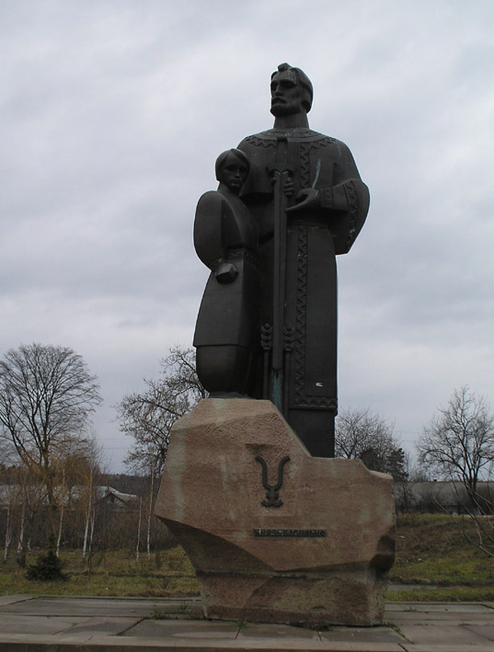And now we are on the main highway called Ternopil – Chernivtsy and here you can see this sign – Terebovlya 1097. This date was first mentioned in old Ipatiev chronicles but in fact the town is much older, as the archeological excavations show. They say there was a settling here long before AD, some 3rd thousand BC. So the town is more than nine hundred years old.

**P2**: Now we are walking along Knyaz Vasylko Street. It’s the longest street in the town. The street is named after Prince Vasylko who ruled Terebovlya principality in the 11th- 12th centuries. The monument to him is in this street too. Here itis.

During the reign of Prince Vasylko Terebovlya was strong and rich, it was an important centre in Halychyna. But the fate of Prince Vasylko was tragic. The story says that Kyiv prince Svyatopolk envied Vasylko’s success and wanted to grasp his lands. So he invited him to Kyiv then captured and took to Zvenyhorod where Vasylko was blinded. Moreover, Svyatopolk put him to prison, but later was forced to free. Blind Vasylko returned to Terebovlya and lived here till the end of his days. This monument shows blind Vasylko with a boy. Such a tragic story, you see.

**P3**: And here, next to the monument, you can see a building with these magnificent columns. It’s a catholic church – Petro-Pavlo kostel. Its building started in 1924 and was finished in 1927. Kostel was designed in the style of old Roman basilicas. The yard is surrounded by tall Doric columns made of Terebovlya stone. There used to be a magnificent statue of Jesus Christ near the entrance but it disappeared in the times when kostel was used as a storehouse first, and then as a local concert hall. Now it’s a catholic church again. It’s a pity we can’t go in, it’s closed.

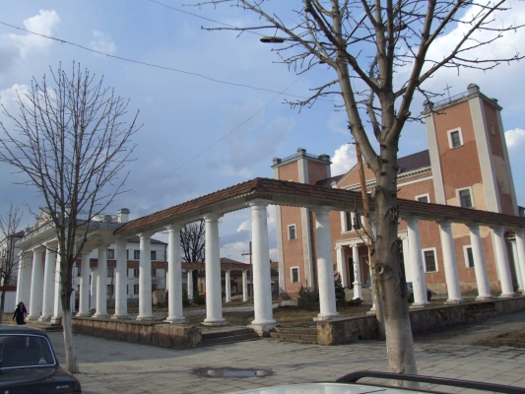

**P4:** Now let’s go along Knyaz Vasylko Street to the very centre of Terebovlya. Have a look at the buildings, some of them are quite old, but some are entirely new built just two or three years ago. This is the building of our district administration; here are a supermarket and a new shopping centre.

**P5:** Now we are approaching one of the oldest monuments of architecture of our town – Mykolaivs’ka church. It’s in the very centre of our town, next to the crossroads. It’s being under the repair now, as you can see.

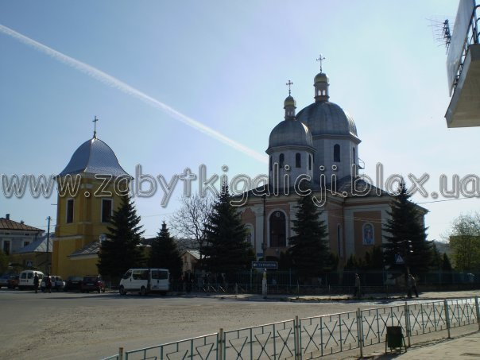

The building of the church belongs to the 16th century; in 1735 it was a bit reconstructed though the basis remained the same. The church was surrounded by a high wall because in the times of different invasions it was used as a defensive building. There were even special defensive niches inside the church itself. The historians say it was characteristic of Galicia churches to be a church and a fortress at the same time.

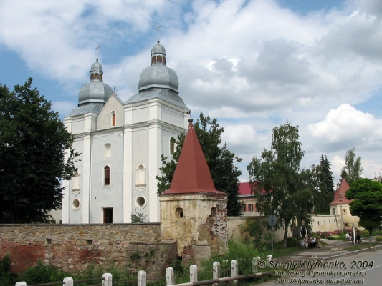**P6**: And now we are at the crossroads made by Knyaz Vasylko and Shevchenko streets. Let’s walk along Shevchenko Street. We’re approaching the orthodox church or the monastery of Carmelites. It’s one of the ancient places which once had a defensive value. The building of the church started in 1635 and was finished by 1640. it is considered to represent the architecture of renaissance baroque. The main entrance in the wall is in the form of an arch with the bells over it. As you see the exterior of the church was strict and simple which was characteristic of renaissance but inside the church used to be more beautiful and exquisite due to rich decorations. There used to be the wall in the yard which divided the territory into two parts the monastery and the church but it was destroyed after the World War II.

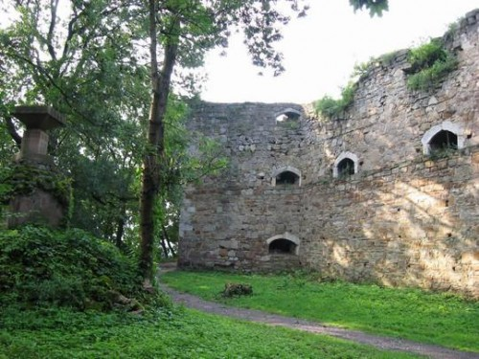**P7**: We go on. Now we are on the bridge over the Hnizna, the river is quietly carrying its waters to the Seret. On the right you can see the building of our high school of culture. And now we are in Shevchenko park, it’s just at the corner of Sichovy Striltsy and Shevchenko streets. This is the monument to Taras Shevchenko A lot of different meetings often take place here.

**P8:** And now we’re near the greatest historical monument of our town – the castle or

the fortress or rather the ruins of it.This is an entrance arch which was designed in the renaissance style. It should be said that the castle was rebuilt several times and now we can see the ruins of the last castle of Alexander Balaban. And now let’s go up this serpentine path that’s how you can reach the ruins from the town centre.

So, the first castle was probably built on this hill by prince Vasylko. It was wooden but as they say there was a stone church near the entrance under which Vasylko is supposed to be buried in sarcophagus

Later Terebovlia was taken up by the polish king Casmir. And around the year 1360 he built a new stone fortress on the ruins of the wooden one. It’s a pity but there’s no description of it or pictures left. The fortress was used as a fortification against Turks and Tatars until it was ruined around the year 1365 as a result of numerous raids of different enemies.

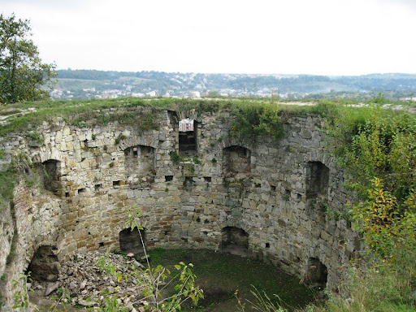

Then the last fortress was built by the head of the town Alexander Balaban. The place used to be a great fortification against turks and tatars until the year 1388 when it was ruined and never renewed again. Now these picturesque ruins meet the visitors with their silence and loneliness. Just look at these solid stone walls and imagine how many attacks they withstood. Let’s go up these stairs. So, now we’re in the middle of the fortress. Let’s go this way and walk along these stone walls. They are wide enough for a horse carriage. And now get ready! You’re going to see a magnificent view. Just look! Isn’t it beautiful? It’s great! The whole town below you, open to your sight, to your soul! Where else can you see such an amazing view!

**P9:** We’re going back. Let’s have a look here. Can you see this deep hole? Long ago, at those historic times, there used to be a well. It’s really very, very deep. Just drop a stone and you’ll see how long it takes the stone to reach the bottom.

So we’re in the middle of the leftovers of the last fortress built by A. Balaban. It has three towers – southern, eastern and western. The towers are connected by thick walls, some of them are about 4 or 5 meters thick. This is the northern defensive wall. Having its height of 18 metres it was considered to be the mightiest. There was a palace, some houses and a bakeryin the fortress to survive the numerous sieges of turks and tatars. This is the northern defensive wall I’ve told you about.

Ps: Here, at this ancient silent place, we’re finishing our excursion. We hope you liked it. So, welcome to Terebovlya.

1. **A game.**

T: So, we’ve just seen the presentation of your project. I think it is great! You’ve done a great job. Thanks a lot!

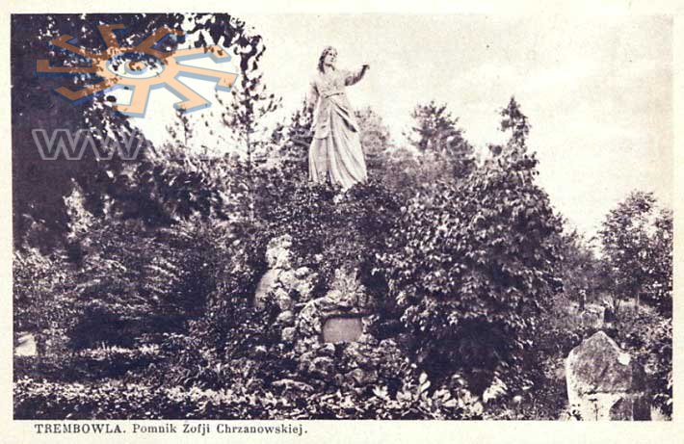 And now we are going to have a kind of competition. Do you remember I told you that Terebovlia has a lot of legends. You’re going to read one of them. But first make two teams. Each member of the team must make a question about the story. Then you come to me with your question. If the question is right I’ll give you a part of the story which answers your question. The questions must begin with WHO, WHY, WHAT, WHEN, HOW. And remember the story is about a woman. Her name was Sophia Hrzanovska. She became so famous that there used to be a monument to her near the castle. The winner is the team that orders the story the quickest and represents it to the class.

(Here are the parts of the story.)

1) It all happened in 1675. It was the time when Turkish hordes often attacked our land. They destroyed towns and villages, sieged and ruined castles and fortresses. Many people were captured and sold in slavery.

2) Terebovlya was under the polish rule at that time, besides it was a boundary town. So the polish king decided to strengthen its defensive might. Jan Hrzhanovsky was appointed the commander of Terebovlya fortress. He was known to be a brave and courageous soldier. Sofia was his wife.

3) On the 20th of September 1675 the Turks sieged Terebovlya, they expected an easy victory. But the courageous people withstood the siege. And to a great extend it was Sofia’s merit. At the moment when the nobility were ready to give up to Turks, she showed her courage, patriotism and honour. With a sward in her hands she took part in the battles like any other soldier.

4) When the Turks left the fortress, the glory of Sofia Hrzhanovska spread all around. There appeared a lot of legends about Sofia. Many poems and songs were dedicated to a courageous woman. Then at the end of the 18th century the first monument to her appeared near the walls of Terebovlya castle.

5) The monument existed till 1829 and then it was ruined. The second monument was opened in 1900. The statue of Sofia was made by a local sculptor Jan Bohenka. But during the World War II the monument disappeared. So now there is only a stone which says ‘‘1675 Sofia Hrzhanovska, 1900’’

**V. Reading**

As you know our town has a lot of amazing legends and now I want you to read some of them. Your task is to read carefully these two legends and find the things which are common for both of them and the things which are different. Put them down in the Vien Diagram

**Magic Treasures (legend 1)**

People say that under the castle in Terebvlya there are underground cellars with huge treasures. These treasures are boundless, great and beautiful but they are cursed. Nobody can take them away though a lot of people have tried.

There are twelve underground cellars; each of them has a solid metal door. The doors open once a year as the legend says. And then you can come in and take the gold. But the doors are open for a very short time and you have to hurry up to come back. It’s not so easy. When the time is up, the doors close and a person who was so careless that didn’t manage to go out, stays there for a year.

That’s what happened to one careless girl. She couldn’t go out so she had to stay there for the whole year. While her mother grieved very much, the daughter was fast asleep. In a year, when the doors opened again, she escaped and appeared in her house safe and sound. As people say, she thought she had stayed underground for only one night.

So why do a lot of people try to take the treasures away but fail? That’s because the treasures are so magnificent and unusual that they seem to do magic with people. Those who have a chance to look at them can’t move, they stand frozen, charmed by the magic of the treasures. Some of these people manage to escape just in time, while others, less attentive, stay there for a year.

**Envious stepmother (legend 2)**

The story happened long, long ago at those ancient times when Terebovlya was not Terebovlya yet. But there was already a palace on the hill. Part of this palace, mainly its cellars were underground. A prince with his beloved wife and a very pretty daughter lived in that palace. The daughter was so beautiful that everyone who looked at her got numb. The prince and the princess loved and cherished their daughter very much.

But soon the princess fell ill and died. The prince grieved so much that he even didn’t leave the palace. But time passed and once he went hunting and lost his way in the forest. After a long time he came to a house where a woman lived. She bewitched him, became his wife and went to live in the palace. Here she learned that the prince’s daughter had the keys to the cellars of gold. She envied her beauty, charm and wealth so much that one day, being a witch, she changed the daughter into a big snake with the keys in the teeth. The keys were from the cellars with gold.

Since that time every year on Kupala’s night the girl opens the seven metal doors and goes out. She waits for a young man to bring her a fern flower and kiss her. Then the curse will disappear and she’ll become young and beautiful again. And then she will marry that man and give him the keys to the gold.

People say a lot of young men came here on Kupala’s night, but some were not lucky to find a fern flower, others got so scared that died.

So the girl is still waiting for her young man and the gold is still hidden in the underground cellars.

**VIEN DIAGRAME**

**Magic Treasures Envious Stepmother**

Characters: a girl time Characters: a prince, his

A witch does magic treasure daughter, a stepmother

gold is magic

Keys open the door a girl the doors open themselves

7 doors magic 12 doors

Kupala night place once a year

1. Summing-up.

T: Thanks to everybody. It was a great pleasure to watch your projects, they were interesting and exciting. Well done! You deserve only good marks. Keep on working hard and you’ll achieve a lot in your life. Good luck!