Теребовлянський районний методичний кабінет

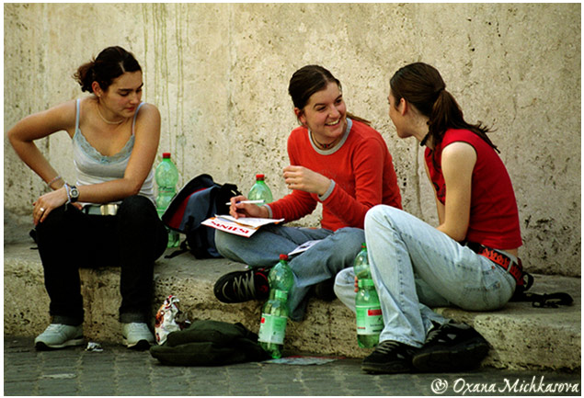

Борисяк Ольга Мирославівна

вчитель англійської мови

Теребовлянської ЗОШ №1

І-ІІІ ступенів



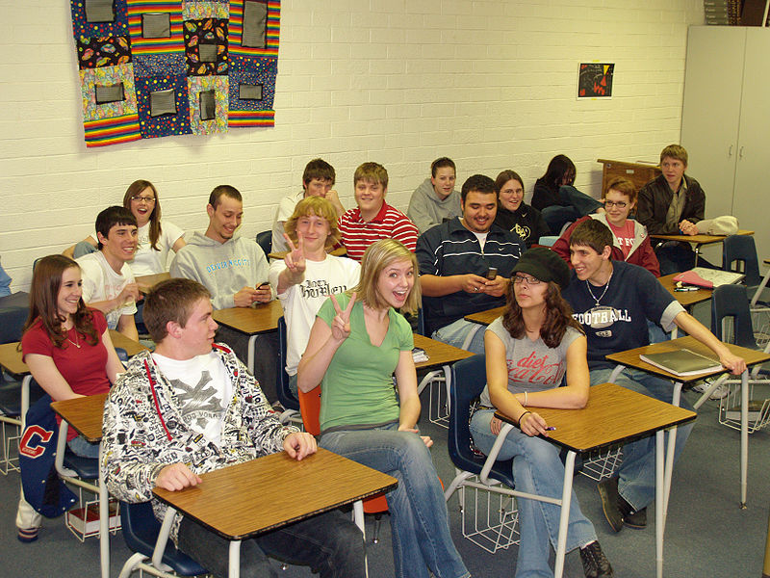

2014

Topic: **Teenagers’ world. Life and problems.**

(10th form)

**Objectives**: 1. to facilitate free speakingby eliciting personal experience and knowledge;

1. to exchange opinions, practicing all the material of the lesson in as natural way as possible;
2. to develop students' power of learning and understanding, the expansion of erudition;
3. to form pupils' ability of using their imagination while discussing different situations;
4. to develop creative thinking;
5. to teach tolerance, understanding and sympathy to the people around.

**Equipment:**

* newspaper articles;
* copies of the poem 'When Life Gets Tough';
* pictures, posters;

**PROCEDURE**

**1. INTRODUCTION**.

T: Hello, everyone! How are you feeling today?

Ps: We are OK.

T: I'm glad you are fine, so I hope you'll be energetic, active and supportive at the lesson, for the topic of today's lesson is `Teenagers' World'. And, as I told you, we are going to have a round-table discussion. So you'll have opportunity to speak about yourselves, your friends, discuss your problems. We'll sum up everything you've learned at the previous lessons on this topic. I hope you'll share your experiences, ideas and opinions.

**2. WARMING UP**

T: Before beginning your discussion, I'd like you to look at the blackboard. Here you see some quotations. Please, read and comment on them.

“O, what times! What habits!”

(O tempera! O mores!)

Marcus Eisero.

“Other times, other manners”.

“The childhood shows the man, as morning shows the day”

(John Milton)

(The pupils give their opinions and points of view)

**T:** Thank you for the comments. And now, please, take sheets of paper and write down your ideas about the life of teenagers, write down the issues you are going to dwell on at our today’s discussion. (The lesson before, the pupils are asked to decide on the issues they would like to discuss and everybody had to choose one to prepare for the discussion.) Then go to the blackboard, please, and pin your ideas here, so that everybody can see what questions we are going to touch upon at our today’s discussion.

**3. PRACTICE IN FREE SPEAKING.**

**T:** Now, you are welcome to start your discussion. Who'll begin? **PI:** Let me begin. Some days ago looking through one newspaper I came across such an expression "typical teenagers", it was written there that "typical teenagers are lazy, irresponsible, and rude to their parents. I was shocked to read this. I thought: "Am I such a person? Are my friends lazy, irresponsible and rude? No, that's not so!" Do you agree?

**P2**: Yes. I agree. Of course, there isn't such a thing as a typical teena­ger. All teens are different, as adults are. Sure, there are some characteristics shared bymodem teenagers, but not all of them are so bad.

**P3**: May I say? To begin with, I'd like to say that a recent survey showed that modern teenagers are a lot busier than adults were at their teens. Many of them try to do well at school, attend different clubs and societies, work at part time jobs and help their parents about the house.

**P4**: I'd like to add that today teenagers are facing a lot of problems. And our life is not as easy as it may seem to be. For example, let's analyze my working day. I have seven lessons every day, so I come home at about 4. I must do mylessons (it takes a lot of time to do 5, 6 or 7 hometasks, you know), then I must help my younger brother with his homework, do some household chores. And, of course, I want to have some rest, to see a film on TV or to listen to my favorite music. Do I have a lot of time for all that? No! I'm always lack of time.

**P5:** You are completely right. Lessons really take a lot of time. As for me, I'm fond of sports. So two times a week, after classes I go to the sports club to play volleyball. We have a good team and we all enjoy our trainings, it’s a good exercise and, of course, it’s great fun for us. Our team often takes part in different competitions and we seldom lose. So neither I nor my friends want to give up our hobby.

**P6**: Right! We all have some hobbies. We have some plans for future. As for me, I'm fond of computers, and I want my future profession to be connected with computers and programming, so I take some computer studies lessons after classes. One friend of mine will need a good command of English in the future so he takes some extra English classes.

**P7**: Besides, we must have some free tine, just to relax, have a rest. We are young, we want to have some fun and enjoy ourselves. As for me and my friends, we usually get together to listen to music, to play our favorite computer games, to watch video or TV and, of course, we go to discos to dance. Isn't it great to meet your friends sometimes and simply have a chat ondifferent topics?

**4.RELAXING. A GAME.**

**P8**: Oh, have an idea. As far as we are talking about our free time, let's relax as well. I suggest playing a game.

**P6**: A game? What game?

**P8**: Someone shows what he does in his free time and all the rest guess.

**P-s**: Oh, that's a good idea. Let's play. (e.g. watching TV, singing, dancing, doing nothing)

**P7**: Aren't we playing too long, friends? My dad would say we spend too much time idling.

1. Right. Our parents sometimes try to establish their own priorities in our lives. They think doing well at school and getting good exam results are the most important things. They don't care whether their child is popular with his or her peers, has a good social life or goes out with friends.

**P 11**: Or vice versa, I must say. Sometimes they care too much about their child’s friends, about the way he or she spends his free time, about the child's appearance, about music he likes. And that sets a conflict between the two generations, so-called generation gap.

**5. LISTENING + DISCUSSION**

T: Well, excuse my interrupting you. I’ve been waiting till you touch upon this problem. I have an article from the newspaper dealing with children-parents conflicts. I’d like to read it to you. It’s called “No place like home.” Listen, think over it, and comment on it.

No place like home

Today Vicky Samson came home from school at four o'clock. She watched TV for half an hour. Then she did her homework. She's working hard at the moment, because she's got exams soon. After dinner, while she was helping with the washing up, she talked to her parents about a problem she has been having at school.

It was a normal day, but it was the kind of day that makes Vicky (and her parents) very happy.

"I can't believe it", says Vick-y. "Life's wonderful. Four months ago I was living in a cardboard box under a railway bridge in London".

Last October Vicky had run away from home. How did it all start? I hated school. We always had so much work to do and I didn't see the point of it all. But it was worse at home. My parents didn't understand. It was all "Do this!", "Don't do that!" We only spoke to each other when we were arguing. One day I just couldn't stand it any more".

_

On that October day, Vicky didn't go to school. She went to the station, put on some clothes she had packed in her school bag, threw her uniform away and caught the train to London.

At first it was really exciting. There were all the bright lights, theatres and shops and some really interesting people. It was just like on the telly. I had to sleep on the streets, but I didn't mind. I was free- no school, no homework, no parents".

But soon there was no food and no money either.

"Someone nicked my purse about a week after I arrived. I couldn't get a proper job, because I was only 15 and you have to be 16. 1 worked in a restaurant for a while, washing up. That was really funny, because I'd always complained about doing the washing up at home. I didn't get much money, but at least it was warm.”

Then the restaurant closed down and Vicky was back on the streets again. She was cold, hungry and miserable, but she survived until one night about a week before Christmas. I was walking down a street, when I looked into someone's front window. There was a girl there, just like me. She was decorating a Christmas tree. I thought "If I was at home, I'd be decorating our tree now." Then I couldn't help it. I just started crying. I sat down on the pavement and cried and cried."

Luckily for Vicky, the man who lived at the house, Mr. Robinson, came home while she was sitting there. He took Vicky into the house and Mrs. Robinson gave her a cup of tea and something to eat. "They were so kind. I told them my whole story. They offered to pay for my ticket home, but I didn’t want that. I thought my parents would be angry.

But the next day she was back home. While Vicky was at their house, Mrs. Robinson went next door and telephoned the police in Birmingham. Three hours later, Vicky's father arrived to collect her. “It was the best Christmas present I'd ever had", said Mrs. Samson. "We're so grateful to the Robinson's for what they did".

**P13**: Oh, that's terrible .I'd never do this. I'd rather speak to my parents and try to persuade them they are not right.

**P1:** Don’t you think it’s exiting and you can get some new experience, meet some new people. I’d like to stay alone for some time. It’s so cool.

**P4**: Don't say that! Do you think it's nice to be somewhere in the street under

the bridge and to sleep in a box . That's terrible. And, to my mind, this is

not a good way out.

**P5**: You are right here. Running away from home isn't a good solution of

the problem. I think Vicky could go to a psychologist and speak about her problem. The specialist might have suggested some correct way out.

**P 1**: Parents-children problem isn't the only problem of modem teens, I'd like

to add that social, political and economic situation in Ukraine nowadays

isn't favorable for teens.

Our parents some 20 years ago knew what they would do, where they would study after school and where they would work after graduating. Now it's much more difficult. Unemployment, economic crisis and financial problems of the parents question all above mentioned.

**P2**: I agree with you and want to add that in Ukraine many young people nowadays think less of mental work, education, research and knowledge in general. There is a crisis of consciousness, cultural and moral values. There is a loss in terms of general human values.

1. That's quite right. And, in my opinion, all this causes alcohol drinking, taking drugs, teen pregnancy and juvenile delinquency among modem teenagers.
2. Well, Yaroslav! Why are you keeping silence? You've lived in the USA for a couple of years. Will you tell us about the life of young people there?
3. America's young people are mostly hard-working. Many have after-school jobs. Nine of ten teenagers either have a job or would like one. Many youths work part-time at fast-food restaurants, baby-sit, hold delivery jobs or work in stores. Volunteers help take care of the elderly and handicapped.

At leisure students spend much time watching TV and listening to music. The average American teenager listens to music about three hours a day. Rock-and-roll music is one of the most favourite among American teenagers.

What are the favourite sports of American young people? They prefer football, basketball, baseball and tennis.

Scouts organizations are also popular. Scouts help their community. Every year they have a Scouting for Food Drive where they collect canned food from their neighbours to give to those who need it. Scouts also clean up trash and litter in parks and school grounds in their neighborhood. Scout's favourite activity is camping. Scouts go hiking and see different animals and birds, plants and trees. They also go fishing. They learn safety rules and first aid to help people when they, are hurt.

Some families send their children to summer camps. These camps are operated by the Boy Scouts, the Girl Scouts or churches. The camps sponsored by the Red Cross teach swmmining., boating and life-saving. Among the summer camps are music camps, computer camps, hiking and backpacking camps, tennis camps, and camps with farms and ranches.

**P5:** Thanks a lot, Yaroslaw. Young people there and in Ukraine are much the same. But I'd like to add that here, in this country, we also have some youth organizations. The most popular are " Plast" and "Young Falcons". "Plast" is the Ukrainian scouting organization. The members of "Plast" have to take an oath to be true to God and Ukraine, to help other people, and to live in accordance with th Rules. It's an educational and sports society. Its activities include camping, sports and learning all about different subjects.

**P6:** I'd like to say about "Yong Felcons". My brother is a member this organization. They often go on excursions about our town and around it. They learn the history and nature of our native land. Once a week they have meetings at which they discuss different problems, work out plans for their future activity, share experiences, and consult with their supervisor. Each month they make a newspaper in which they describe a lot of new interesting facts they have found out about our town and its outskirts.

**6. CONCLUSION**

T: My dear friends! Sorry for interrupting your discussion, but our time is over. Thanks to all of you. It was interesting to listen to your various points of view and ideas. As the conclusion of our topic "Teenagers’ world" I'd like you to read a poem written by an Australian teenager Jenny Murray ”When Life Gets Tough”

When life gets tough and the road is long. When it should be right, but all seems wrong.

When the mountain's steep and too far to climb.

When the hurdles are so many, and your friends let you down.

You know you should smile, but you can only frown. When the mist creeps up, and it's hard to see. You've got to keep going, otherwise you'll freeze.

T: So, I wish you never freeze and always keep going! Be patient and wise!