***Методична розробка***

***виховної години***

***“PARADE OF THE GREAT BRITISH WOMEN”***

***PARADE OF THE GREAT BRITISH WOMEN***

*Objectives:*

* *to get the pupils acquainted with the information about famous women of Great Britain by means of their reports and Power Point presentation;*
* *to deepen and enrich pupils’ knowledge about great women and their role in the history of the UK;*
* *to encourage the pupils to get interested in history and culture of England;*
* *to give opportunities for expression of opinions about people, facts and their actions*

*Aids:* a computer (laptop), a Power Point presentation, photos, pictures

**Procedure**

*(The blackboard is decorated with pictures and portraits of famous people of Great Britain)*

***Teacher****: No matter how the world changes, no matter what country and social system people live in, no one can deny women's importance in history. But it doesn't mean that women have always been treated well and fairly, and the women's role in history was different depending on the period, too. So, today we are going to speak about women of Great Britain and their role in the history of the country.*

*England and Great Britain have had a few reigning queens when the crown had no male heirs (Great Britain still has primogeniture -- inheritance by the oldest son takes precedence over any daughters). These women rulers include some of the best-known, longest-reigning and culturally most successful rulers in British history.*

**Queen Elizabeth I**

**P1**: Queen Elizabeth I of England is one of the most fascinating women of history. Taking the throne in her own right was unusual for the time. The only previous woman Queens in England were her older sister, Mary I, the Nine Day Queen Lady Jane Grey, and the Empress Matilda whose attempt to be crowned Queen resulted in decades of civil war. During Mary's reign, there had been significant conflict over religion. Jane Grey's brief reign ended with her imprisonment and later execution.

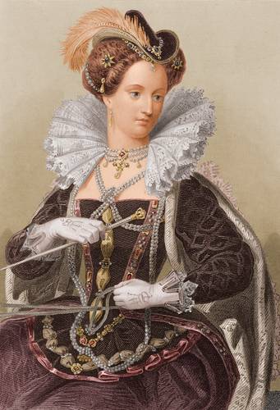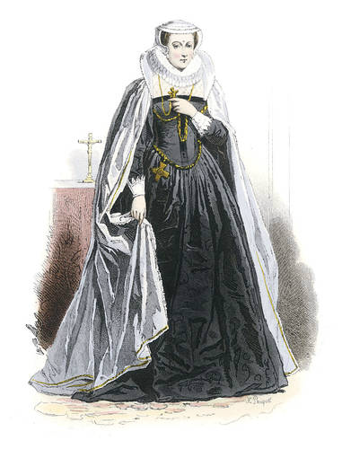 Elizabeth I was able to do what her predecessors had not been able to do.

Daughter of King Henry VIII of England and his second wife, Anne Boleyn, Elizabeth I ascended the throne of England on the death of her sister Mary. Queen Elizabeth I reigned from 1558 until her death in1603, and her early years were subject to much concern whether she would succeed -- or even survive.

**P2**: **Mary, Queen of Scots**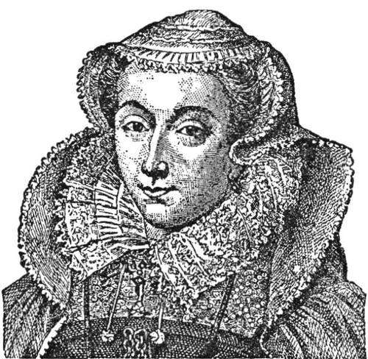

Known for: tragic ruler of Scotland whose marriages were disasters and who was imprisoned and eventually executed as a threat by her cousin, Queen Elizabeth I of England

Dates: December 8, 1542 - February 8, 1587

Also known as: Mary Stuart, Mary Stewart

The mother of Mary, Queen of Scots, was Mary of Guise (Mary of Lorraine) and her father was James V of Scotland, each in their second marriage. Mary was born on December 8, 1542, and her father James died on December 14, so the infant Mary became Queen of Scotland when she was just a week old.

James Hamilton, duke of Arran, was made regent for Mary, Queen of Scots, and he arranged a betrothal with prince Edward, the son of Henry VIII of England. But Mary's mother, Mary of Guise, was in favor of an alliance with France instead of England, and she arranged for Mary to be promised in marriage to France's dauphin, Francis.

**P3:** The young Mary, Queen of Scots, only six years old, was sent to France in 1548 to be raised as the future queen of France. She married Francis in 1558, and in July 1559, when his father Henry II died, Francis II became king and Mary became queen consort of France.

Mary, Queen of Scots, also known as Mary Stuart (she took the French spelling rather than the Scottish Stewart), was the granddaughter of Margaret Tudor; Margaret was the older sister of Henry VIII of England. In the view of many Catholics, the divorce of Henry VIII from his first wife, Catherine of Aragon, and his marriage to Anne Boleyn were invalid, and the daughter of Henry VIII and Anne Boleyn, Elizabeth, was therefore illegitimate. Mary, Queen of Scots, in their eyes, was the rightful heir of Mary I of England, Henry VIII's daughter by his first wife.

Mary Stuart's time as queen of France was very short. When Francis died, his mother Catherine de Medici assumed the role of regent for his brother, Charles IX. Mary's mother's family, the Guise relatives, had lost their power and influence, and so Mary Stuart returned to Scotland, where she could rule in her own right as queen.

**P4:** In 1560, Mary's mother died. After the death of Mary of Guise, the Catholic and Protestant nobles of Scotland signed a treaty recognizing Elizabeth's right to rule in England. Mary, Queen of Scots, was herself a Catholic, and insisted on her freedom to practice her religion.

Mary, Queen of Scots, held on to hopes of claiming the English throne which she considered hers by right. She turned down Elizabeth's suggestion that she marry Lord Robert Dudley, Elizabeth's favorite, and be recognized as Elizabeth's heir. Instead, in 1565 she married her first cousin, Lord Darnley, in a Roman Catholic ceremony.

Mary Stuart was held under house arrest for 19 years on orders of Queen Elizabeth, who saw her as a dangerous rival for the throne.

Mary, Queen of Scots was executed in Fotheringay Castle, February 8, 1587. Letters linking Mary, Queen of Scots, to a proposed uprising by Catholics, prompted Queen Elizabeth to order the execution of her cousin.

***Teacher:*** *Mary Stuart was briefly Queen of France, and became Queen of Scotland from her infancy. Mary, Queen of Scots, was considered a rival for the throne of Queen Elizabeth I - a special threat since Mary was a Catholic and Elizabeth a Protestant. Mary's choices in marriage were questionable and tragic and she was accused of plotting to overthrow Elizabeth. But Mary Stuart's son, James VI of Scotland, was the first Stuart king of England, named by Elizabeth as her successor.*

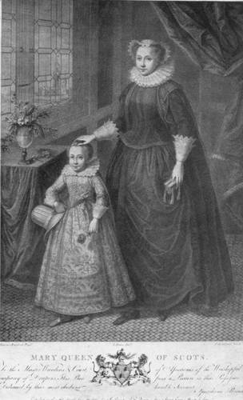

Mary's son by her second husband, Lord Darnley, succeeded her as James VI of Scotland, and succeeded Queen Elizabeth I as James I, beginning Stuart rule.

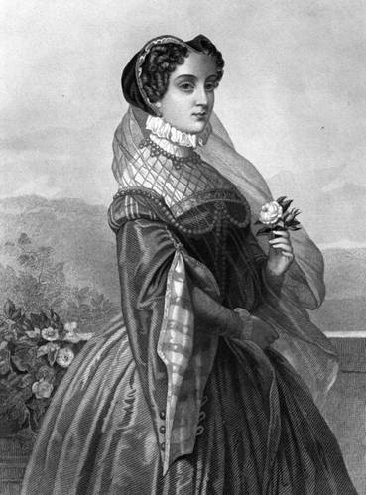

Long after her death, artists have continued

to depict Mary, Queen of Scots.

**Florence Nightingale**

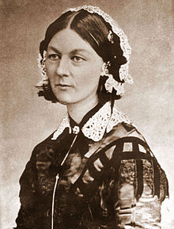Dates: May 12, 1820 - August 13, 1910

Occupation: nurse, reformer

Known for: founder of the modern.

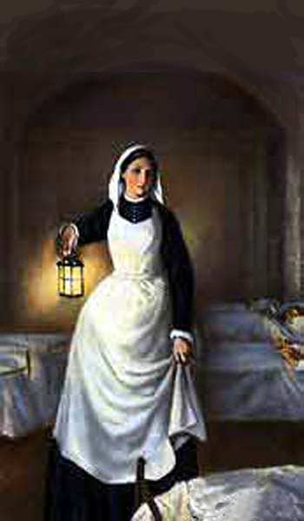Also known as: Lady with the Lamp; Flo

**P5:** Born to a comfortable family, Florence Nightingale was educated by governesses and then by her father, with her older sister, Parthenope. She was familiar with the Greek and Latin classical languages, and modern languages of French, German, and Italian. She also studied history, grammar, and philosophy. At twenty, she overcame parental objections to receive tutoring in mathematics.

On February 7, 1837, Florence Nightingale heard, by her account, the voice of God telling her that she had a mission in life. It took her some years of searching to identify that mission. This was the first of four occasions where Florence Nightingale said she heard the voice of God.

Young Florence rebelled against the life of her family, and became determined to serve society. She developed an ambition to work in hospitals. Her family was horrified, as nursing, in the early 1800s, was not considered a respectable profession.

**P6:** When the Crimean War began, reports came back to England about terrible conditions for wounded and sick soldiers. Florence Nightingale volunteered to go to Turkey, and she took a large group of women as nurses. Thirty-eight women, including 18 Anglican and Roman Catholic sisters, accompanied Florence Nightingale to the warfront.

Florence Nightingale left England on October 21, 1854, and entered the military hospital at Scutari, Turkey, on November 5, 1854.

From 1854-56, Florence Nightingale headed nursing efforts in English military hospitals in Scutari, Turkey. She established more sanitary conditions and ordered supplies, beginning with clothing and bedding. She gradually won over -- at least enough to get cooperation -- the military doctors. 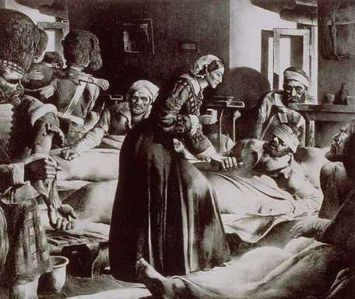

Soon, Florence Nightingale focused more on administration than on actual nursing. But she continued to visit the wards, and to send letters back home from injured and ill soldiers. Her rule that she be the only woman in the wards at night earned her the title "The Lady with the Lamp." The mortality rate at the military hospital fell from 60% at her arrival to 2% six months later.

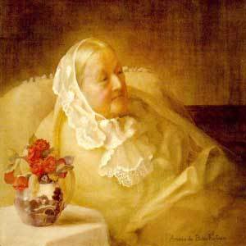Florence Nightingale was already a heroine in England when she returned. In 1860 she founded the Nightingale School and Home for Nurses in London, England.

By 1901, Florence Nightingale was completely blind. The King awarded her the Order of Merit in 1907, making Florence Nightingale the first woman to receive that honor.

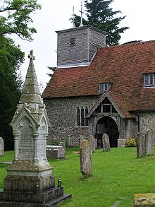 Florence Nightingale declined the offer of a

national funeral and of burial at Westminster

Abbey, requesting that her grave be marked

simply.

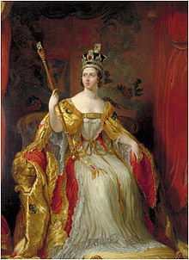 **Queen Victoria**

Known for: Longest-ruling monarch of Great Britain, ruled during a time of economic and imperial expansion. Gave her name to the Victorian Era.

Dates: May 24, 1819 - January 22, 1901

Also known as: Alexandrina Victoria, Victoria Alexandrina

**P7:** Alexandrina Victoria was the only child of the fourth son of King George III: Edward, duke of Kent. Her mother was Victoria Maria Louisa of Saxe-Coburg, sister of King Leopold of the Belgians.

Victoria became heiress-apparent of the British crown on the death of her uncle George IV, and when her uncle William IV died childless in 1837, she became Queen of Great Britain. She was crowned the next year.

She'd met her cousin, Prince Albert of Saxe-Coburg and Gotha, when they were both seventeen. When they were twenty, he returned to England, and Victoria, in love with him, proposed marriage. They were married on February 10, 1840.

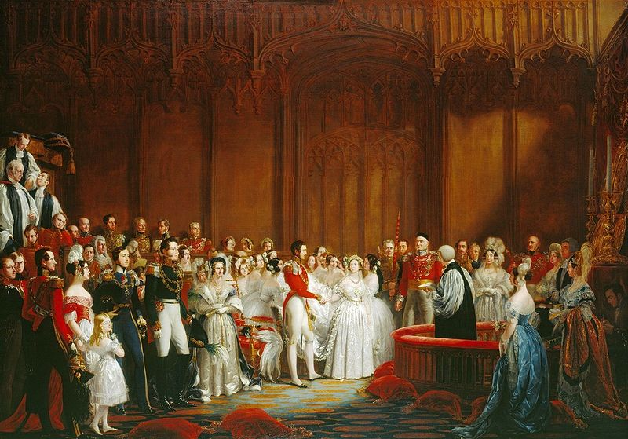

Marriage of Victoria and Albert. Painting by George Hayter

Their first child, a daughter, was born in November 1840, and the Prince of Wales, Edward, in 1841. Three more sons and four more daughters followed.

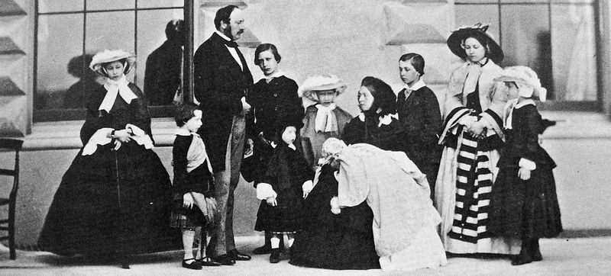

Prince Albert, Queen Victoria and their nine children, 1857. Left to right: Alice, Arthur, The Prince Consort, The Prince of Wales, Leopold (in front of him), Louise, Queen Victoria with Beatrice, Alfred, Victoria and Helena

**P8:** Victoria had traditional views on the role of the wife and mother, and though she was Queen and Albert was Prince Consort, he shared government responsibilities at least equally. His death in 1861 devastated her; her prolonged mourning lost her much popularity.

Eventually coming out of seclusion, she maintained an active role in government until her death in 1901. Her reign, the longest of any British monarch, was marked by waxing and waning popularity -- and suspicions that she preferred the Germans a bit too much always diminished her popularity somewhat. By the time she had assumed the throne, the British monarchy was more figurehead and influence than it was a direct power in the government, and her long reign did little to change that.

***Teacher:*** *The marriage of her daughters into other royal families, and the likelihood that her children bore a mutant gene for hemophilia, both affected the following generations of European history.*

**Emmeline Pankhurst**

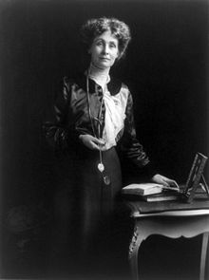 **P9:** Emmeline Pankhurst (born Emmeline Goulden) (15 July 1858 – 14 June 1928) was a British political activist and leader of the British suffragette movement which helped women win the right to vote. In 1999 Time named Pankhurst as one of the 100 Most Important People of the 20th Century, stating: "she shaped an idea of women for our time; she shook society into a new pattern from which there could be no going back."She was widely criticized for her militant tactics, and historians disagree about their effectiveness, but her work is recognized as a crucial element in achieving women's suffrage in Britain.

The suffragette movement started in the middle of the 19th century. Women demanded not only the rights to vote, but also better education for girls. However, there was a strong opposition. Many men argued that women were less intelligent and more emotional than men, and therefore could not make important decisions.

The first suffragettes believed in being legal and peaceful. They used to write letters to Parliament and organize petitions. Nothing happened. Nobody noticed them. Emmeline Pankhurst and her daughters Christabel and Sylvia decided they needed puplicity. They encouraged women to break the law. They marched through the streets. They painted “VOTES FOR WOMEN” on walls and broke windows. The women chained themselves to the railings outside Parliament and 10 Downing Street. A lot of them went to prison and refused to eat there.

Pankhurst was horrified by the screams of women being force-fed during hunger strikes. In her autobiography she wrote: "I shall never while I live forget the suffering I experienced during the days when those cries were ringing in my ears."

Gradually, opinion changed. On 6th February 1918, the British Parliament passed the law that gave women in Britain the right to vote for the first time.

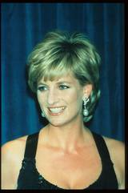 **Princess Diana**

Dates: July 1, 1961 - August 31, 1997

Known for: charity work; press focus on her fashion image

Also known as: Lady Diana Frances Spencer, Lady Diana,

Lady Di, Princess Diana. (Princess Diana, the name by which many

knew and know her, was not her proper title; it was "Diana, Princess

of Wales")

**P10:** Diana Spencer was a direct descendant of King Charles II

Father: (Edward) John Spencer, Viscount Althorpe, later Earl Spencer.

He was a personal aide to King George VI and to Queen Elizabeth II, and was a godson of Queen Mary. Diana was the third of four children. Her siblings: Lady Sarah, married Neil McCorquodale; before she married, Sarah and Prince Charles dated.

As to Princess Diana's Education, she was educated at home to age 9, then follows Riddlesworth Hall (age 9-12) and West Heath School (Kent) (age 12-16); dropped out, finishing school in Switzerland, Chateau d'Oex; left after a few months.

Married Charles, Prince of Wales (July 29, 1981; divorced August 28, 1996; heir-apparent to the throne of Great Britain). Children: William Arthur Philip Louis, Prince William, born June 21, 1982 and Henry Charles Albert David, Prince Harry, born September 15, 1984.

**P11:** Just after midnight on August 31, 1997, in Paris, a car carrying Diana, Princess of Wales, and her new love interest, "Dodi" Fayed, plus a bodyguard and a driver, went out of control in a Paris tunnel and crashed. Fayed and the driver were killed instantly; Diana died later in a hospital despite efforts to save her. The bodyguard survived despite critical injuries.

The world reacted.

First came horror and shock. Then blame: at first, the entire blame seemed directed at the paparazzi, photographers who were following the princess' car, and from whom the driver was apparently trying to escape. Later tests showed the driver had been well over the legal alcohol limit, but immediate blame was on the photographers and their seemingly incessant quest to capture images of Diana that could be sold to the press.

Then came an outpouring of sorrow and grief. The Spencers, Diana's family, established a charitable fund in her name, and within a week, $150 million in donations had been contributed.

Diana's funeral, on September 6, drew worldwide attention. About half the people in the world saw it on television. Millions turned out to line the path of the funeral procession.

**Margaret Thatcher (1925 - )**

**P12:** Margaret Thatcher was Britain's first female prime minister and served three consecutive terms in office. She is one of the dominant political figures of 20th century Britain, and Thatcherism continues to have a huge influence.

Margaret Hilda Roberts was born on 13 October 1925 in Grantham, Lincolnshire, the daughter of a grocer. She went to Oxford University and then became a research chemist, retraining to become a barrister in 1954. In 1951, she married a wealthy businessman, Denis Thatcher, with whom she had two children.

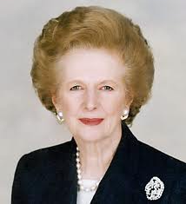Thatcher became Conservative member of parliament for Finchley in north London in 1959, serving as its MP until 1992. Her first parliamentary post was junior minister for pensions in Harold Macmillan's government. From 1964 to 1970, when Labour were in power, she served in a number of positions in Edward Heath's shadow cabinet. Heath became prime minister in 1970 and Thatcher was appointed secretary for education.

**P13:** After the Conservatives were defeated in 1974, Thatcher challenged Heath for the leadership of the party and, to the surprise of many, won. In the 1979 general election, the Conservatives came to power and Thatcher became prime minister.

An advocate of privatisation of state-owned industries and utilities, reform of the trade unions, the lowering of taxes and reduced social expenditure across the board. Thatcher's policies succeeded in reducing inflation, but unemployment dramatically increased.

Victory in the Falklands War in 1982 and a divided opposition helped Thatcher win a landslide victory in the 1983 general election. In 1984, she narrowly escaped death when the IRA planted a bomb at the Conservative party conference in Brighton.

In November 1990, she agreed to resign and was succeeded as party leader and prime minister by John Major. In 1992, Thatcher left the House of Commons for the House of Lords as Baroness Thatcher of Kesteven.

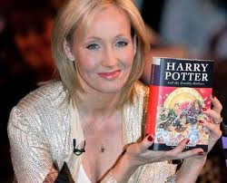 **J.K. Rowling**

**P14:** Born: 31 July 1965. Birthplace: Chipping Sodbury, England . Best Known As: The creator of the fictional wizard Harry Potter

Joanne K. Rowling (pronounced rolling) is the author of the Harry Potter series of books, which began with the 1997 tale Harry Potter and the Philosopher's Stone.

Rowling has led a "rags to riches" life story, in which she progressed from living on social security to multi-millionaire status within five years. As of March 2011, when its latest world billionaires list was published, Forbes estimated Rowling's net worth to be US$1 billion.

As a child, Rowling often wrote fantasy stories, which she would usually then read to her sister. She recalls that "I can still remember me telling her a story in which she fell down a rabbit hole and was fed strawberries by the rabbit family inside it. Certainly the first story I ever wrote down (when I was five or six) was about a rabbit called Rabbit. He got the measles and was visited by his friends, including a giant bee called Miss Bee. When she was a young teenager, her great aunt, who Rowling said "taught classics and approved of a thirst for knowledge, even of a questionable kind", gave her a very old copy of Jessica Mitford's autobiography, Hons and Rebels. Mitford became Rowling's heroine, and Rowling read all of her books.

**P15:** In 1990, while she was on a four-hour-delayed train trip from Manchester to London, the idea for a story of a young boy attending a school of wizardry "came fully formed" into her mind.She told The Boston Globe that "I really don't know where the idea came from. It started with Harry, then all these characters and situations came flooding into my head.

Rowling then moved to Porto in Portugal to teach English as a foreign language. While there, on 16 October 1992, she married Portuguese television journalist Jorge Arantes. Their child, Jessica Isabel Rowling Arantes (named after Jessica Mitford), was born on 27 July 1993 in Portugal.They separated in November 1993. In December 1993, Rowling and her daughter moved to be near Rowling's sister in Edinburgh, Scotland. During this period Rowling was diagnosed with clinical depression, and contemplated suicide.It was the feeling of her illness which brought her the idea of Dementors, soul-sucking creatures introduced in the third book.

*Harry Potter series:*

Harry Potter and the Philosopher's Stone (26 June 1997)

Harry Potter and the Chamber of Secrets (2 July 1998)

Harry Potter and the Prisoner of Azkaban (8 July 1999)

Harry Potter and the Goblet of Fire (8 July 2000)

Harry Potter and the Order of the Phoenix (21 June 2003)

Harry Potter and the Half-Blood Prince (16 July 2005)

Harry Potter and the Deathly Hallows (21 July 2007)

**Kate Middleton**

**P1:** Kate Middleton, born with her real name Catherine Middleton, is a wife of the prestigious Prince William of Wales. She was born and raised in the small town of Buckleberry in the county of Berkshire in the southern are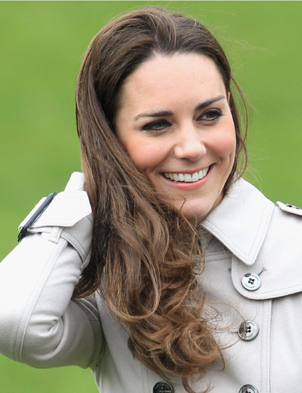a of the country of England. Her father is Michael Middleton who is a business man in England. Along with her mother Carole, both parents own the company “Party Pieces” which as the name suggests, sell party supplies. She also has a younger sister named Pippa and a brother named James.

As for her education, she attended Marlborough College which is a public British boarding school nearby Berkshire County in the county of Wiltshire. She was a very good student in college. She got eleven General Certificate of Secondary Education! These certificates certify various courses a student has passed very strenuous tests in. Not only did she do that, but of these eleven certificates, three of them were at the A level.

**P2:** In 2001, she was a student at the University of St. Andrews in the Fife, Scotland. It was here at St. Andrews where she met her sweetheart Prince William of Wales. At first they were just friends. Then in 2003, she broke up with her then boyfriend and befriended William. They have been a couple ever since. They were seen as a couple for the first time on a ski trip to Switzerland.

On April 29, 2011, the couple married at Westminster Abbey in London. Kate wore a dress designed by Sarah Burton—a fact that remained a closely guarded secret until the big day. Shortly before the wedding, Queen Elizabeth conferred Kate with the title of Catherine, Her Royal Highness the Duchess of Cambridge. She will not officially be declared a princess until the current Prince of Wales, Prince Charles, inherits the throne.

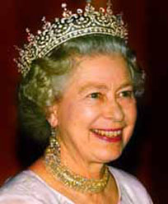 **Elizabeth II**

1952-Present

**P3:** Elizabeth II became Queen of the United Kingdom of Great Britain and Northern Ireland in 1952. In addition she is head of the Commonwealth.

Elizabeth was born on 21 April 1926 in London, the first child of Albert, Duke of York (Герцог Йоркський), and his wife, formerly Lady Elizabeth Bowes-Lyon. She initially had little prospect of succeeding to the throne until her uncle, Edward VIII, abdicated in December 1936. Her father then became George VI and she became heir.

Elizabeth and her younger sister Margaret were educated at home. On the outbreak of war in 1939, they were evacuated to Windsor Castle. In 1945, Elizabeth joined the war effort, training as a driver in the Women's Auxiliary Territorial Service (WATS) (Жіноча допоміжна територіальна служба (існувала в часи 2-ї світової війни)). In November 1947, she married a distant cousin, Philip Mountbatten (formerly Prince Philip of Greece and Denmark), who was created duke of Edinburgh. The couple have four children.

**P4:** George VI died on 6 February 1952 while Elizabeth and Philip were in Kenya. She returned home immediately, and was crowned at Westminster Abbey in June 1953. For more than 50 years, during a period of great change in Britain, the Queen has carried out her political duties as head of state, the ceremonial responsibilities of the sovereign and a large annual programme of visits in the United Kingdom as well as numerous foreign tours. In 1953 "Head of the Commonwealth" was added to the long list of royal titles which she possesses.

Despite the controversies and scandals surrounding her children and other members of the royal family, she remains a respected head of state . In 2002, Elizabeth celebrated her golden jubilee (50 years on the throne) and in 2006 her 80th birthday.

**APPENDICES**

*Some additional information to learn and tasks to do*

***I. Queen Elizabeth II***

**I.** The Queen meets thousands of people each year in the UK and overseas. Before meeting Her Majesty, many people ask how they should behave. The simple answer is that there are no obligatory codes of behaviour - just courtesy.

However, many people wish to observe the traditional forms of greeting.

For men this is a neck bow (from the head only) whilst women do a small curtsy. Other people prefer simply to shake hands in the usual way.

On presentation to The Queen, the correct formal address is 'Your Majesty' and subsequently 'Ma'am'.

You can write to Her Majesty at the following address:

*Her Majesty The Queen*

*Buckingham Palace*

*London SW1A 1AA*

If you wish to write a formal letter, you can open with 'Madam' and close the letter with the form *'I have the honour to be, Madam, Your Majesty's humble and obedient servant'.*

This traditional approach is by no means obligatory. You should feel free to write in whatever style you feel comfortable.

**II.**  The Queen of England (Elizabeth II) has got lots of homes. Sometimes she lives at Buckingham Palace in London and sometimes at Windsor Castle in Windsor.

|  |  |  |
| --- | --- | --- |
| 1.Write the verbs in the gaps. | | **lived had stays ~~built~~  started** |
| ***Buckingham Palace***  сканирование0007 - копия (2)In 1705, the Duke of Buckingham (1) *built* Buckingham Palace. Queen Victoria (2) _____ there in 1837. After that, different kings and queens lived in the palace. Today, Queen Elizabeth II often (3) _____ there. When she is at 'home', a flag flies from the roof. | ***Windsor Castle***  William I (William the First) (4) _____ to build* this castle in the 1070s. The castle is a favourite place for royal weddings. Prince Charles and Camilla Parker-Bowles (5) _____ a big party in the castle after their wedding in 2005.  сканирование0007 - копия (2) - копия | | |

2.Match the pictures with the numbered texts.

***1. Money problems* __________**

The Queen opened Buckingham Palace to the public for the first time in 1993. Why? Because she needed money after a big fire at Windsor Castle. The fire lasted for 15 hours and it destroyed a lot of rooms.

***2. Big Houses* __________**

Buckingham Palace has more than 500 rooms and 78 bathrooms. 19 of the rooms are open to the public for two months each year. Windsor Castle is a lot bigger - it has over 1,000 rooms!

***3. The Royal Guard* __________**

Every day, lots of tourists stand in front of the palace to watch the Changing of the Guard. The Guards wear red jackets and 'bearskins' (very big black hats). They mustn't smile at the tourists when they are working. This is sometimes very difficult!

***4. The gardens* __________**

The gardens at Buckingham Palace are very big. In 2002, the Queen had a big pop concert there to celebrate 50 years of being Queen. She also has big tea parties there and invites different people to them. For a picnic, go to Windsor. The gardens there are bigger and they are always open.

***5. Not invited* __________**

In 1982 the Queen woke up at Buckingham Palace with a surprise. There was a strange man sitting on her bed! His name was Michael Fagan. They talked for half an hour. Fagan asked the queen for a cigarette, but she couldn't give him one. She doesn't smoke. There are 200 bedrooms in the Palace. How did he find the right one?

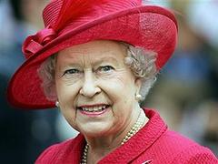

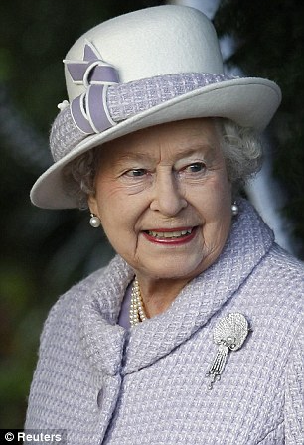

***II. Florence Nightingale***

1.Complete the text about Florence’s life with these words.

|  |
| --- |
| **food countries ~~angry~~ dirty student books hospital job** |

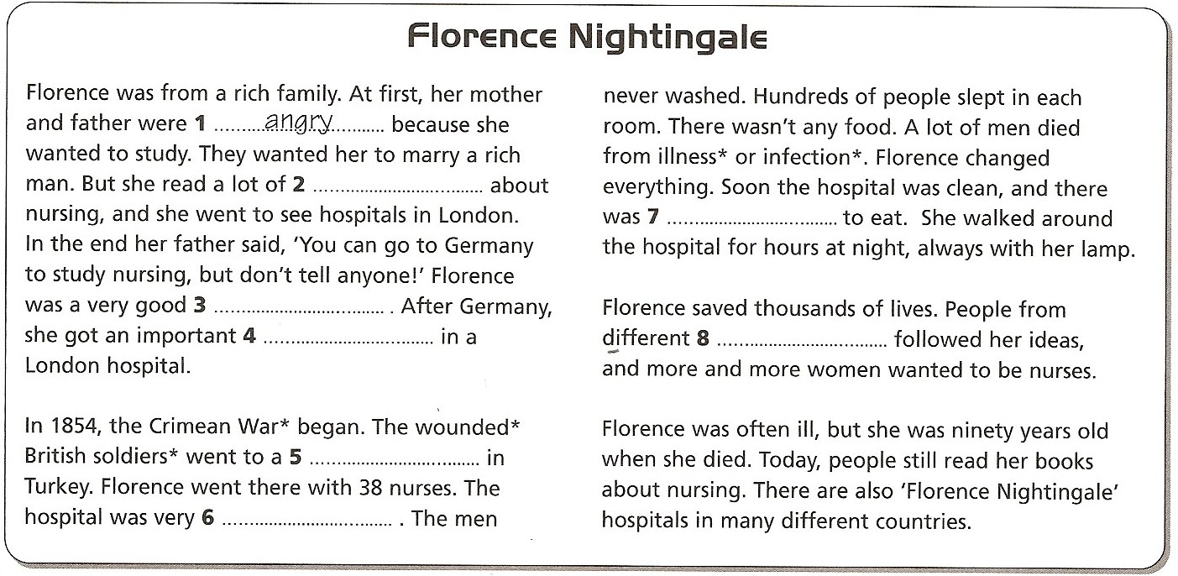

2. Join the sentences halves in the lamps to learn more about Florence. Write the sentences.

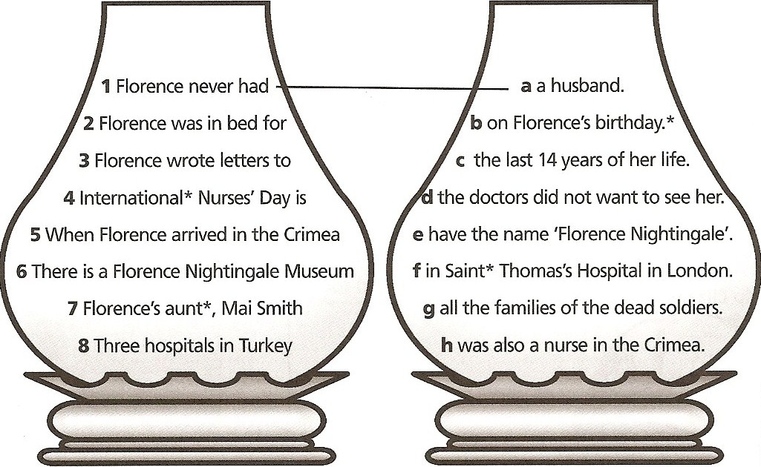

***III. Kate Middleton***

Buckingham Palace has sent out invitations for the wedding of Prince William and Kate Middleton. Officials have not (1) ____ who is invited but journalists who follow the royal family say half of the guests are family and friends. The (2) ____ will be leading British politicians, VIPs from all over the world, and a (3) ____ of stars and celebrities. Of those invited to the ceremony at London’s Westminster Abbey on April 29, a third will go (4) ____ to attend a celebration reception at Buckingham Palace hosted by Queen Elizabeth, and then half of those will go on to a dinner party hosted by Prince Charles, William’s father. This (5) ____ group will be family and close friends of the (6) ____ couple. It is expected they will go on honeymoon the following day.Prince William and Kate Middleton met at St. Andrew’s University in Scotland. They began (7) ____ in 2003 and shared an apartment together. Their relationship became the subject of (8) ____ media speculation from the very beginning. This intensified after Ms Middleton attended a special parade when William graduated from the Sandhurst military academy. The attention from the press became so (9) ____ that William had to ask the paparazzi to keep their distance and respect Ms Middleton’s privacy. William has painful (10) ____ of how the media hounded his mother, Princess Diana. In 2007, there were reports that the couple had split (11 ____, even though they were regularly seen together at various high-profile events and holidays. Prince William (12) ____ to Kate on 19 October 2010 on a trip to Kenya.

*Put the correct words from the table below in the above article.*

|  |  |  |  |  |
| --- | --- | --- | --- | --- |
| 1. | a) enclosed | b) closed | c) reclosed | d) disclosed |
| 2. | a) rest | b) fest | c) lest | d) pest |
| 3. | a) scatter | b) scattered | c) scattering | d) scatters |
| 4. | a) in | b) on | c) an | d) into |
| 5. | a) selection | b) select | c) selects | d) selecting |
| 6. | a) fine | b) smiley | c) happy | d) joy |
| 7. | a) dating | b) dated | c) dates | d) date |
| 8. | a)considering | b) considerate | c) considerably | d) considerable |
| 9. | a) pretense | b) tenses | c) presence | d) intense |
| 10. | a)memorial | b) memories | c) memory | d) remember |
| 11. | a) up | b) in | c) down | d) over |
| 12. | a)proposal | b)proposing | c) proposed | d) proposition |

***IV. Selected Queen Elizabeth I Quotations***

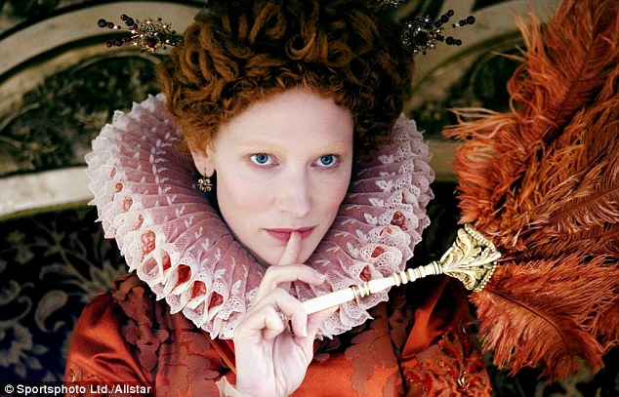

• Monarchs ought to put to death the authors and instigators of war, as their sworn enemies and as dangers to their states.

• For me it will be enough that a marble stone should declare that a queen having reigned such a time, lived and died a virgin.

• I know I have the body but of a weak and feeble woman; but I have the heart and stomach of a king, and of a king of England, too.

• I would rather go to any extreme than suffer anything that is unworthy of my reputation, or of that of my crown.

• I have the heart of a man, not a woman, and I am not afraid of anything.

• A clear and innocent conscience fears nothing.

• It is a natural virtue incident to our sex to be pitiful of those that are afflicted.

• Though the sex to which I belong is considered weak you will nevertheless find me a rock that bends to no wind.

• Ye may have a greater prince, but ye shall never have a more loving prince.

• To be a king and wear a crown is a thing more glorious to them that see it than it is pleasant to them that bear it.

***V. Margareth Thatcher Quotes :***

*A world without nuclear weapons would be less stable and more dangerous for all of us.*

*Any woman who understands the problems of running a home will be nearer to understanding the problems of running a country.*

*Being powerful is like being a lady. If you have to tell people you are, you aren't.*

*Being prime minister is a lonely job... you cannot lead from the crowd.*

*Democratic nations must try to find ways to starve the terrorist and the hijacker of the oxygen of publicity on which they depend.*

*Disciplining yourself to do what you know is right and important, although difficult, is the highroad to pride, self-esteem, and personal satisfaction.*

*Europe was created by history. America was created by philosophy.*

*I always cheer up immensely if an attack is particularly wounding because I think, well, if they attack one personally, it means they have not a single political argument left.*

*I am in politics because of the conflict between good and evil, and I believe that in the end good will triumph.*

***I do not know anyone who has got to the top without hard work. That is the recipe. It will not always get you to the top, but should get you pretty near.***

*I don't mind how much my Ministers talk, so long as they do what I say.*

*It's passionately interesting for me that the things that I learned in a small town, in a very modest home, are just the things that I believe have won the election.*

*I like Mr. Gorbachev, we can do business together.*

*I love argument, I love debate. I don't expect anyone just to sit there and agree with me, that's not their job.*

*I seem to smell the stench of appeasement in the air.*

*I usually make up my mind about a man in ten seconds, and I very rarely change it.*

*I'm extraordinarily patient provided I get my own way in the end.*

*I've got a woman's ability to stick to a job and get on with it when everyone else walks off and leaves it.*

*If my critics saw me walking over the Thames they would say it was because I couldn't swim.*

*If you just set out to be liked, you would be prepared to compromise on anything at any time, and you would achieve nothing.*

*If you lead a country like Britain, a strong country, a country which has taken a lead in world affairs in good times and in bad, a country that is always reliable, then you have to have a touch of iron about you.*

*If you set out to be liked, you would be prepared to compromise on anything at any time, and you would achieve nothing.*

*If you want something said, ask a man; if you want something done, ask a woman.*

*If you want to cut your own throat, don't come to me for a bandage.*

*It is not the creation of wealth that is wrong, but the love of money for its own sake.*

*It may be the cock that crows, but it is the hen that lays the eggs.*

*It pays to know the enemy - not least because at some time you may have the opportunity to turn him into a friend.*

*It's a funny old world.*

*No one would remember the Good Samaritan if he'd only had good intentions; he had money as well.*

*No woman in my time will be prime minister or chancellor or foreign secretary - not the top jobs. Anyway, I wouldn't want to be prime minister; you have to give yourself 100 percent.*

*Nothing is more obstinate than a fashionable consensus.*

*Of course it's the same old story. Truth usually is the same old story.*

*One of the things being in politics has taught me is that men are not a reasoned or reasonable sex.*

*Ought we not to ask the media to agree among themselves a voluntary code of conduct, under which they would not say or show anything which could assist the terrorists' morale or their cause while the hijack lasted.*

*Pennies do not come from heaven. They have to be earned here on earth.*

*People think that at the top there isn't much room. They tend to think of it as an Everest. My message is that there is tons of room at the top.*

*Plan your work for today and every day, then work your plan.*

*Platitudes? Yes, there are platitudes. Platitudes are there because they are true.*

*Power is like being a lady... if you have to tell people you are, you aren't.*

*Standing in the middle of the road is very dangerous; you get knocked down by the traffic from both sides.*

*The battle for women's rights has been largely won.*

*There are still people in my party who believe in consensus politics. I regard them as Quislings, as traitors... I mean it.*

*There can be no liberty unless there is economic liberty.*

*There is no such thing as society: there are individual men and women, and there are families.*

*This lady is not for turning.*

*To cure the British disease with socialism was like trying to cure leukaemia with leeches.*

*To me, consensus seems to be the process of abandoning all beliefs, principles, values and policies. So it is something in which no one believes and to which no one objects.*

*To wear your heart on your sleeve isn't a very good plan; you should wear it inside, where it functions best.*

*We were told our campaign wasn't sufficiently slick. We regard that as a compliment.*

*What Britain needs is an iron lady.*

*What is success? I think it is a mixture of having a flair for the thing that you are doing; knowing that it is not enough, that you have got to have hard work and a certain sense of purpose.*

*You and I come by road or rail, but economists travel on infrastructure.*

*You don't tell deliberate lies, but sometimes you have to be evasive.*

*You may have to fight a battle more than once to win it.*

