1O Famous American Women

'.
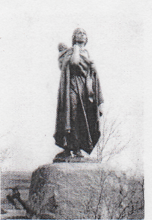

Sacaqawea was a Native
American woman who traveled with the Lewis and Clark Expedition (excursion). She worked as an interpreter and guide for the explorers. They explored the Western United States from 1804 to 1806. She traveled thousands of miles from North Dakota to the Pacific Ocean on this excursion. Without Sacagawea, Lewis and Clark would have had serious problems. She was able to speak to other Native Americans and she taught the explorers a lot about nature.
Emily Dickinson is _{one} of
the most famous American poets. She lived from 1830-1886. Emily Dickinson was a very shy person, but wrote beautiful poetry. Many of her poems were about death and immortality. An example of the words of Emily Dickinson: "Because I could not stop for death, He kindly stopped for me; The carriage held but just ourselves and immortality."

Harriet Tubman
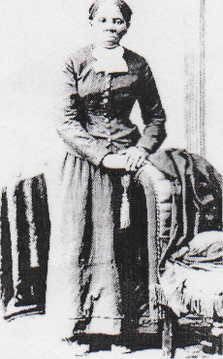
was a very
important person during the American Civil War (1861-1865). This was a war between the Northern and Southern American States. The North wanted to end slavery in the USA and the South still wanted slavery. Harriet Tubman was an African American woman who escaped slavery, and then helped more than 300 slaves to escape to the North to freedom. Her organization was called the Underground Railroad.

