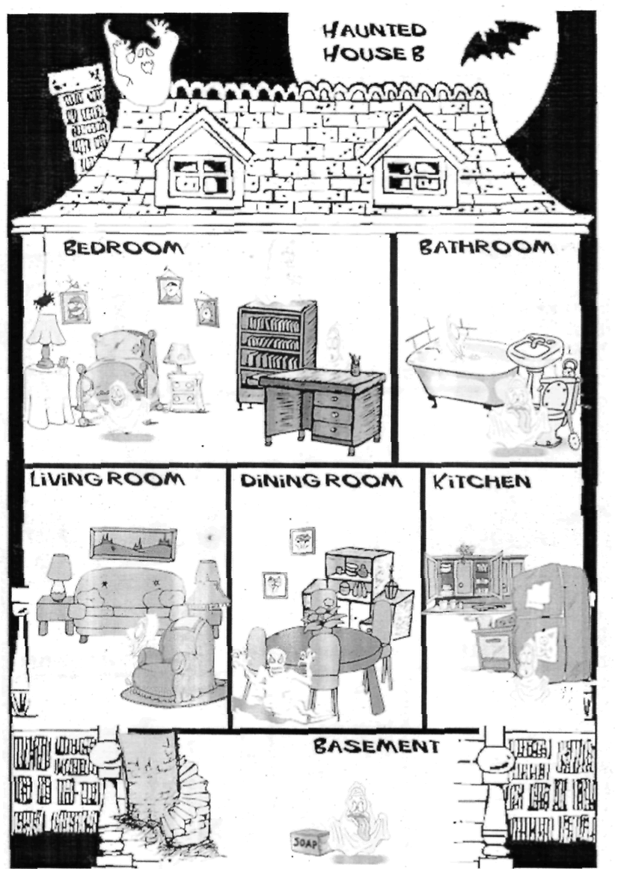
Where is the ghost?
He is

SPEAKING

