What’s Wrong?

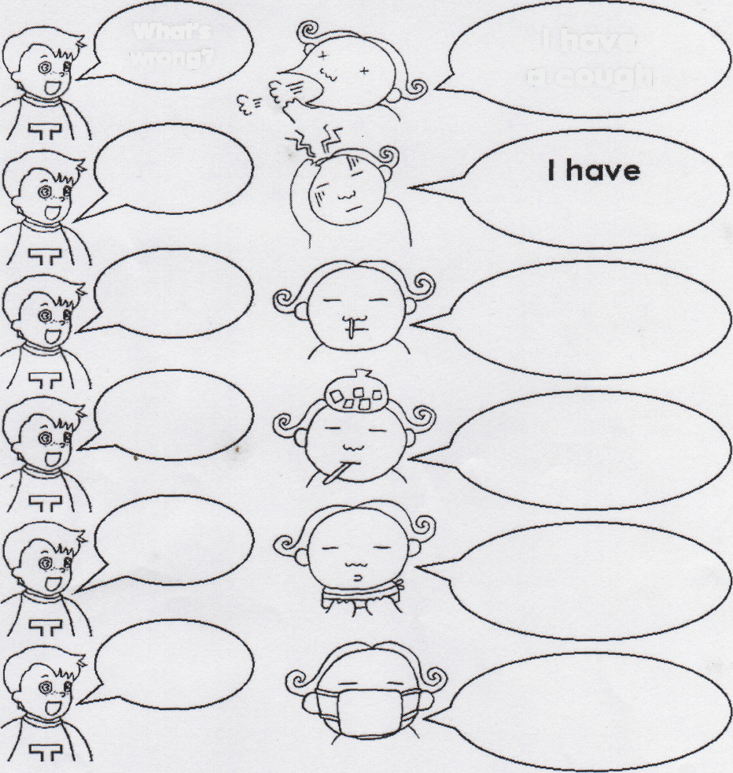
What's wrong?
I have a cough

a runny nose a cough a sore
throat a headache a cold
a fever

