Name: Date:

Class:
St. Valentine's Day

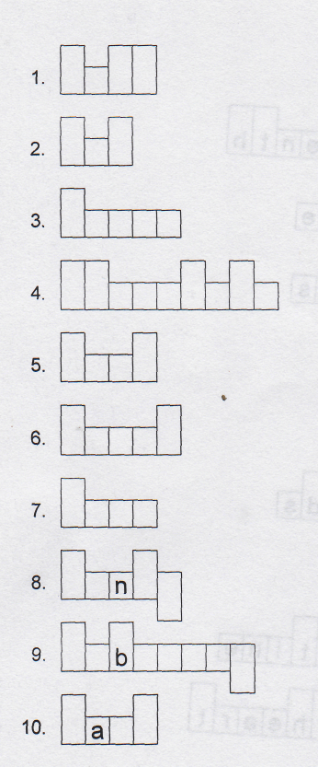
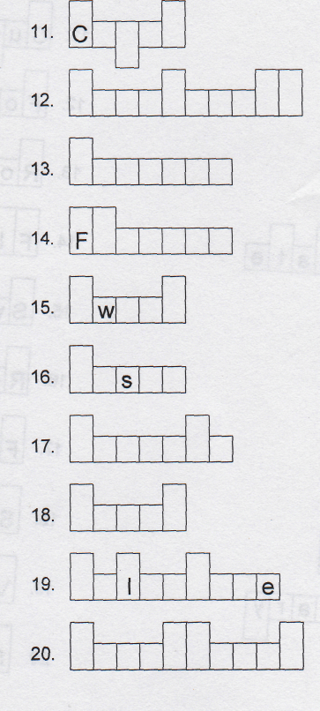

1 . Arrow | 6. February | 11. Heart | 16. Roses
2. Candy | 7. Flowers | 12. Love | 17. Saint
3. Card | 8. Fourteenth | 13. Pink | 18. Sweet
4. Chocolate | 9. Friends | 14. Red | 19. Sweetheart
5. Cupid | 10. Gift | 15. Romance | 20. Valentine
Score:

