Superlative Fun!
Directions: Complete the sentence by looking at the picture and using the keywords provided.



Kanyes West—good—rapper 2-

Scarlett Johansson—pretty—Hollywood actress
3-
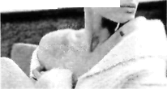
Angelina Jolie—beautiful—woman in the world
4-

Brad Pitt—handsome—man in the USA
5-
Lady Gaga—weird—pop star nowadays


Johnny Depp—cool—movie star 7-

Obama—interesting—international politician 8-

This mouse—talented—mouse in the world 9-

He—clever—boy in our class 10-


Baseball—awesome—sport

