Susan B. Anthony
a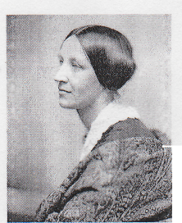
was a
social activist who fought for Women's Rights. She helped change how people think about women. For example, Susan B. Anthony believed that woman should have the right to vote. 14 years after her death, in 1920, the USA changed their laws and since that time, woman in the USA can vote. She is also the first American woman to be on an American coin.

Amelia Earhart
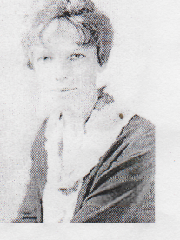
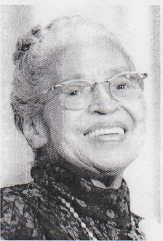
was the first
woman pilot to fly across the Atlantic Ocean. She made this trip in 1928. Later, in 1932, she was the first woman pilot to fly across the Atlantic Ocean alone. She had many successes as a woman pilot and won many awards. Amelia Earhart is considered a feminist icon (symbol). In July 1937, Earhart was flying alone and her airplane went missing. This was a sad day for the American people. Amelia¹ Earhart was never seen again.
Rosa Parks
was a famous Civil
Rights Activist. She believed that all people, no matter what race (for example: black or white) should have the same rights. Her most famous action as an activist happened on December 1, 1955 in the state of Alabama. On this day Rosa Parks refused to give up her seat for a white passenger. She became a symbol and a leader of the Civil Rights Movement.

