Jacqueline Kennedy Onassis Jackie O
a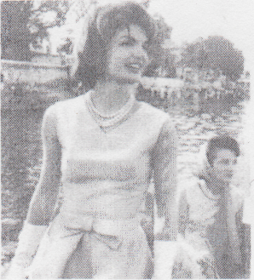

the wife of the John F. Kennedy (the 35^{fh} President of the USA). As a First Lady, she is remembered for her style and elegance. She was also loved by Americans for being brave after the assassination of John F. Kennedy in 1963. (Later in life, she was remarried to Aristotle Onassis.) Jackie O is also remembered for her successful career as a book editor and for being a great supporter of the arts.

Oprah Winfrey
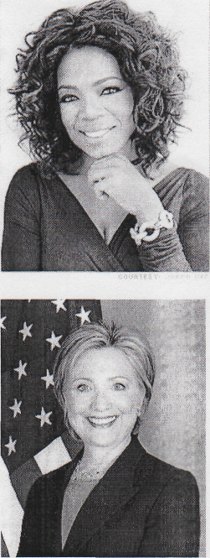
Is a contemporary American television host, producer, and philanthropist. She is most known for her talk show, which is one of the most famous TV programmes in the USA. Her work made her very influential and a billionaire. She is the richest African American woman in the world. Oprah gives a lot of money to charities all around the world.
Clinton
t
American politician. She is currently the Secretary of State of the USA. Before this, Hillary Clinton worked as a New York Senator. In 2008 she was a Democratic candidate for the presidential election, but was beaten by Barack Obama. In her political work, she is a champion of health care, education, and family rights.

