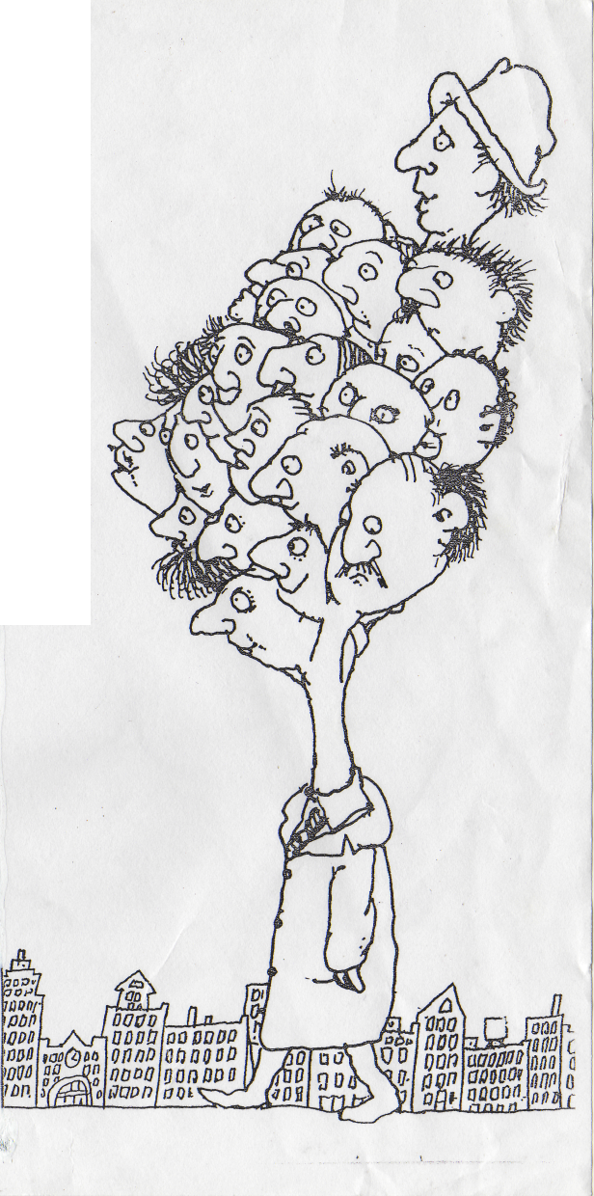
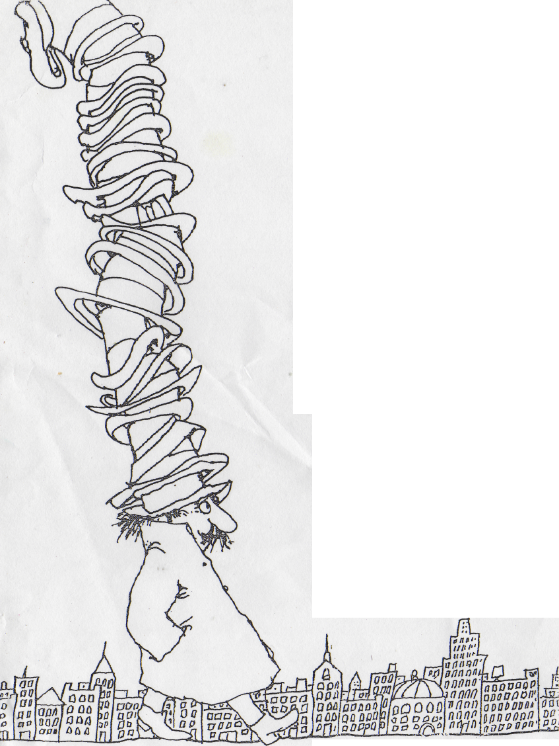
MR. SMEDS AND MR. SPATS
Mr. Spats
Had twenty-one hats,
And none of them were the same.
And Mr. Smeds
Had twenty-one heads
And only one hat to his name.
Now, when Mr. Smeds Met Mr. Spats, They talked of the Buying and sellingiof hats. And Mr. Spats Bought Mr. Smeds'hat! Did you ever hear anything Crazier than that?

