Spitting Image

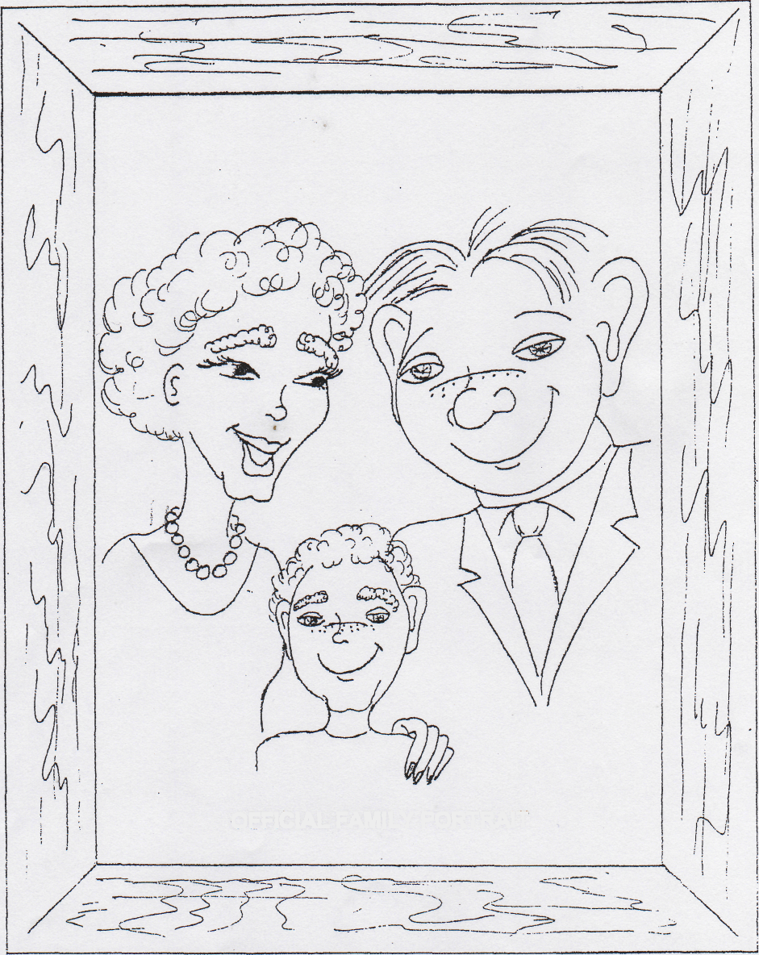
OFFICIAL FAMILY PORTRAIT

