The growing need in communication and cooperation between different countries, people with different languages and various cultural traditions, the new educational system in Ukraine demand complete changes in approaches to teaching, renovation of the content, methods of teaching foreign languages at the secondary school level. The Ministry of Education and Science of Ukraine has made up a decision on creating the new program on foreign languages teaching for non-specialized secondary schools.
The knowledge of foreign languages is important and essential condition for personal, cultural, professional and economic contacts development. The renovation of the goals and content of education affects the renovation of the teaching technologies. This program is based on the results of the contemporary psycho-pedagogical and methodical researches, which regard learning foreign languages as the process of the student's individual development in the context of "the polylogue of cultures".
Defining new goals, the content and methods of teaching, this program assists the process of reforming the secondary education in the branch of teaching foreign languages, taking into consideration Recommendations of the Council of Europe.
This Program does not limit teacher independence and creative initiative. It assumes the flexibility in selecting and distributing the educational material according to the students" needs and means of teaching (leaching and learning complexes (resources), student books, textbooks, audio/video aids, etc.).

Program principles
The main principles of the program are:
communicative approach;
individual orientation;
- student autonomy;
- integrated teaching different language skills (listening, speaking, reading & writing).

Educational goals
Teaching foreign languages assumes student's practical mastery of the speech skills on the level sufficient for foreign language communication with four types of speech activities (listening, speaking, reading and writing) in standard situations. The content of the communicative competence, which is assumed as acquired by students, is submitted in the following scheme:
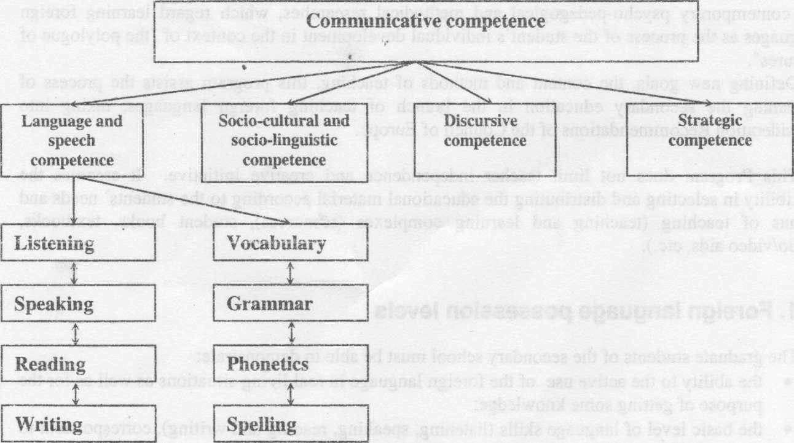

Willbrand M. L. & Riecke R.D. in their book named as ‘Teaching oral communication in Elementary schools' (1983) defined ‘Oral Communication' as the process of interacting through heard and spoken messages in a variety of situations. And instruction which integrates the teaching of listening and speaking over various situations has been termed "the communicative approach to language teaching."

CHARACTERISTICS OF THE COMMUNICATIVE APPROACH
Although no single methodology has been described for the communicative approach, several characteristics are summarized as follow. -

Communicative approach stimulate ‘real life' communicative experiences

The learning task is content-based, theme-based, project-based or some combination of the three mentioned ones.

Analysis of language is done in specific contexts.

The focus is not upon listening and speaking but upon using language to communicate and to learn

Speaking becomes valuable not only as isolated skills or groups of skills, but as vehicles for learning across all subject areas. Oral communication should be integrated with other areas of teaching.

CLASSROOM ACTIVITIES USED BY ME AT THE MODULES IN THE CLT

Role play |  | Interviews |  | Group work |  | Games |  | Pair work

1. Fundamentally it is important to me to establish an appropriate physical and psychological atmosphere in the classroom in which students feel comfortable and take increasing risibility for their own learning.
2 Listening has suggested specific ways in which I effectively model listening in the classroom. So I follow communicative approach. These include the following

(a) Providing a wait time for students to answer.

(b) Engaging in attending behaviors such as eye contact and responsive facial expression.

(c) Giving students undivided attention when they are speaking.

(d) Providing a supportive climate by being approachable.

(e) Not interrupting students.

(f) Withholding judgments until students have finished speaking and

(g) Giving prompt and thoughtful responses to students questions.

3. Developing oral language pragmatic skills and communicative competence I use various speaking skills within appropriate classroom settings so that they should follow communicative approach. Important conversational skills include turn taking imitation strategies, maintenance strategies and termination strategies. The instructor's role is as that of a presenter, and with that role such practices as speaking clearly with adequate volume and engaging listeners by means of appropriate nonverbal behavior can be modeled.

4 I also suggest creative activities for involving students in various kinds of talking experiences. Drama, role-plying, puppetry, debate, formal reporting and small and large group discussions have been covered in language arts text books.

5 Two types of communicative activities that are implemented by me in the class. One controlled communicative activities and the other, free
communicative activities. Controlled communicative activities include situations creation, guessing games, information gap exercises, exchange of personal information etc and free communicative activities include pair work and group work, role play.

6 To follow communicative approach in the class, I use workouts. Workouts are language learning and language using activities, which enhance the learner's overall acquisition process, providing by the teacher with variety of ways through which to make this process engaging and rewarding

Communicative approach is not just limited to oral skills. Reading and writing skills need to be developed to promote pupils' confidence in all four skill areas. I use elements encountered in variety of ways (reading/ summarising/ translating/ discussion/ debates) - makes language more fluid and pupils' manipulation of language more fluent.

Communicative approach seeks to use authentic resources.I use authentic textbooks from Oxford University Press to teach my students. They are more interesting and motivating. In Foreign language classroom authentic texts serve as partial substitute for community of native speaker. Newspaper and magazine articles, poems, manuals, recipes, telephone directories, videos are also used by me at the modules. Visual resources can be exploited at whatever level one wishes - help to motivate and focus pupils' attention.
Effective Writing:
is focused on the topic and does not contain extraneous or loosely related information;
has an organizational pattern that enables the reader to follow the flow of ideas because it contains a beginning, middle, and end and uses transitional devices;
contains supporting ideas that are developed through the use of details, examples, vivid language, and mature word choice;
follows the conventions of standard written English (i.e., punctuation, capitalization, and spelling) and has variation in sentence structure
The kinds of activities, used by me at the modules are different:
Dictations  poems |  | Stories  Tongue-twisters |  | Advertisements  e-mails |  | Recipes  summaries

The communicative approach is activity based, interactive, and learner centred. It encourages learners of a language to use that language as much as possible, for real, purposeful communication, in real life or in other relevant situations, such as role-playing. Learners are expected to become competent communicators in the language, able to convey meaning to others.
The goals of the communicative approach are to enable learners to:
use language appropriately in a range of social and cultural contexts
understand and convey meaning through interaction with other speakers of the language. To my mind communicative approach helps students to develop their creative abilities,to overcome language barrier.
Of course, I faced some problems in my teaching practice too.
1 Unwillingness of pupils to study in general.
2 To be persistant on the way of achieving goals.
I try to motivate them and stimulate every time. Success comes in cans, not cant’s.

