План-конспект відкритого уроку
з англійської мови
в 9 класі

«Natural disasters»

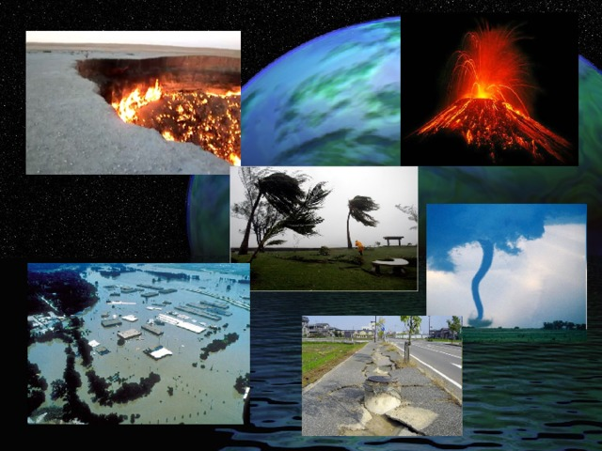

Підготувала
вчитель англійської мови
Тилятинська Н. М.

Тема уроку : Natural disasters
Мета (формувати компетентності): предметні :навчати учнів розуміти та вживати лексику, що стосується теми «Природні катастрофи» в усному та писемному мовленні; проконтролювати навички аудіювання; навчати учнів правилам безпеки під час природніх катастроф; навчати здобувати інформацію з тексту;
ключові : вміти вживати лексичний матеріал по темі в мові, письмі; вдосконалювати лексичні навички говоріння, аудіювання і письма;
комунікативні: розвивати творчі вміння складати газетну статтю; продовжувати формувати навички роботи в колективі та в групах ;
інформаційні: навчати орієнтуватися в іншомовному аудіо тексті, навчати узагальнювати інформацію з різних джерел по темі;
загальнокультурні : вчити емоційно ціннісно ставитися до природи та всього, що нас оточує; виховувати позитивне ставлення до іноземної мови як засобу спілкування, виховувати толерантність.

Обладнання: дошка, НМК Solutions Pre-Intermediate 2nd edition,
дидактичний матеріал, пов’язаний з темою уроку, електронна
презентація.
Тип уроку: урок вивчення нового навчального матеріалу.

Хід уроку:
І.ПІДГОТОВКА ДО СПРИЙНЯТТЯ ІНОЗЕМНОЇ МОВИ
- Greetings
T.: Good morning, dear friends!
We live in a magic world. This wonderful world is our nature. Nature gives us life. Nature teaches us to be kind and clever, attentive and creative. It teaches to understand the world around us. But our Planet is very fragile. Every year small and big natural disasters occur in different parts of the world.
- Theme, aims. (slides 2-3 )
T.: As you guessed the theme of our lesson is “Natural disasters”. Today we are going to speak about different kinds of natural disasters. Clear up how these natural disasters affect humans and what we should do to live with them and to protect ourselves from different natural catastrophes.
For the slogan I`ve chosen famous words “Mother planet is showing us the red warning light – be careful – she is saying”. The Dalai Lama.
By the end of lesson you should be able:
- to recognize and understand new words and words combinations;
- to participate in common conversational exchanges about the topic of today`s lesson
- Warming-up
T.: I`d like you to read this quotation and understand the importance of knowledge.
We cannot stop natural disasters
But we can arm ourselves with knowledge:
So many lives wouldn’t have to be lost
If there was enough disaster preparedness.
Petra Nemcova. ( slide 4)

ІІ. ОСНОВНА ЧАСТИНА УРОКУ.
1. Presenting topical vocabulary.
T: You see the pictures of 12 natural disasters and we will learn their names during our lesson today . Have you ever heard of them? ( Ex.3, p.74 )
T: There are 6 photos of some natural disaster in your books . Can you name them? ( Ex. 2, p.74 )
T: Open your books at page 131. Here you can see more pictures of natural disasters. What are they ?
2. Group work. Ex .4 , p74
T: Now you will work in groups. You have to divide these natural disasters into 4 groups .
- water ( in any form ) or no water
- wind
- very hot temperatures
- rocks or earth moving
- Listening. Ex .5 , p74

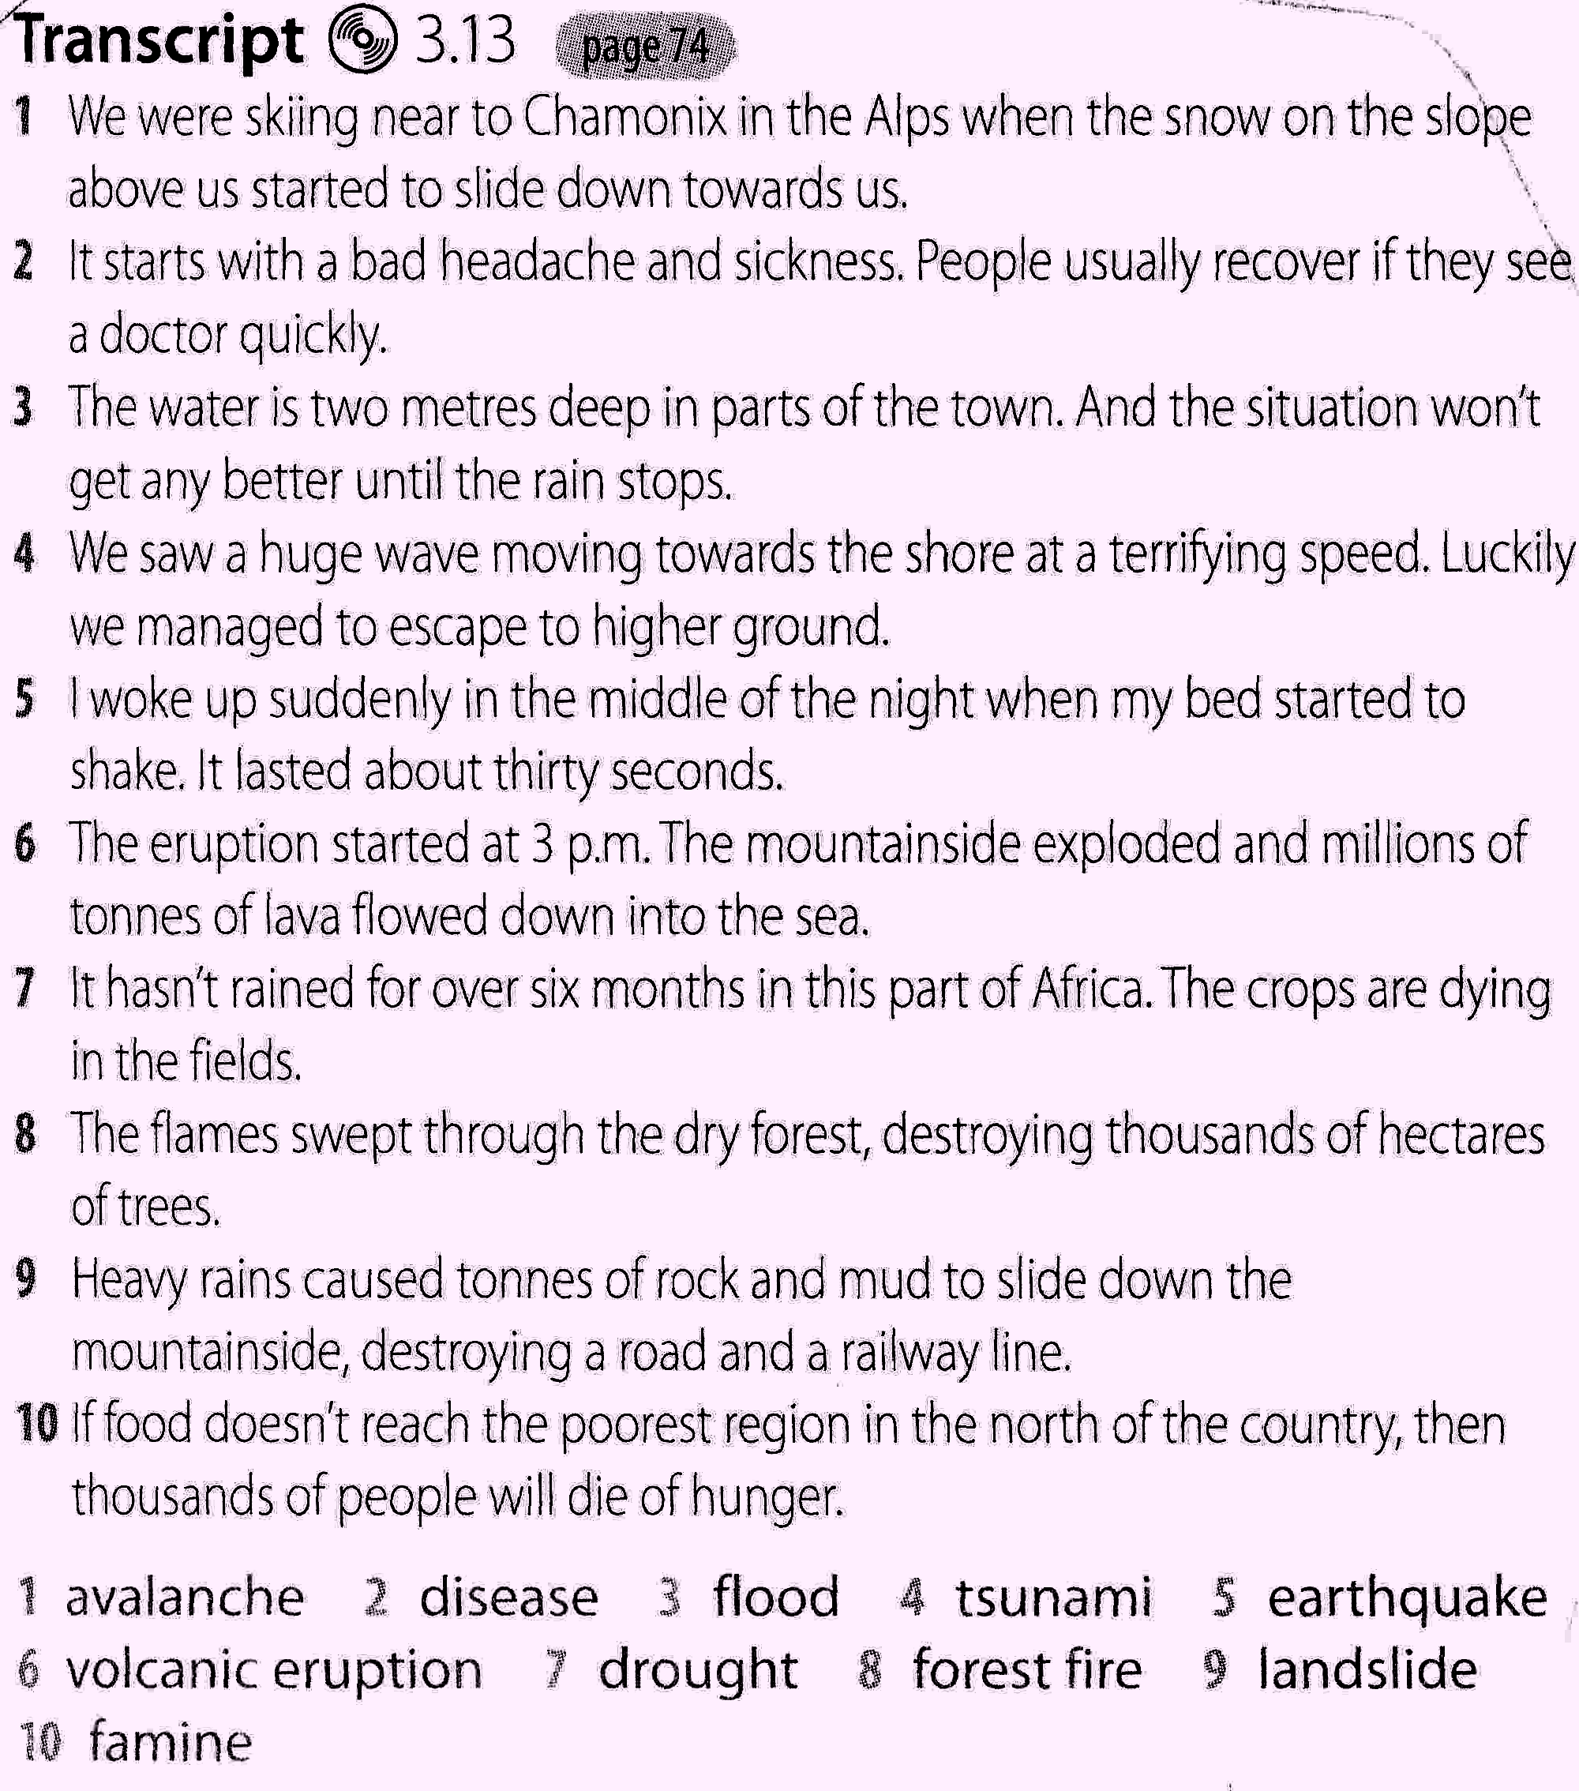
a. Pre-listening .
T: You will listen to ten people talking about a natural disaster. But before listening let’s think about words related to each natural disaster that you can listen out in the recording.
b. Checking answers as a class.
1 avalanche 2 disease 3 flood 4 tsunami 5 earthquake 6 volcanic eruption 7 drought 8 forest fire 9 landslide 10 famine
- Reading. Ex.6 , p74
a. Pre-reading .
T: Look at the news report . You are going to read it . But before reading you will have to complete the report with the words given .
b. Reading and checking the answers.
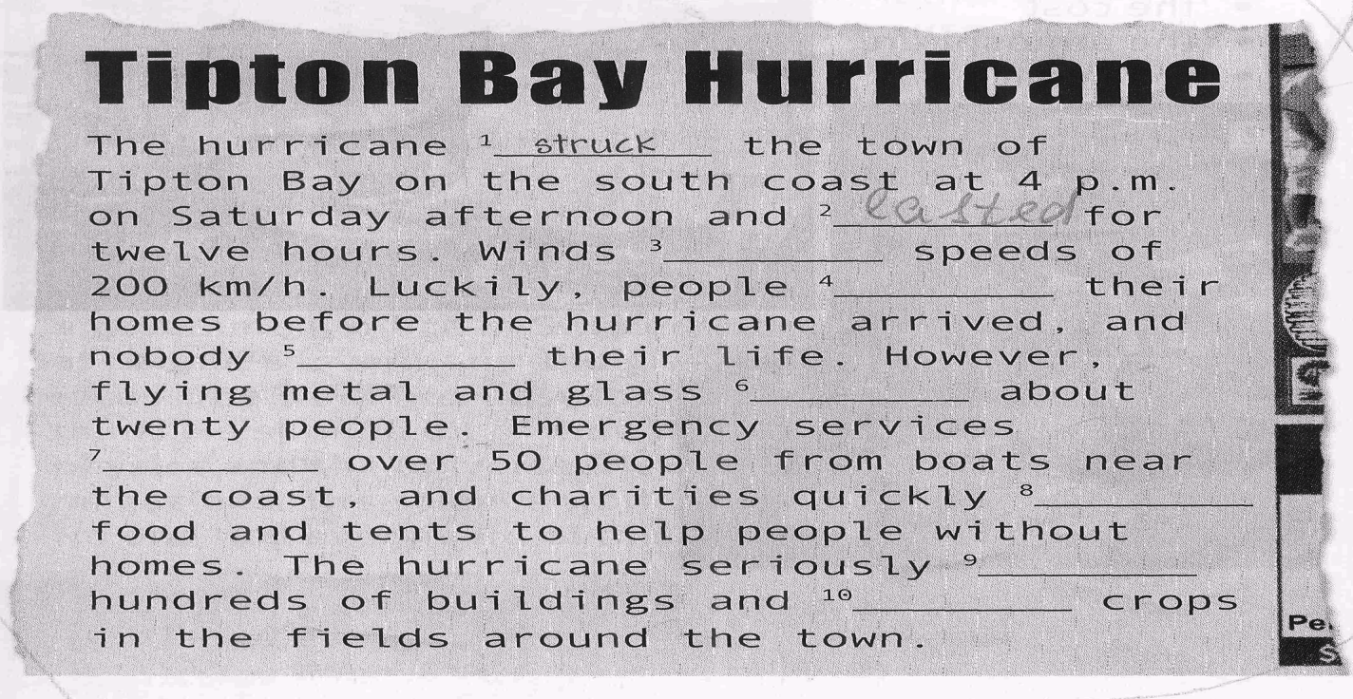
c. Post-reading .
T: And now I’d like you to answer the questions :
1 When did the hurricane strike the town ?
2 Where did it happen ?
3 How long did the hurricane last ?
4 What was the speed of the winds ?
5 How many people were injured and how many were rescued by emergency services ?
6 What did charities send to people without homes ?
7 How many buildings did it damage ?
- Writing. Ex.7 p74.
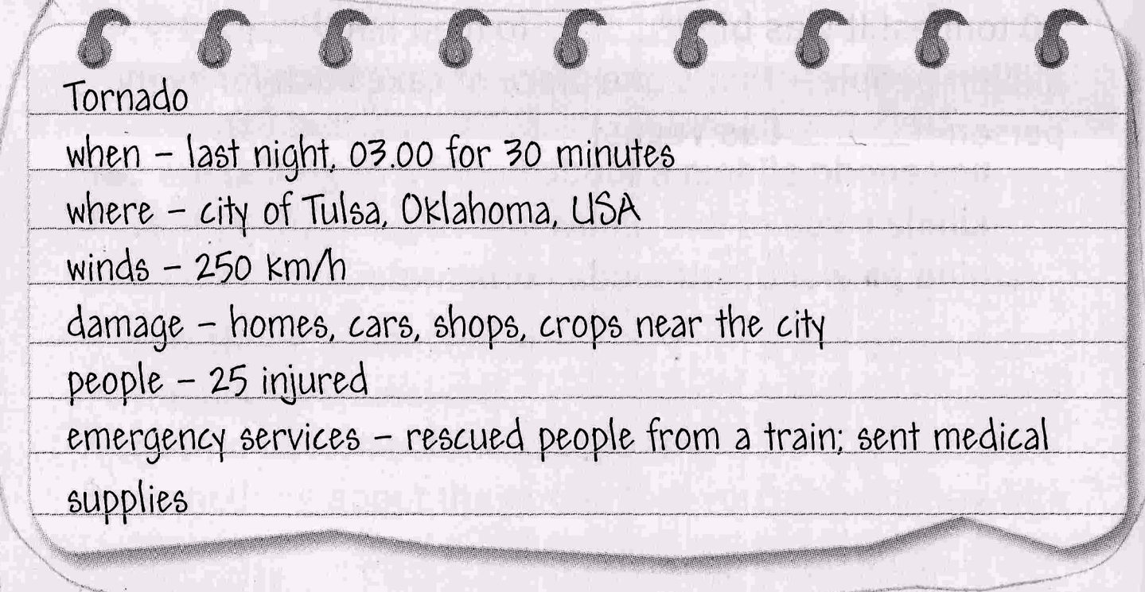
T: For this exercise you will be divided into 3 groups . Each group will have to write a short news report similar to the one in exercise 6 . Use this exercise as a model and use the words and phrases from it.
Presentation of students’ news reports to the class.
III. ЗАКЛЮЧНА ЧАСТИНА УРОКУ
  - Summarizing
I hope you`ll find the way to help Nature and to protect yourselves from natural disasters. Oskar Wild said: “Who are you to bring the pain into God`s world?” Let`s bring happiness and peace. I am happy to have an opportunity to work with such audience. You`ve heard a lot of information. Share it with the other people.

2.Teacher: I`d like you to fill in a self-assessment card at the end of the lesson.

Skills | Points (0-3)
- I can tell many names of natural disasters
- I can understand the text in English easily
- I can communicate on the topic
- I can work in group
- I know safety measures
- I`ve got good listening skills
Total

Results:
18-13 – a very good result
12-7 – rather well
6-0 – not good
3.Home task. Your home task is to create a mini-project in groups about natural disasters which happened in our region. Don`t forget about safety measures. Good luck to you. I am looking forward to our next meeting

