Навчально-виховний комплекс
«Загальноосвітня школа І-ІІІ ст.№1-гімназія»
м.Копичинці

Competition
/урок -змагання, 5 кл./

вчитель англійської мови
Танькова О.М.

Theme: Competition
Objectives: 1) Practical: to practice students’ skills in using lexical material
2) Developing: to develop speaking skills
to improve skills of pronunciation
3) Up-bringing: to teach to compete and encourage team spirit
Equipment: handouts with crosswords and chainwords, proverbs

PROCEDURE
T.: Dear friends! The day of our competition has already come. Everybody will have possibility to be a winner. At the end of the lesson the winner will be given a prize. Be very attentive and try to do everything correctly.
We have two teams – “Champions” and “Winners” and their first task will be to introduce themselves. So, let’s begin.
Students introduce themselves. F.e.: My name is Ann. I live in Kopychyntsi. I’m in the fifth year at school-gymnasium. I like dancing. I have a pet. It’s my dog Barse. I love it.
T.: Our second task is tongue-twisters. Read them on your cards and try to pronounce them correctly.
- Tim’s thirteen and his sister’s three.
- That’s my aunt’s cat Charlie. He’s fantastic at art!
- Thanks to those thirty-three thirsty girls!
- Yes! You! We want your yellow shirts this week.
- Sisters and brothers,
And cousins and mothers.
Cousins and mothers,
and sisters and brothers!
- If a dog chews shoes
What shoes would he choose to chew?
Too few for sure.
You're a choosy shoe chewer.
T: Now listen to the riddles.
- I’m tall and green, I’m in the garden (a tree).
- I have four legs, but I can't walk (a chair).
- Name two animals which together have four legs (two hens).
- It does not have legs, but it goes (a clock).
- It takes a house when it goes (a turtle).
- It does not have legs, but it jumps (a ball).
- It's not a man, it's not a woman, but it teaches us (a book).
- Five sons with one name (fingers).
- Two brothers, but they don't see each other (eyes).
- One face, two hands, it goes, yet stands (a clock).
- It’s white and cold and sweet. All children like it (ice-cream).
- It gives us milk and butter too. It's very kind and likes to moo (a cow).
T: I think you like proverbs and sayings. Now we will have possibility to check up you knowledge.
Students are given proverbs. They must find Ukrainian equivalents to them.
- Actions speak louder than words.
- A friend in need is a friend indeed.
- All's well that ends well.
- Better late than never.
- Like father, like son.
- Bad news travels fast.
- No smoke without fire.
- Out of sight, out of mind.
T: Well, everything was all right. Now listen to the verses and try to put in the missed words.
1.
How much is one plus one?
... apples growing in the sun (two).
How much is two plus two?
... apples for little Sue (four).
How much is three plus three?
... apples are on the apple-tree (six).
How much is four plus four?
... red apples and no more (eight).
2.
My dog has four legs. I have only... (two)
My dog likes to run, I like to run, too.
3.
Eleven little boys are playing ball with Ben.
Two boys go away and then there are... (ten).
4.
Five little girls as you can see
Are in the garden under the... (tree).
5.
When little Ann goes out to tea,
She washes her... as you can see (hands).
6.
Two little boys, Johny and Sam,
Sit down to have some tea with... (jam).
7.
Do you see that big... tree (green)?
Let's run there: one, two, three.
8.
Here sits the dog under the tree
It likes the tree as you can... (see).
T: During our school year we have studied different topics. Do you remember what are they? Yes, you are right. They are “Animals”, “Food” “Body parts” and others. Your task is to choose one of the topics (the names of them are written on the cards and they are in the box) and say as many words to it as you can.
The captains come to the table and choose the topic. Then the members of the team name the words.
T: I think you like chain words very much. Now please look at this chain word and be quick in solving it.
CHAINWORD
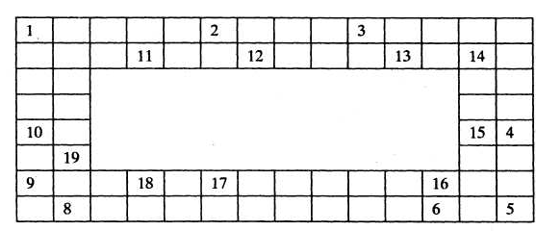
The last letter of one word is the first letter of the next. The sentences below tell you what word to use.

- You go to it every day except Sunday and holidays. (school)
- That's what you do when you are there. (learn)
- You write in it. (notebook)
- You or your younger brother fly it after school. (kite)
- You do it in the morning, afternoon and evening. (eat)
- She teaches you. (teacher)
- You must be always... to answer at the lesson. (ready)
- You say it when you answer the general question. (yes)
- When you read a book you... letters in it. (see)
- The language you learn. (English)
- When your classes are over you go... (home)
- You go to school at... o'clock. (eight)
- You must always do this when you want to achieve smth. (try)
- 14. In the classroom you sit at... desk. (your)
- In school you learn to speak, ... and write. (read)
- You have it when you come home after school. (dinner)
- You open the door when you go into the... (room)
- "I like to study English very... ", said Ann. (much)
- We can... with our ears. (hear)
T: And now a rather difficult riddle. Who will be the first?
RIDDLE
What cards must you move so as that the result of the columns will be alike?
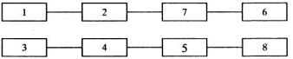
Students change the places of cards 6 and 8 then the result of each column will be 18.
T: Well I see it wasn’t an easy task but you have done it. Thank you. And now crossword.
CROSSWORD
Across: 2. штани 6. радіо 7. дев’ять10. прапор 13. вчора
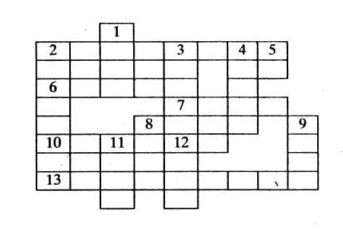
Down: 1. холодний 2. жахливо 3. незабаром 4. круглий 5. отже 8. неозначений артикль 5. лінивий 11.гніздо 12. коли-небудь

T: Very good. Now I want you to work with the English proverbs. To find an English proverb you must know the ABC very well. Each figure stands for the letter of the alphabet.
1) 5, 22, 5, 18, 25, 2, 9, 18, 4, 12, 9, 11, 5, 19, 9, 20, 19, 15, 23, 14, 14, 5, 19, 20.
Clue: Every bird likes its own nest
2) 4, 15, 9, 14, 7, 9, 19, 2, 5, 20, 20, 5, 18, 20, 8, 1, 14, 19, 1, 25, 9, 14, 7.
Clue: Doing is better than saying
T: And now chainword again.
CHAINWORD
The clue is the antonyms of the following words: late, no, big, more, buy, short, bad, up, far, poor, low, cold, thin.
Clue: early, yes, small, less, sell, long, good, down, near, rich, high, hot,
thick.
CROSSWORD
Down: 1. вулиця 2. одинадцять 3. зелений
Across: 3. давати 4. залишатися 5. санки 6. дерево 7. спати
Key: down: 1. street, 2. eleven, 3. green, across: 3. give, 4. stay, 5. sledge, 6. tree, 7. sleep.
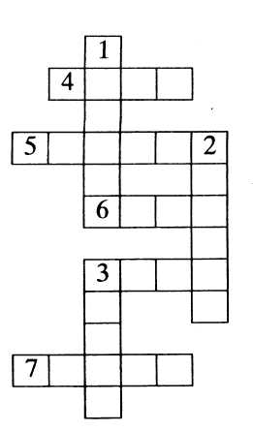

ІІІ. Summing up.
- Homework
Level 1. Make your own chainword
Level 2.Make your own crossword
- Summarizing
T: Thank you very much for your work. I think our lesson was very interesting for you. You know a lot about different things. I see that you are very clever and know English very well. Now our winners:

