Навчально-виховний комплекс
«Загальноосвітня школа І-ІІІ ст.№1-гімназія»
м.Копичинці

Home-reading.
Little Red Riding Hood
/урок домашнього читання з елементами рольової гри, 6кл./

вчитель англійської мови
Танькова О.М.

Theme: Home-reading. Little Red Riding Hood
Objectives:
- Practical: to form language competence in speaking and reading, to develop students’ pair and group communicative skills in an oral speech; to practice speaking in dialogues and monologues
- Developing: to develop pupils’ imagination, memory, logical thinking, creative abilities and talents, attention, to broaden pupils’ outlook
- Up-bringing: to bring up kind attitude towards animals
Equipment: a text of a fairy-tale, computers, filmstrips, pictures

Procedure
- Introduction.
- Greetings
T.: Nice to meet you dear boys and girls, merited guests. I am very glad to see you at our English lesson.
2. Aim
T.: First of all let me determine the topic of our lesson. Today is a special day. We are going to recollect information we have learned about animals. We’ll discuss the fairy-tale “Little Red Riding Hood” you have read at home and do the tasks based on the text.
3. Warming-up
T.: At our previous lessons we spoke about animals and I want you to take a card and tell what fairy-tales are these animals from.
wolves wolf The wolf and
monkeys lamb the lamb
bear
tiger Mowgli
panther
buffalo
snake

pigs Three wolf Little Red Riding
wolf little pigs Hood

- Main part
- Description
T.: So, you see a wolf is a very popular animal. You can meet it in many fairy tales. What do you know about wolves?
P₁: Wolves live in the woods. They are grey. They can run fast.
P₂: They’ve got long body and strong legs. They’ve got two yellow eyes and two ears.
P₃: They…
- Guess who?
T.: What are the other four characters in LRRH?
P₁: Little Red Riding Hood
P₂: Granny
P₃: Mum
P₄: Woodcutter
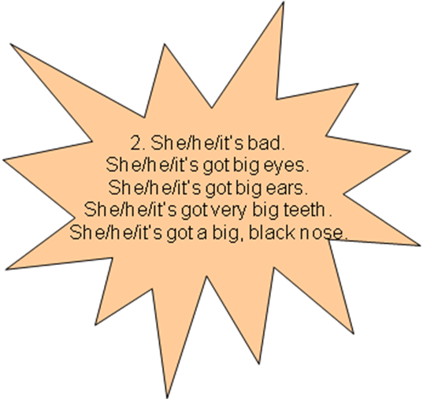
T.: Let’s do the task “Guess who?.” Turn to your computers and try to guess whose description it is?
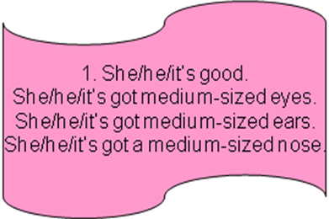

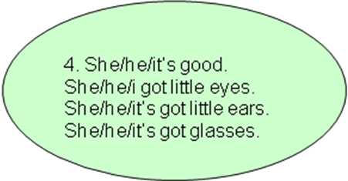

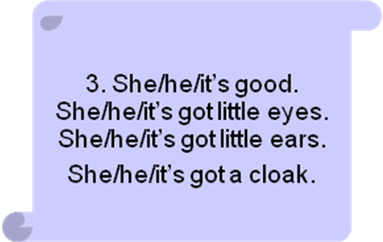

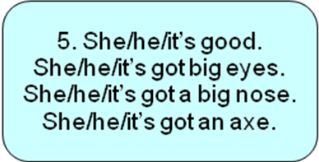

P₁: Number 3 is Little Red Riding Hood
P₂: Number 4 is Granny
P₃: Number 1 is Mum
P₄: Number 5 is Woodcutter
P₅: Number 2 is Wolf
- Categorise the words!

T.: And now I want to divide you into two groups. We’ll review the words from the text. I’ll show you a picture flashcard and you tell me which category it belongs to.
Now look at your sheets of paper.
There are three categories on your sheets of papers. One of you points at the object the other tells what category it is from. Then you write the words into the spaces on your sheets
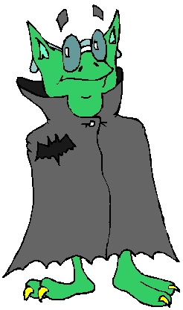

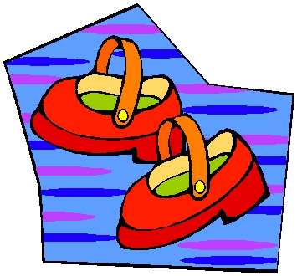
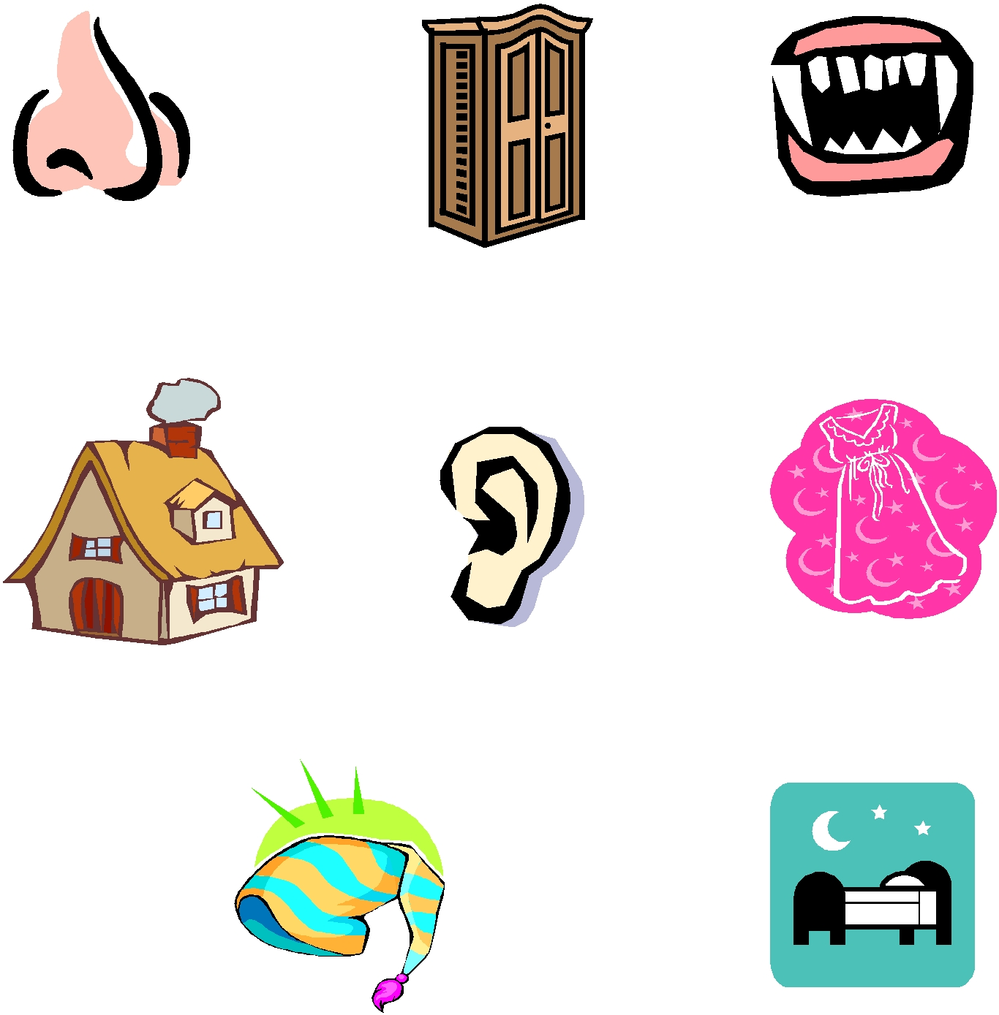
Body Home Clothes
Ear cottage nightdress
- Crossword
T.: Look at your screens and do the crossword. The words are in different order.
- Little Red Riding Hood is carrying a… .
- Where is the wolf when Little Red Riding Hood gets to Granny’s house?
- What is in Little Red Riding Hood’s basket?
- “All the better to see you with.” What are they?
- Who is Little Red Riding Hood visiting?
- What is on Little Red Riding’s head?
- The woodcutter hears a loud … ?
- “All the better to eat you with.” What are they?
- Who does Little Red Riding Hood meet in the wood?
- Little Red Riding’s house is in a… .

b | m | e | y | e | s | f | r | t
e | a | m | a | e | r | c | s | j
d | y | s | u | w | t | a | l | o
q | a | d | k | f | e | k | o | w
w | j | x | g | e | e | e | p | o
o | h | o | o | d | t | v | d | o
l | n | b | c | z | h | c | s | d
f | t | y | n | n | a | r | g | e

- Filmstrip
T.: I give a set of story flashcards to the first group and sentence strips to the other. Your task is to order the pictures and the sentence strips. After you have finished one of the pupils from the first group will stick the flashcards and the pupil from the second group will stick sentence strips under them. Now read the sentences aloud.
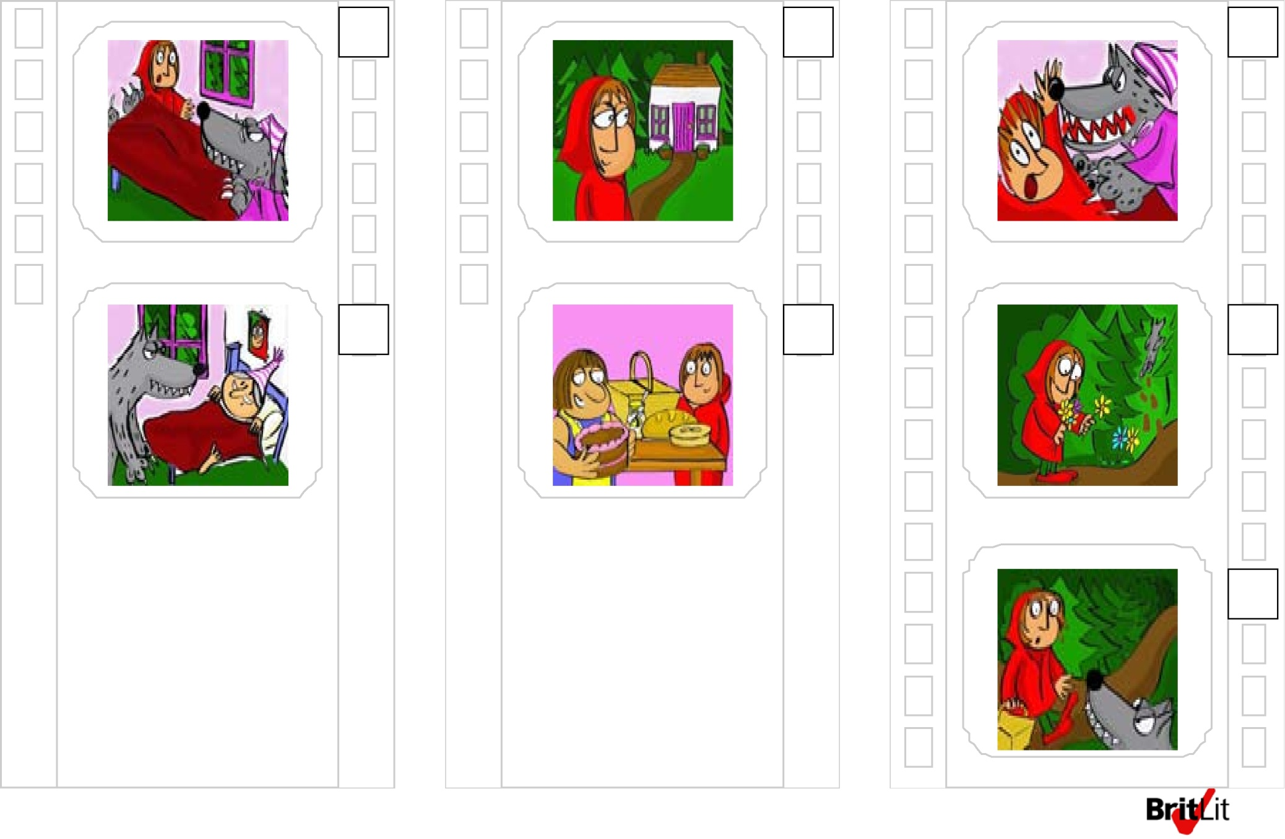
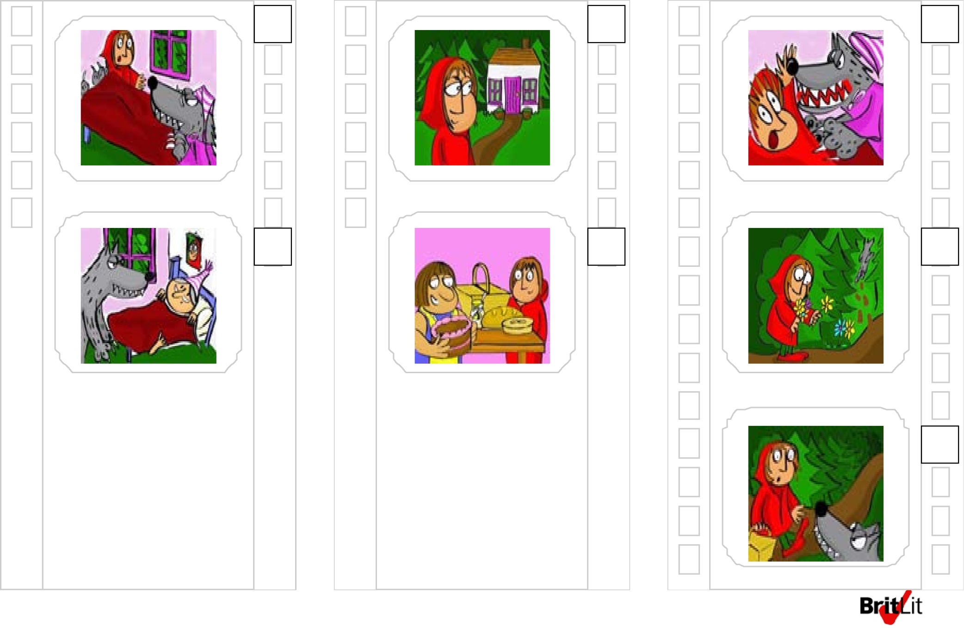
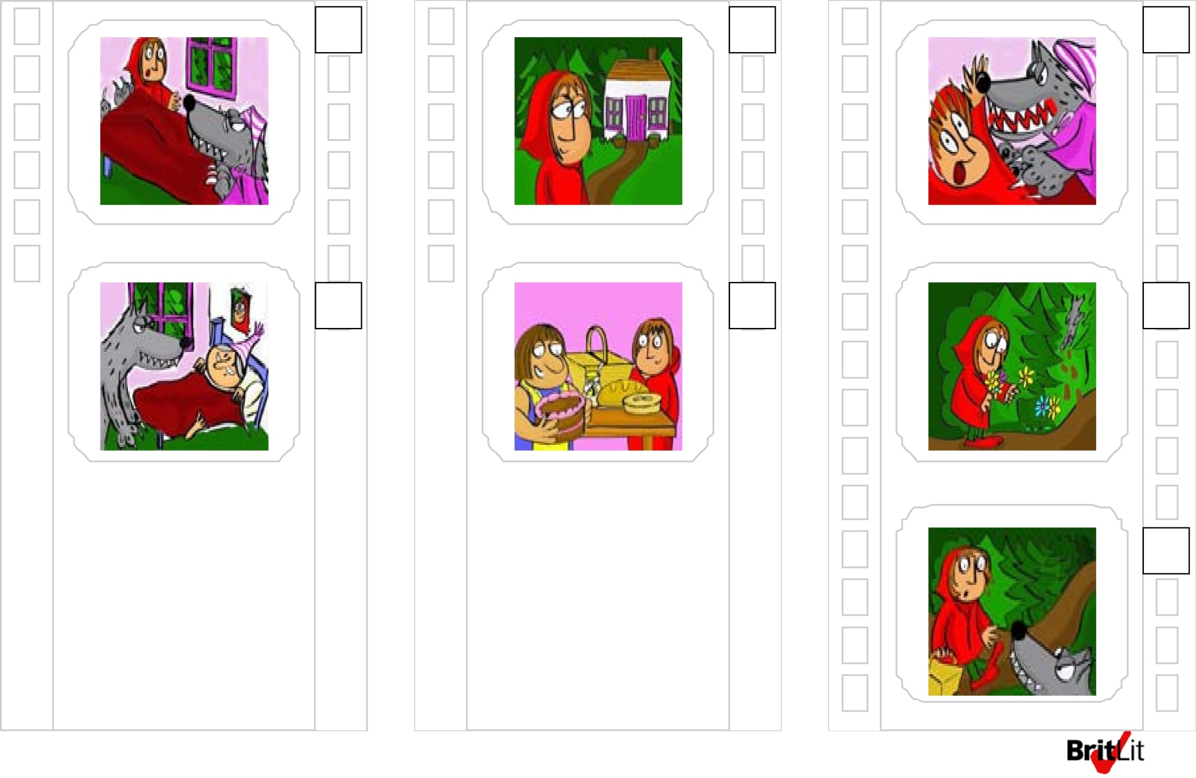
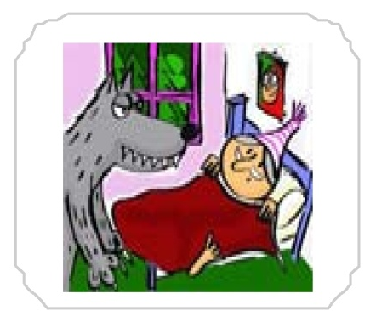
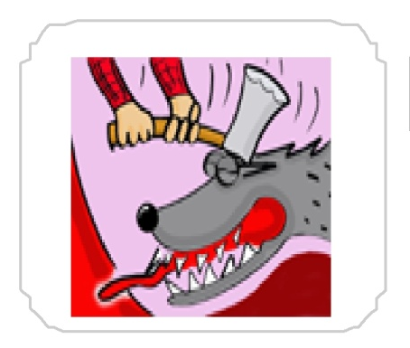
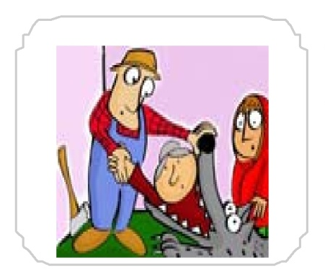

Little Red Riding Hood’s in the wood. The wolf stops her.
The wolf runs away. Little Red Riding Hood picks some flowers.
Grandma! What big teeth you’ve got!

Little Red Riding Hood arrives at Grandma’s cottage.

The woodcutter hits the wolf on the head.

Grandma! You’re alive!

The wolf runs to Grandma’s cottage and jumps into her bed.

The wolf jumps out of bed.

Little Red Riding Hood’s at home. Mum’s got a cake for Grandma.

- Role play
T.: Now let us role play the story. You are given the tasks. Read your tasks and be ready to present a short play.
Scene 1. At Little Red Riding Hood’s house.
1.You are mum. Say good morning to your daughter. Ask her to put the cake into the basket and go to see grandma who lives in the forest. Say good-bye to your daughter.
2. You are LRRH. Say hello to your mum. You take the basket which looks yummy and go to Granny. Say good-bye to your mum.
Scene 2. In the wood.
1. You are LRRH. You see a lot of flowers in the wood. They are beautiful. You meet wolf and say hello. Tell him your name and ask him what his name is. Tell him that you go to your grandma and say good-bye.
2. You are wolf. Say hello to LRRH and ask her what her name is. Say that you are Big Bad Wolf and ask what is in the basket. Say good-bye.
Scene 3. At Grandma’s.
1.You are Wolf. Say hello to grandma and jump into her bed. Pretend you are grandma and say hello to LRRH. Say you feel very bad. Say you have such big eyes to see her better, such big ears to hear her better, such a big nose to smell her and such big teeth to eat her.
2. You are grandma. You see wolf and cry for help.
3. You are LRRH. Say hello to grandma. Ask how she is. Ask what big eyes (ears, a big nose, teeth) she has got. Run away.

- Story Summary
T.: Turn to your computers. We are going to retell the story. In turn some pupils from the groups try to describe pictures on the screen.
- Solve the problem
T.: Do you agree with the last episode? What will you do if you were a woodcutter? As for me I felt pity for the wolf.

- Summing up

- Home assignment
Level 1. Your task is to learn the words and make up 5 sentences with them.
Level 2. Learn the words and write a short story using them.
- Summarizing
What have we done today? I’d like you to draw the stars and show your attitude to the lesson.

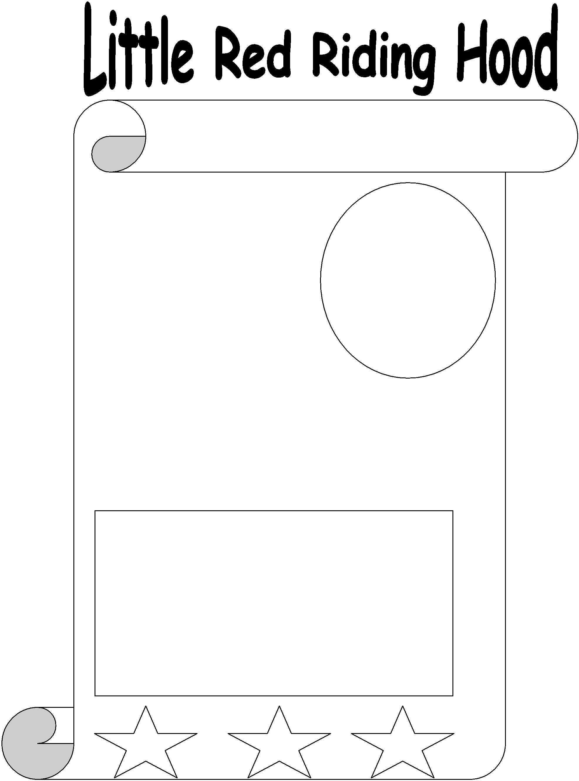

My favourite character

I like this character because
________________________
_________________________

My favourite part of the story

I like this part because ____________________

_______________________________________

