Навчально-виховний комплекс
«Загальноосвітня школа І-ІІІ ст.№1-гімназія»
м.Копичинці

Ukraine is our Motherland
/урок-презентація, 6 кл./

вчитель англійської мови
Танькова О.М.

Theme: Ukraine is our Motherland
Objectives:
- Practical: to practise reading and writing skills; to develop students’ communicative skills; to improve students’ skills in using lexical material
- Developing: to develop students’ imagination, memory and creative abilities; to broaden students’ outlook
- Up-bringing: to extend the knowledge and cultivate students’ curiosity towards Ukrainian traditions and customs
Equipment: textbooks, a map, sayings, a presentation, a quiz

PROCEDURE
І. Introduction
1. Greeting
T.: Good morning, dear guests. Good morning, dear boys and girls. How are you today?
Ps: Fine, thanks.
T.: I’d like to start our today’s lesson with a poem.
I wish I were a fairy
I wish I were a witch
To make all people merry
To make all people rich.
I wish I lived in Holland
I wish I lived in Spain
But I do love my homeland
My dearest Ukraine.
T.: As you’ve understood today we’ll speak about our Motherland – Ukraine. You’ll know a lot about the country. And the motto of our lesson are the words of G.G.Bayron “He who loves not his country can love nothing.”

2. Mind Map
T.: Do you know other sayings about homeland.
P₁: East or West home is best.
P2: There is no place like home.
T.: Right. There is no place on our planet like our native country. Whenever people go they always return home.
What words is Ukraine associated with. Think of them. In the centre of our Mind Map I write the word Ukraine.

Ukraine
capital
emblem
language
places of
interest
traditions and customs

history
cities

songs

ІІ. Main part
- Practising vocabulary
T.: Could you make up sentences with some of them.
P₁: Kyiv is the capital of Ukraine.
P₂: There are a lot of places of interest in our country.
P3: Ukraine has got a state emblem.

T.: For each of us our country is different. What words will you use to describe its beauty?
P₁: It’s picturesque. P₅: It’s wonderful.
P₂: It’s remarkable. P₆: It’s hospitable.
P₃: It’s fantastic. P₇: It’s interesting.
P₄: It’s beautiful. P₈: It’s nice.
T.: Yes, I agree. For us it is the best country in the world.
- Game “Interview”
T.: Our friends from Canada want to know more about Ukraine. But first let’s ask them what they have already known. The reporter will ask some children about Ukraine. Now listen to their answers.
R.: What do you know about Ukraine?
C₁: I know that it is somewhere in Europe.
R.: Do you know anything about our country?
C₂: I’ve read that it has rich traditions and customs.
R.: Have you got any idea about Ukraine?
C₃: Yes, I have. I’ve heard that it’s capital is Kyiv.
R.: How do you imagine Ukraine?
C₄: It’s a country with many places of interest.
R.: What about you? What is your idea of Ukraine?
C₅: I know that many people from Ukraine came to Canada in the 19th century.

3. Quiz “Ukraine”
T.: As you see from the interview some Canadians have got a general idea about our country. Now I want to check your knowledge of your country. Turn to your computers and do the quiz “Ukraine.”
- Which of the following rivers flows into the Black Sea in Ukraine?
  - ? Danube
  - ? Dnipro
  - ? Don
- The most famous health resort on the Crimea Peninsula is called ...
  - ? Jalta
  - ? Sevastopol
  - ? Simferopol
- How many inhabitants does the Ukraine approximately have?
  - ? 25 mln
  - ? 46 mln
  - ? 20 mln
- What is the name of the Ukrainian currency?
  - ? Rouble
  - ? Bani
  - ? Hryvnia
- Which of the following cities is the capital of the Ukraine?
  - ? Krivyi Rih
  - ? Kyiv
  - ? Kirovohrad
- The Ukraine has got common borders with ...
  - ? Slovakia, Hungary, Croatia
  - ? Moldova, Romania, Bulgaria
  - ? Russia, Belarus, Poland

T.: You coped with your task quite well. I’ve put down your scores. And our winner is…

4. Matching
T.: Now look at the photos and match the descriptions with places.
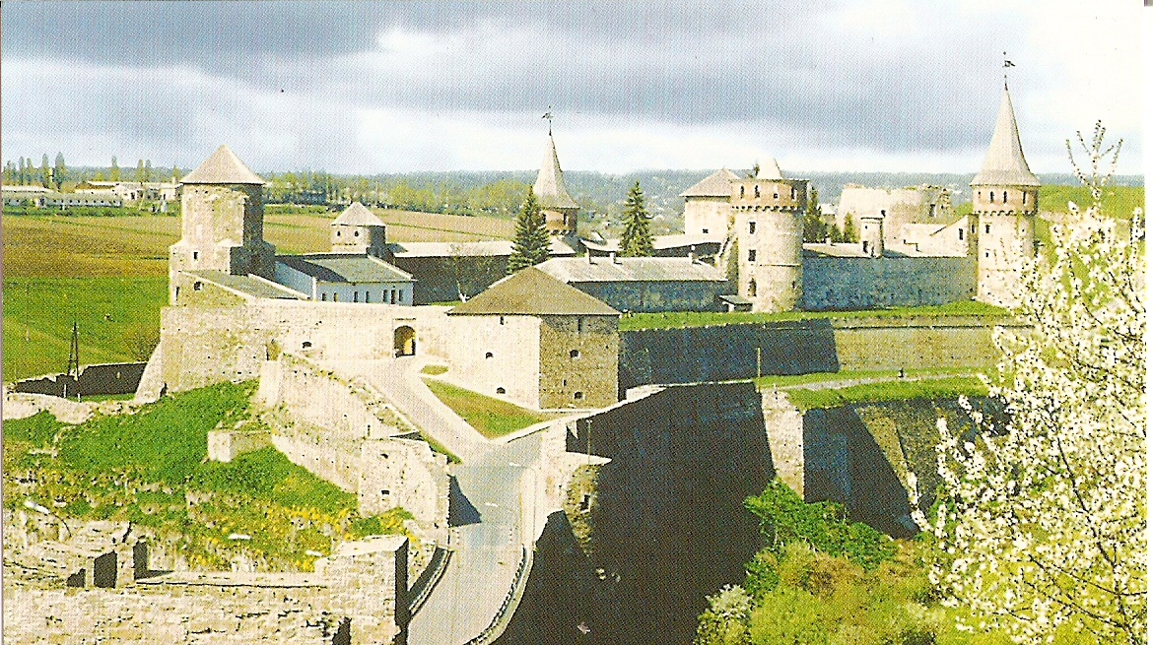
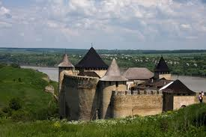
Fortress in Kamianets Podilskiy

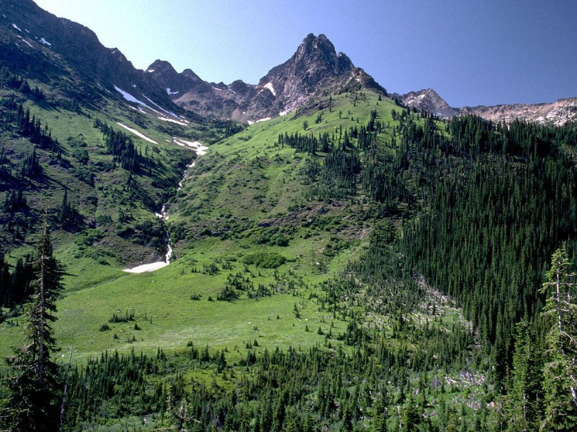
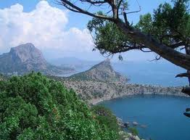

the Carpathian Mountains

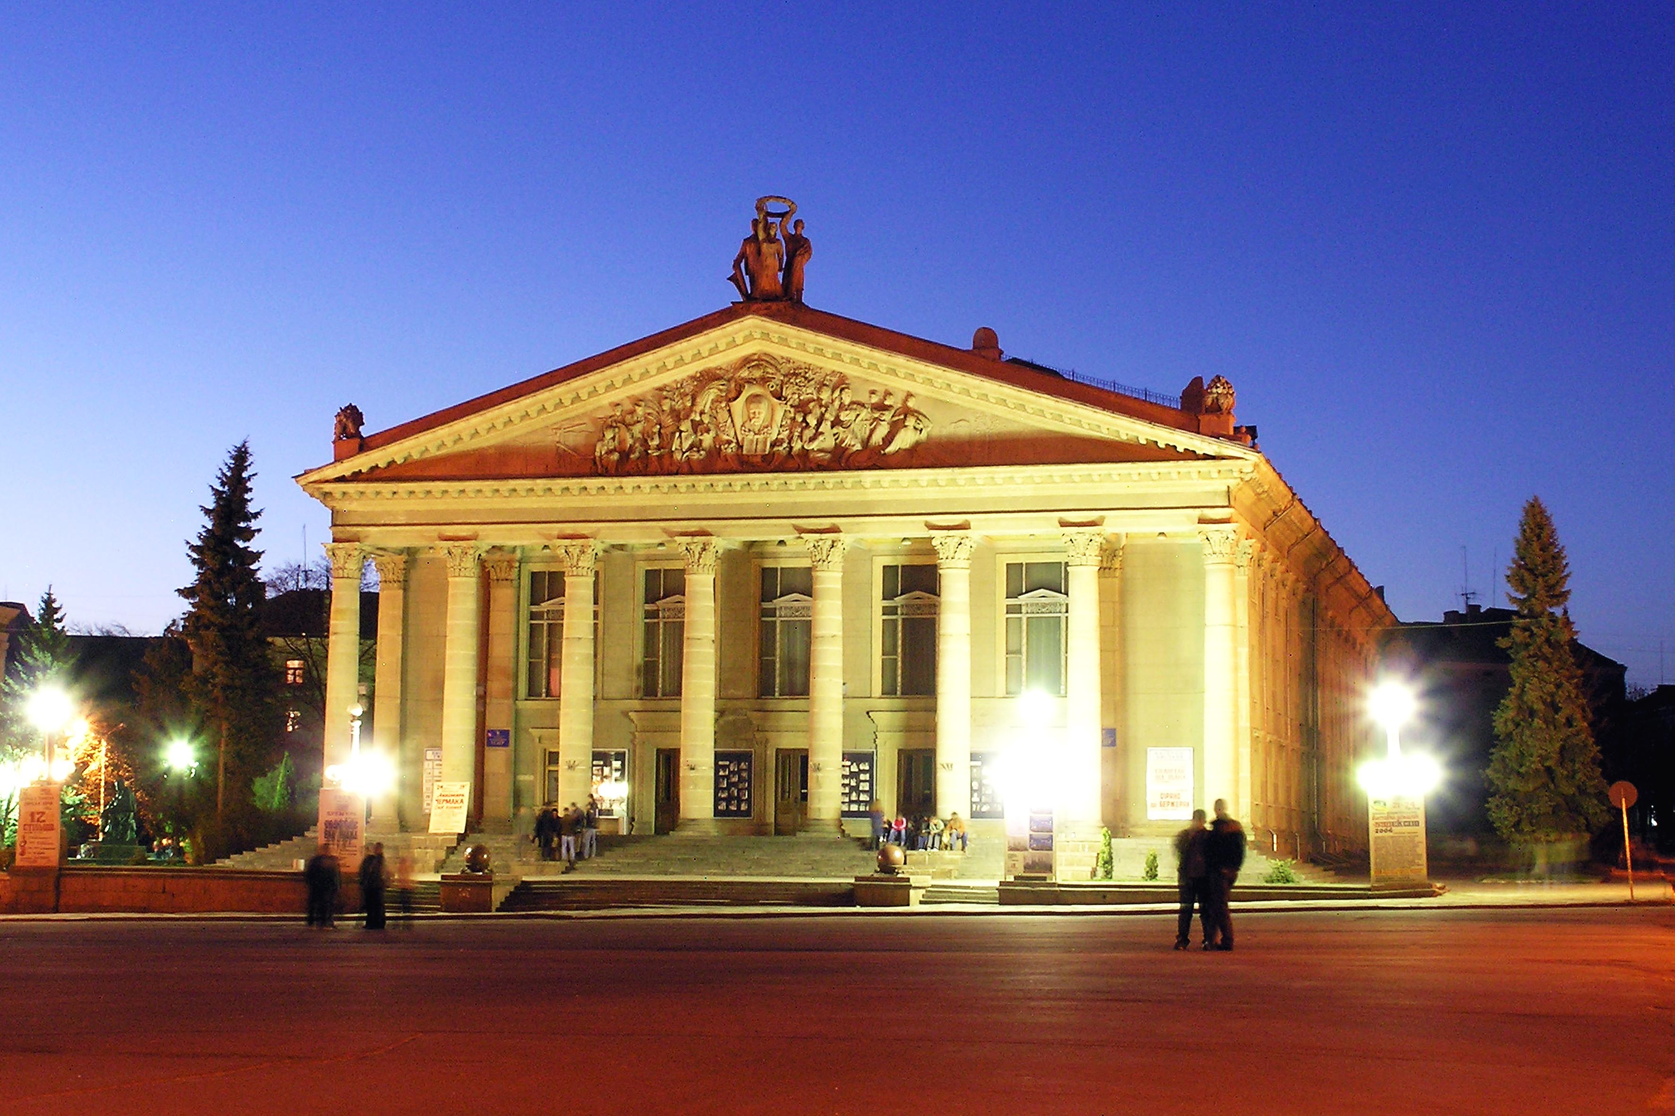
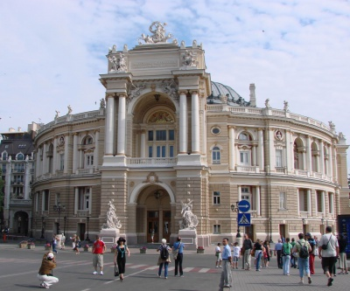

Ukrainian music and drama theatre in Ternopil

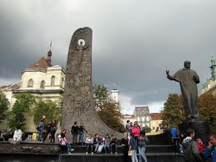
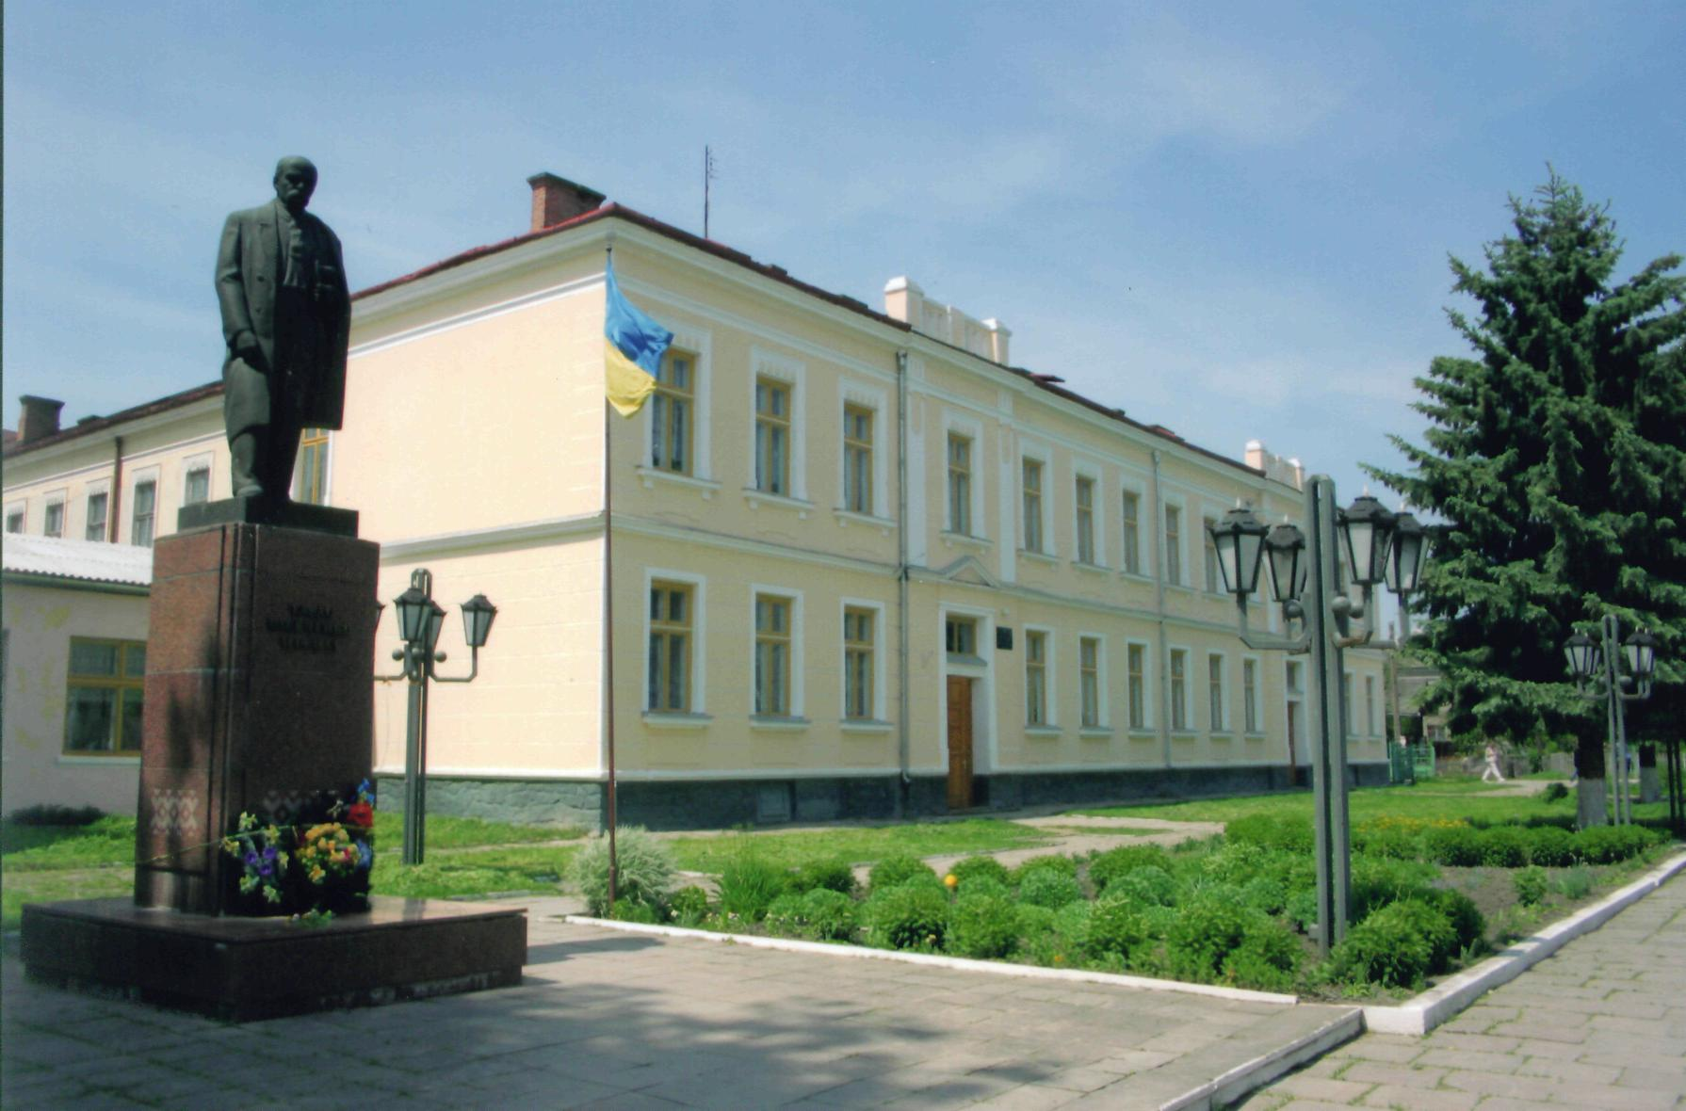

the monument to T.Shevchenko in Lviv

5.Writing
T.: So we’ve revised the facts about our country and now I want you to open your books on p.114. Ex.1. Read the task, please. As you see, you have to write a letter to your Canadian e-mail friends who want to know more about Ukraine and its lifestyle. Some pupils have already done this task but they made some mistakes. Look at the screens of your computers. Find the mistakes and rewrite the letter into your notebooks.
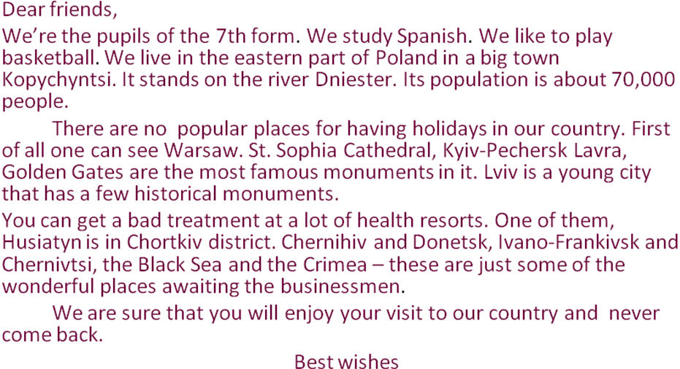

T.: Let’s check your task.
P_{s}: Read the letter without the mistakes.

- Oral practice

T.: Imagine that you meet foreign guests at school. Present your country to your guests.
P₁:
Ukraine
Ukraine is a beautiful country
It is the best to my mind
Ukrainian people are friendly,
Talented, hard-working and kind.
Ukraine is a good place to live in
To study in it and to stay
This country of course is worse seeing
So people, welcome to Ukraine.

P₂: We live in Ukraine. It is our Motherland. Its independence was proclaimed in 1991. The national anthem is “She lives on, our Ukraine.” The Ukrainian symbols are the national flag and the Trident. The national flag has 2 wide stripes: blue and yellow. The yellow colour symbolizes the colour of the sun and the wheat, and the blue colour mens the sky.
Another symbol of Ukraine, which all Ukrainian people know and love is a snowball tree. You can see these bushes everywhere.
P₃: Ukraine borders on Russia, Bilorus, Moldova, Poland, Slovakia, Hungary and Romania. There are two seas in the South of Ukraine. They are the Black Sea and the Sea of Azov. There are the Crimean Mountains and the Carpathian Mountains in Ukraine. The highest peak of the Carpathian Mountains is Hoverla.
P₄: The largest rivers are the Dnipro, the Dniester, the Bug, the Donets and others. There are many beautiful
towns on their banks. All of them are interesting places, famous for their history.
Kyiv and Poltava, Kharkiv and Lutsk, Sevastopol and Rivne are awaiting for tourists.
P₅: Kyiv is the capital of Ukraine. It is one of the largest capitals of the world.
There are so many chestnuts in Kyiv that a chestnut tree has become its symbol. There are a lot of museums, theatres, interesting old buildings and monuments in Kyiv.
P₆: Ukraine has got a very rich culture. Many ancient monuments have been preserved till our days. The St. Sophia Cathedral, Andriivska church, Kyiv-Pechersk Lavra, Lavra in Pochaiv are the places worth seeing.
Embroidered towels, wooden souvenirs and pysankas are the examples of Ukrainian Folk Art.So, welcome to Ukraine.

T.: We can’t tell everything about Ukraine in one small presentation but now your friends can imagine what our country is like. But they can see all the rest when they visit our country.

8. Reading
T.: Look at Ex.1 on p.115. Travellers from different countries noticed some characteristics about the Ukrainians. Read and say whether you agree with them or not, using the following phrases.
Phrases to be used
- I’m afraid I can’t agree with the fact.
- I disagree with this information.
- I’m not sure about that.
- Exactly!
- Absolutely true.
- I completely agree.
ІІІ. Summing up.
1.Hometask
Level 1. Make your own quiz about Ukraine. Include 6 items in it.
Level 2. Imagine that you are from England. Write back to England sharing your impressions of Ukraine.
2.Summarizing
T.: What have we done today? What did you like most?
You are given 60 seconds to speak about something we’ve covered today.
Some of you are rewarded with reward stickers.

