Навчально-виховний комплекс
«Загальноосвітня школа І-ІІІ ст. №1-гімназія»
м.Копичинці

Тренувальні вправи для підготовки учнів до виконання тестових завдань з англійської мови
(для учнів 7 класу)
Упорядник:
Танькова О.М. – вчитель англійської мови НВК «ЗОШ І-ІІІст.№1-
гімназія м.Копичинці»

Даний навчальний посібник містить завдання для перевірки граматичних навичок учнів. Вони також можуть бути використані для написання самостійних та контрольних робіт. Посібник побудовано на матеріалі, засвоєння якого передбачається програмою 7 класу, і обсяг якого є достатнім для забезпечення практичного володіння англійською мовою. Посібник ілюстрований малюнками, деякі з яких, виконують і практичну функцію.

Рецензент Гулик А.Т.
(методист РМК)

Рекомендовано методичною радою Гусятинського РМК
(Протокол № ___ від 17.01.2019 р.
наказ № ____)
Unit 1

1. Write about arrangements for the weekend. Use the correct form of the present continuous.
1. they/ watch/ a film/ at the cinema/ Saturday evening
_____________________________________________________________________________
2. Jane/ do/ karate/ Friday afternoon
______________________________________________________________________________
3. I/ visit/ my cousins/ Sunday morning
_______________________________________________________________________________
4. we/ have/ birthday party/ weekend
_______________________________________________________________________________
2. Complete the conversation. Use the correct form of will or going to.

Ian What (1you do) ________________________________ at the weekend?
Jack There’s an action film at the cinema. I(2 watch) ______________________it.
Ian I’m sure you (3 like) ______________________it. It’s a pity but I won’t be able to join you. I (4 stay) _________________________at home. I must do my homework. It’s English and I’m bad at English.
Jack OK, then. I (5 not go) ________________ to the cinema. I(6 help) ________________you with English.
Ian But I (7 play) _____________________ tennis first.
Jack That’s a good idea. I (8 join) _____________________ you.

3. Complete the sentences. Use the correct form of the present continuous, will or going to.
- Are you tired? I ____________________________ (take) you home.
- I _______________________________ (watch) a DVD tonight. I’ve already bought a disc.
- What ____________ you ________________________ (wear) for your first day at work?
- “We haven’t got any sugar.” “I ________________ (get) some in town later.”
- Look at the time! We _______________________ (be) late.
- Look! That cyclist ________________________(hit) the dog!

4. Complete the sentences with the correct reflexive pronouns.
1. Every morning I wash ________________.
2. She is too small to eat by ________________.
3. The cat cleans _______________ with its tongue.
4. They’re going to decorate the house by _____________________.
5. Don’t cut ______________with that knife, Tom!
6. Peter never does his homework ______________.
7. Anna and Jane, you can make __________________at home.
8. We’ll enjoy _____________________at the party.

5. Describe people’s clothes.
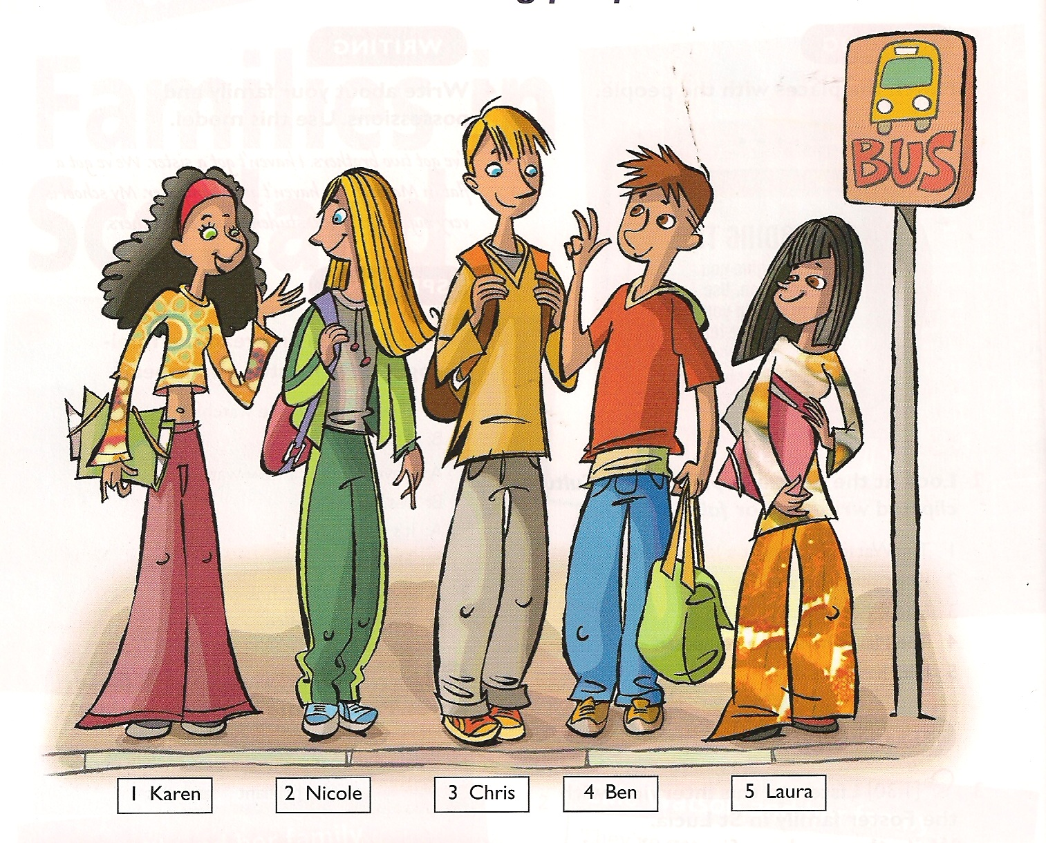
Unit 2
1.Write questions with How long…? Complete the answers with for or since.
1. I work for a company in London.
______________________________________________________________________
_________________ 6 years.
2. I have a beautiful old Volkswagen van.
_______________________________________________________________________
________________ 2014
3. They live in Lviv.
_______________________________________________________________________
___________________last year
4.We play football.
_______________________________________________________________________
___________________ 2 years.

2. Use the correct form of the words in brackets and for and since to complete the conversation. INTERVIEWER: Ben, how long have you been swimming?
BEN: Well, I started swimming when I was eight, so I’ve been swimming (1) _______________ 14 years.
INTERVIEWER: And when (2) _______________ (do) you start swimming in competitions?
BEN: I (3) _______________ (enter) my first competition when I was ten.
INTERVIEWER: (4) _______________ (do) you win?
BEN: No, didn’t. I (5) _______________ (win) my first race when I was twelve. It was fantastic. INTERVIEWER: And how many times have you won (6) _______________ then?
BEN: Oh! Lots of times. I’ve (7) _______________ (swim) in so many races I can’t remember. INTERVIEWER: What is the best moment so far?
BEN: When I (8) _______________ (be) in the Athens Olympic Games in 2004.
INTERVIEWER: Yes, I remember, you won a medal …
BEN: That’s right. I won a bronze medal.

3.Fill in the blank with the correct comparative form of the adverb
EX: He is singing more loudly than the other singers. (loudly)
1. He arrived ___________________ than expected. (early)
2. We walked ___________________ than the rest of the people. (slowly)
3. They called us ___________________ in the afternoon. (late)
4. My mother and my sister talked ___________________ than the other guests. (loudly)
5. He hit his arm ___________________ than before. (hard)
6. The Spanish athlete ran ___________________ than the other runners. (fast)
7. Jim threw the ball ___________________ than Peter. (far)

4.Complete the table

Verb | Person | Noun
 | competitor
 |  | performance
organize
 | manager | management
 | producer
present
collect

5.Give good and bad news. Write sentences.
Tom/lost his keys
I’ve got some bad news. Tom has lost his keys.

- I/got a new car
_______________________________________________________
- My mum/gone into hospital
________________________________________________________
- Jane/failed her driving test
________________________________________________________
- You/passed your exam
_________________________________________________________
Unit 3

1. Write questions and answers. Use the correct form of the present perfect with Have you ever …, never, once, twice and three times.

- meet an alien ˅˅
___________________________________________________________________________________
2 have dinner on a roof × ___________________________________________________________________________________
3 eat sushi ˅
___________________________________________________________________________________
4 score a goal ˅˅˅
___________________________________________________________________________________
5 do homework on a bus ×
___________________________________________________________________________________
6 try hang-gliding ˅ ___________________________________________________________________________________

2. Write sentences or questions with the present perfect. Put the word in brackets in the correct position.
1 we/ have/ dinner (already)
___________________________________________________________________________________
- they/ finish/ this book? (yet)
___________________________________________________________________________________
3 I/ wash/ my hair (just)
___________________________________________________________________________________
4 she/ clean/ the windows (already)
___________________________________________________________________________________
5 your friends/ see/ the film? (yet)
___________________________________________________________________________________
6 he/ not eat/ his bread (yet)
___________________________________________________________________________________

3. Complete the conversations. Use the correct form of the present perfect or past simple.
Mother: I want to prepare dinner. (1 you / wash) __________________the dishes yet?
Daughter: I (2 wash) ________________ the dishes yesterday, but I (3 not have )____________ the time yet.
Mother: (4 you / do) ____________________________________ your homework yet?
Daughter: No, I (5 return / just) _____________________ home from my tennis lesson.
Mother: You (6 come) ___________________________ home from your tennis lesson two hours ago!
Daughter: Well, but my friend Lucy (7 call) ____________ when I (8 arrive) _______________ and I (9 finish / just) __________________ the phone call.
Mother: But (10 you / see) ____________________ Lucy at the lesson.
Daughter: Yes, but we (11 not have) _________________________ time to talk then. We (12 play) ________________ tennis.

4. Write the correct words for the things in the pictures.

1 _____________________
2______________________
3 _____________________
4______________________
5______________________
6______________________
7 ______________________
8 ______________________
9 ______________________
10 _____________________

5 Complete the sentences.

1 In tennis, you mustn’t ____________ the net with your racket.
2 In basketball you can’t __________ the ball for more than five seconds.
3 He’s going to __________ the ball with his right foot.
4 The ball’s in the air. The fielder’s going to ____________ it.
5 In tenpin bowling you ____________ the ball along the ground.
6 He’ll ___________ the ball very hard with his racket.
7 ___________ the ball into the air!

6. Answer the questions.
1 Would you like to go swimming? (prefer/ snowboarding)
______________________________________
2 Would you like to do athletics? (rather/ gymnastics)
______________________________________
3 Would you like to go to the park? (prefer/ cinema)
______________________________________
4 Would you like to play football? (yes)
______________________________________
5 Would you like to be a doctor? (prefer/ teacher)
______________________________________

Unit 4
1.Write a sentence using the present perfect continuous. Use the words in brackets.
1. John is sunburnt. He has been sitting in the sun. (sit/in the sun)
2. The ground is wet.___________________________________________________ (rain)
3. Jack has no money left._______________________________________________ (shop)
4. Fred is covered in paint. ______________________________________________(paint/the kitchen)
5. Maisy is tired. ____________________________________________(drive/for 4 hours)
6. Harry is very hot and dirty ____________________________________________(dig/the garden)

2.Write questions and short answers. Use the correct form of the present perfect continuous.

A you/ have your dinner? ˅
1 ____________________________________________________________________________
B Jane/ watch the film?×
2 ____________________________________________________________________________
A you/ listen to music?×
3 ____________________________________________________________________________
B Amy/play the guitar?˅
4 ____________________________________________________________________________
A your friend/ wait here for long?×
5 ____________________________________________________________________________

3.Put the verb in the most suitable form, present perfect simple or continuous.
1. You look tired. _______________ (you/study) hard?
2. Mr Brown is new here, isn't he? How 1ong _______________ (he/work) for the company?
3. I _______________ (lose) my wallet. Have you seen it anywhere?
4. I _______________ (read) the magazine you lent me, but I _______________ (not/finish) yet.
5. _______________ (you/hear) the bad news? Simon _______________ (break) his leg!

4.Fill in the correct form (Present Perfect Simple or Present Perfect Continuous).
Tom: Hi Ana. Where (you / be) _____________?
Ana: I (be) ___________ at home all the time. But I (clean) _____________________ the house all day, so maybe I haven't heard the phone ring.
Tom: (you / clean) ______________________ everything yet?
Ana: No, not yet. I (not /tidy) ______________________ up the kitchen yet. But why are you here?
Tom: Don't you remember? Jane (invite) _______________________ us to her birthday party and we (not /buy) ______________________ a present for her yet. She (learn) __________________ Spanish for a year and wants to spend her next holiday in Mexico. Maybe we could get her a guide book.
Ana: That's a good idea.

5. Circle the odd one out in these word groups.
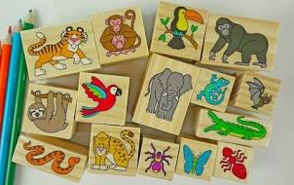
1. jungle spotted desert field
2. tame deadly gloves endangered
3. helmet fierce wild mighty
4. beak wing shell handkerchief
5. tarantula cheetah collector tiger
6. Write the names of the animals in the picture.
Unit 5
1.Complete the sentences with the verbs in the box. Use the correct form of the past perfect or the past simple.
not touch break take switch lose give not play not have

1. He showed us the place where he _____________ his leg.
2. I looked at the photos that he _________________ .
3. I read an interesting book which my teacher ____________________to me.
4. He discovered he __________________ his wallet
5. I _______________ a snake before that day.
6. Andy won the match although he _____________________ tennis before.
7. When I left the house, I ____________________ breakfast yet.
8. ____________ you ______________off the lamp before we left?

2. Put the verbs into the correct tense (Past Simple or Past Perfect).
- My friend ate up all the biscuit we (bake) ____________.
- The teacher corrected the tests we (write) _______________ .
- I (give) __________ them some of the candies I had bought.
- My sister (not find ) __________ the note that I had left on the kitchen table for her.
- We wanted to watch a film that we (not see) _______________ before.
- By the time I arrived at the cinema, the film (already start) _______________________.
- (he finish) __________________his homework when you arrived?
- I (be)_________________tired in the morning because I had gone to bed late.
3.Change the reported speech into direct speech.
- Helen says she went to London in July.
____________________________________________________________
- She says she is very hungry.
____________________________________________________________.
- They say they are doing their homework.
____________________________________________________________
- They say they’ll wash the windows.
____________________________________________________________
- Tom says he’s done the task.
_____________________________________________________________
- She says she is bad at sport.
_____________________________________________________________
4.Change the sentences into reported speech.
- I’ve joined the football club.
She said ________________________________________________________________.
- I’ll wash up later.
She said ________________________________________________________________.
- I was at the cinema.
She said ________________________________________________________________.
4. I’m listening to my favourite band.
She said ________________________________________________________________.

5.Write the opposites of the adjectives.
1 miserable ___________________________
2 generous ____________________________
3 dishonest ____________________________
4 brave _____________________________
5 polite _____________________________

6.Complete the sentences with the correct adjectives.
1 He’s a __________________ person. He always smiles.
2 She’s very ________________. She buys a lot of presents.
3 It’s a little puppy. Don’t be __________________.
4 They have stolen money. They are _____________________.
- Be __________________! Say ‘good bye’

7.Complete the sentences. Use the correct phrasal verb.
1 She ____________________________ her little sister at the moment.
2 The police _______________________the robbery at the moment.
3 You can _________________________the information in the Internet.
4 I ___________________________________ my purse all morning.
    - Are you _____________________________ the school trip?

8.Write questions and short answers.
teacher / work hard? ˅
Does your teacher make you work hard?
1 ________________________________________________________

brother / wash his car? ˟
2 ________________________________________________________________________
3 ________________________________________________________________________

friends / help them˅
4_________________________________________________________________________
5 _________________________________________________________________________
Unit 6
1. Complete the sentences. Use the correct form of the past perfect simple or the past
perfect continuous.
- Peter was happy. He _____________(finish) his project.
- The children were wet because they ________________ (play) football in the rain all morning.
- We were very hungry because we ______________ (not / eat).
- I was glad when I found my keys. I ___________________ (look) for them for hours.
- She was tired because she ____________________(work) since eight o'clock that morning.
- Everything was white because it ______________________(snow).
- The people were angry because the airline ____________ (lose) everyone's bags.
- I _________________(not / see) Jacob for several years, but I recognised him immediately.
2. Combine the sentences. Use who or which/that.
1. He is a cheerful boy. Everybody loves him.
________________________________________________________________________________
2. This is the house. Jack built it.
_______________________________________________________________________________
3. That is the road. It leads to the railway station.
________________________________________________________________________________
4. She likes the CD. She bought it this morning.
________________________________________________________________________________

3 Complete the text. Use who, which/that, whose, where and when.

There are still 125 million children worldwide ____________ parents are too poor to send them to school. This happens in poor countries__________ the governments cannot afford to give children free education. Kibera is a poor town________ is near the capital city of Nairobi in Kenya. In Kibera there are people from Oxfam __________are working to change the situation. Oxfam is providing books, and paying for twelve trainee teachers ___________ have been employed in Kibera. Old classroms are being rebuilt, and now 572 pupils are looking forward to the day ________they are going to go to school.

4.Write the name of disasters.

5. Complete the sentences. Use the verbs in the box in their correct form.

destroy, equip, erupt, explain, inform, investigate, argue
1 There is a police ______________________ at our school because somebody stole a bike.

2 There was a volcanic ____________________ last week.
3 I had an _________________ with my friend.
4 You can get ____________________ about this animal in the Internet.
5 The teacher didn’t believe his __________________.
6 The storm caused a lot of _________________
in the area.
7 What ____________________do you need for skiing?

Unit 7
1. Change the reported questions into direct questions.
1.Peter asked him why he was so late.
_________________________________________________________________________________
2.The policeman asked the boy where he lived.
_________________________________________________________________________________
3.He asked how old her mother was.
_________________________________________________________________________________
4.He asked me if I spoke English.
_________________________________________________________________________________
5.He asked me if I was British or American.
_________________________________________________________________________________
6.She asked if it was raining.
_________________________________________________________________________________
7.He asked her whether I had come by train.
_________________________________________________________________________________
8.He asked me if I had a computer.
_________________________________________________________________________________

2. Change the direct questions into reported questions.
1. “Are you married?”
She asked Anne ___________________________________________________________________
2.“Why are you wearing a yellow jumper?”
He asked me ______________________________________________________________________
3. “How many times did you ring?”
We asked him _______________________________________________________________________
4. “Where is he going?”
I asked him _________________________________________________________________________
5. “Do you want to go to the park?”
She asked me _______________________________________________________________________
6.“Will you go to the cinema?”
I asked her _________________________________________________________________________

3. Change direct commands and requests into reported speech
1 “Jessica,write a text message!”
__________________________________________________________________________________
2 “Fred, wash your hands!”
__________________________________________________________________________________
3 “James, please do your homework.”
_________________________________________________________________________________
4“Don’t eat my apple, Lisa”
________________________________________________________________________________
5 “Victoria, please check your e-mails."
_________________________________________________________________________________
6 “Mike, please don't shout at Peter!”
___________________________________________________________________________________

4. Choose correct indefinite pronouns.
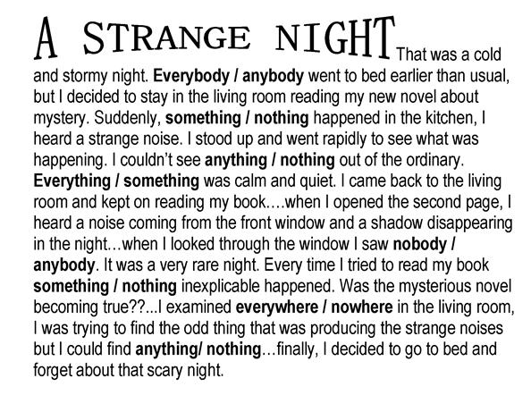


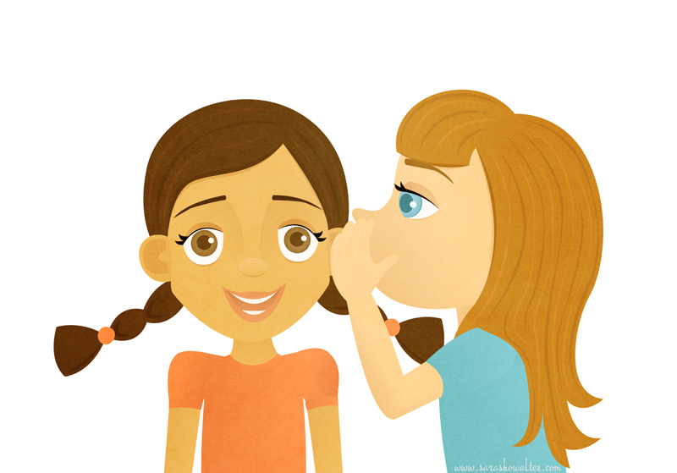
5.What are the people doing?

1 He’s _____________________ 2 _____________________________

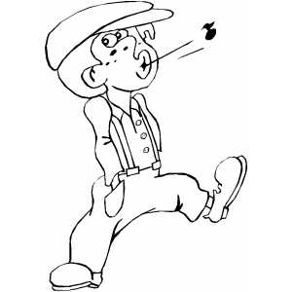

3 ______________________ 4 _________________________


5 ____________________________________

- Complete the sentences. Use adjectives and prepositions from the box.
excited annoyed proud fond frightened
of with about

- I'm very _____________________ my daughter. She’s worked really hard.
- She’s very ____________________ the party.
- Are you _______________ romantic films?
- He’s ________________ his sister because she takes his things.
- My brother is __________________ spiders. He screams when he sees one.
Unit 8
1. Choose the correct form of the zero or first conditional.
- If I go to bed after midnight, I am always / will always be tired in the morning.
- I don’t / won’t tell you anything if you can’t keep a secret.
- If you heat water to 100 C, it boils / will boil.
- I won't go to the party unless she invites / will invite me.
- If you multiply / will multiply 6 by 2, you get 12.
- If plants don’t have enough water, they die / will die.
- We will have / have a great time if they come with us.

2.Rewrite the sentences. Use the Second Conditional.
I haven’t got any money, so I won’t buy that CD.
If I had some money, I would buy that CD.

1) Dogs don’t fly because they haven’t got wings.
_______________________________________________________________________________
  - He gets bad marks because he doesn’t work hard.
________________________________________________________________________________
3) I won’t come with you because I’m busy.
________________________________________________________________________________
4) He won’t lend you his camera because he needs it. ________________________________________________________________________________
5) We like Rachel because she’s nice. ________________________________________________________________________________
6) She walks to school because she hasn’t got a bike. ________________________________________________________________________________
7) We won’t go to the beach because it’s cold.
________________________________________________________________________________

3.Complete the sentences. Use the correct form of the zero, first or second conditional.
1) If you clear up this mess now, I ____________________ (not/tell) Mum.
2) If Kelly invited me to the party, I ________________ (go).
3) The man ________________ (hurt) himself if he jumps from that tree.
4) If I met an alien, I ____________________ (not/be) scared.
5) If you put ice cream in the freezer, it (stay) __________________ cold.
6) Rosie will get into trouble if she ___________________ (not/finish) the project.
7) If I had some money, I _________________ (buy) a new jacket.
8) We will take you with us if we _____________ (go) to the beach.

4.Complete the text. Use the correct form of the words with the correct suffix.

Rock climbing can be a very (enjoy) ___________________ hobby. If you’re quite (adventure) ___________________________, then you’ll love it. There are many (fame) __________________ rock climbers – people who have done difficult and (danger) _____________________ climbs. If you want to go rock climbing, make sure that you’re wearing (suit) ___________________ clothes. And always wear a (protect) ___________________ helmet on your head.

5. Peter is ill in bed. Give him some advice. Begin with “If I were you”.
1. make a cup of tea 2. stay in bed all day 3. call the doctor 4. take an aspirin 5. not go to school tomorrow
1) If I were you, I would make a cup of tea.
2) _______________________________________________________________________________
3) _______________________________________________________________________________
4) _______________________________________________________________________________
5) ______________________________________________________________________________
Unit 9

Rewrite these sentences in the passive voice.

a. They serve breakfast at eight o’clock every day.
_________________________________________________________________________________
b. Someone built this house 200 years ago.
_________________________________________________________________________________
c. A thief stole my purse.
_________________________________________________________________________________
d. They produce cars in this factory.
_________________________________________________________________________________
e. People throw away rubbish every day.
_________________________________________________________________________________
g. They don’t make coffee in Ukraine.
_________________________________________________________________________________
d. Someone found my wallet.
________________________________________________________________________________
e. The students broke the window.

Complete with the passive. Use the correct passive form.
a. This programme _______________________ (not show) yet.
b. Rockets __________________________(send) to the Mars soon.
c. I’m not wearing my jeans today. They _________________________ (wash).
d. London __________________________ (visit) by thousands of tourists every year.
e. The biology class _________________________ (teach) by Mr Green next year.
f. English _____________________ (speak) all over the world.
g. Lunch _____________________ (serve) at the moment.
h. Those books _____________________ (translate) last year.

Complete with the passive. Use the correct passive form of the verbs in the box.
invent paint use send make not write feed take

a. Paper _____________from wood.
b. The telephone __________________by Mr Bell.
c. This picture _____________________by Peter at the moment.
f. The letters ___________________next week.
g. The animals ________________three times a day.
h. This article _________________________ by Stanley.
i. Our photo _______________ when we were at the party.
j. The computer _______________ at the moment.

Complete the sentences with methods of transport.
1. Astronauts travel into space in a __________________________.
2. You can travel across London by bus or by ____________________.
3. Eight people went on the trip. They travelled in a ______________________.
4. A ______________ is bigger than a van. It is used for carrying heavy things.
5. My uncle is very rich. He goes to work by _________________. It lands on his office roof.
6. You must wear a helmet when you ride on a motorbike or a _______________.
7. When people first travelled to Australia, they went by _________________.

Complete the sentences.

1. How long does your ___________ to school take?
2. Is your doctor a man or a __________________?
3. What did you _____________ your name was?
4. We sometimes ______________ money from the bank.
5. I’m going on a ______________ to London.
6. My uncle and his ______________ set off on a journey last week.
7. Did you ____________ your parents about the call?
8. I can ____________ you some money if you forgot yours.

Complete the conversation.
Lisa’s mum Hello?
Jane ____________________ Lisa, please?
Lisa’s mum Yes, of course. __________________________?
Jane It’s Jane.
Lisa’s mum Just a moment, Jane. __________________.

Lisa Hello?
Jane ____________________. It’s Jane.
Lisa Hi, Jane. ________________?
Jane Fine, thanks. How are you?
Unit 10

- Combine the sentences. Use who or which.
1 The song made millions. He wrote it in ten minutes.
__________________________________________________________________
2 The girl is ten. She lives in New York.
__________________________________________________________________
3 The shopping centre is excellent. It is near our house.
__________________________________________________________________
4 Tom plays for school team. He loves football.
__________________________________________________________________
2 Complete the sentences with who, where or which, when, whose.
1 The woman, ___________ helped me, is my English teacher.
2 The shop, ____________ I used to buy my clothes, is very old.
3 My new dress, ____________ my boyfriend hated, cost £100.
4 The woman, ___________ dog was stolen, was interviewed on TV.
5 On Monday morning, ___________I woke up, I didn’t feel very well.
- Jake, ___________is the band’s lead singer, plays the guitar too.

- Use gerunds or infinitives.
- What have you decided (do) _______on Saturday?
- My sister wants (go) _________cycling, but I hate (cycle) ___________. I prefer (swim)________________.
- I like (swim) ___________ too. Let’s go to the swimming pool today.
- But I promised (help) ________ my mum in the morning. She agreed (buy) ________ me a new phone if I clean the carpets. I don’t enjoy (clean) _________ carpets, but I love (chat) __________ on the phone with my friends.
- Add question tags to the statements.
1 You didn’t like the concert, _____________ ? 2 He hasn’t got a job, _________?
3 They don’t have a dog, _____________? 4 She goes training everyday, __________ ?
5 There isn’t any cake left, _______? 6 He wasn’t at school, ____________?
7 I am a teacher, __________? 8 The can go out, _____________?

- Use the vocabulary words.
Here’s my family. My dad, who is 46, is a ________________________. My mum is 10 years younger than him, so she is an _____________________. My grandma, who is an ____________________, helps her about the house. I am 14. I am a ________________. My brother is 10 years older than me. His wife is a ____________________ of the same age. They have a _____________ who is 2 months old. My younger sister is a _________________. She will be 5 next year.

- Use make and do in the correct form.
Last week I _________________ the housework while my younger sister ______________a jigsaw puzzle. After I finished it, I _________my homework. I __________ some mistakes because I wasn’t attentive. Then I decided _________________ lunch. I ___________ two cups of coffee and invited my friend. We didn’t ___________ much noise when my sister was sleeping.

Unit 11
Complete the third conditional sentences.
- If he (come)________________ earlier, he (meet) __________________Tina.
- If I (see)______________ you, I (talk)______________________ to you.
- We (give)__________________ the man the documents if we (know)_________________ him.
- They (understand) ________________the film if they (read) ____________________the book.
- If the car (turn) _______________left, the old lady (cross) _____________________the street.
- The boys (win) ____________________ match if they (train)___________________regularly.
- Lucy (not/hurt)____________________ her foot if she (not/drop)______________ the old box.
- If you (use) ______________a sharp knife, you (not/cut)______________________yourself.
Write third conditional sentences.
- You didn’t listen to the radio. You didn’t hear about the storm.
____________________________________________________________________________
- I met you. I went to the party.
____________________________________________________________________________
- He bought the tickets. He went to the concert.
____________________________________________________________________________
- I didn’t know about the test. I didn’t study last night.
_____________________________________________________________________________
- We tidied our room. Mum wasn’t angry.
_____________________________________________________________________________
Сomplete the sentences.
- I am too short. _______________________________________________________
- I don’t have a dog. _____________________________________________________
- I can’t speak French. ___________________________________________________
- My house is small._____________________________________________________
- The weather is bad. _____________________________________________________
Rewrite the sentences using the correct form of have something done.
- Somebody has dyed my sister’s hair. My sister _______________________________________.
- Somebody is doing her nails. She __________________________________________________.
- Somebody painted the house for Nelly. Nelly ________________________________________
- Somebody will cut the grass for my parents. My parents _______________________________
- Somebody is going to repair our car. We ___________________________________________ .
- Somebody washes up for them. They ______________________________________________
Complete the sentences with jobs from the world of films.
- The ___________________________ is responsible for actors’ clothes.
- The ___________________________does Jane’s make-up.
- The _________________________ tells everyone what to do.
- The _________________________does all the dangerous scenes herself.
- The _________________________is repairing the lights.
- The _________________________ has written a great story.

Complete the sentences with the correct adjectives.
1 He's such a monotonous speaker. I was so _______________________ . (bored / boring)
2 Everyone's very _____________________________about the news. (excited / exciting)
3 I thought the horror film was __________________.(frightened/frightening) I couldn’t sleep.
4 It is very _________________ (annoyed/annoying) when the mobile phone rings at the lesson.
5 I fell over in front of boys. It was very ___________________ (embarrassed/embarassing).
6. Tom moved away. I was _______________(surprised/surprising) when I saw him in the town.

Order the conversation.
- Great. Thank you very much.
- How much are the tickets?
- Could you tell me when Avatar is on today, please?
- Good morning. The Dniester Cinema. Can I help you?
- It’s on at 11 am and 3 pm.
- They’re 25 UAH for children and 40 UAH for adults.
- You’re welcome.

Unit 12

1.Choose the correct variant.
a. The toothbrush was invented / is invented in the 15th century.
b. Basketball has been played / is being played since 1892.
c. The new bridge is built / will be built next year.
d. The film is watched / is being watched at the moment.
e. Breakfast cooked / is cooked every day.
f. Cocoa beans were made / are made in South America.
2.Use the correct form of the passive
Letters __________________________by the postman at 8 every day. (deliver )
This bag ______________________in the bus yesterday. (find)
These offices __________________now. (clean)
The message _____________________tomorrow. (send)3.
Your motorbike ___________________yet.(repair)

3.Write third conditional sentences.
1. You forgot to bring a map. We got lost.
______________________________________________________________________________
2. You didn’t water the flowers. They died.
_______________________________________________________________________________
3. She trained hard. She was a good player.
_______________________________________________________________________________
4.Ms Dawson loved animals. She had six cats.
________________________________________________________________________________
5.The critic didn’t like the film. She wrote a bad review.
________________________________________________________________________________

4.Combine the sentences. Use who, which, whose, where or when.
1. Ivan, _________ is Helen’s brother, is very good-looking.
2. The book, __________ was written by Agatha Christie, is about a murder on the Nile.
3. My friend, __________ father is a TV presenter, wants to do media studies.
4 The new club, ___________ Jamie works, plays great music.
5. My holiday in Ibiza, _________ I first met Jenny, was wonderful.

5.Gerunds and infinitives.
- We enjoy (read) _________________ comics.
- I hate (get up) ___________________ early in the morning.
- I promised (help) ____________________ my parents with the housework/
- They really like (play) _________________ tennis.
- I’ve decided (work) __________________ really hard at school this term.
- He refused (lend) _________________ it to me.

6.Choose the correct form of the verbs.
- Tom mustn’t / might / doesn’t have to take the exam again because he has already passed it.
- We shouldn’t / may / have to go to the beach this weekend. We have nothing to do.
- I must / don’t have to / ought not to visit my grandparents. I haven’t seen them for a long time.
- You’re ill. You ought to / might not / may stay at home today.
- I can’t go to the cinema. I mustn’t / could / have to look after my cousin.
- You look tired. You shouldn’t / should / might not go to bed early.

Список використаної літератури

1. Norman Whitney, Driscoll Liz. Oxford Team 3 SB, OUP, 2001

2. Norman Whitney, Driscoll Liz. Oxford Team 3 WB, OUP, 2001
3. https://ego4u.com/en/cram-up/grammar
4. www.englisch-hilfen.de/en/exercises_list/alle_grammar.htm
5. inglescarmelitaslb.files.wordpress.com

