Theme: A letter from an American friend. Giving information about recent events.
Objectives: to develop students’ speaking, listening and reading skills;
to practise students in using Present Perfect;
to teach students to enjoy communication in English;
to form students ability of using their imagination while discussing different situations
Equipment: textbooks, pictures, hand-outs
PROCEDURE
І. Introduction
1. Greeting
Good morning, boys and girls. How are things with you today?
2. Aim
Today we’ll learn how to talk about general experiences and ask about the duration of the action. We’ll also learn how to say about recently completed actions and about something that has happened sooner than expected. So let’s start.
3. Warm-up
Game “Snowball fight”
Students write two questions about the things other students have experienced on a piece of paper. Then they crumple the paper up into a ‘snowball’ and have a one-minute snowball fight. At the end of the minute, everyone grabs the closest snowball and has to answer the questions.
II. Main part
- Board races
Let us play another game to review Past Participle. Break into 2 teams.
One student from each team goes to the board and write the third form of the verb into the appropriate column - V_{ed} or V_{ir}.
The first team to successfully write the correct response wins.

V_{ed} like V_{ir} V_{ed} see V_{ir}
be was buy
cook invited invite
write wash
finish study
drop tell
know have
hear win
- Present Perfect with for and since
The choice of the words are often confused by students when using the Present Perfect. You are given two cards with FOR and SINCE. I’m going to read the sentence We have known Paul … with different time expressions and you must hold up the right sign.
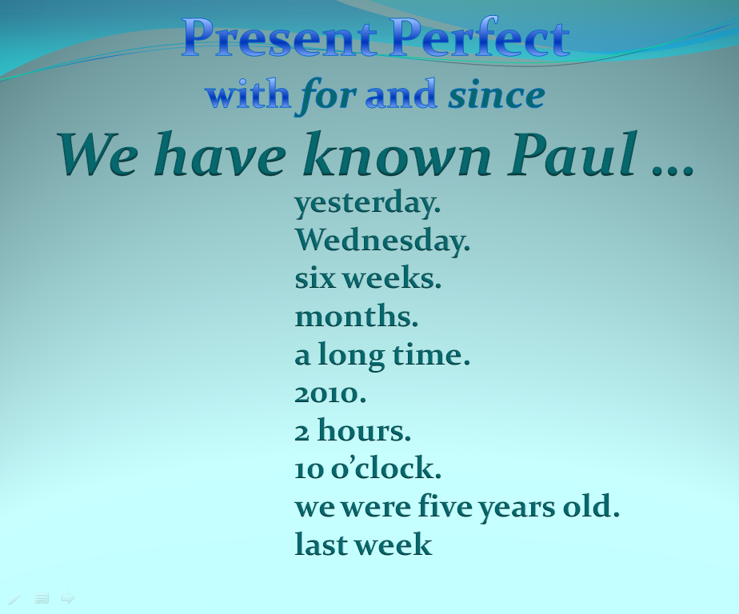

- Talking about experiences

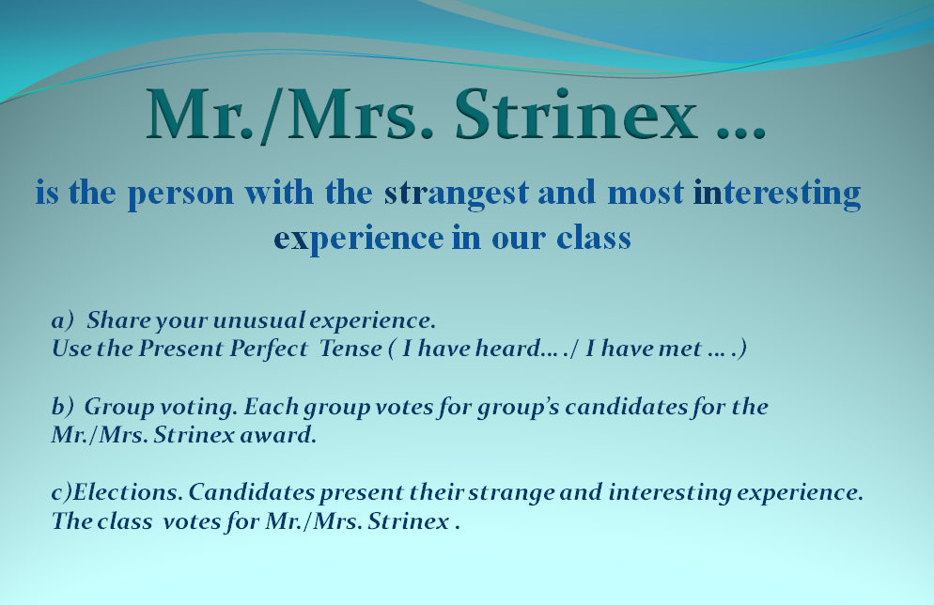

Now we are going to choose Mr/Mrs Strinex. First of all let’s divide into two groups. Take these M&M’s and form groups according to the colours you have chosen. We’ve got Browns and Reds.
- Your task is to share your unusual experiences. Remember to use the Present Perfect tense.
- Now each group votes for its group’s candidates for Mr/Mrs Strinex award.
- Candidates present their strange and interesting experiences. Then the class votes for Mr/Mrs Strinex.
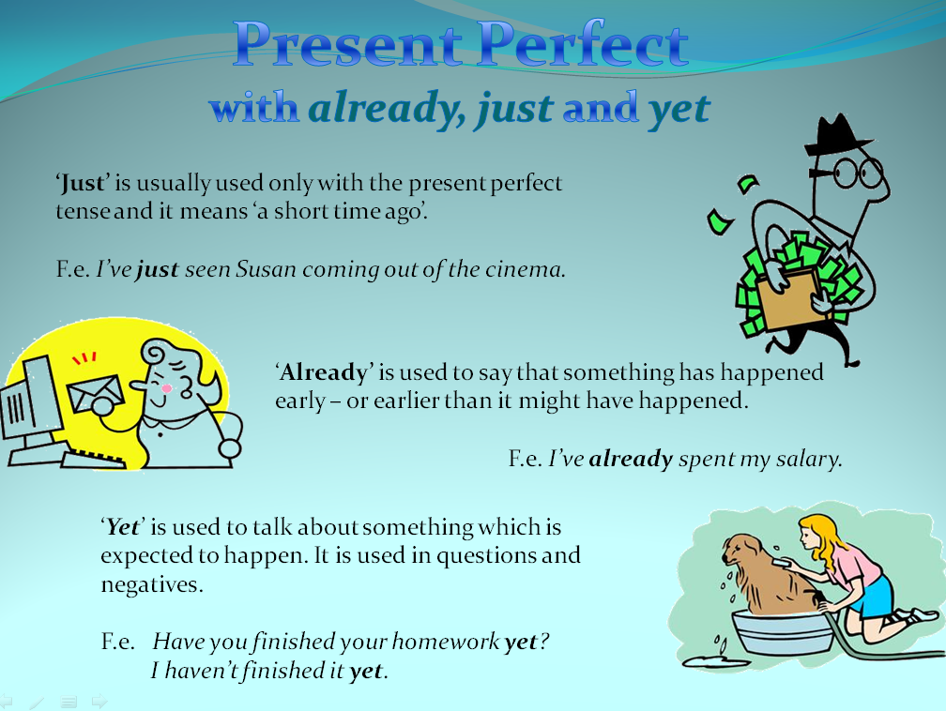
- Present perfect with already, just and yet.

- Now your task is to say what you have already done and what you haven’t done yet.
S₁ I have already had my lunch. I haven’t written the test yet.
S₂ … .
- Look at the screen. You are going to watch a short video film about Gran’s adventures. Your task is to circle True or False sentences.
- Gran hasn’t been to London. True False
- John has been to London. True False
- Gran hasn’t seen the Eiffel Tower. True False
- John’s seen the Eiffel Tower. True False
- Gran has eaten sushi. True False
- John hasn’t eaten sushi. True False
- Gran’s been to Tokyo. True False

- Cut up story
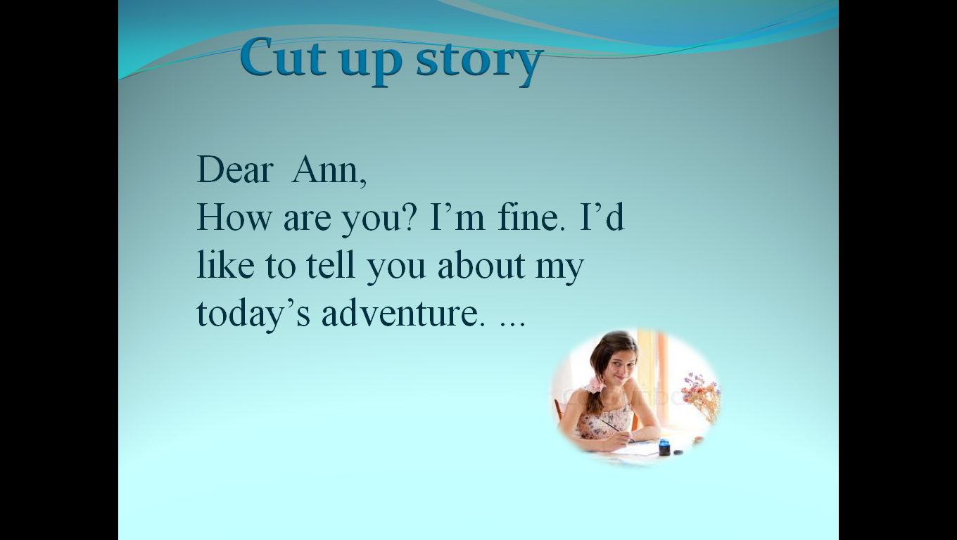
Here’s a message that you’ve got from your best friend from the USA.

You split into two groups Browns and Reds. Your task is to write a short story on a piece of paper, with each sentence on a new line of paper.
Then you cut up your story, so that each sentence is on a separate strip of paper and give it to another group. The group who receives the story has to put the sentences in the correct order. Then one member of the first group (who wrote the story) will check the second group’s work, and see if they put the story in the correct order.
III. Summing up
      - Hometask
Learn the words p. 89 (WB)
Do ex.3-5p.41 (WB)
      - Summarising
What have you learned today? What have you done?
Навчально-виховний комплекс
«Загальноосвітня школа І-ІІІ ст.№1-гімназія»
м.Копичинці

A letter from an American friend. Giving information about recent events
/2 гімназійний клас/

вчитель англійської мови
Танькова О.М.

