Topic: A Virtual Trip Across English-Speaking Countries
Objectives: to provide opportunities for developing speaking skills based on the topic;
to revise the material on the topic;
to enrich pupils vocabulary on the topic;
to develop pupils’ memory;
to teach pupils to collect information and make the conclusions;
to widen pupils outlook;
to teach pupils to respect our native country and the countries the
language we are learning.
Supplies: smartboard, a notebook, handouts.
Type of the lesson: speaking lesson
Procudere
- The beginning of the lesson
1.Greeting
Aim
Dear friends! Today we are going to have an interesting media project about English-Speaking Countries. Our today’s media project is devoted to extending the knowledge of English-Speaking Countries in all possible aspects: culture, geography, history and symbols.
Warming up
Match the names of the English-Speaking Countries with their capitals
The USA London
England Ottawa
Canada Canberra
Australia Wellington
New Zealand Belfast
Wales Edinburg
Scotland Washington
North Ireland Cardiff
- The main part of the project
1. First of all I want to tell you some general information about English and the countries, the language we are learning. Look at the smartboard and listen to the information.
English is without doubt the actual universal language. It is spoken as the native language by around 377 million and as a second language by around 375 million speakers in the world. Around 750 million people are believed to speak English as a foreign language. English has an official or a special status in 75 countries with a total population of over 2 billion.English is the official language of the United Kingdom of Great Britain and Northern Ireland, of the United States of America, of Australia and New Zealand. It is used as one of the official languages in Canada, the Republic of South Africa and the Irish Republic. English is also spoken as a second language in the former British and US colonies.

2. For your homework you had to devide into small groups and prepair the project presentation about each English- speaking country.
But first of all I’d like to show you a short video about the beauty of these countries.
And now imagine a situation: I am a tourist. I want to visit any English-speaking country. The groups will persuade me to visit one of the best English- speaking countries. Now we can see it and listen to you. You are invited!
The first country is England
Wales
Scotland
North Ireland
The USA
Canada
Australia
New Zealand
3. All pupils were good at making presentation. I would like to visit each country because I haven’t been anywhere. It’s my dream to visit an English- speaking country.
4. We have had a virtual trip to English- speaking countries. It’s time to sum up our results. I like the way you worked- you were creative, energetic and bright but I’d like to know if you were attentive today. I have prepared some tasks for you. Let’s do some tasks.
Answer the questions:
- Where was William Shakespeare born?(Stratford-on Avon.)
- What is the name of the flag of Britain?(The Union Jack.)
- What is the highest mountain in Britain?(Ben Nevis.)
- What is the most famous clock in London?(Big Ben.)
- Where was the Beatles born?(Liverpool.)
- What is the longest river of the UK?(The Severn.)
- Who first stepped on the moon?(Neil Armstrong.)
- When is Christmas celebrated in the UK?(December 25.)
- What are the national clothes of Scotland?(Kilts.)
- What river does London stand on?(The Thames)
- What is a Christmas dish in England?( A turkey.)
- Who discovered America?(Columbus.)
- What is the Royal residence in London ?(Buckingham Palace.)
- Name the national symbol of England? (A rose.)
- What is the favourite topic of conversation in the UK?(weather.)
- The capital of Scotland is…(Edinburg.)
- The university towns are…(Oxford and Cambridge)
- The capital of Wales is…(Cardiff.)
- Where does USA situated?(In the central part of the North American Continent.)
- What is the population of the USA?(More than 236 million people.)
- How many states are there in the USA?(Fifty)
- What is the capital of Canada?(Ottawa.)
- What are the most important cities?(Montreal, Toronto, Edmonton, Hamilton, Winnipeg, Quebec.)
- What are the largest lakes in Canada?(The Great Lakes Superior, Huron, Erie, Ontario, Great Bear Lake, Great Slave Lake and Lake Winnipeg.)
- What kind of state is Canada?(A federal state and a member of the Commonwealth)
- In what hemisphere is Australia situated?(The South hemisphere.)
- What is the capital of Australia?(Canberra.)
- What is the population of Australia?(About 15 million people.)
- What are the biggest cities in Australia?(Sydney, Melbourne, Adelaide, Perth, Brisbane.)
- Who is formally the head of the state?(The Queen of England.)
- Who represents the Queen of England?(The governor-general.)
- Where is New Zealand situated?(South-east of Australia)
- What is the national emblem of New Zealand? (Kiwi.)
- What are the main cities?(Auckland, Christchurch, Dunedin.)
- What is the population of New Zealand?(Over 3 million people)
Choose the correct answer
1.The full name of the UK is …
- Great Britain
- The United Kingdom of Great Britain and Northern Ireland
- The United Kingdom and Irish Republic
2.The UK consists of…
a) 2 parts
b) 3 parts
c) 4 parts
3. What language isn’t spoken in the UK?
a) Welsh
b) Irish
c) Latin
4. What separates Europe and Great Britain?
a) The English Channel
b) The Irish Sea
c) The North Sea
5. The largest part of the UK is ..,
a) Wales
b) England
c) Scotland

6. Edinburg is the capital of…
a) Scotland
b) Northern Ireland
c) Wales
7. What is the national symbol of Wales?
a)Two red crosses
b) The red dragon
c) The Loch Ness monster
8. What is Britain’s population now?
a) 29 mln
b) 58 mln
c) 40 mln
Game Quiz
- What nationality are people from the USA?( Americans)
- What is the name of the English Queen?(Elizabeth)
- What city has the same name as the president of this country?(Washington)
- Where is the Statue of Liberty?(In the USA)
- What is the kiwi?(It is the bird, the national emblem of NZ)
- Where in the world can you see double-deckers(The USA)
- Where is Glasgow situated? ( In Scotland, on the river Clyde)
- What English has a very good football team? (Manchester)
- What is the biggest industrial centre in Britain ? (Birmingham)
- What are the biggest university cities in England ? (Oxford and Cambridge)
- Where does the President of the USA live and work? (In the White House)
- How many states does the USA consist of?(50)
- How is New York City informally called today?(The Big Apple)
- What is the population of New York? (over 16 million people)
- What do 50 stars of the US flag mean? (They mean 50 states today)
- What is the national bird of the USA?(bald eagle)
- What is the largest state of the USA?(Alaska)
- What is the emblem of Alaska?(forget-me-not)
- What is the symbol of American democracy?(The Statue of Liberty)
- What is the national motto of the USA ?(In God we trust – expressing the counry’s ideals)
Restoration of the text
The Statue of________ is also the _________ of American democracy. It stands on ________
Island in New York. It _________one of the first things people _________ when they arrive in
New York. Liberty carries______ torch __________ freedom in her right __________. In her ________ hand she _______ holding a tablet with the inscription “ July”, 1776. American _________ __________ .
Do crosswords “London’s sights”
- What city is the capital of Britain?(London)
- What square of London is famous for Nelson’s column?(Trafalgar Square)
- What is the most famous of all historical buildings in London almost unchanged since 11th century?(Tower)
- What palace is the residence of the Queen of England?(Buckingham)
- Where can you see a lot of people in hot summer days?(Hyde Park)
- Where are the graves and memorials to many English writers?(Poet’s Corner)
- What is the second name of the Houses of Parliament?(The Palace of Westminster)

2
1
3
4
5
6
7

T
r
a
f
a
l
g
a
r
o
n
d
o
n
W
e
s
t
m
i
s
t
e
r
p
o
e
t
s
c
r
n
e
r
H
y
e
p
a
r
k
t
w
e
r
B
u
c
k
i
g
h
a
m
III.Reflection
Now it’s time to check up your memory. Look at the smartboard . You can see numbers and your task is to say “ What do these numbers mean?”
50 (states)
4( The United Kingdom of Great Britain and Northern Ireland)
3 (Great Britain)
75(English has an official and special status in these countries)
86(The age of the queen Elizabeth II)
33.(The population of Canada)
22.(The population of Australia)
60 (Brilliant jubilee of the Queen Elizabeth
What country does this symbol belong to?
A red rose …(England)
A thistle…(Scotland)
A shamrock..(Ireland)
A leek and daffodil (Wales)
A kiwi ( New Zealand)
The Statue of Liberty( The USA)
A maple leaf( Canada)
An aborigine ( Australia)
Where are these famous people from?
Princess Diana (England)
Madonna(The USA)
Nicole Kidman( Australia)
Russell Crowe( New Zealand)
Sem Neill( Northern Ireland)
Catherine Zeta- Jones( Wales)
Gerard Butler( Scotland)
Justin Bieber( Canada)
In what country can you visit these places of interest?
Disneyland( The USA)
Niagara Falls(Canada)
Sydney Opera House ( Australia)
Madame Tussaud’s Museum (England)
Edingburg Castle( Scotland)
Sky Tower(New Zealand)
Belfast Castle(Northern Ireland)
Cardiff Castle (Wales)
V. At home make a project about the food in English- speaking countries.
VI. Now it’s time to appreciate yourselves. You get a card on which you have to put a sign v if you know how to do it.

Let’s sum up our great work.
Our trip has finished. Today you have done a good job. You will get 11, 10… I hope you will visit these beautiful countries in future. Good- bye! Have a good luck!

The USA

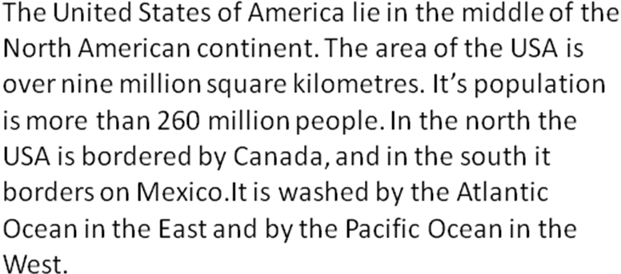
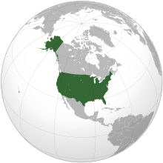

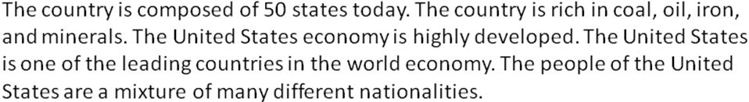

The flag of the USA

Red colour is for courage.
White is for purity.
And blue is for justice.

The president of the USA is Barack Obama.

The national motto is “In God we trust”-expressing the country’s ideals.

The symbols of the USA :
The Statue symbolizes a welcome to a land of freedom .
Bald eagle
The capital of the USA is Washington.

The cities of the USA are Atlanta, Los Angeles, New York, Chicago, Boston, Dallas, Philadelphia, Miami, Washington, Houston.

Places of interest in the USA are Disneyland, Hollywood, The White House, Hyde Park, Manhattan, Times Square, Moravian village, Harvard University.

The United States dollar is the official currency of the USA and its overseas territories.

Typical animals are the American bison, the moose, the deer,the bighorn ship, the American black bear.

Sports in the USA are baseball, American football, soccer, golf, ice hockey, basketball.

Famous people are Marilyn Monroe an actress, Neil Armstrong an astronaut, Madonna a singer, Michael Jackson a singer, Whitney Houston a singer, Bruce Willis an actor.

Canada
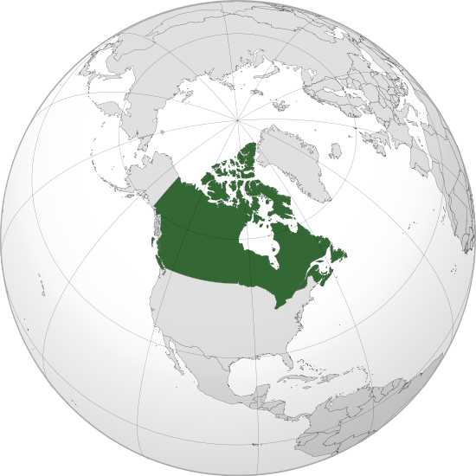

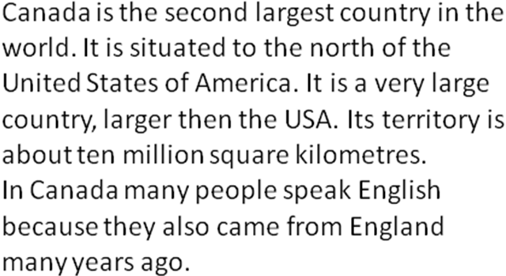

Now Canada is an independent country but the British Queen is still the head of the state.

The Canadian Dollar is the official currency of Canada.

The symbol of Canada is the maple leaf.

The capital of Canada is Ottawa.

Big cities are Vancouver, Montreal, Edmonton, Calgary, Quebec.

Places of interest are CN Tower in Toronto, Niagara Falls.

Typical animals are the Canadian goose, the Eastern moose, the painted turtle, the North American beaver.

Sports in Canada are lacrosse, soccer, ice hockey, basketball.

Famous people are James Cameron a film director, Avril Lavigne a singer, Justin Bieber a singer, Nelly Furtado a singer, Ryan Reynolds an actor, Celine Dion a singer.

England
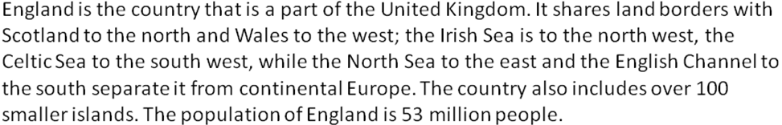
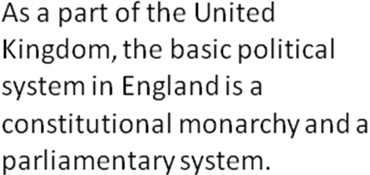
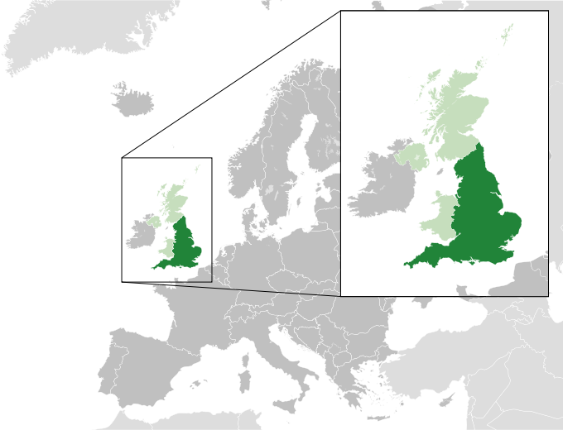

The flag of England is The Union Jack.

The symbols of England are the oak tree, the red rose, the black tea with milk, the ball, the Big Ben.

The pound sterling is the official currency of England.

The capital of England is London

The cities of England are Oxford, York, Liverpool, Birmingham, Cambridge.

Places of interest are Madame Tussauds Museum, Cambridge University, Oxford University, London Eye, Buckingham Palace, Westminster Abbey, The Houses of Parliament.

Typical animals are the red deer, the common seal, the hazel dormouse, the pole cat.

Sports in England are cricket, football, badminton , rugby.

Famous people are Adele, Orlando Bloom, Emma Watson, Kate Winslet, David Beckham, Victoria Beckham.

Wales
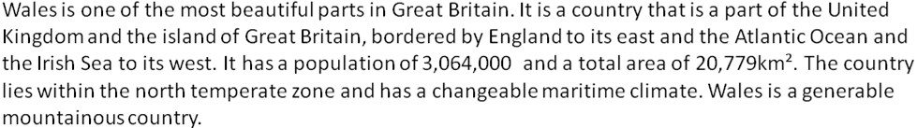

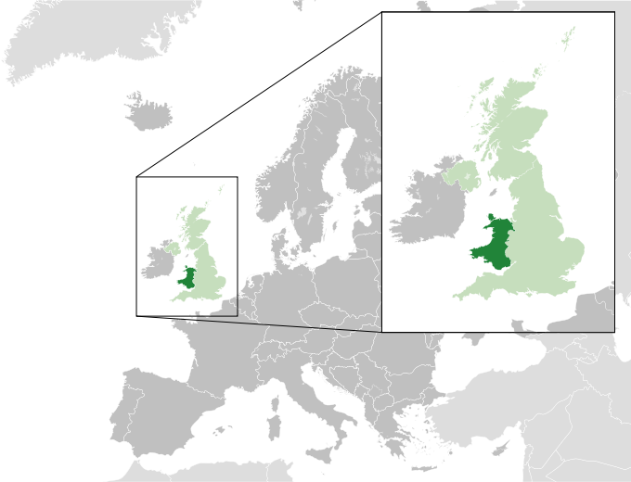
A leek and a daffodil are the symbols of Wales.

Wales is a country that is a part of the United Kingdom of Great Britain and the islands. The monarch is Elizabeth II. First Minister is Carwyn Jones.

The capital of Wales is Cardiff

The cities of Wales are Bangor, Cardiff, Newport, Swansea.

Places of interest in Wales are Cardiff Castle, Llechwedd Slate Caverns, Plassey Craft and Retail Centre, Plantasia.

The currency is the pound sterling.

Typical animals are the Mute Swans, the Red Kite,the Duck.

Sports in Wales are cricket, football, rugby, boxing

Famous People are Catherine Zeta-Jones, Duffy, Patrick Rafter

Scotland
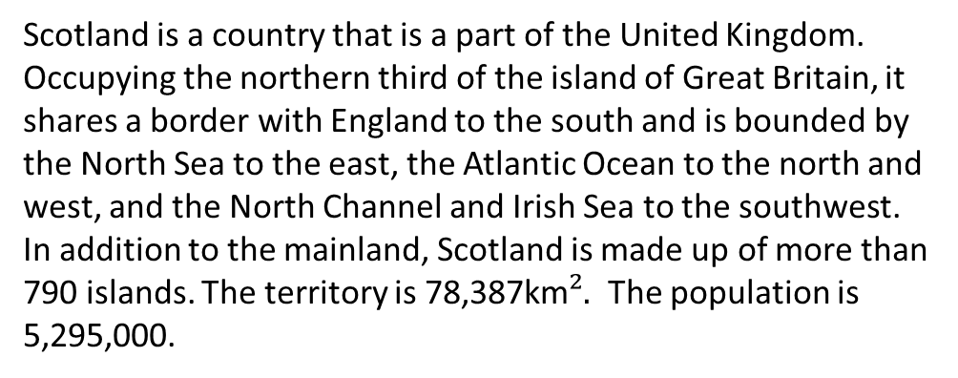

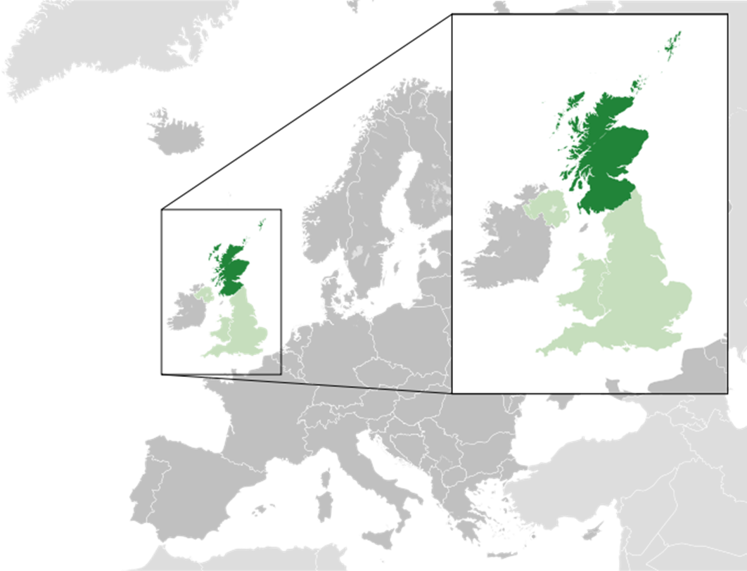

A thistle is a symbol of Scotland.
On 1 May 1707 the government of Scotland came to the signing of a political union with England to create the United Kingdom. The head of state is Elizabeth II. First Minister is Alex Salmond .

The capital of Scotland is Edinburgh

The cities of Scotland are Aberdeen, Dundee, Glasgow, Paisley.

Scotland's currency is the pound sterling.

Kilts are the national clothes of Scotland.

Places of interest in Scotland are Edinburgh Castle, Craigmillar Castle, Loch Ness, Melrose Abbey.

Typical animals are the Red Deer,the Red Squirrel,the Red Kite, the European Beaver.

Sports in Scotland are skiing, rugby, cricket.

Famous People are Calvin Harris, Kelly MacDonald, Gerard Butler, James McAvoy.

Northern Ireland
Northern Ireland is a part of the United Kingdom. Northern Ireland shares a border with the Republic of Ireland to the south and west. The area is 13,843km². The population is 1,810,900.
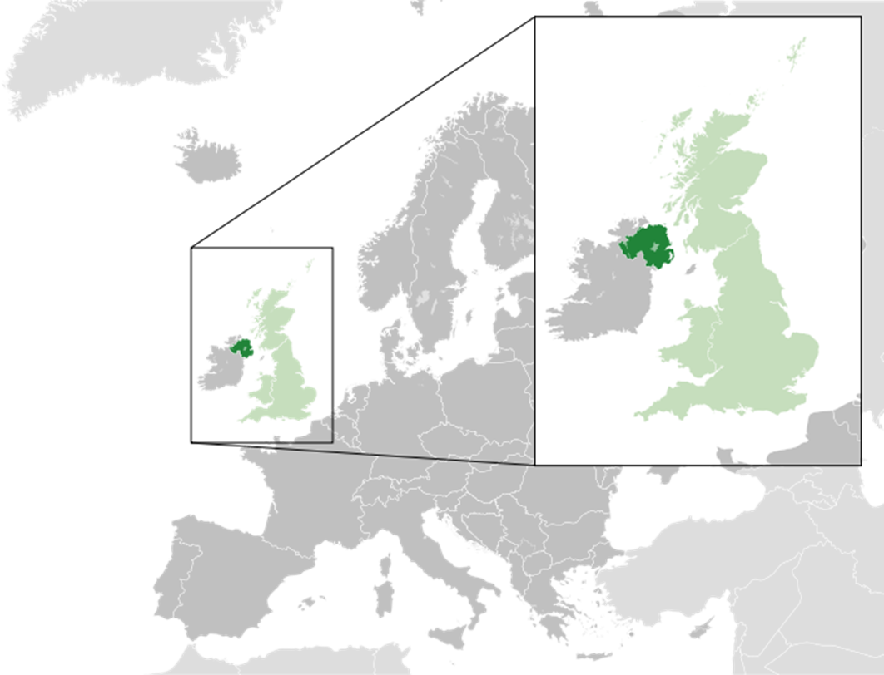
A shamrock is a symbol of Northern Ireland

Since 1998, Northern Ireland has devolved government within the United Kingdom. The head of state is Elizabeth II. Prime Minister of Northern Ireland is Gordon Brown.

The capital of Northern Ireland is Belfast

The cities of Northern Ireland are Armagh, Lisburn‎, Derry‎, Newry, Belfast.

Places of interest in Northern Ireland are Belfast Castle, Giants Causeway, Tollymore Forest Park, Transport Museum.
Northern Ireland's currency is the pound sterling.

Typical animals are Badgers, Hedgehogs, Foxes, Stoats, Rabbits.

Sports in Northern Ireland are cricket, basketball, rugby.

Famous People are Liam Neeson, Sam Neill.

Australia
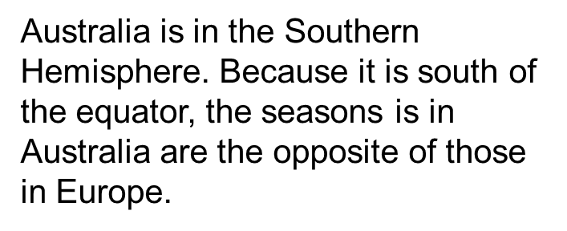
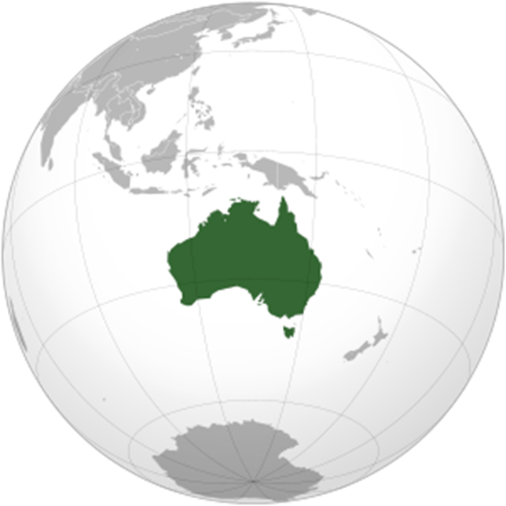

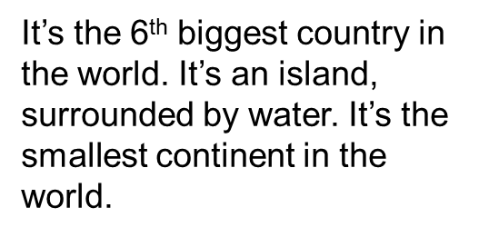
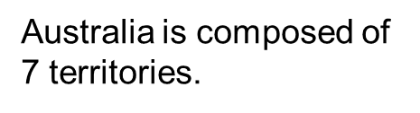
James Cook discovered Australia in 1770.

Native Australians. The Aborigines have lived in Australia for over 40,000 years. Now they only represent 1% of the population.The total population of Australia is 22 million.

The capital city is Canberra.

The biggest city is Sydney, where there is the famous Sydney Opera House.

The cities of Australia are Melbourne, Adelaide, Perth, Brisbane.

The Australian Flag is Union Flag 6th British colony.

The currency is the Australian dollar.

Sports in Australia are surfing, swimming, scuba-diving, cricket.

Animals in Australia are Kangaroo, Koala, Tasmanian devil, Dingo.

Some Australian Symbols are Devils Marbles Conservation Reserve, an Aborigine, Sydney Opera House.

Famous People are Nicole Kidman, Mel Gibson, Chris Hemsworth, Hugh Jackman, Elle Macherson, Kylie Minogue.

Places of interest are Ayers Rock, The Great Barrier Reef.

New Zealand
It’s a small country. It’s situated next to the Australian continent in the Oceania.

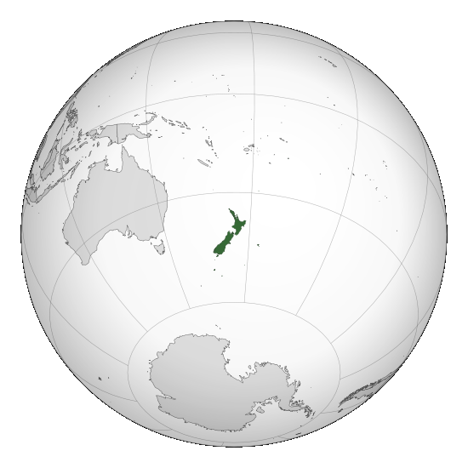
New Zealand is a beautiful country of mountains, active volcanoes, waterfalls, geysers and glaciers in the Southern Alps.

New Zealand is a constitutional monarchy with a parliamentary democracy although its constitution is not confident. Queen Elizabeth II is the Queen of New Zealand and the head of state. The Queen is represented by the Governor-General, whom she appoints on the advice of the Prime Minister.

The capital of New Zealand is Wellington.

The cities of New Zealand are Auckland, Gisborne, Tauranga, Christchurch, Napier, Palmerston North, Whanganui, Hamilton, Dunedin .
Places of interest in New Zealand is Sky Tower.

The New Zealand dollar is the currency of New Zealand.

The symbols of New Zealand are kiwi, Coat of Arms, Silver fern.

Typical animals are dear, ostrich, lama, kiwi, tiger.

Sports in New Zealand are rugby, cricket, soccer, netball, tennis, Indoor Bowls.

Famous People are Keith Urban, Russell Crowe, Cameron Russell, Elizabeth Knox, Lucy Lawless.

