AFTER-CLASS ACTIVITY
JEOPARDY GAME SHOW
“WE AND THE ENVIRONMENT”
Objectives: -to develop pupils’ listening, reading, speaking skills;
-to practice questions “Who is/are…!” and “What is/are…?”
- to develop pupils’ critical thinking and general knowledge skills;
- to develop pupils’ socio-cultural competence;
- to enhance pupils’ knowledge on environmental protection problems.
Equipment: Power Point Presentation for round 1 “Jeopardy!”, Power Point Presentation for round 2 “Double Jeopardy!”, cards duplicating questions from the presentations and a card with a question for the “Final Jeopardy!”, Jeopardy theme song “Time” to play in the background.
PROCEDURE
- INTRODUCTION.
Teacher: I’m glad to see our teams in good mood today.
Let’s greet the green team with applause. Are you ready to compete?
Let’s greet the blue team. Are you ready to show your best?
Let’s greet the orange team. Are you ready to win?
Today we are going to play the most popular game show in the history of American television. The original version debuted in 1964. And the program is still airing.
The game comprises three rounds: Jeopardy!, Double Jeopardy!, and Final Jeopardy!


- ROUND 1. JEOPARDY!
Teacher. The Jeopardy! Round 1 features five categories, each of which contains five clues. They are valued by difficulty( from 10 to50). You can see them on the board.
I have three cards in my hands. Each team has to choose one card. If you have the picture of the Earth, you begin the contest. If you respond correctly, you get the clue’s value to your score and may select a new clue from the board. An incorrect answer deducts clues value from the score and allows the other teams to respond.
There’s one peculiarity in the game. You will be presented with clues in the form of answers, and you must phrase your responses in the form of questions. Giving responses you should say "who is/are" for people or "what is/are" for things or words.
(Power Point Presentation “Jeopardy! Round 1”)
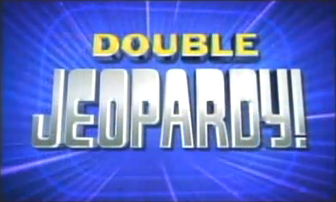
- ROUND 2. DOUBLE JEOPARDY!
Teacher. Double Jeopardy! round 2 is similar to Jeopardy! Round 1. Here the value of the clue is doubled (from 20 to 100). Also, be careful with your responses. If you forget about “Who is/What is…?” , your response will be considered wrong. The team with the least score at the end of the Jeopardy! round makes the first selection in Double Jeopardy!
(Power Point Presentation “Double Jeopardy! Round 2” )
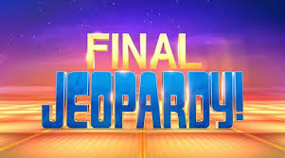
- ROUND 3. FINAL JEOPARDY!
Teacher. The Final Jeopardy! round features a single clue. In the Final Jeopardy! you have to write the response to the clue. You have 1 minute to write your responses. Don’t forget about “Who is/What is…?” . For the right answer you will get 500 points and you will lose 500 points if the response is wrong .
Clue: A number of conditions caused by hypersensitivity of the immune system to something in the environment. Often happens because of pollution of the environment.
- GAME SUMMARY.
The winner is the team with the highest score at the end of the game. The participants get prizes.

Resources: http://www.edtechnetwork.com/powerpoint.html
https://www.youtube.com/watch?v=IkdmOVejUlI
https://en.wikipedia.org/wiki/Jeopardy!

