28

Literature
1. Robert Shuman – father of Europe.
Robert Shuman foundation. Published Serge Domini General Council of Moselle.
2. EU Fact File Longman. The map Our Europe.
3. L. Zakharova. Europe is our home. English language and culture. №25-28 July, 2002.
4. V. Chetyrko. Ukraine’s choice: European Integration. English language and culture №15 April, 2004.
5. H. Ivanova. Fruitful cooperation. English language and culture №4 January, 2005.
6. Азбука Європейської інтеграції. Навчально – методичний посібник під редакцією І.В.Яков’юка. Харків 2006.
7. Сушко В.Я. “Вивчення курсу”Європейський вибір України”” – Історія та правознавство, 2005, №26.
8. Комов А. “Україна і ЄС”- Історія та правознавство, 2005 №44.
9. Internet resources: WWW.EUROPA.EU.INT§
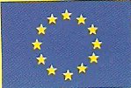
WWW.DELUKR.EC.EUROPA.EU

Project work prepared by the
pupils of the 11th form
Zboriv gymnasium

Teacher T. Budnyk

Zboriv
2007
2
Plan
- Europe is our home.
- From the history of the European Union (EU)
- European Union, its institutions, members and symbols.
- Relations between Ukraine and the European Union.
- Advantages for Ukrainian integration into the European Union.

27
We have a reason to believe that we’ve convinced you that Europe is our home and we should keep it clean, safe and peaceful.
The European Union (EU) is a family of democratic European countries, committed to working together for peace and prosperity. It is not a State intended to replace existing states, but it is more than any other international organization. It’s unique.
The historical roots of the EU lie in the World War II. The idea of European integration was conceived to prevent such killing and destruction from ever happening again.
The European Union has delivered half century of stability, peace and prosperity. It has helped to raise living standards, build a single Europe – wide market, launched the single European currency, the euro, and strengthened Europe’s voice in the world.
In the increasingly interdependent world of 21 century, it will be even more necessary for every European citizen to cooperate with people from other countries in a spirit of curiosity tolerance and solidarity.
The European Union is built on an institutional system which is the only one of its kind in the world.
We are for integration of Ukraine to Europe, but on the condition to come to it as economically and politically strong partners.

26
Most probably, when the regionalisation tendencies in the EU become stronger, the collective power of these countries can then be directed toward solving the problems which each of these countries faces.The integration of Ukraine into the EU would increase Ukraine’s foreign policy potential and would help to ballance the influence of neighbouring countries in the region. Tne strategic importance of Ukraine as the new eastern frontier of the EU will be manifest.

4) Safety-Related Consequences
While the EU is not a military organisation and offers no safety guarantees, the safety of its citizens is often advanced as one of the most important membership benefits. The very fact of membership can operate as a certain protection from outer aggression. Furthermore, membership also contributes to internal safety, since a growing economy tends to reduce social tensions and strengthen democracy. Moreover, the participation in the legal institulions of the EU will make more fruitful the battle against such international problems as illegal migration, organised crime, terrorism.
Ukraine, like all nations, should strive to have good relations with all of its neighbours — both to the east and west. If Ukraine is serious about its intentions to move in an irreversible direction toward free markets, stronger democracy, and the rule of law, the EU is a vehicle that can assist in that endeavour. The question must be asked: If Ukraine is “outside“ Europe, then what is it “inside“? While high demands are made for EU membership, advantages await those countries serious about joining.

3
1.Europe is our home.
Europe is one of the sixth continents, which lies to the north of the Mediterranean Sea and goes to the east as far as the Ural Mountains in Russia. When Americans speak of Europe they usually mean both: Britain and the continent. Europe is completely situated in the Northern Hemisphere. It’s not so big as Asia, isn’t so compact as Australia and less exotic than Africa. But as a rule, Europe is considered to be the model, which the rest parts of the world are compared with. Western Europe is the home for 42 countries. Among them there are such big ones as Sweeden, Finland, Germany, France and Spain. But Ukraine takes the first place being larger than any country in Western Europe. Europeans speak different languages but the majority of the population belongs to the Indo-European language. According to UNESCO Ukrainian occupies 22 place among the world languages and the second place among the Slav languages after Russian. Moreover, Ukraine has good geographical and geopolitical position. Powerful highways, oil and gas pipelines pass across its territory from Asia to Europe. It’s rich in mineral raw materials and soil resources.

2.From the history of the European Union.
For centuries, Europe was the scene of frequent and bloody wars. In the period 1870 to 1945, France and Germany fought each other three times, with terrible loss of life. A number of European leaders became convinced that the only way to secure a lasting peace between their countries was to unite them economically and politically.
So, in 1950, the French Foreign Minister Robert Schuman proposed integrating the coal and steel industries of Western Europe. A a result, in 1951, the European Coal and Steel Community (ECSC) was set up, with six members: Belgium, West Germany, Luxembourg, France, Italy and the Netherlands. The power to take decisions about the coal and steel industry in these countries was placed in the hands of an independent, supranational body called the "High Authority". Jean Monnet was its first President.
4
From three communities to the European Union
The ECSC was such a success that, within a few years, these same six countries decided to go further and integrate other sectors of their economies. In 1957 they signed the Treaties of Rome, creating the European Atomic Energy Community (EURATOM) and the European Economic Community (EEC). The member states set about removing trade barriers between them and forming a "common market".
In 1967 the institutions of the three European communities were merged. From this point on, there was a single Commission and a single Council of Ministers as well as the European Parliament.
Originally, the members of the European Parliament were chosen by the national parliaments but in 1979 the first direct elections were held, allowing the citizens of the member states to vote for the candidate of their choice. Since then, direct elections have been held every five years.
The Treaty of Maastricht (1992) introduced new forms of co-operation between the member state governments - for example on defence, and in the area of "justice and home affairs". By adding this inter-governmental co-operation to the existing "Community" system, the Maastricht Treaty created the European Union (EU).

Integration means common policies
Economic and political integration between the member states of the European Union means that these countries have to take joint decisions on many matters. So they have developed common policies in a very wide range of fields - from agriculture to culture, from consumer affairs to competition, from the environment and energy to transport and trade.
In the early days the focus was on a common commercial policy for coal and steel and a common agricultural policy. Other policies were added as time went by, and as the need arose. Some key policy aims have changed in the light of changing circumstances. For example, the aim of the agricultural policy is no longer to produce as much food as cheaply as possible but to
25
Membership in the EU would mean that Ukraine would be required to contribute dues to the EU; Ukraine would, in turn, receive funding from the EU budget for the benefit of Ukraine‘s less economically developed regions. lt could be forecast that payments to Ukraine would be of greater monetary value than its EU membership dues. And so, the benefits Ukraine could derive from integration into the EU would be the appearance of new markets, demonopolisation, greater economic efficiency and effectiveness. and an increase in the supply of goods and services available to its citizens.

2) Social Consequences
If Ukraine becomes a member of the EU, the statutes of the institution will apply to the citizens of Ukraine. All of the residents of EU countries are also residents of the EU. The EU can help ensure the stability of the institutions that vouch for democracy, the supremacy of Iaw, the protection of human rights, and respect for national minorities.
Having borders that may be freely crossed does not mean that the volume of emigration would necessarily rise. lt is possible that emigration may even decline, because of the greater employment opportunities that Ukraine should accrue from EU membership.
The integration of Ukraine into the EU may also mean a greater cosmopolitanism and a weakening of xenophobic attitudes. The growth of the Ukrainian economy will create the neccessary foundation for the development of a middle class, which will reduce income gap between the rich and poor and contribute to the social stability of the country.

3) Political Consequences
Membership in the EU means representation in the EU‘s institutions. This participation will give Ukraine the opportunity to influence the decisions made within the EU. Ukraine will have a voice on issues that are important to the emerging central and eastern European countries.
24
5.Advantages for Ukrainian integration into the European Union.
Beneficial consequences for Ukraine that should result from the membership of Ukraine in the European Union (EU) can be categorised as: 1) economic,2) social, 3) political, and 4) safety-related.

1) Economic Consequences
The EU is a vast united market, and includes about 400 million residents. The EU market has no internal borders, and therefore merchandise, people, and capital move freely there.
Free movement of services means that any service can be provided within the entire area ofthis internal EU market. Free movement of capital means that the right to invest, buy property and securities, and use profits freely is ensured in any state within this market. Free movement of people means the unlimited freedom to live, establish one‘s own business, and work in any country which belongs to the EU.
The abolition of trade barriers would make it possible for Ukraine to take fuil advantage of this united market. The total volume of trade — as well as of production of export goods — would rise; this would permit the exploitation of the advantages of scale economics (i.e. more could be produced at a lower cost).
Admission into the EU would mean fewer protectionist actions taken against Ukraine. This would both increase the volume of exports from Ukraine to the countries and encourage investment of foreign capital into the Ukrainian economy.
The appearance of new companies inside Ukraine would augment competition and lead to a more rational use and distribution of the economic resources of work and capital. This, in turn, would mean a greater choice of more inexpensive, higher-quality goods. Currently, Ukraine is influenced by the decisions made by the EU; at the same time, it cannot influence the EU as an EU member might. Only after having become a member Ukraine would have the opportunity to influence the decisions and politics of the EU.
5
support farming methods that produce healthy, high-quality food and protect the environment. The need for environmental protection is now taken into account across the whole range of EU policies.
The European Union's relations with the rest of the world have also become important. The EU negotiates major trade and aid agreements with other countries and is developing a Common Foreign and Security Policy.

The Single Market: banning the barriers
It took some time for the Member States to remove all the barriers to trade between them and to turn their "common market" into a genuine single market in which goods, services, people and capital could move around freely. The Single Market was formally completed at the end of 1992, though there is still work to be done in some areas - for example, to create a genuinely single market in financial services.
During the 1990s it became increasingly easy for people to move around in Europe, as passport and customs checks were abolished at most of the EU's internal borders. One consequence is greater mobility for EU citizens. Since 1987, for example, more than a million young Europeans have taken study courses abroad, with support from the EU.
In 1992 the EU decided to go for economic and monetary union (EMU), involving the introduction of a single European currency managed by a European Central Bank. The single currency - the euro - became a reality on 1 January 2002, when euro notes and coins replaced national currencies in twelve of the 15 countries of the European Union (Belgium, Germany, Greece, Spain, France, Ireland, Italy, Luxembourg, the Netherlands, Austria, Portugal and Finland).

6
The growing family
The EU has grown in size with successive waves of accessions. Denmark, Ireland and the United Kingdom joined in 1973 followed by Greece in 1981, Spain and Portugal in 1986 and Austria, Finland and Sweden in 1995. The European Union welcomed ten new countries in 2004: Cyprus, the Czech Republic, Estonia, Hungary, Latvia, Lithuania, Malta, Poland, Slovakia and Slovenia. Bulgaria and Romania expect to follow in 2007; Croatia and Turkey are beginning membership negotiations in 2005.To ensure that the enlarged EU can continue functioning efficiently, it needs a more streamlined system for taking decisions. That is why the Treaty of Nice lays down new rules governing the size of the EU institutions and the way they work. It came into force on 1 February 2003.

3.European Union, its institutions, members and symbols.
The European Union (EU) is a family of democratic European countries, committed to working together for peace and prosperity. It is not a State intended to replace existing states, but it is more than any other international organisation. The EU is, in fact, unique. Its Member States have set up common institutions to which they delegate some of their sovereignty so that decisions on specific matters of joint interest can be made democratically at European level.This pooling of sovereignty is also called "European integration".
The historical roots of the European Union lie in the Second World War. The idea of European integration was conceived to prevent such killing and destruction from ever happening again. It was first proposed by the French Foreign Minister Robert Schuman in a speech on 9 May 1950. This date, the "birthday" of what is now the EU, is celebrated annually as Europe Day.
There are five EU institutions, each playing a specific role:
- European Parliament (elected by the peoples of the Member States);
23
The PCA established a Cooperation Council to supervise implementation of the Agreement. It meets at ministerial level at least once a year.
The Co-operation Council is assisted in the performance of its duties by a Co-operation Committee composed of representatives of the members of the Council of the European Union and of members of the Commission of the European Communities on the one hand and of representatives of the Government of Ukraine on the other.
The PCA also provides for regular political dialogue at parliamentary level within the Parliamentary Co-operation Committee.
The Ukraine-EU Co-operation Council may decide to set up any other special committee or body that can assist it in carrying out its duties and shall determine the composition and duties of such committees or bodies and how they shall function.
At present in the framework of Ukraine-EU Co-operation Council have been established and function 4 Subcommittees and 3 Working Groups (in the framework of the Subcommittee #3).

1. EU-Ukraine Subcommittee on Trade and Investment.
2. EU-Ukraine Subcommittee on Finance, Economy and Statistics.
3. EU-Ukraine Subcommittee on Transport, Energy, Civil and Nuclear Cooperation, Environment, Science, Education and Technology.
EU-Ukraine Working Group on Energy Savings and Renewables.
EU-Ukraine Working Group on Climate Change.
EU-Ukraine Working Group on Energy Strategies.
4. EU-Ukraine Subcommittee on Customs and Cross-boarder Cooperation, Combating Illegal Migration, Money Laundering and Illicit Drugs.
The Agreement has been concluded for an initial period of ten years.
22
The EU-Ukraine cooperation in the sphere of outer space is also very promising. Given Ukraine's place among 8 countries demonstrating significant technological background on space programmes, on 2 September 2004 the European Commission sought Council approval for its recommendation to start negotiations on a cooperation agreement with Ukraine on the development of a Civil Global Navigation Satellite System (GNSS). The cooperation is expected to cover research and scientific activities especially on standardisation issues, regional integrity monitoring and financial investment in GALILEO.
Today Ukraine sees its main task in consolidation of the European values and standards in political, economy and social spheres, regarding it as a pledge of its public stability and sustainable development.

The Partnership and Co-operation Agreement
The Partnership and Co-operation Agreement ("PCA") between the European Communities and their Member States, on the one part, and Ukraine, on the other part, was signed in Luxembourg on 14 June 1994 and came into force in March 1998.
The main objectives of the PCA are to develop close relations by means of permanent dialogue on political issues, to provide an appropriate framework for political dialogue, to promote trade and investment between the parties, to provide a basis for mutually advantageous economic, social, financial, civil, scientific, technological and cultural co-operation and to support Ukrainian efforts to consolidate its democracy, to develop its economy and complete the transition to a market economy.

The PCA Institutions
In accordance with the PCA Parties have established a regular political dialogue.
Talks at the highest political level are held in the framework of Summits.

7
- Council of the European Union (representing the governments of the Member States);
- European Commission (driving force and executive body);
- Court of Justice (ensuring compliance with the law);
- Court of Auditors (controlling sound and lawful management of the EU budget).
These are flanked by five other important bodies:
- European Economic and Social Committee (expresses the opinions of organised civil society on economic and social issues);
- Committee of the Regions (expresses the opinions of regional and local authorities);
- European Central Bank (responsible for monetary policy and managing the euro);
- European Ombudsman (deals with citizens' complaints about maladministration by any EU institution or body);
- European Investment Bank (helps achieve EU objectives by financing investment projects);
A number of agencies and other bodies complete the system.
The rule of law is fundamental to the European Union. All EU decisions and procedures are based on the Treaties, which are agreed by all the EU countries.
Initially, the EU consisted of just six countries: Belgium, Germany, France, Italy, Luxembourg and the Netherlands. Denmark, Ireland and the United Kingdom joined in 1973, Greece in 1981, Spain and Portugal in 1986, Austria, Finland and Sweden in 1995. In 2004 the biggest ever enlargement took place with 10 new countries joining.
In the early years, much of the co-operation between EU countries was about trade and the economy, but now the EU also deals with many other subjects of direct importance for our everyday life, such as citizens' rights; ensuring freedom, security and justice; job creation; regional development; environmental protection; making globalisation work for everyone.
8
The European Union has delivered half a century of stability, peace and prosperity. It has helped to raise living standards, built a single Europe-wide market, launched the single European currency, the euro, and strengthened Europe's voice in the world.
Unity in diversity: Europe is a continent with many different traditions and languages, but also with shared values. The EU defends these values. It fosters co-operation among the peoples of Europe, promoting unity while preserving diversity and ensuring that decisions are taken as close as possible to the citizens.
In the increasingly interdependent world of the 21st century, it will be even more necessary for every European citizen to co-operate with people from other countries in a spirit of curiosity, tolerance and solidarity.
The European Union is built on an institutional system which is the only one of its kind in the world.
The Member States delegate sovereignty for certain matters to independent institutions which represent the interests of the Union as a whole, its member countries and its citizens.
The Commission traditionally upholds the interests of the Union as a whole, while each national government is represented within the Council, and the European Parliament is directly elected by citizens. Democracy and the rule of law are therefore the cornerstones of the structure.
This "institutional triangle" of Commission, Council and Parliament is flanked by two more institutions - the Court of Justice and the Court of Auditors - and five other European bodies. In addition thirteen specialised agencies have been set up to handle certain essentially technical, scientific, or management tasks.
Symbols of European Union
Flag of the EU
The history of the flag goes back to 1955. At that time, the European Union existed only in the form of the European Coal and Steel Community, with just six Member States. But a separate body with a larger membership - the Council of Europe - had been set up several years earlier and was busy defending human rights and
21
negotiations within the WTO on the permanent basis. After the conclusion in 2003 of the bilateral Protocol on the access to the markets of goods and services within the framework of the WTO, the parties started elaboration and adjustment of the draft Report of the Working Party.
The EU-Ukraine cooperation in the sphere of justice and home affairs, in particular on the issues of granting asylum, border management, fight against money laundering and illegal drug trafficking is consistently strengthening.
In the context of the EU enlargement Ukraine strives to prevent the creation of a new dividing lines in Europe and advocates non-discriminatory approach to the regime of movement of its citizens across the territory of the EU Member States. The work in this direction in particular includes: perspective introduction of long-term multiply visas for the citizens of Ukraine who take part in economic, cultural and sports exchanges with the EU on a permanent basis; simplification of visa regime for citizens of Ukraine - border areas inhabitants and in the long-term prospect - facilitation of visa regime for all categories of the Ukrainians.
Ukraine and the EU proceed with dynamic cooperation in the sphere of energy, including the nuclear one, agriculture and environment. The EU political and financial assistance to Ukraine in addressing the most urgent problems in the energy sector as well as in mitigating the consequences of the Chornobyl catastrophe is gradually increasing.
The EU has also provided support for reforming the control system of the Ukrainian gas-transporting system, holding technical audit of the oil terminal "Pivdennyi" and technical and economic assessment of the project of transportation of the Caspian oil by Odesa-Brody-Gdansk pipeline, development of the alternative energy and modernization of the coal industry etc.
The EU is the largest donor to Ukraine. Total assistance since 1991 in the framework of the TACIS program, macro financial and humanitarian assistance amounted to more that 1 billion euro.
20
Union to a qualitatively new level. Proper implementation of the Action Plan should also facilitate gradual integration of Ukraine into the EU Single Market and create
prerequisites for establishing Free Trade Area with the EU. The conclusion of a new enhanced agreement with the EU should become the ultimate political goal of the Action Plan.
Remaining outside the EU borders, Ukraine has successfully associated with the realization of the EU Common Security and Defense Policy (ESDP). Our state takes part in the EU Police Missions in Bosnia and Herzegovina and the Former Yugoslav Republic of Macedonia. The expected conclusion of an Agreement on the security procedures for exchange of classified information and of an Agreement establishing a framework for Ukraine's participation in the EU crisis management operations, should contribute to strengthening legal base of cooperation in this sphere.
The EU also recognizes an important role of Ukraine in providing security and stability on the continent as well as its vast industrial and technological potential in the military sphere. The practice of inviting Ukraine to military training with the participation of the EU units is a clear confirmation of that.
The EU-Ukraine trade and economic cooperation has recently experienced notable intensification. From year to year the bilateral foreign trade turnover and direct EU investment in the Ukrainian economy are constantly increasing. Today the EU is the largest foreign trade partner of Ukraine (the share of the EU in the foreign trade of Ukraine reached 33% upon the accession to the Union of new ten Members-States). In June 2004 the Parties initialed the Agreement on trade in steel products, whose signature is scheduled for the fall this year. According to the Agreement, Ukraine's quota on steel for the year 2004 is amounted to 606 thousand tons. The EU consideration of the correspondence of the Ukrainian economy to the market standards within the framework of the EU antidumping procedures is almost completed.
Ukraine and the EU actively cooperate in the framework of the Working Party on Ukraine's accession to the WTO. The EU side supports Ukraine in multilateral as well as bilateral
9
promoting European culture. The Council of Europe was considering what symbol to adopt for its own use. After much discussion, the present design was adopted - a circle of twelve gold stars on a blue background. In various traditions, twelve is a symbolic number representing perfection. It is also, of course, the number of months in a year and the number of hours shown on a clock face. The circle is, among other things, a symbol of unity. So the European flag was born, representing the ideal of unity among the peoples of Europe.
The Council of Europe then encouraged other European institutions to adopt the same flag and, in 1983, the European Parliament took up the call. Finally, in 1985, the flag was adopted by all EU heads of State and government as the official emblem of the European Union - which, in those days, was called the European Communities.
All European institutions have been using it since the beginning of 1986.
The European flag is the only emblem of the European Commission - the EU's executive arm. Other EU institutions and bodies use an emblem of their own in addition to the European flag.

The European Anthem
This is the anthem not only of the European Union but also of Europe in a wider sense. The melody comes from the Ninth Symphony composed in 1823 by Ludwig Van Beethoven.
For the final movement of this symphony, Beethoven set to music the "Ode to Joy" written in 1785 by Friedrich von Schiller. This poem expresses Schiller's idealistic vision of the human race becoming brothers - a vision Beethoven shared.
In 1972, the Council of Europe (the same body that designed the European flag) adopted Beethoven's "Ode to Joy" theme as its own anthem. The well-known conductor Herbert Von Karajan was asked to write three instrumental arrangements - for solo piano, for wind instruments and for symphony orchestra. Without words, in the universal language of music, this anthem expresses the ideals of
10
freedom, peace and solidarity for which Europe stands.In 1985, it was adopted by EU heads of State and government as the official anthem of the European Union. It is not intended to replace the national anthems of the Member States but rather to celebrate the values they all share and their unity in diversity.

Europe Day
On the 9th of May 1950, Robert Schuman presented his proposal on the creation of an organised Europe, indispensable to the maintenance of peaceful relations.
This proposal, known as the "Schuman declaration", is considered to be the beginning of the creation of what is now the European Union.
Today, the 9th of May has become a European symbol (Europe Day) which along with the single currency (the euro), the flag and the anthem, identifies the political entity of the European Union. Europe Day is the occasion for activities and festivities that bring Europe closer to its citizens and peoples of the Union closer to one another.
19
4. Relations between Ukraine and the European Union
Relations between Ukraine and the European Union were established in December 1991, when the Minister for Foreign Affairs of the Netherlands as the EU Presidency, on behalf of the Union officially recognized the independence of Ukraine.
The Partnership and Cooperation Agreement between Ukraine and the EU (PCA) signed on 16 June 1994 (entered into force on 1 March 1998) constitutes the legal base of the EU-Ukraine relations and establishes cooperation on a wide range of political, trade, economic and humanitarian issues.
At present there are 7 priorities of the EU-Ukraine cooperation envisaged by the PCA's framework: energy, trade and investments, justice and home affairs, adaptation of the Ukrainian legislation to that of the EU, environment, transport, trans-border cooperation, collaboration in the sphere of science, technology and outer space.The EU-Ukraine dialogue is carried out through annual meetings of the EU-Ukraine Summit with the participation of the President of Ukraine; Cooperation Council with the participation of the Prime-Minister of Ukraine; Cooperation Committee; Committee on parliamentary cooperation; regular Ukraine-EU Triyka meetings; permanent expert consultations. The EU and Ukraine annually hold more that 80 different official meetings and consultations at the high and expert levels.
The European integration is a key and irreversible priority of Ukraine's foreign policy. In the address to the Verkhovna Rada of Ukraine in June 2002 the President of Ukraine outlined the European integration as a streamline of Ukraine's economic and social strategy for the next decade.
Present development of the political dialogue between Ukraine and the EU is based on implementation by Ukraine of the Strategy of integration into the EU, implementation of the PCA and elaboration of the Action Plan in the framework of the European Neighborhood Policy. Ukraine is proceeding form the fact that the implementation of this document should contribute to strengthening cooperation with the EU in the light of enlargement, create necessary preconditions for raising its relations with the
18

Poland
Ambassador: Mr. Marek Ziolkowski
Address:
Yaroslaviv val, 12
Tel.: 230 07 03
Fax: 464 13 36
E-mail: ambasada@polska.com.ua

Slovakia
Ambassador:
Address:
Jaroslaviv Val 34
01901, Kyiv
Tel.: 212 03 10, 212 13 10
Fax: 212 32 71
E-mail: slovak@i-kiev.ua

Slovenia
Ambassador: Mr. Primoz SELIGO
Address:
3, Nekrasivska Str., Off. 6
04053 Kyiv
Tel.: 216 01 86, 216 44 11
Fax: 234 94 11

11

EU Member States

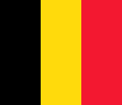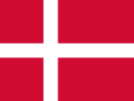

Belgium Denmark

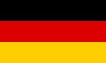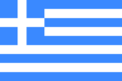

Germany Greece

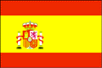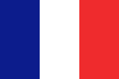

Spain France

12
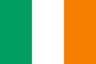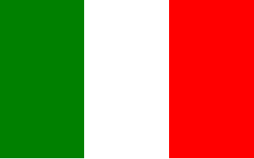
Ireland Italy

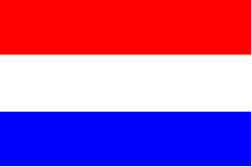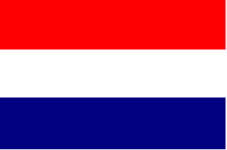
Luxembourg The Netherlands

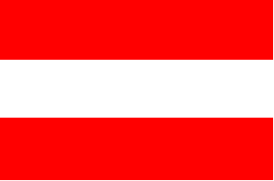
Austria Portugal

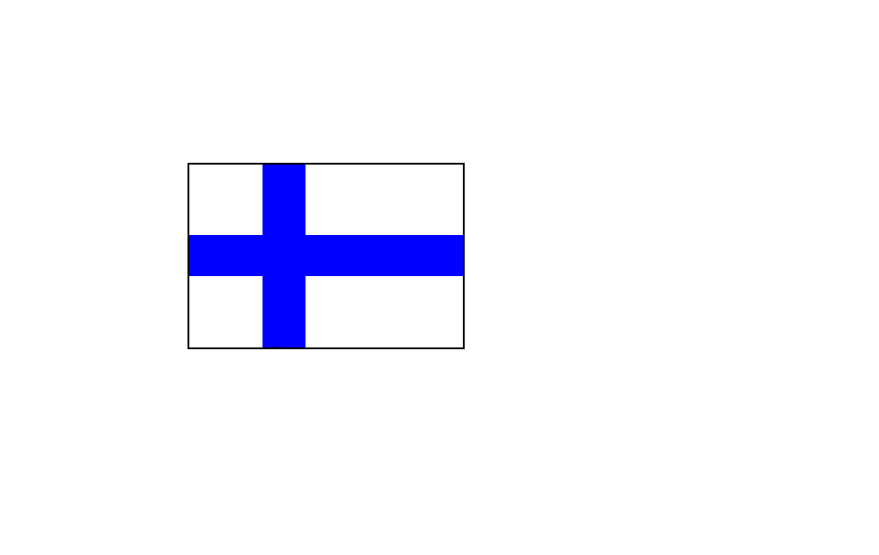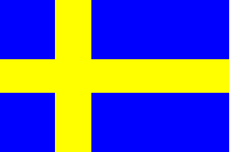
Finland Sweden
17
Cyprus  Ambassador: Pedro Manuel Sarmento de Vasconcelos e Castro  Address:  Kiev , 18/24 Dmitrovska St.  Tel.: 216 36 05 | Czech Republic  Ambassador:  Address:  Yaroslaviv Val, 34A  01901 Kiev  Tel.: 272 08 07, 272-21-10, 272-04-31  Fax: 272 62 04  E-mail: kiev@embassy.mzv.cz
Estonia  Ambassador: Mr. Paul Lettens  Address:  61/11, Volodymyrska St.  01901, Kyiv  Tel.: 235 85 82  Fax: 234 14 03  E-mail: saatkond@estemb.kiev.ua | Hungary  Ambassador: Mr. Janos TOTH  Address:  33 Reytarska Str., Kyiv  Tel.: 238-6381, 238-6382, 238-6384  Fax: 272 20 90  E-mail: po.box@hunemb.com.ua
Latvia  Ambassador: Mr. Andris Vilcans  Address:  6B Sichnevogo Povstannya Str.  01901 Kyiv  Tel.: 490 70 30, 288 97 03  Fax: 490 70 35 | Lithuania  Ambassador: Mr. Viktoras Baublys  Address:  21, Buslivska St.  01901, Kyiv  Tel.: 254 09 20  Fax: 254 09 28  E-mail: embassy@ltembua.org

16
Italy  Ambassador: Jolanda Brunetti Goetz  Address:  Yaroslaviv Val 32B  01901 Kyiv  Tel.: 230 31 00  Fax: 230 31 03  E-mail: Ambital.Kiev@utel.net.ua | Netherlands  Ambassador: Monique P.A. Frank  Address:  Kontraktova Ploshcha 7  01901 Kyiv  Tel.: 490 82 00  Fax: 490 82 09  E-mail: kie@minbuza.nl
Portugal  Ambassador: Pedro Manuel Sarmento de Vasconcelos e Castro  Address:  Vul. Velyka Vasylkivska 9/2, office 10  01901 Kyiv  Tel.: 227 24 42  Fax: 227 20 66  E-mail: embport@ukrpack.net | Spain  Ambassador: Luis Gуmez de Aranda y Villйn  Address:  Vul. Degtiariovska 38/44,7th floor  01901 Kyiv  Tel.: 213 04 81  Fax: 213 00 31/ 211 38 15 - visa section  E-mail: embespua@mail.mae.es
Sweden  Ambassador: Еke Peterson  Address:  Vul. Ivana Franka 34/33  01901 Kyiv  Tel.: 494 42 70  Fax: 462 05 81  E-mail: ambassaden.kiev@foreign.ministry.se | UK  Ambassador: Robert Brinkley  Address:  Vul. Desyatynna 9  01025 Kyiv  Tel.: 490 36 60  Fax: 490 36 62  E-mail: ukembinf@sovam.ua.com

13
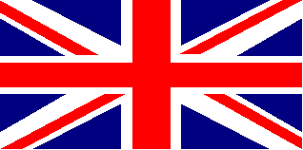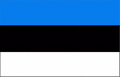
The United Kingdom Estonia


Cyprus Latvia

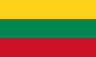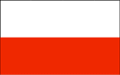
Lithuania Poland
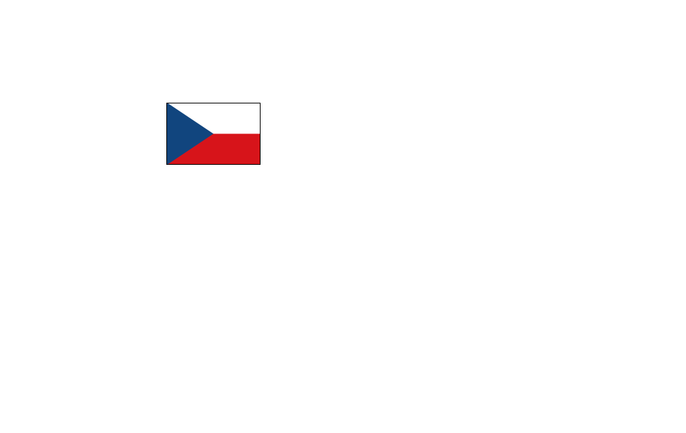
The Chech Republic Malta

14
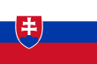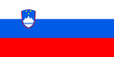
Slovakia Slovenia

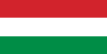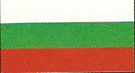

Hungary Bulgaria

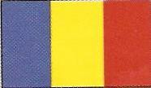

Romania

15
EU member states embassies in Kyiv

Austria  Ambassador: Michael Miess  Address:  Vul. Ivana Franka 33  01030 Kyiv  Tel.: 220 57 59  Fax: 227 54 65  E-mail: kiew.ob@bmaa.gv.at | Belgium  Ambassador: Pierre Colot  Address:  Vul. Leontovicha 4  Kyiv  Tel.: 238 26 00  Fax: 238 26 01  E-mail: Ambbkiev@gu.net
Finland  Ambassador: Laura Reinilд  Address:  Vul. Striletska 14  01901 Kyiv  Tel.: 228 70 49  Fax: 228 20 32  E-mail: info@finemb.kiev.ua | France  Ambassador: Philippe de Suremain  Address:  Vul. Reitarska 39  01901 Kyiv  Tel.: 228 73 69  Fax: 229 08 70  E-mail: pressefr@carrier.kiev.ua
Germany  Ambassador: Dietmar Stьdemann  Address:  Vul. B. Khmelnitskogo 25  01901 Kyiv  Tel.: 247 68 00  Fax: 247 68 18  E-mail: pr@german-embassy.kiev.ua | Greece  Ambassador: Panayotis Goumas  Address:  Vul. Sophievska 19  01901 Kyiv  Tel.: 229 57 30  Fax: 229 13 38  E-mail: greece@inec.kiev.ua

