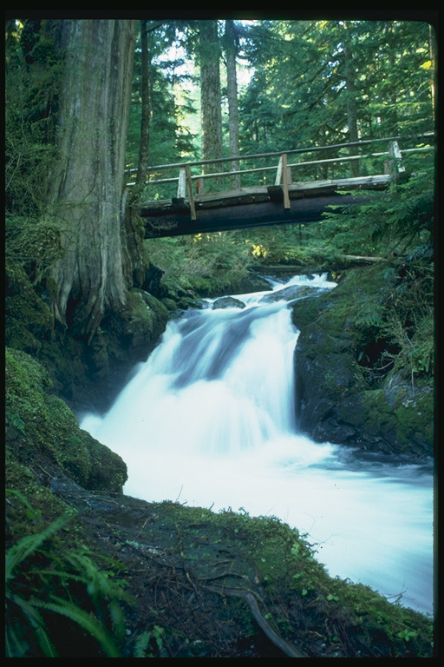
The Ukrainian painting is famous for its beauty and charm. It helps people to love life and enjoy it. At the end of the last century several painting schools were formed in Kyiv, Odessa and Kharkiv.They united such prominent Ukrainian artists as N.Murashko, N.Konstandi, N.Pymonenko, N.Samokish.
Among the modern painters the names of T.Yablons' ka, M.Khmel' ko, V.Yakubych are best known.Canvases by Boichuk,Krainov,Krychevs'kyi,Trokhymenko, Kassian,Shovkunenko,Shyshko,Borodai, Kotska, Hlushchenko, Kashshai are a sheer delight to the eye.
A.A.KOTSKA (1911- 1987)

Andriy Andriovych Kotska was born in Uzhgorod. He entirely gave himself to the beauty of nature and man. His landscapes '' Spring Morning '', '' Early Spring '', '' Spring '' are too lovely for words. We can' t help admiring these masterpieces.
Looking at them we find ourselves in the realm of beauty. A.Kotska was an extremely modest man, but it can' t be said about his art. It' s so rich and original.

Mykola Petrovych Hlushchenko
Mykola Petrovych Hlushchenko is a prominent Ukrainian landscape painter. All his canvases are full of optimistic, love of life. The painter noticed the beauty everywhere: spring was so picturesque, summer was so bright, autumn was of unique beauty, and even cold and severe winter was so wonderful for the painter. He couldn’t help reflecting the beauty of the Ukrainian nature in his landscapes: “Ukraine”, “Over the Dnipro River”, “Storm”, “Lilac”, “March Birches”, “Kyiv Autumn”, “Winter Morning”, For in the Field”.They are so beautiful that we can’t tear ourselves away from them. They make us stand and state admiring the mysterious beauty of nature. They make a deep impression on us and lead us to the realm of beauty. There is such beauty in Hlyshchenko’s painting that they are as hard to describe as beautiful music.

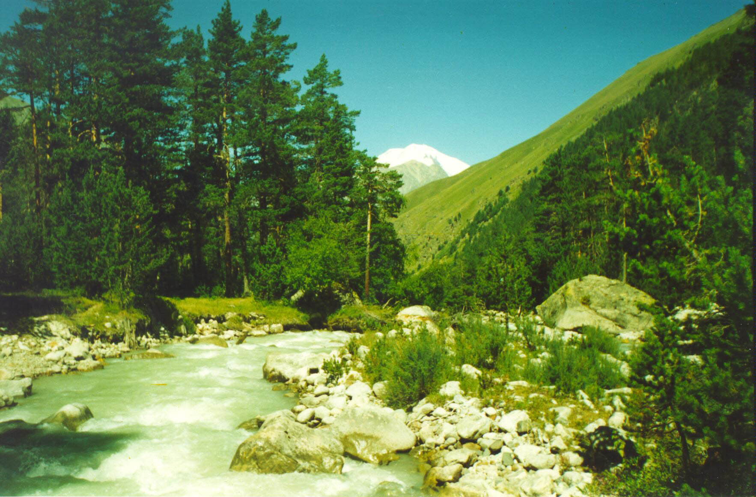

A.M.Kashshai.
A.Kashshai is a famous Ukrainian painter. He was born in Dubrynych, Transcarpathian region, in 1921921. While a boy he was fond of drawing. He had a talent for it. I.Bokshai, an outstanding Ukrainian artist, took notice of him. And he considered Anton Kashshai to be one of his best and talented students. His art is full of love for man, belief in him, readiness to serve people. And he created wonderful canvases for them and gave them a great opportunity of getting pleasure in admiring the real unique beauty of Transcarpathian region. Look at the picture “Spring in the Carpathians” and you’ll enjoy a wonderful view of the forest with a veil on. You see slim pines slumbering in the violence of white snowstorm in the painting “First Snow”. And a real beauty of the autumn decorated with gold is depicted in the canvas “Late Autumn”
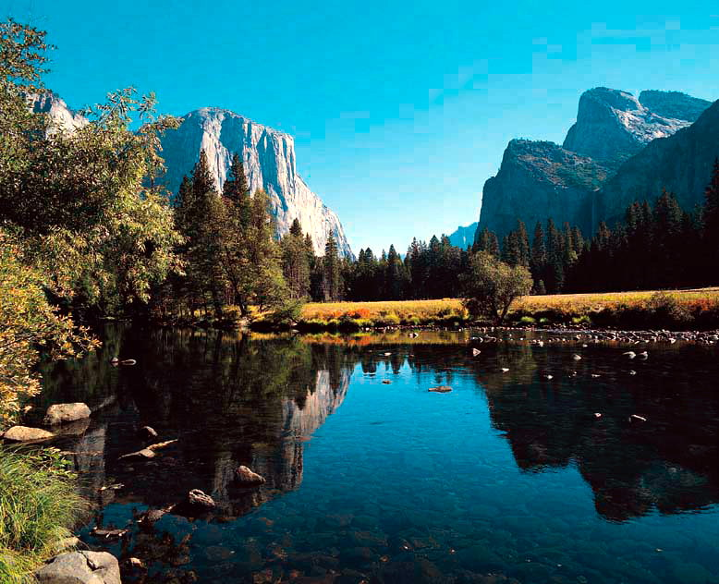
Anton Mykhailovych Kashshai is known as a master of landscape painting. His pictures excite and impress us greatly. They bring to us a better understanding and a greater love of life. His picture show how beautiful nature in Ukraine is and how wonderful the people of this land are.

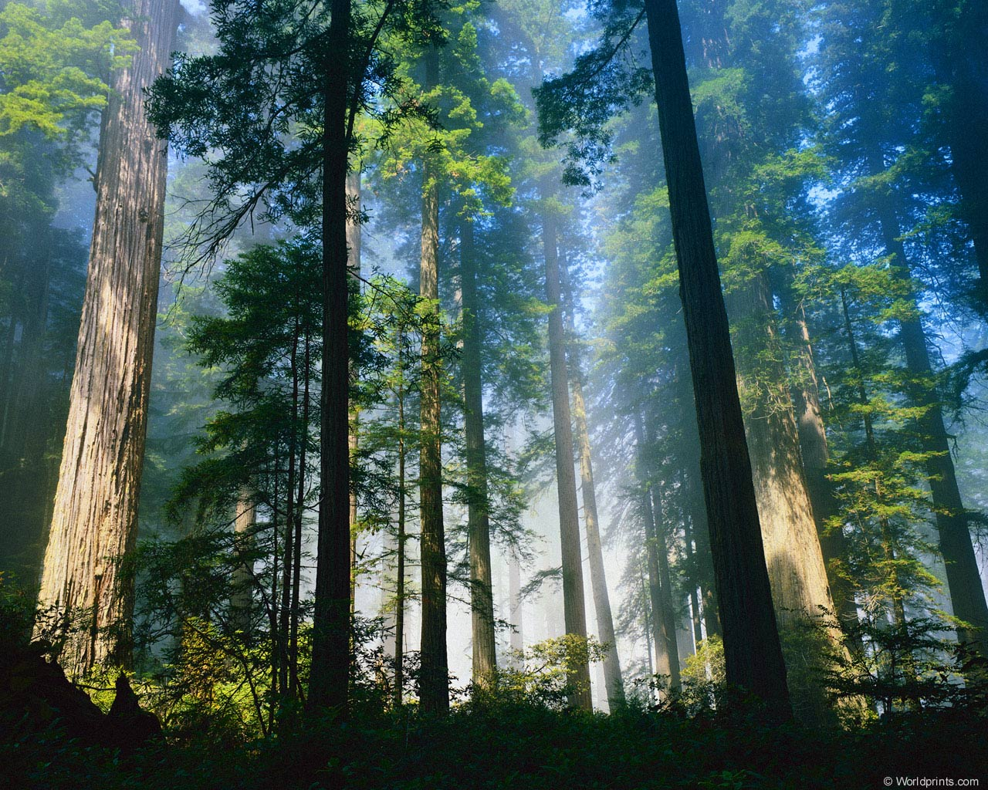

S. F. Shyshko
S. F. Shyshko, a famous Ukrainian landscape painter, was born on June 25, 1911. He is the author of wonderful landscape dedicated to Kyiv.
They are real masterpieces. The pictures “Volodymyr‘s Hill”, “The Dnipro in Autumn”, “Kyiv’s Distance” reflect the beauty of the capital of Ukraine.
Look at the picture “The Dnipro in Autumn” and you’ll be charmed with the autumn Dnipro. Its deep blue waters reflect the beauty of the sunny sky and golden trees growing on the river side. And you can’t help admiring such a view. How beautiful is the Dnipro! It has its charm even in autumn.

Famous Ukrainian Painters.
Project work

Vladymyr I. Doskoch R. Bashutskyi V. Vons P.

Form 9

